Lab 2. The Roots of Human History

Lab in Brief:
The Purpose of this assignment is to introduce you to thinking about finding solutions using spatial data – i.e., “making fancy maps.” In this case, you'll be learning how to process and use satellite imagery to attempt and identify locations for human habitation, and using that data to defend your choices. Further, you will learn how to produce a new type of data visualization from scratch using datasets: a “map”. Believe it or not, geographers still make those things!

Data and Materials:
This time around, we'll be using the open source GIS program “Quantum GIS” (Q for short), along with satellite information drawn from a number of different satellite and space shuttle missions (including the Shuttle Radar Topography Mission [SRTM], MODIS Satellite Series, and a variety of weather and climate satellites). We'll be combining this with information collected on the ground throughout French Polynesia.

Objectives:
In this lab, you will (a) answer a series of questions regarding the relative suitability of different locations within French Polynesia for human habitation, taking into account a variety of environmental concerns (including sea level rise), and (b) select two sites – one that is a strong choice for human habitation, and one that Is a weak choice. Finally, you will produce a mapped visualization that defends your choice.

Deliverables:
By Friday, September 25th at 11:59PM EST, you will submit the following on blackboard:
(1) A word document answering the questions at the end of the lab, including your selection of two sites (a good and bad choice) for human habitation.
(2) A mapped visualization providing information that defends your choice, with your selected sites and other relevant information clearly presented.

Grading:
This lab will be graded according to the same rubric used for Lab 1, which can be found on blackboard. The four key criteria are Creativity, Clarity, your ability to Define the Problem and use pertinent information to defend your site selections.
Part 1: Getting Setup

  - First, create a new folder on your H drive, and then download all of the data from blackboard and put it into that folder. You'll have quite a lot in there, including vectors (i.e., “shapefiles”) and raster (i.e., “tif” files) data.
Fun (“for Dan”) Geography Fact: A vector is generally used to define boundaries, for example a state, on a map. Rasters store information that is collected over space, for example satellite data or temperature.

  - Go to the Start button and type in “Qgis”, or simply “Q”. You'll see Quantum GIS Desktop appear as an application – go ahead and launch it. Note it will take a little while to start the first time (2-3 minutes), but should be much faster after this.
Fun (“for You”) Fact: Quantum GIS is free, and you can install it on your computer and do this entire lab at home (if you really want!). The URL is: http://www.qgis.org/

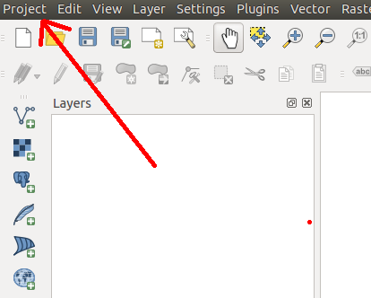
  - Once Q (we'll call it Q from now on) opens, the firs thing you'll want to do is create a new “project” (this is what you'll be saving into). To do that, click the “Project” button at the upper-left, then click “Save As”. Pick your H drive folder and create a name you'll remember!
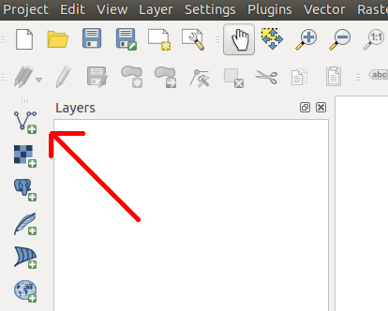
  - Now, we're going to add in our first bit of GIS data. Ultimately, we're attempting to identify the best sites across French Polynesia for human habitation, so we want to load a boundary that tells the computer where French Polynesia is. Because it is a boundary file, it's saved as a vector, so click on the “Add Vector Layer” button, then navigate to your H:\ drive and find the file “PYF_adm0.shp”, and add it to your map.
Fact number 3(ish): you can download boundaries for any country in the world from http://www.gadm.org !
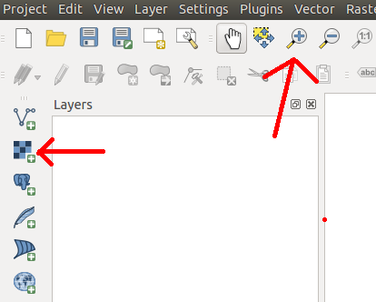
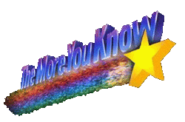
  - You're probably thinking “well, that doesn't look very impressive”. All you've loaded are the national boundaries for French Polynesia, but it's awfully hard to tell what's really going on without something called a “basemap” - i.e., data that shows where you are in the world. Let's add one of those. The basemap is our first raster file, so you're going to click “Add Raster Layer.” Now, navigate to your H drive and find the file “NE2_HR_LC_SR_W_DR.tif”, and add that to your map.
That long file name stands for “Natural Earth 2 – High Resolution – Land Cover – Shaded Relief – Water and Drainages. You can have many different types of base maps with a variety of different features included. Take a look at http://www.naturalearthdata.com/ for more!
  - To understand what you just did, you'll want to do two things. First, use the magnifying glass tool to zoom in on one of your islands. You'll see it looks kind of fuzzy – that's caused by what's called “spatial resolution” - i.e., satellites can only see as well as the camera that powers them. Better satellites have finer spatial resolution, which makes things less fuzzy. Second, use the zoom-out magnifying glass (with the “minus” inside it) to zoom out and see the entire world (you may need to click a few times; you can also use your mouse wheel). You can zoom in to any area to see how it's represented with the base map. Hundreds of basemaps exist – for example, if you use maps.google.com and type in “French Polynesia”, you'll see a basemap with much finer spatial resolution. However, the file size for such images is far larger than systems like blackboard (or even your computers!) could hold.
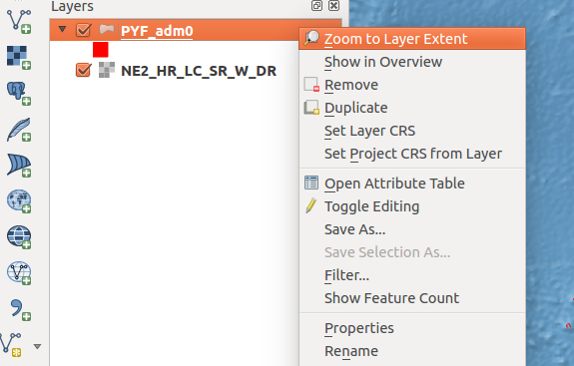
  - You may notice you “lost” your original islands when you added the base map. This is because the base map was effectively put “on top” of the polygons. To fix this, drag the PYF_adm0 to the top of the list on the left (this list is called the “Table of Contents”). Once you've done that, let's head back to French Polynesia by right clicking on “PYF_adm0” in our Table of Contents and choose “Zoom to Layer Extent”.

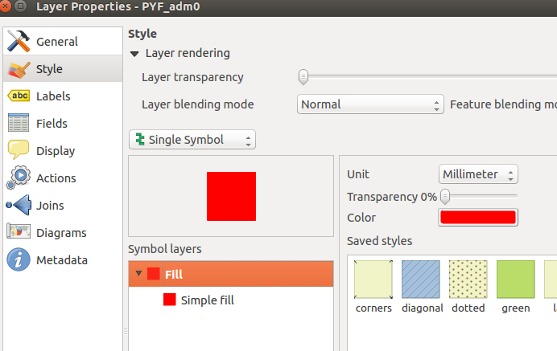
  - Even now, those islands and atolls are difficult to see, so let's make them more obvious. Right click on “PYF_adm0” in the table of contents, and choose “Properties”. Change the color (under “Style” on the left) to something easier to see – I chose bright red, but you can do whatever is easiest for you. You can also play with things like transparency here to make your map easier to understand and more visually appealing.
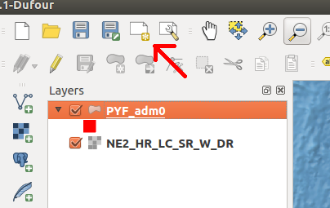
  - Once you're happy with your coloring, close that window (you can always go back later). We're going to use what we just produced to make our first – very basic – map. Click on the “Map Composer” in the upper left, which will open a new window. Now, name your map something you'll remember later.
  - The window that just opened is the “Map Composer”. All we're going to do this time is add the map you just produced, a legend (i.e., something that explains what symbols on the map mean), and scale bar (a representation of how many miles an inch is), but you'll want to do much more for the map you turn in for this lab so make yourself comfortable with this tool. Let's get started: click on the Add new map button and then drag a square in the white canvas. Adjust you r map so you can see it, then try the add legend and scalebar options.
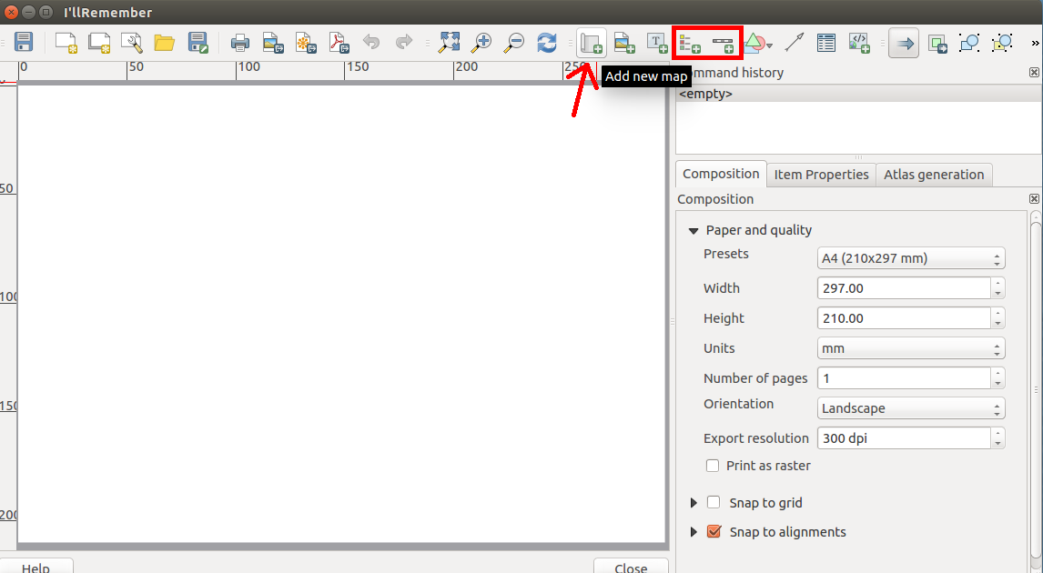

11. While you won't need to save this test map, in the future you can export it to a PDF document by clicking the “Export to PDF” button at the top of the composer. To save your map, simply close this window – you can pick up where you left off by clicking the button next to the map composer on the main window (the one with a wrench), then choosing your map name.

12.

