Lab 5. Visionmaking

Lab in Brief:
This lab will have you going public with your own datasets – choosing how to visualize them and how to use those datasets to support a particular argument in an online environment. You'll then create a number of different websites – using both R and an online program called visionmaker – to communicate these visualizations to a broader audience. While the focus of this lab will be on climate and climate change, the tools and procedures you will learn can be applied to any dataset.

Data and Materials:
We'll be using climate data from an online source made available by the FAO, http://geonetwork3.fao.org/climpag/agroclimdb_en.php

Objectives:
In this lab, you will be applying all of the skills you've learned in previous labs to:
(A) Condense a very large dataset into meaningful, interactive visualizations.
(B) Put those visualizations online.
(C) Use these visualizations to argue that the area of the world you selection has (or has not) experienced imapcts from climate change to date.
(D) Finally, you'll be using an online program called visionmaker to leverage spatial modes of climate resilience in an online environment.

Deliverables:
By Friday, November 13th you will turn in the deliverables outlined on the final page of this lab.

Grading:
This lab will be graded by rubric, following the same grading strategy we've used for all of the labs to date. The rubric can be viewed on blackboard.
Part 1: Getting The Data and Cleaning it Up
The first steps of this lab will have you downloading data and cleaning it so that it's useful. For all of these examples I will use the United States, but you can download climate data from any country you are interested in. Keep in mind, though, that some countries will have very few weather stations and thus are not strong candidates for this lab.

1. In your browser, go to http://geonetwork3.fao.org/climpag/agroclimdb_en.php , then click on “by country” towards the bottom of the screen (we want to pick out climate data for each country).
2. Choose the country you're interested in, make sure you have “time series” selected, then click continue.
3. Choose Temperature, Monthly mean, then click continue.
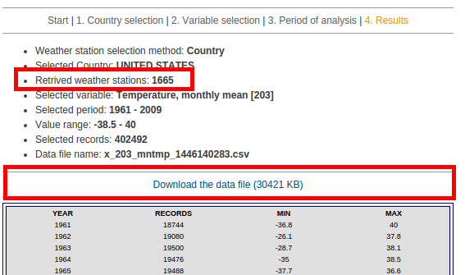
4. Check where it says “Available Weather Stations”, and make sure you have at least 100 weather stations available to sample from. If you don't, you need to pick another country. If you do, you can continue - in the from and to fields, enter 1961 to 2009. We choose this date range as data is very sparse before 1961 from weather stations.
5. After a few minutes your final dataset will be ready for download – double check the retrieved weathers stations count is greater than 100, then click the download link and save the file into your H: drive (i.e., your R working directory). If you have less than 100 records, you need to select a different country.

6. Open up R (I knew all along you were anxiously waiting for this step!!).

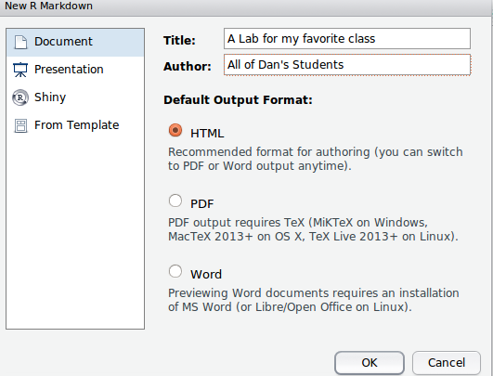
7. We're going to do something a bit different than before – instead of a normal R document, we're going to make something called an Rmarkdown document. These are very similar to normal R documents, but they let you put your content online. To do this, click on File → New File → Rmarkdown Document. In the wizard that pops up, you'll put a title and your name, but leave everything else at the defaults as shown below, then click OK.

8. Your default R document is now going to look a little crazy. It's OK! Click on File → Save, and save your field with the file extension “Rmd” in your H: working directory. For example, “MyFavoriteClass_Lab5.Rmd”.

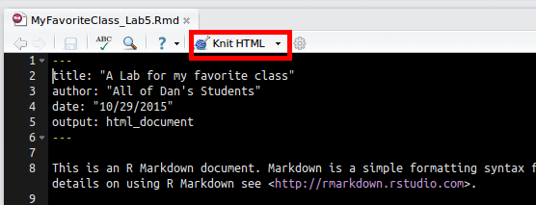
9. The advantage of Rmarkdown documents is they let you automatically build websites using your R code. To try this out, click on the “Knit HTML” button at the top of your screen and view the output. Later on, it will be very easy to publish these types of outputs to the web. On the window that pops up, you can click on “View in Browser” to see what it will look like online.

10. There are a couple of new things in Rmarkdown you need to know. First, is the ``` set of characters. This character (above tab to the far left of your keyboard, just under escape) is what Rmarkdown uses to define where R code lives in your document. So, for example, if you type in:

MyClimateData ← read.csv(x_203_mntmp_1446136697.csv)

R won't know what to do, and will just print out the text. Instead, if you type in:

```
MyClimateData ← read.csv(x_203_mntmp_1446136697.csv)

```
With the three “`” before and after your R code, R will be able to interpret the code correctly.

11. Alright, time to get started for real. Delete everything in your document and just put in the following lines:

```{r, echo=TRUE}

print("Hello, Web!")

```

Now, click the “Knit” button – you'll see both the R command you put in, as well as the return come out on the website. Now, change the echo=TRUE to echo=FALSE and knit it again. Question 1-11: what changed when you changed echo from TRUE to FALSE? Why?

12. We won't want to show all of our code on the website, as not all of it will be relevant for our argument. Let's start with a block of code that we don't show (i.e., echo=FALSE) and inside that block of code read the CSV you downloaded into R, i.e.:

```{r, echo=FALSE}
setwd("/home/dan/Desktop/GitRepo/COLL_100/labs/lab5_cga/Data")
ClimateData <- read.csv("x_203_mntmp_1446136697.csv")

```

Now, click run on just your R lines – note your CSV will be different from mine! If you knit your HTML at this point, you shouldn't see anything (as echo = FALSE).

13. Let's make a map to visualize our data. We'll use a new library called “ggmap” to give our points some context – install it (install.packages()) and load it (library()). We'll want to do all of the code to make the map in our “echo=FALSE” part of the code.

14. Just like we did way back in lab 1, we're going to make a map with our geographic location and all of the weather station points on top of it. In the US example, this works:

map <- get_map(location = 'United States', zoom = 4)
mapPoints <- ggmap(map) +
geom_point(aes(x = ClimateData$LONGITUDE, y = ClimateData$LATITUDE))

To test if it worked for you, type in “mapPoints” into the console and hit enter – after a minute your map should come up. If it worked, add a new section of your code in which echo is equal to TRUE, and then just type in mapPoints. The code should look something like this:
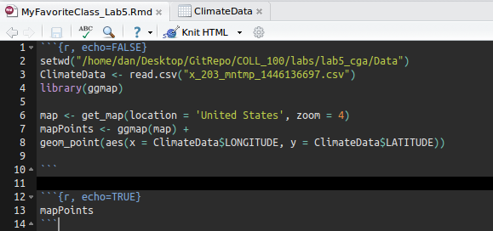

15. Click the knit HTML button, and see if your map comes out on the web page. If it does, great! You're ready to move on to the next section. Take a screenshot or export your map and use it to answer question 1-15.

Part 2: Building Interactive Figures

16. First, let's build a traditional climate graph – taking a look at what has happened to temperatures over time. First, we need to build what's called a “time series object” out of our data. To do that, we first need to formally declare our “Date” field as a “Date” - i.e., the computer doesn't know that a column of data represents time unless we tell it so:

ClimateData$DATE <- as.Date(as.character(ClimateData$DATE))

17. Now that we have that, we will build the time series itself – we're primarily interested in temperature for now, so that's all we'll pick out. First, install and load the library “xts”. Then:

#Aggregate to an average for every day in your time series
ClimateDailyAg <- aggregate(VALUE ~ DATE,
data = ClimateData,
FUN = mean)

#Create a time series formally (xts) by telling the computer the date and value
ClimateTimeSeries <- xts(ClimateDailyAg$VALUE, order.by = ClimateDailyAg$DATE)

#Aggregate to the yearly timesteps
ClimateTimeStep <- apply.yearly(ClimateTimeSeries,mean)

18. Let's take a quick look at what we just did – question 2-18: copy and paste the figure you produce showing temperature over time:

plot(ClimateTimeStep)

19. That's pretty handy, but we really want to make something even more dynamic. Install the package “dygraphs”, and then add the following code to a echo=TRUE section:

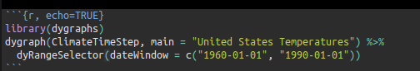

20. Now, click “Knit HTML” - if you have a new, dynamic graph that shows up, you did it right and can move to the next step! You should now have a map and a slider that shows you temperature fluctuation over time.

Part 3: Building an Interactive Map

Lab Deliverables:
(1) Answer the following questions:
Question 1-11: what changed when you changed echo from TRUE to FALSE? Why?

Question 1-15: Include the map of weather stations you produced.

