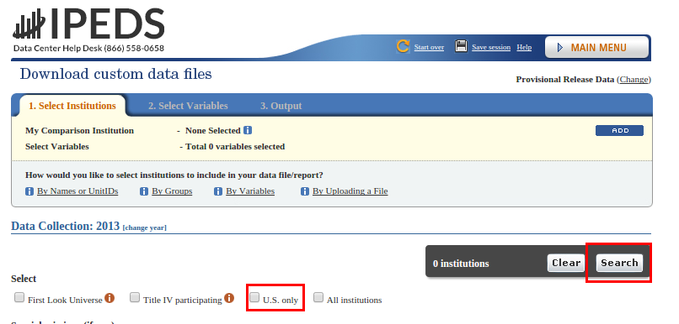
Breaking Intuition – COLL 100

Lab 2. The Basics

Due by noon on Friday, September 11th.

Objectives:
In this lab, you will:
- Use “a lot more data” to explain to yourself, parents, significant other, or your best friend that William and Mary really is “the best”.
- Begin to learn how to use R. This isn't CS, but you need to know a little.
- Visualize your findings for “System 1” (we'll be learning all about this in the lecture!).

You're probably thinking “am I really going to have to defend my choice to attend William and Mary for another two weeks?” The goal of this assignment is broadly to not only force you to consider your choice of college (which, by the way, was a good one), but to force you to justify it using raw, unprocessed data – and providing the skills you'll need to do other, even cooler stuff later in the semester.

Materials
- R and Rstudio
- Your old visme from last week (we're going to make it bigger, stronger, and full of more data!).
- The “internet”, which you will use to download data from https://nces.ed.gov/ipeds/datacenter/InstitutionByGroup.aspx

Grading
This lab will be graded based on the six deliverables identified on the final page of this lab. The first five questions are worth 50% of your grade, and are based on your capability to work through the steps below (i.e., if you follow the steps, you'll get the right answer!). The last question – question 6 – asks you to update your visualization you created last week using not only the datasets referenced in this lab, but asks you to download at least one additional variable to use in your update. The process of critically deciding what data to use, how to analyze it, and how to visualize it will be worth the remaining 50% of your grade.

Step 1: Really, Why W&M? (i.e., Let's get the data!)
- First, let's download a file which gives statistics on colleges across the U.S. - type https://nces.ed.gov/ipeds/datacenter/InstitutionByGroup.aspx into your browser to access the large government database we'll use in this lab.
- You should see something that looks a bit like the below – check U.S. only and then click “Search”.

- Click on “continue” to get to the variable selection stage – this automatically selects all data available.
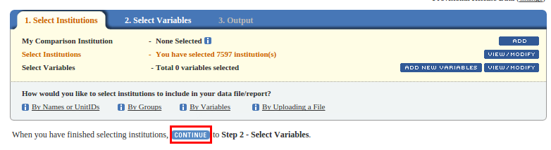
- Expand the “frequently derived variables” tab:
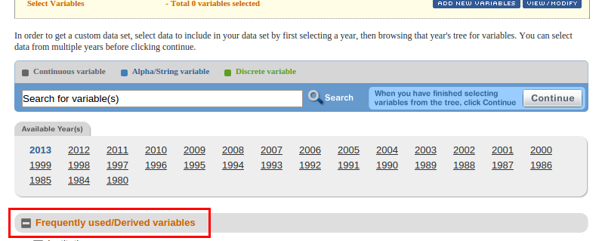
- Now the fun part – let's choose some data. For this stage of the lab we will walk you through one very specific analysis, but to get the maximum grade on this assignment you will need to download more data to make your own case, so you may want to choose one or two additional variables you think are interesting now! To download the data we'll use in the guided portion of the lab:
  - Click the “institutions” tab and put a checkmark beside “state abbreviation”.
  - Click the “price” tab, and check the first four boxes (Tuition and fees, 2010-11; Tuition and fees, 2011-12; Tuition and fees, 2012-13; Tuition and fees, 2013-14).
  - Click “Revenues and expenditures: Fiscal year 2013”, then choose “Expenses for salaries, wages, and benefits as a percent of total expenses, by function.” Finally, check the first four boxes - “core expenses, instruction, research, and public service”.
  - Finally, scroll back up to the top and click “Continue”, then download your data as a CSV.
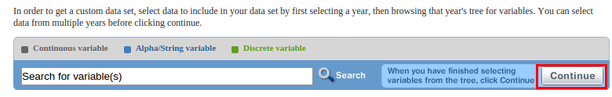
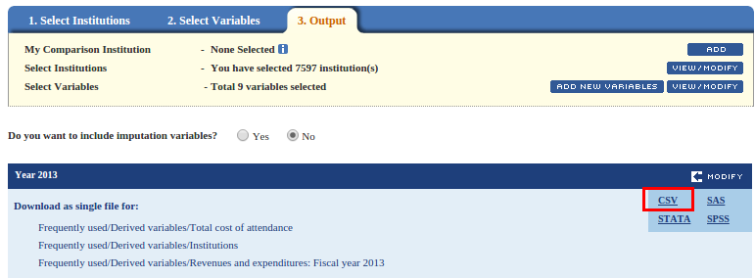

Step 2: Bringing your data into R, and basic investigations.
- Open up “Rstudio”. This is your first big test – can you find the link on your desktop or your start menu? (note, if you want to do this at home or on another computer [or, you're just brave], you can download Rstudio for free from https://www.rstudio.com/ ). It'll be trickier on Macs. Note you can also open up the R script that accompanies this assignment at this point, which contains all of the same information as this file!
- Take a look at the scary looking interface, and know the you can't break anything. Don't hesitate to take risks!
- On the left side of the screen, you'll see this:
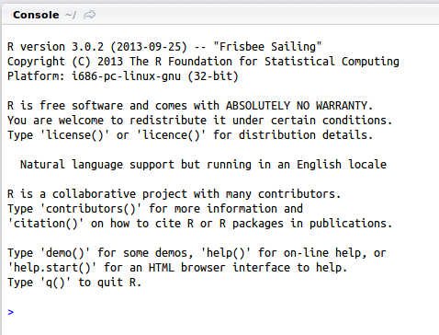
- Let's try out the tremendous power of R. At that little blue arrow, type in.... “1+1” (without the quotes – never include the quotes unless specifically instructed). If you dare, hit “enter”.
- Let's get a little fancier. Type in “A=2”, and hit enter. Now type in just “A”, and hit enter again.
- Type in “A+A”, and hit enter one more time. Did you get 4? If so, welcome to programming! If not, raise your hand and ask for help. If you made it this far, you can also do A*A, A/A, or even “2+3/4*A+A^2”.
- Now, let's do some real work. We want to start a new “R” script, so that we can keep track of everything we do (and, most importantly, save our work so we can turn it in to get an A!). Click on “File”, then “New File”, then “R Script”.
- The left side of your screen will change, and look a little different:
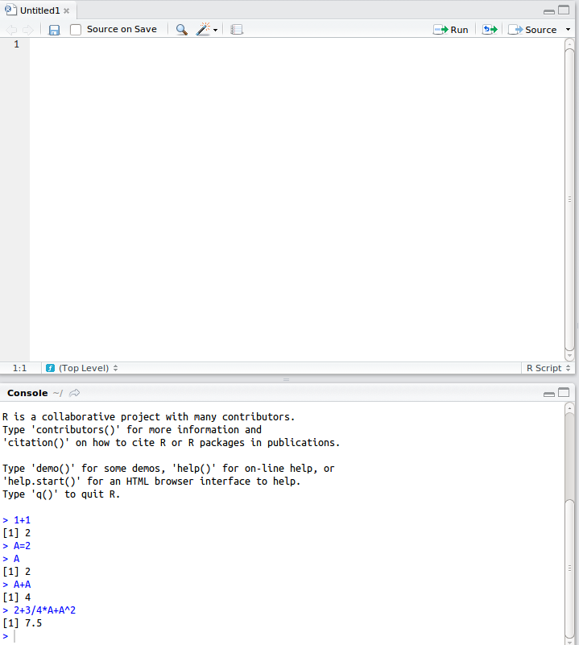
- Now, at the bottom is the “console” - you can still type things straight into here, but it won't save so you probably don't want to.
- At the top is your “R script”. This is what you'll actually save. Make it look like the picture here:
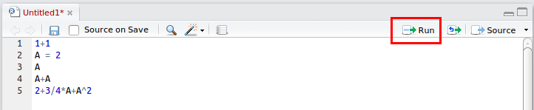
- Now, highlight everything (either hit ctrl+a on your keyboard, or use your mouse) and click Run. Watch the console at the bottom – your results should come out.
- Now, let's save our file so we could pick back up here later – go to file → save as, and then save the file somewhere you can find it again later. Your William and Mary “H” drive is a good choice.
- Alright, you've got the basics now! Let's load that file we downloaded into R. First, copy the file into your William and Mary “H” drive so it doesn't get deleted. To do this, open up “My Computer”, go to “Downloads”, and copy the file you downloaded (click on it and push “ctrl+c”). Now, go back to My Computer, choose your H drive, and paste it (ctrl+v on your keyboard). Note this file may be a zip file, in which case you will need to extract it. I recommend you google “how to extract a zip file” if you need help, but you can also raise your hand to ask an instructor or TA. This stuff can get complicated, so never hesitate to ask if you get lost!
- Back in R, in the window at the top, type in the new commands below. The first one (setwd) tells R where your files are going to be located. The second one (read.csv) tells R to load your new CSV, and save it as a new variable (“collegeData”). Note you may need to change the name of your CSV, as the download file names change slightly. To make sure everything worked right, we then type in “View(collegeData)”, which lets us see the data we just produced. Click on each line and then click “run” like we did before to see each line in action, or select the entire script and click “run” to run it all at once.
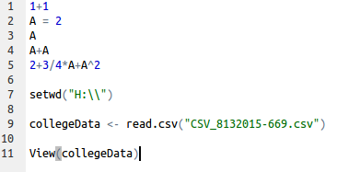
- Let's explore the data a little bit – try adding the following lines of code, run them and see what they report:
names(collegeData)
dim(collegeData)
nrow(collegeData)
ncol(collegeData)
- From here out, I'll be typing all the R commands in blue, so you can quickly identify them. Let's actually run a quick analysis – how many colleges are in each state? When you type in names(collegeData), you'll notice one of the names is “HD2013.State.abbreviation” - one of the columns you requested when you did the download. To see how many colleges are in each state, type in:
table(collegeData$HD2013.State.abbreviation)
- Now, let's use a different command to identify the average tuition across all colleges:
summary(collegeData$DRVIC2013.Tuition.and.fees..2013.14)
- We can also do the same thing, but only looking at Virginia schools – does Virginia have a higher average tuition or lower than the rest of the country?:
VA_colleges <- collegeData[which(collegeData$HD2013.State.abbreviation=="Virginia"),]
summary(VA_colleges$DRVIC2013.Tuition.and.fees..2013.14)
- What if we want to get really clever, and identify only those institutions in VA that are above the national mean? Is William and Mary above the national mean?
AboveUSMeanVA <- collegeData[which(collegeData$HD2013.State.abbreviation=="Virginia" & collegeData$DRVIC2013.Tuition.and.fees..2013.14 > 14140),]
View(AboveUSMeanVA)
- You can read through each entry to figure out what William and Mary's tuition is, or you could type this:
collegeData[which(collegeData$institution.name=="College of William and Mary"),]$DRVIC2013.Tuition.and.fees..2013.14
- You can use similar approaches to find the cheapest and most expensive schools in the country:
min(collegeData$DRVIC2013.Tuition.and.fees..2013.14, na.rm=TRUE)
max(collegeData$DRVIC2013.Tuition.and.fees..2013.14, na.rm=TRUE)
minColCost <- min(collegeData$DRVIC2013.Tuition.and.fees..2013.14, na.rm=TRUE)
maxColCost <- max(collegeData$DRVIC2013.Tuition.and.fees..2013.14, na.rm=TRUE)
collegeData[which(collegeData$DRVIC2013.Tuition.and.fees..2013.14 == minColCost),]$institution.name
collegeData[which(collegeData$DRVIC2013.Tuition.and.fees..2013.14 == maxColCost),]$institution.name

Step 3: Start some basic analysis
- Now, we're going to do one basic analysis that you can include on your revised infographic. Note the goal of this R tutorial is not to create beautiful visualizations – though R can do that. Rather, we want to extract data you can then use in visme to improve your original infographic. Let's do something very simple to start: how does the percentage increase of William and Mary's tuition compare to (a) all schools, and (b) Virginia schools from 2010 to the 2013-2014 school year?
- First, let's calculate this for William and Mary (type in “WM_change”) at the end!:
WMTuition_2014 <- collegeData[which(collegeData$institution.name=="College of William and Mary"),]$DRVIC2013.Tuition.and.fees..2013.14
WMTuition_2010 <- collegeData[which(collegeData$institution.name=="College of William and Mary"),]$DRVIC2013.Tuition.and.fees..2010.11
WM_change <- WMTuition_2014 / WMTuition_2010

- Now, let's calculate the average change for every other school. This is the first time we're going to add our own new “column” to the data frame. To see how this works, first type in the below command, which will show you the current set of columns (i.e., the data available for each college):
names(collegeData)
- Now, let's create a new one that tells us how much tuition has changed. Note this is the same thing we did for just William and Mary, but for every school:
collegeData$All_change <- collegeData$DRVIC2013.Tuition.and.fees..2013.14 / collegeData$DRVIC2013.Tuition.and.fees..2010.11
names(collegeData)
- Note now there is a new “name” in collegeData, which represents a new column. Let's summarize the change column now:
summary(collegeData$All_change)
- Let's do a comparison between the tuition in 2014 and the percent of that money spent on instructors salary. First, let's look it up for William and Mary:
collegeData[which(collegeData$institution.name=="College of William and Mary"),]$DRVF2013.Salaries..wages..and.benefit.expenses.for.instruction.as.a.percent.of.total.expenses.for.instruction..GASB.

- And second, let's compare that to the national average:
summary(collegeData$DRVF2013.Salaries..wages..and.benefit.expenses.for.instruction.as.a.percent.of.total.expenses.for.instruction..GASB.)

- Finally, let's plot out all schools tuition in 2014 contrasted to the % of tuition they spend on instructors salary.
plot(collegeData$DRVF2013.Salaries..wages..and.benefit.expenses.for.instruction.as.a.percent.of.total.expenses.for.instruction..GASB., collegeData$DRVIC2013.Tuition.and.fees..2010.11)
- That on it's own isn't particularly helpful, as it's hard to see patterns with outliers and without knowing which dot is William and Mary. It's also probably more fair to compare to only Virginia schools, so let's drop out everything that isn't Virginia and label W&M in an appropriate color. First, re-use the old VA_colleges dataset you made:
plot(VA_colleges$DRVF2013.Salaries..wages..and.benefit.expenses.for.instruction.as.a.percent.of.total.expenses.for.instruction..GASB., VA_colleges$DRVIC2013.Tuition.and.fees..2010.11)
- Now, let's label just W&M – save this figure (click the “export” button above the chart) as you will be turning it in!
WM_plot <- collegeData[which(collegeData$institution.name=="College of William and Mary"),]
points(WM_plot$DRVF2013.Salaries..wages..and.benefit.expenses.for.instruction.as.a.percent.of.total.expenses.for.instruction..GASB., WM_plot$DRVIC2013.Tuition.and.fees..2010.11, col="green")

This is the end of the guided tutorial, but to get full points you will now need to (a) download at least one variable that was not included in this analysis (way back up at step 5), and (b) run your own analysis. Finally, you will need to update the visualization you produced on visme! Refer back to Lab 1 if you forgot how to use it.

Name: _____________________________________________________

Lab Questions
Please turn in this worksheet with the answers you calculated using R. Your grade will be basd on this worksheet. You should edit this worksheet in R, and then print it out or submit it digitally.

1. What state has the most colleges, and how many does it have? Second-most?

2. What is the mean tuition cost for the US? Virginia? Does Virginia have a higher average tuition cost than the rest of the US? By how much?
_____________________________________________________________
_____________________________________________________________
_____________________________________________________________
_____________________________________________________________

3. Fill in the following table:
 | Tuition in 2010-2011 | Tuition in 2013-2014 | Percent Change
William and Mary
All Virginia (Mean)
All US (Mean)
4. Make a copy of your chart showing the $s spent on instruction as contrasted to tuition, with William and Mary highlighted. For bonus points, make a similar chart but including all schools in the U.S.

5. What are the most expensive and cheapest schools in the U.S.? Virginia?

6. Attach a printed copy of your “visme” visualization to this document, or submit it electronically. What variable did you include that was not explicitly a part of this lab? What challenges did you have in retrieving it, and how did you use it to illustrate William and Mary is an exceptional (or, crazy!) choice of where to get your degree?
_____________________________________________________________
_____________________________________________________________
_____________________________________________________________
_____________________________________________________________

STRETCH GOALS:
Made it this far? Want to try to go even farther? Just want to learn? Try any of the following to really impress us – it won't count for your grade, but it'll give you a leg up on future assignments:
- In your download, ask for the “latitude” and “longitude” columns, then plot colleges following this tutorial: http://www.milanor.net/blog/?p=594
- Examine how US schools compare to international schools.
- Make similar comparisons with a different dataset – i.e., try

Or, noone. It's really up to you.
Or play devil's advocate!

