Daniel Graham
2/24

Project 3

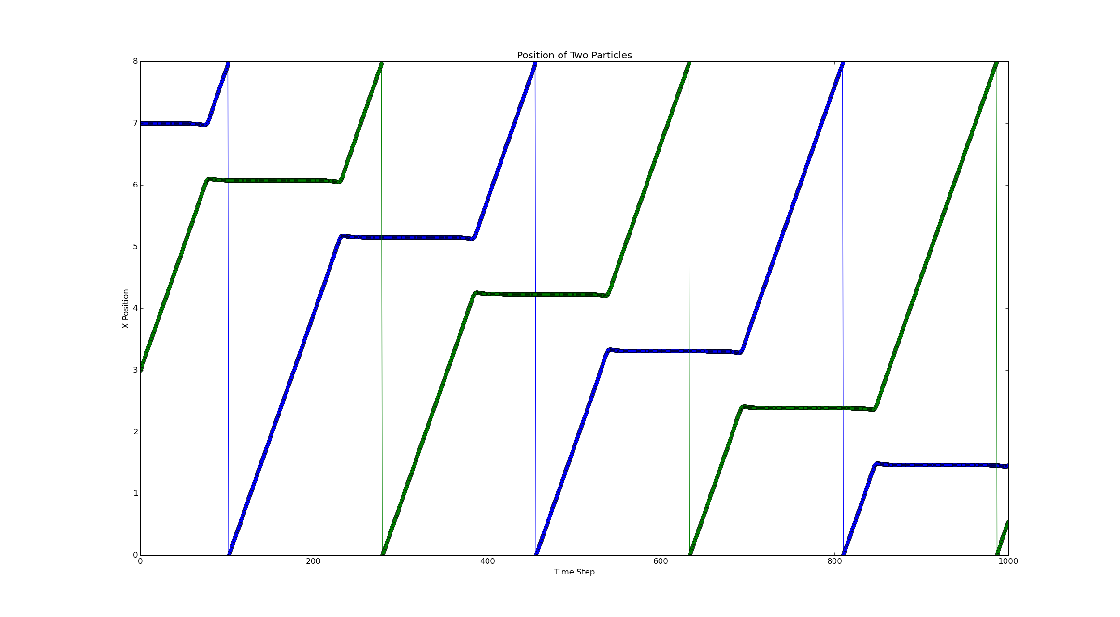
1.

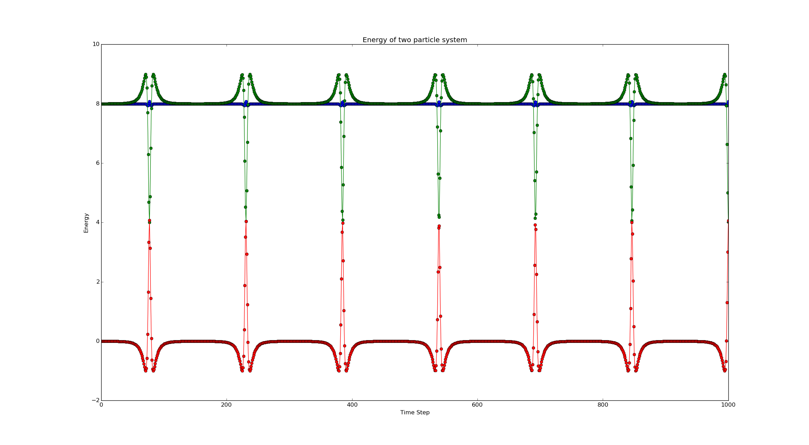

2. Reduced Temperature = 0.92556 where reduced T is T in Kelvin divided by Boltzman constant
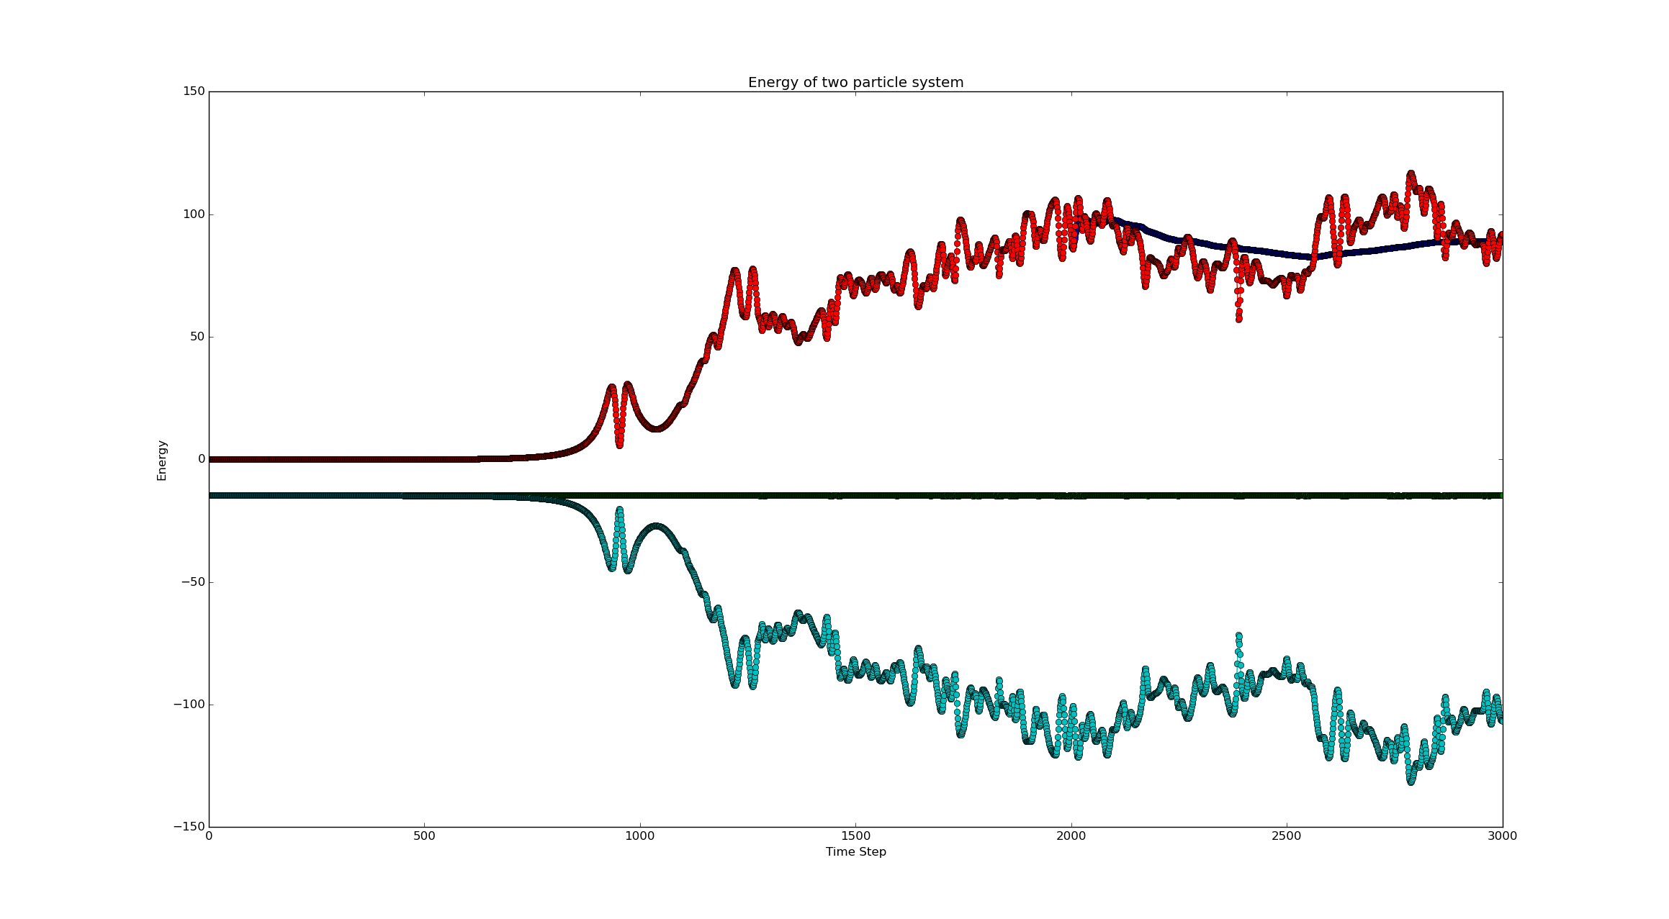

3. Pair correlation function presented below.

