Daniel Graham

Project 6

1.

I = = 0.783333333333

error:

2.

< f > = 0.784952578118

< f² > = 0.641722913912

σ² = 0.0255723640179

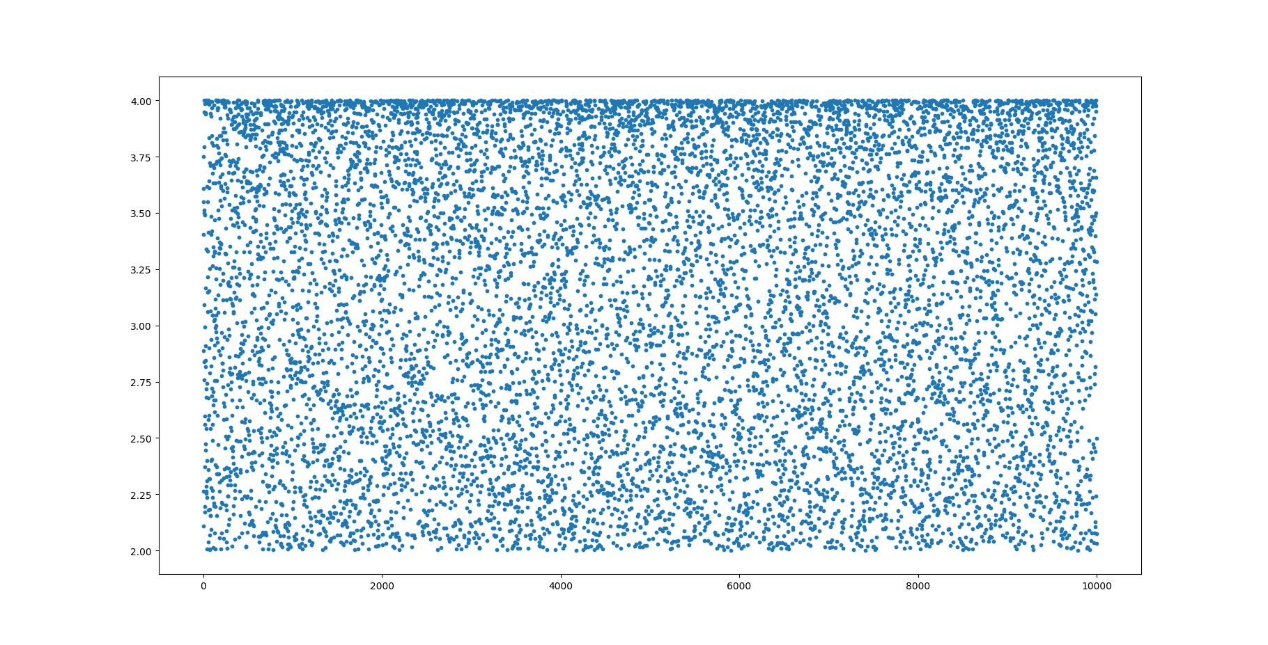

3.

< h > = 0.784417930081

< h² > = 0.61670587166

σ² = 0.00139438262656

a = 0.7
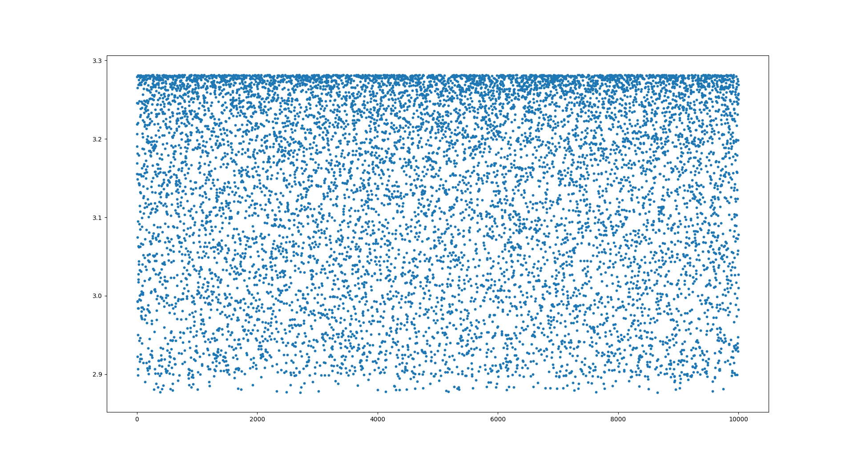
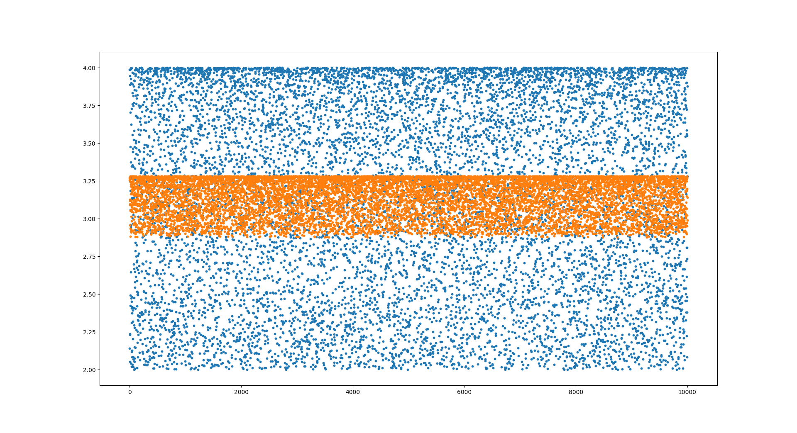
The above graph is a comparison of the h(x) method with the traditional monte carlo integration. The h(x) method is shown in orange and clearly has much lower variation in values.

