# Objective:

**MAZE MUNCHER**

Create a MAZE GAME where your character moves around, collecting food and scoring points.

# Tasks to complete:

* Your character needs to move LEFT, RIGHT, UP and DOWN using keys on the keyboard.
* Draw your ‘walls’ on your game screen using one colour.
* Your character may not cross over a wall. When it HITS a wall, it must STOP.
* Place some food on the screen for your character to collect.
* When your character HITS a piece of food, they score points, and the food becomes HIDDEN (eaten).
* Show the character score on the screen.
* The “GAME OVER” token is HIDDEN at the start.
* When the last piece of food is eaten, the “GAME OVER” sign appears in the maze.
* When the “GAME OVER” sign is HIT, the character scores final points, and the game is over (STOP the APP)

# Design

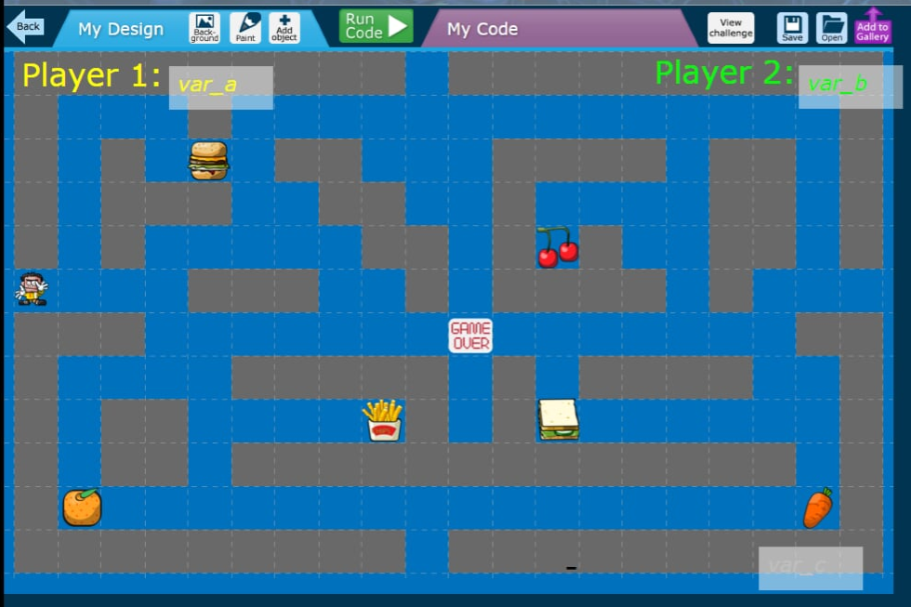You can design your maze however you like. Here’s my example:

# Extra Challenge!

When you have it working for 1 Player/Character, add another and make the game 2-player! You’ll need to add new KEYPRESS and HIT events for the 2nd Character, food, and “GAME OVER” tokens.

**MAZE MUNCHER**

**Help Sheet**

# CHARACTER

* Make the character 40 pixels big, so that it can easily fit inside the “walls” of the maze
* Use the “KEYPRESS” events to move the character up, down, left and right (for example, I use W,S,A,D)
* Use the BGEQ event to STOP the character when it tries to cross a wall square
* Create a VARIABLE to track the character score

# FOOD

* Use a variable to keep track of how many items of food are left (or count how many eaten, if you prefer)
* When the character HITS a food item:
  + Increase their score VARIABLE (V = V + 1)
  + Decrease the number of food items left (V = V – 1) (or increase if you’re counting up)
  + HIDE the food

# GAME OVER

* When the number of food items reaches zero (0) (or 6 if you’re counting the number of eaten items), SHOW the “GAME OVER” token.
  + Use the “IFEQ” event to test the variable.
* When a character HITS the “GAME OVER” token, they score final points and STOP the APP.

# 2-PLAYER

* Add a new VARIABLE to keep track of the Player 2 score
* Add a new set of KEYPRESS events. Choose keys away from the existing ones (e.g. 8,4,6,2).
* Each item of food needs new HIT events for the second player, increasing their score
* The “GAME OVER” token needs a new HIT event for the second player

**MAZE MUNCHER**

# What did we learn?

## Coding Skills

**Free Coding** – for many, this was the first time you’d used the Free Coding to create your own apps. It was great to see everyone figuring out what to do.

**Collision detection** – we learned a new way to build “walls” in our game, and be able to detect when our player ‘hit’ them!

**Picking keys that make sense for direction control** – our mind works best when we pick Up, Down, Left, Right that are arranged the same on the keyboard. This kind of thinking is called “User Experience Design”.

**Variables** – using a variable to keep track of “points”, and to keep track of how many prizes we’ve collected. Variables are a great way to keep track of information that our game needs to remember. The more complicated our apps get over the next few weeks, the more variables we’ll need to use.

## Game Design

Saw lots of you thinking about how your game should look, but also thinking about the best layout and format to give the best game experience! In real game development (and coding in general) sometimes this ‘planning’ stage happens before anyone writes ANY code, and it can take MONTHS!

## Open Discussion

How would YOU make the game better?