**GONE WRONG!**

**Pets in Peril**

In this debugging challenge, we’re going to build a simple “Whack-a-Pet” game. This worksheet will give you all of the steps you need, but in most of them, something is wrong – and your job is to figure out what!

# Step 1 – The Game Design Screen.

Build your app so that it looks like this below. Use the same animals as below, size 100, so that the rest of the code makes sense!

This app also needs two VARIABLES. “var_a” is the time left in the game. “var_b” is the player score. You add variables from the “Add object” button and choose “variable”.

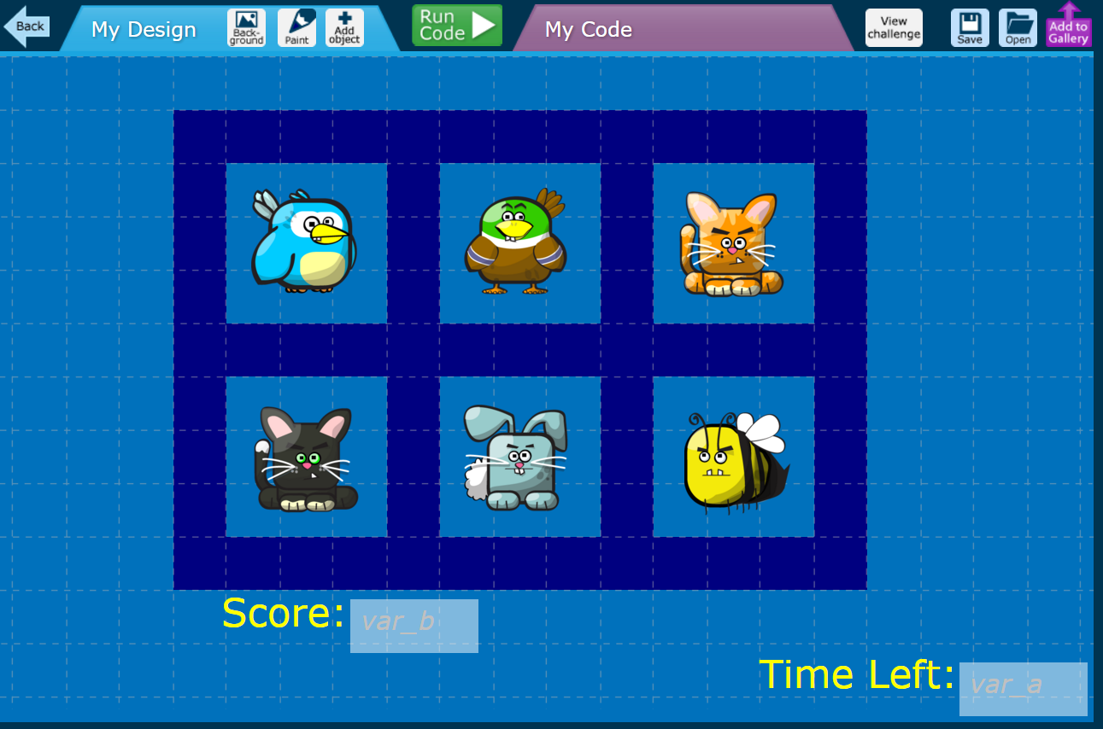

You can also add the text “Time Left:” next to var_a, and “Score:” next to “var_b” if you want to show the player what’s going on. “Text” is another object in the “Add Object” button menu.

# The Code

Okay, so time to add some code! Switch to the “My Code” panel and add a new “Start” event.

At the start, we want to set the “time left” in the game to 30 seconds. But I’ve missed out the variable that needs to be set. Should it be “a” or “b” (or something else?) Check back on the previous page if you are stuck.

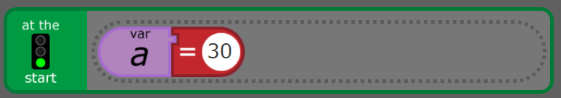

?

Okay, next add FIVE (yes, FIVE!) “Every..” events from the “Add Event” button menu. Make the first one every 1 second, the next one every 2 seconds, the next one 3 seconds, the next one 4 seconds, and the last one 5 seconds. PHEW!

For the 1 second box, we want to reduce the “time left” in the game by 1 second. But which variable is the time left in the game (“a” or “b)? Again, check the first page if you’re stuck. Also, over the next few boxes we’re going to add “show” and “hide” actions for each of our animals. Each animal should have 1 “show” and 1 “hide” box somewhere across the 5 “every” events. Add a “show” for the Bee in the 1 second box.

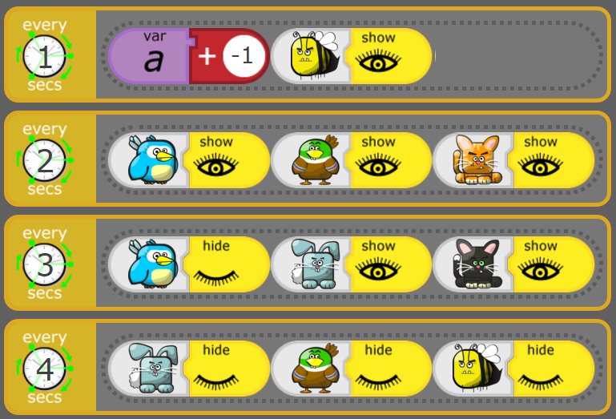

?

Right! For the next few events (2, 3, 4 and 5 second events), I’ve gone a bit wrong. As you might remember, I’m supposed to have ONE show and ONE hide for each Pet. But as you can see, I’ve made them ALL SHOW! Fix the code so that each animal has ONE show and ONE hide – don’t forget that the Bee has his “show” in the 1 second box above!

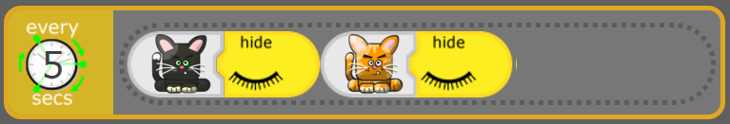

**Scoring Points**

Okay, so in the next section, let’s add THREE “Click” events from the “Add event” menu button. The idea here is that when the player clicks the pet, it will disappear and score 1 point (variable “b”). However, when I ran this code, for some reason the second and third pets didn’t disappear!! Can you work out why? Fix the code for each animal.

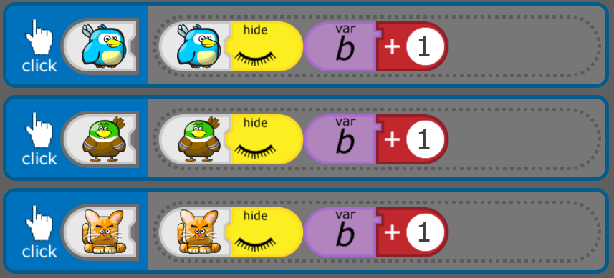

Next, add THREE more for the second row of pets. This time, something else is wrong. When I click the Black Cat, all three animals vanish (Black Cat, Rabbit and Bee). Can you spot what’s wrong?

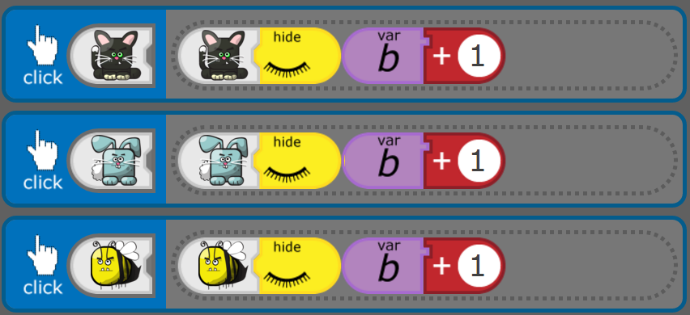

Finally, when the timer reaches zero, I wanted to STOP the APP – but I forgot to add the action! Can you insert the right blocks?

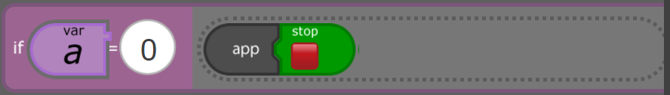

If you fixed all the steps correctly, you should now have a “Whack-a-pet” game that finishes after 30 seconds and scores points! If you have time left, go ahead and add your own personal touches to the game, and I look forward to seeing them all in action next week!!