Client Brief

Chosen Brief

# Client Requirements and Expectations

The client wants a game, where the player can perform several verbs, which are key to gameplay. They clearly want a game that’s focused on diverse literacy and its utility in gameplay.

# Client’s Needs

For this project, the client wants a game where verbs are performed, and are a key aspect of gameplay. They also want the game to avoid non-essential actions that don’t revolve around these verbs.

Their key requirement is to have a variety of actions with the verbs, that all have importance to the player.

# Identify Factors

**Project Goals:**

- Verbs are used in gameplay

- Verbs require diversity of use, as to not repeat certain words

- Little mechanics outside direct connection to verbs

**Limiting Factors:**

- Making a enjoyable game system that relies heavily on verbs

- Making the use of verbs fun as to make up for the lack of other systems

**Required Elements:**

- Use of verbs as a primary driver

- Use of verbs as

**Target Audience:**

- Mid-Core audiences, who enjoy puzzles but also RPG experiences

- Those who want a conceptually simple puzzle game, who’s depth can come from experience outside of gameplay

# Elevator Pitch

The player is a magician, who must uncover lost verbs and adverbs in a dungeon to solve puzzle and defeat their enemies.

In the dungeon, they can use their verbs in unique combinations to create spells and solve puzzles. Doing so will unlock new verbs, which allow them to perform new spells, and adverbs which make some spells stronger.

# How are Client’s Needs Addressed

The way this concept addresses the client’s needs, is by prioritizing the verbs use in gameplay. By making a system that relies on verb combination and adverb usage, it focuses strongly on the diverse use of verbs.

Another factor which fits the clients’ needs is by slimming down the presence of other factors outside verbs. There would be a simple movement system through a dungeon, puzzle sections which require interaction with the verb system, and a method of gaining verbs through puzzles.

# How it effectively addresses the target audience and project goals

**Target Audience:**  
- The target audience wants a game that feels more developed than kids’ games, so having one set in a fantasy setting with more traditional elements might be appreciated.

- The target audience also wants a game that’s ideally simple, just mixing verbs in certain combinations. But the difficulty can come through the wide required use of verbs, and how certain combinations can result in unique effects.

**Project Goals:**  
- The project goals want verbs used in gameplay, and by making them a primary system of interacting with the world, I believe this idea ties into the goals needed.

- The project goals also want verbs to be used in a diverse way, and by making a system where the specific placement of verbs and their additions would result in separate effects, fulfills the required goal.

- The project goals also request for little mechanics outside the use of verbs, and by simplifying this into a simple collection system, and movement system, which both are tertiary compared to the verb system.

# Game Mechanics

- 1st Person movement, no jumping, mainly focuses on a steady jog. Ideally it would be similar to the old Elder Scrolls games visually.

- Verb System, the player can pause the game, and be give 4 slots to place verbs. They have a list of verbs on the bottom of their screen, under 3 categories, all colour coded. Depending on the order of verbs setup, by colour, depends on the effects.

- Verb Exhaustion, during a spell, each verb can only be used once. This pushes the player to search for more verbs in the level.

- Glossary Grimoire, a book which details specifics on enemies, the only way players would find the right verb use to defeat certain enemies

- Collection system, by a player either solving a puzzle or defeating an enemy, they would gain new verbs

# Art Style

- Simple 3d environment, with, with low-poly textures  
- Flat, dungeon crawler AI. Characters face in the bottom of the screen  
- Low fidelity graphics, reminiscent of old fantasy games  
- Verb usage is bright and colourful, strongly contrasting with environment. Visually looks like magic being cat, lots of floating particle effects.

## Game References

|  |  |
| --- | --- |
| Elder Scrolls 2: Daggerfall | Bethesda's classic The Elder Scrolls II: Daggerfall goes free | Engadget |
| Arx Fatalis | Arx Fatalis - Gameplay Xbox HD 720P - YouTube |
| King’s Field | King's Field (2000) - PC Gameplay / Win 10 - YouTube |

## Model References

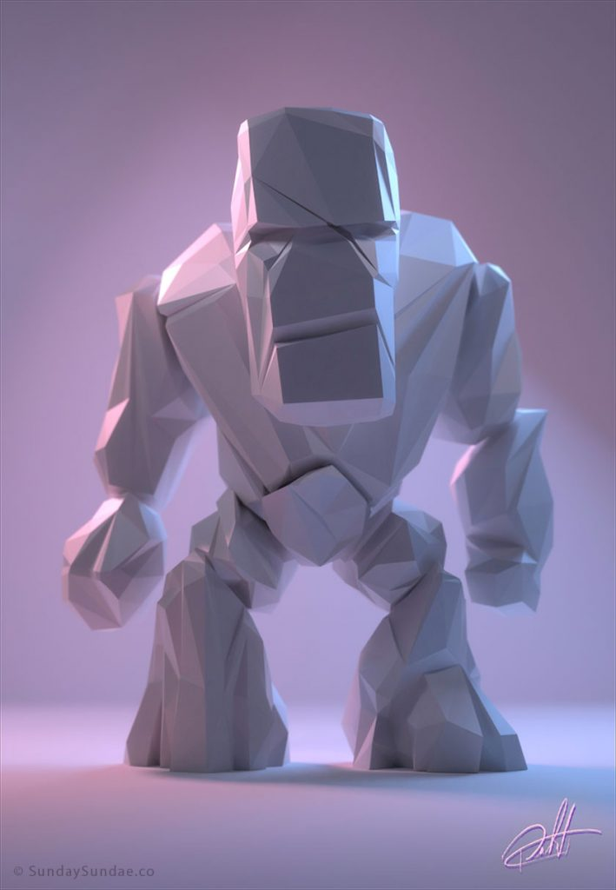Skeleton Enemy Stone Golem  
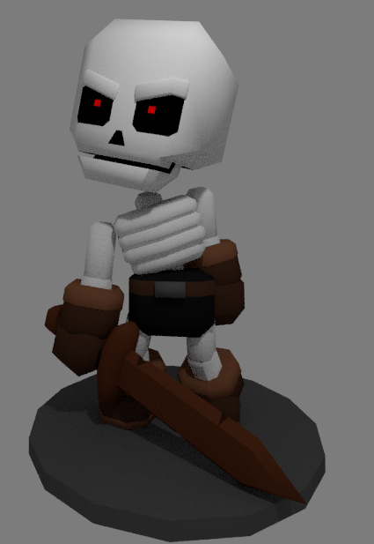

Enchanted Armour

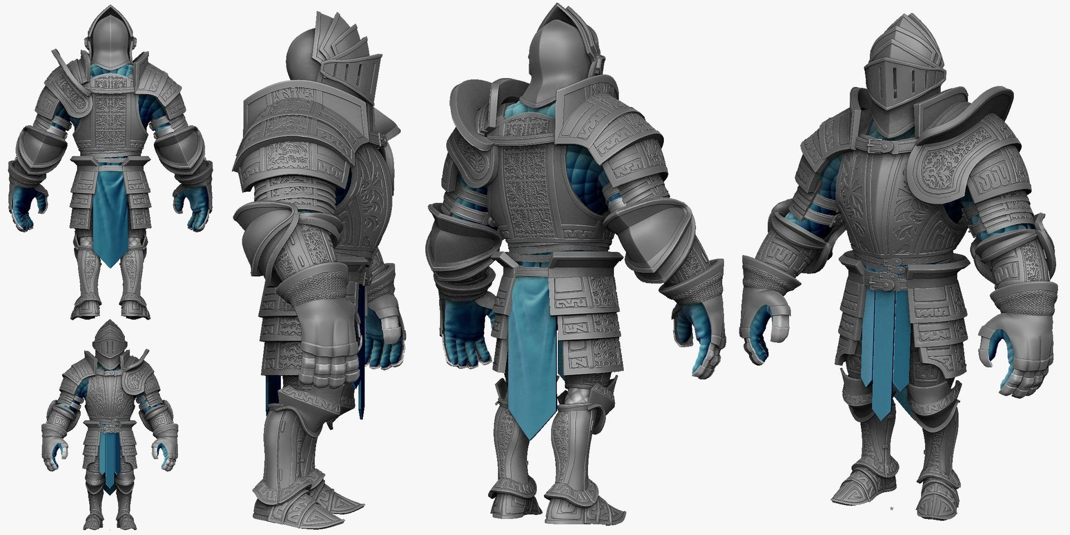

## Colour References

Stone + Environmental Colour Pallet

Spell Verb Colour Pallet

# Controls

Tank controls, since the game mainly focuses on verb usage:

**- W/S** = Move forward and Backwards

**- A/D** = Rotate left and right

UI controls outside movement:

**- Esc** = Pause Menu

**- Left Click** = Enter Verb usage mode

**- Right Click** = Exit Verb usage mode

Verb use mode controls:

**- Left Click Hold** = Hold and drag verbs from list

**- Right Click** = To cast spell, and to exit Verb usage mode

# Interface

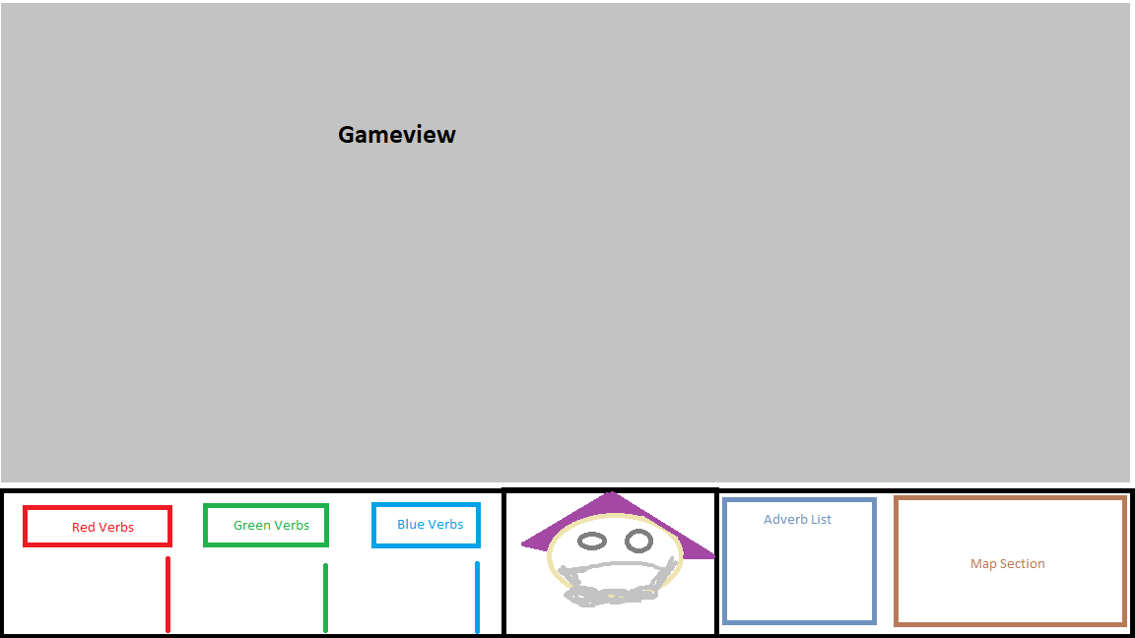**Main Game UI:**

Verb Usage UI:

Enemy/Puzzle UI:

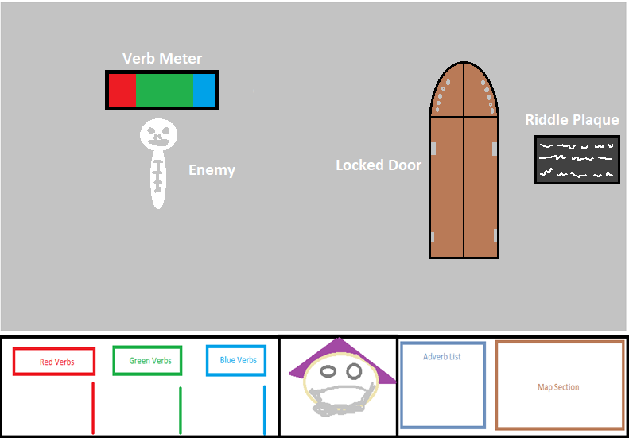

# Audio

The required sound effects need to cover 5 main features:

- Ambient sound and music

- Verb Usage and effects

- Movement and collecting verbs

- Enemies being defeated

- Puzzles being solved

# Delivery Platform

The ideal delivery platform for this game is **Computer**, but if there is time, I’d like to transmit the controls to **Mobile**. Since the keyboard controls are limited and can be easily replaced with button inputs on the screen.