**Level Design Document for:**

All work Copyright ©2021

Written by Team AIE Production

Table of Contents

1.0 Revision History 4

2.0 level Design Overview 4

2.1 Level Design concept 4

2.2 Gameplay Mechanics 4

2.3 Camera 4

3.0 Theme and Characters 4

3.1 Characters 4

3.2 Theme 4

4.0 Level Information 5

4.1 Level Location 5

4.2 Level Setting 5

4.3 Level Layout/Architecture 5

5.0 Level Design 5

5.1 Main Objectives 5

5.2 Optional Objectives 5

5.3 WOW Moments 5

5.4 Level Progression 5

5.5 Player Experience 5

6.0 Art Style and Aesthetics 6

6.1 References 6

6.2 Lighting 6

6.3 SFX/Music 6

6.4 Particle FX 7

7.0 Level Asset List 7

8.0 Delivery Milestones 7

# 1.0 Revision History

<As you revise the document, list what was changed and when it was changed>

|  |  |
| --- | --- |
| Version | Description |
| 1.0 | Initial document |

# 2.0 Level Design Overview

## 2.1 Level Design concept

An old underground tunnel network made of ruins of an old civilization. The map features tight corridors, multiple entrances that loop together, and sparsely placed open areas.

## 2.2 Gameplay Mechanics

The game centers around the management of ammunition, and spatial awareness. Put ammo pickups at the end of corridors, making them risky spots to enter (harder to exit if flanked).

## 2.3 Camera

The camera will be over the player’s shoulder.

# 3.0 Theme and Characters

## 3.1 Characters

* An armed archeologist.
* Old zombie.
* Fresh zombie.
* Grown zombie.

## 3.2 Theme

The theme would be a claustrophobic, frenetic tunnel fight, where the player is barely fending off constant attacks by zombies.

# 4.0 Level Information

## 4.1 Level Location

The level is a buried, medieval sewer tunnel system.

## 4.2 Level Setting

The setting would be modern, dark fantasy.

## 4.3 Level Layout/Architecture

The layout is designed to be a series of cramped tunnels, enough width for 2-player models to clog the pathways. There is only 1 open space, which is filled with doors & openings.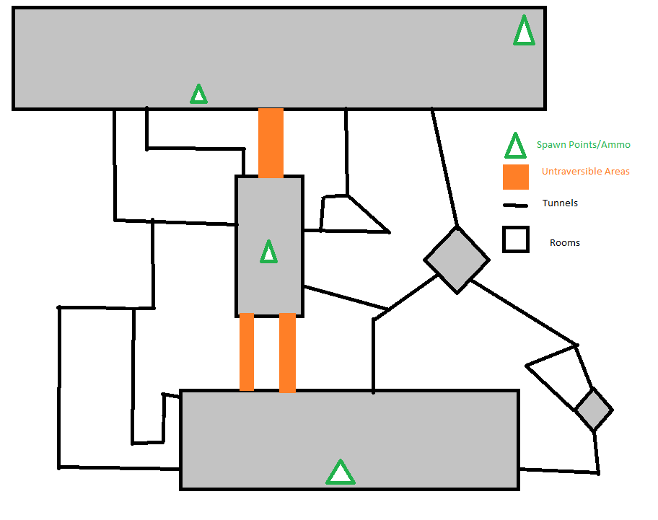

# 5.0 Level Design

## 5.1 Main Objectives

Survive a certain number of waves, against the zombie horde.

## 5.2 Optional Objectives

<What does the player try to accomplish on each level/mission?>

## 5.3 WOW Moments

<Side missions, free roam, secrets>

## 5.4 Level Progression

The level is more of a large arena, where areas can be visited freely. The player will be pressured to travel around the map as to not get boxed in.

## 5.5 Player Experience

*<The player would be press>*

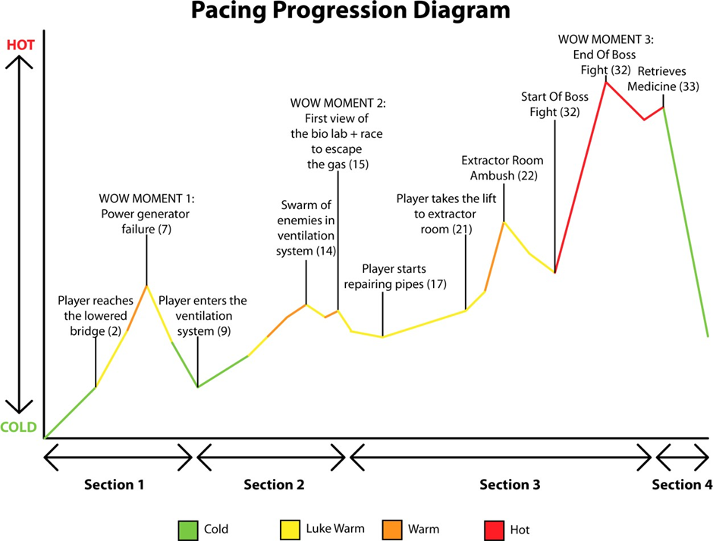

# 6.0 Art Style and Aesthetics

Refer to the Mood Boards and 2D level Design maps

## 6.1 References

<Provide images here or links to mood boards and reference images>

## 6.2 Lighting

<Color ,mood, Signposting, Narrative >

## 6.3 SFX/Music

List music clips and where they’re used.

List all sound effects and where they’re used

## 6.4 Particle FX

List particle effects and why they are used

# 7.0 Level Asset List

<Static and dynamic objects relative to the environment>

|  |  |
| --- | --- |
| Item | Description |
| Car | Modern sedan |
| Bus | Drivable |
| Bus Wreckage | Static, damaged by explosion, scalable |
| Ladder | Industrial, metal, painted yellow, 4m, 8m variants |
| Table x 3 | Office, Kitchen, warehouse |

# 8.0 Delivery Milestones

<Provide milestone dates for Prototype, Testing Phases and Final Build>

**Prototype:** When will your first playable prototype of your level be ready? This will be a prototype/grey-box that will show off how your level works.

**Testing and Iteration:** You will need to test your level, get feedback, and make changes to your level and design based on your testing results. Allocate time for this to be done and complete.

**Final Build:** The final polished and complete build of your game.