**Level Design Document for:**

*Ah! Zombies!*

All work Copyright ©2021

Written by Team AIE Production

Table of Contents

1.0 Revision History 4

2.0 level Design Overview 4

2.1 Level Design concept 4

2.2 Gameplay Mechanics 4

2.3 Camera 4

3.0 Theme and Characters 4

3.1 Characters 4

3.2 Theme 4

4.0 Level Information 5

4.1 Level Location 5

4.2 Level Setting 5

4.3 Level Layout/Architecture 5

5.0 Level Design 5

5.1 Main Objectives 5

5.2 Optional Objectives 5

5.3 WOW Moments 5

5.4 Level Progression 5

5.5 Player Experience 5

6.0 Art Style and Aesthetics 6

6.1 References 6

6.2 Lighting 6

6.3 SFX/Music 6

6.4 Particle FX 7

7.0 Level Asset List 7

8.0 Delivery Milestones 7

# 1.0 Revision History

<As you revise the document, list what was changed and when it was changed>

|  |  |
| --- | --- |
| Version | Description |
| 1.0 | Initial document |

# 2.0 Level Design Overview

## 2.1 Level Design concept

An old underground tunnel network made of ruins of an old civilization. The map features tight corridors, multiple entrances that loop together, and sparsely placed open areas.

## 2.2 Gameplay Mechanics

The game centers around the management of ammunition, and spatial awareness. Put ammo pickups at the end of corridors, making them risky spots to enter (harder to exit if flanked).

## 2.3 Camera

The camera will be over the player’s shoulder.

# 3.0 Theme and Characters

## 3.1 Characters

* An armed cowboy.
* Default zombie.
* Fast zombie.
* Heavy zombie.

## 3.2 Theme

The theme would be a claustrophobic, frenetic tunnel fight, where the player is barely fending off constant attacks by zombies.

# 4.0 Level Information

## 4.1 Level Location

The level is a buried, medieval sewer tunnel system.

## 4.2 Level Setting

The setting would be modern, dark fantasy.

## 4.3 Level Layout/Architecture

The layout is designed to be a series of cramped tunnels, enough width for 2-player models to clog the pathways. There is only 1 open space, which is filled with doors & openings.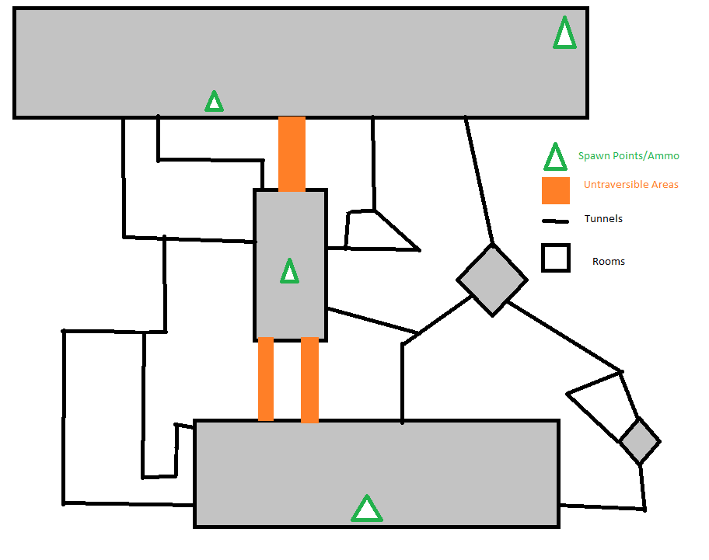

# 5.0 Level Design

## 5.1 Main Objectives

Survive a certain number of waves, against the zombie horde.

## 5.2 Optional Objectives

Conserve ammunition, to avoid losing health.

## 5.3 WOW Moments

Tunnels between rooms allow players to see incoming zombie groups, and ammo boxes.

## 5.4 Level Progression

The level is more of a large arena, where areas can be visited freely. The player will be pressured to travel around the map as to not get boxed in.

## 5.5 Player Experience

The player would be travelling through a dimly lit tunnel network, fighting off zombies, occasionally going into open spaces to collect ammo. All this to whittle down a limited number of zombies, before the next wave starts.