**SDN Outputs**

Running the topo

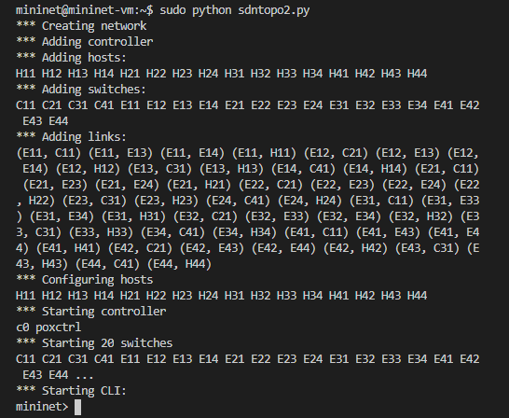

Running policy.py

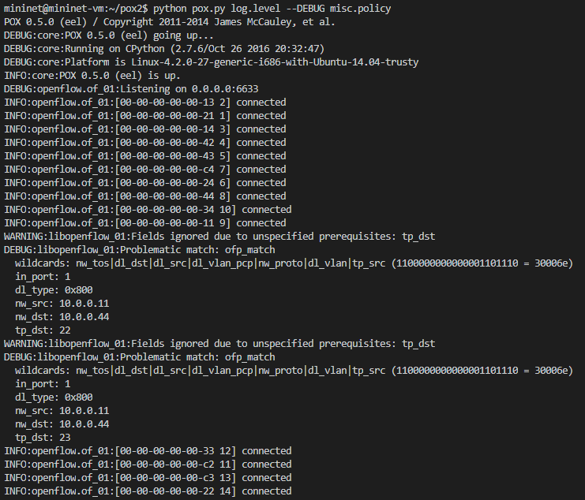

Flow Rule 1

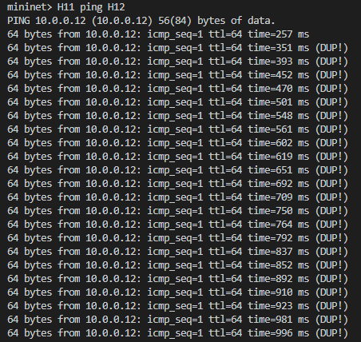

On Cancelling it:

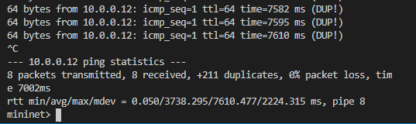

Flow Rule 3: Note it only refuses H44

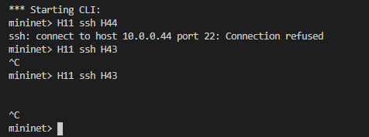

Dump:

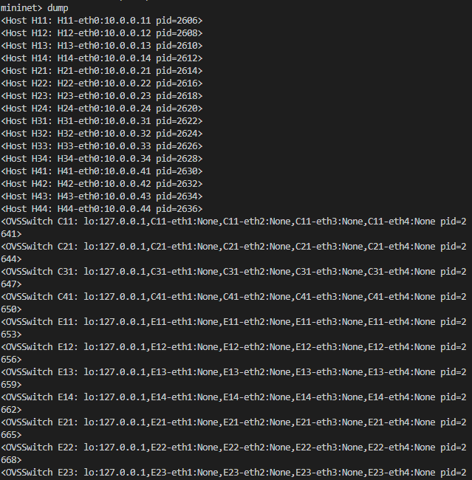

Dump 2nd half (overlap in image):

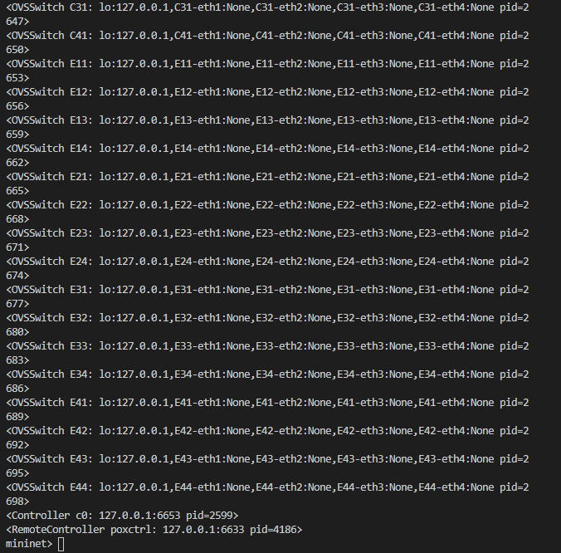

Hping3:



Note: The mininet I’m using has no connection to the internet so I couldn’t get hping. I hope the rest is proof enough.