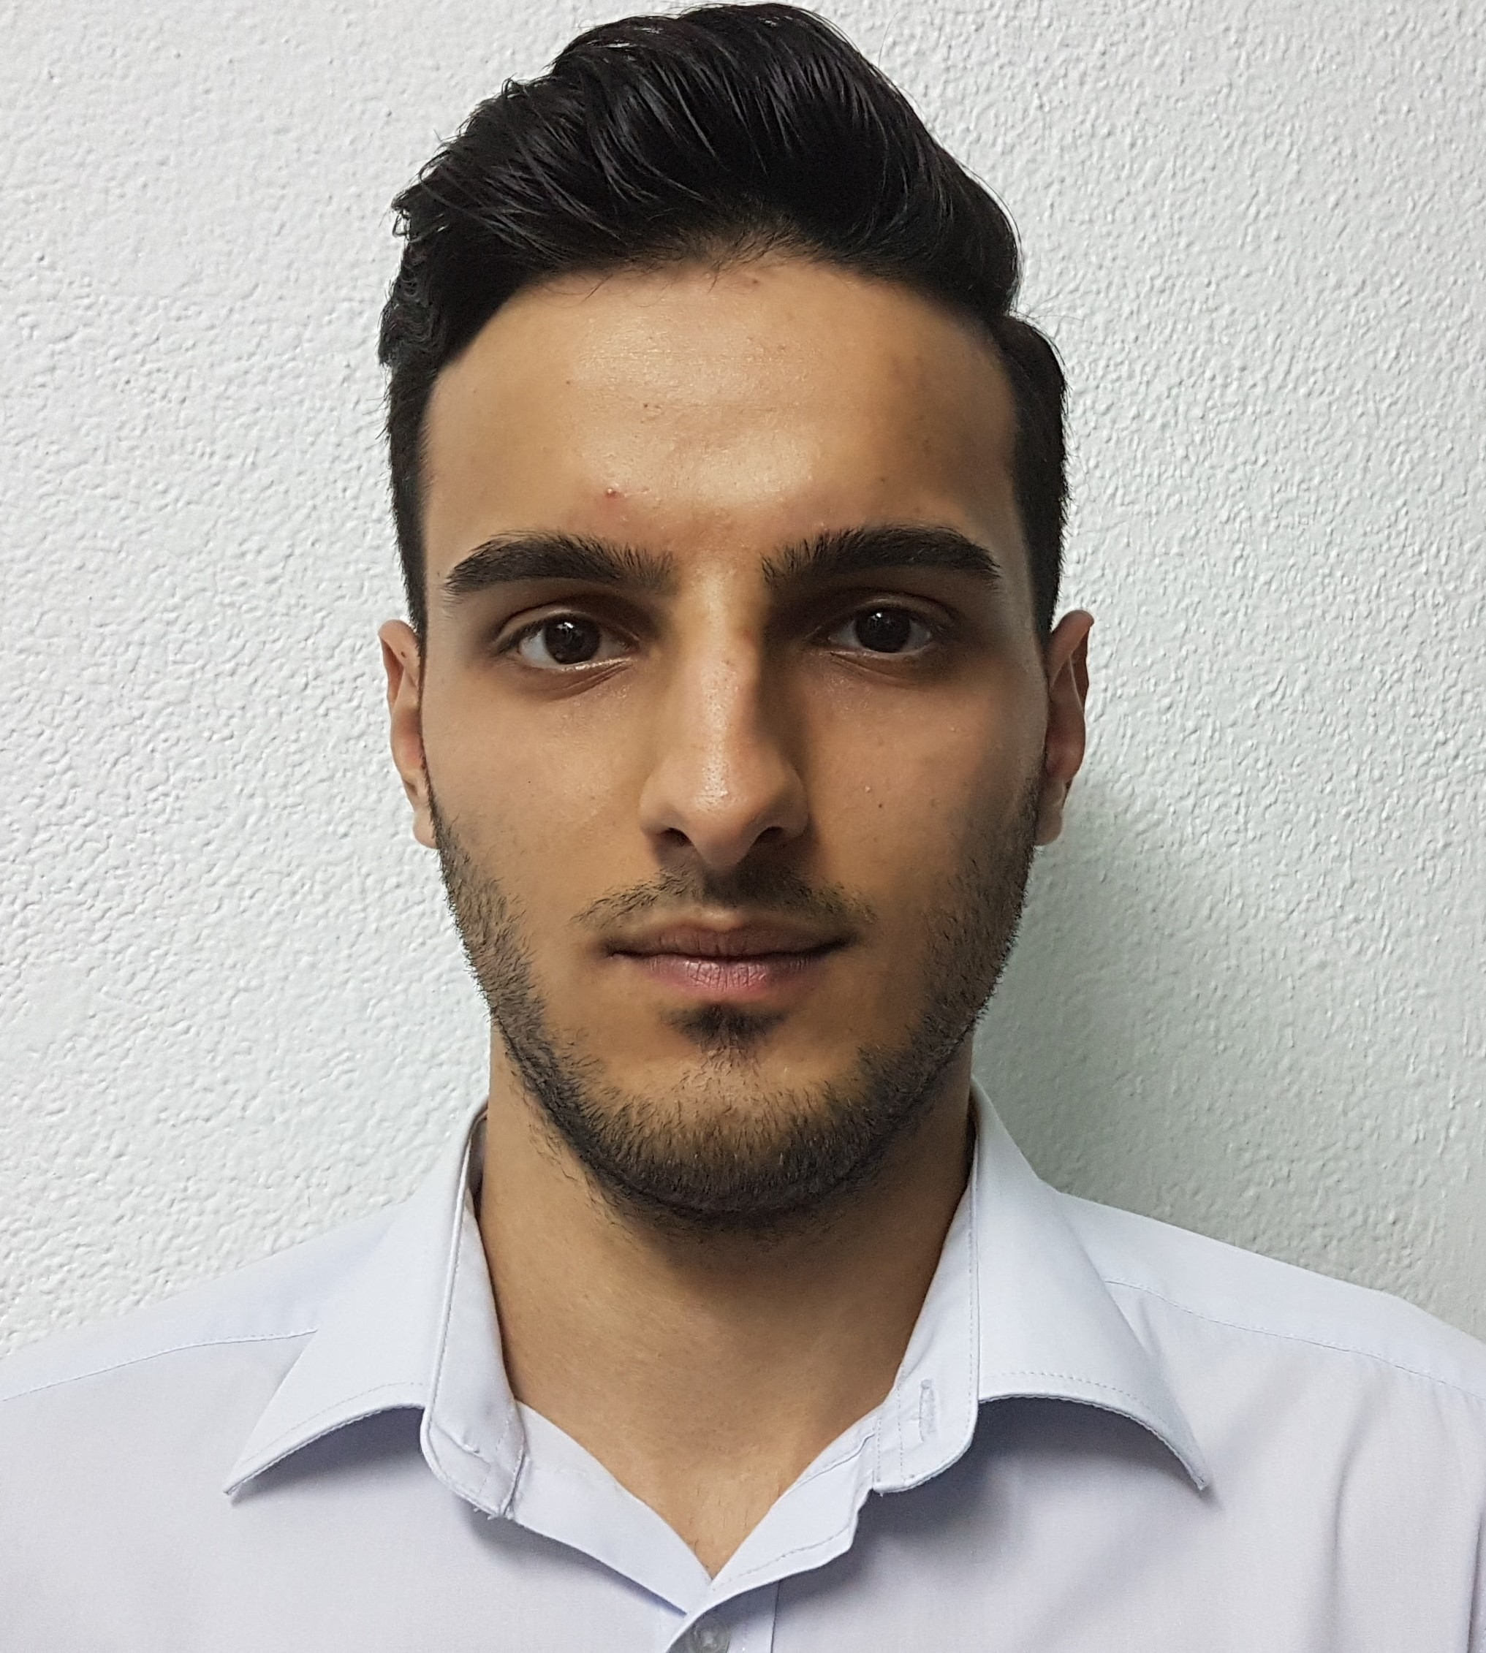

sdfsdg | sdgsg | sdgsdhs

# About me

sgdsg

# Work experience

**sdgsdhs** *sdgdsg - shdsh*sgsdgdhs

# Skills

* skill
* golang