Assignment 6 Report for Part A

Dan Wang

1. Using the menu commands, set up the MDP for TOH with 3 disks, no noise, one goal, and living reward=0. The agent will use discount factor 1. From the Value Iteration menu select "Show state values (V) from VI", and then select "Reset state values (V) and Q values for VI to 0".

Use the menu command "1 step of VI" as many times as needed to answer these questions:

**1a.** How many iterations of VI are required to turn 1/3 of the states green? (i.e., get their expected utility values to 100).

4

**1b.** How many iterations of VI are required to get all the states, including the start state, to 100?

8

**1c.** From the Value Iteration menu, select "Show Policy from VI". (The policy at each state is indicated by the outgoing red arrowhead. If the suggested action is illegal, there could still be a legal state transition due to noise, but the action could also result in no change of state.) Describe this policy. Is it a good policy? Explain.

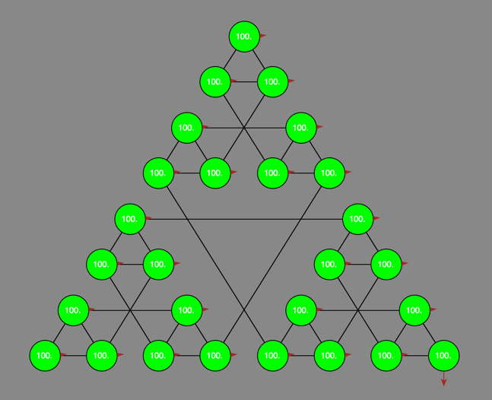

The policy is shown in the picture, and some illegal actions are suggested. No. It is not a good policy since some actions are not legal. And it doesn’t indicate the golden path.

2. Repeat the above setup except for 20% noise.

**2a.** How many iterations are required for the start state to receive a nonzero value.

8

**2c.** At this point, view the policy from VI as before. Is it a good policy? Explain.

Yes. The policy indicates the golden path.

**2d.** Run additional VI steps to find out how many iterations are required for VI to converge. How many is it?

56

**2e.** After convergence, examine the computed best policy once again. Has it changed? If so, how? If not, why not? Explain.

No. The policy often converges long before the values. The “max” at each state rarely changes.

3. Repeat the above setup, including 20% noise but with 2 goals and discount=0.5.

**3a.** Run Value Iteration until convergence. What does the policy indicate? What value does the start state have? (start state value should be 0.82)

The policy indicates the shortest silver path.

The start value is 0.82

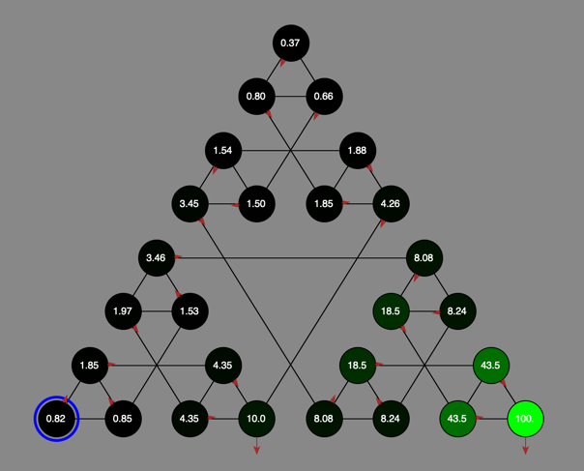

**3b.** Reset the values to 0, change the discount to 0.9 and rerun Value Iteration until convergence. What does the policy indicate now? What value does the start state have? (start state value should be 36.9)

The policy indicates the golden path.

The start state is 36.9

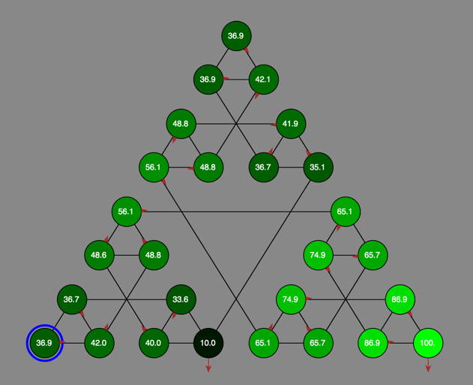

4. Now try simulating the agent following the computed policy. Using the "VI Agent" menu, select "Reset state to s0". Then select "Perform 10 actions". The software should show the motion of the agent taking the actions shown in the policy. Since the current setup has 20% noise, you may see the agent deviate from the implied plan. Run this simulation 10 times, observing the agent closely.

**4a.** In how many of these simulation runs did the agent ever go off the plan?

8 (use discount as 0.9 for this question, see the appendix for the table)

**4b.** In how many of these simulation runs did the agent arrive in the goal state (at the end of the golden path)?

6

**4c.** For each run in which the agent did not make it to the goal in 10 steps, how many steps away from the goal was it?

In four runs, the agent did not make to the goal in 10 steps. Two of them are 3 steps away, and the other two are 1 step way.

**4d.** Are there parts of the state space that seemed never to be visited by the agent? If so, where (roughly)?

Yes. Near the upper corner of the triangle.

5. Overall reflections.

**5a.** Since it is having a good policy that is most important to the agent, is it essential that the values of the states have converged?

No. The policy often converges long before the values.

**5b.** If the agent were to have to learn the values of states by exploring the space, rather than computing with the Value Iteration algorithm, and if getting accurate values requires re-visiting states a lot, how important would it be that all states be visited a lot?

Not important. It is important in the sense that the states near the optimal policy are visited a lot.

**Appendix**

**Problem 4 Ten runs of "Perform 10 actions"**

|  |  |  |  |
| --- | --- | --- | --- |
|  | **Go off plan?** | **Reach goal?** | **Steps away from goal** |
| **1** | No | Yes |  |
| **2** | Yes | Yes |  |
| **3** | No | Yes |  |
| **4** | Yes | No | 3 |
| **5** | Yes | Yes |  |
| **6** | Yes | Yes |  |
| **7** | Yes | No | 1 |
| **8** | Yes | Yes |  |
| **9** | Yes | No | 3 |
| **10** | Yes | No | 1 |