AQ Mapper — Air Quality Lab
Log air-quality readings on your phone — no app to install.
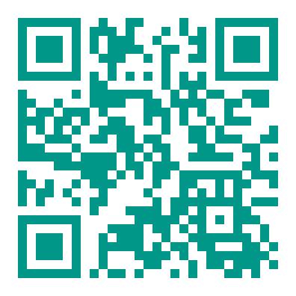
https://danweaver-ca.github.io/aq-mapper/

Getting started
- Scan the QR code with your phone camera (or type the link above). The app opens right in your web browser — nothing to download.
- Recommended — keep it handy: iPhone → tap the Share button → “Add to Home Screen.” Android → tap the menu (⋮) → “Add to Home Screen” / “Install.” Then open it from the new icon.
- Enter your Group name and device ID when prompted.
- Tap “Add Measurement” to log a reading. Allow location access when asked so each reading is placed on the map.

⚠ Export before you leave! Your readings are saved only on your phone. Before you finish, open the Data screen, tap “Export & Share CSV,” and send the file to your instructor. Closing or clearing your browser can erase the data.
Tip: the campus map works even without wifi, but it needs a connection the first time you open the app.

