PneumoTRACE Serotype Report
Dan Weinberger and Nate Grubaugh
2025-04-13


Data use terms

The data presented in these reports is the property of Dan Weinberger and Nate Grubaugh at Yale School of Public Health and will be embargoed for a period of 18 months from the date of release of this report. During the embargo period, subscribers may use the data for internal planning purposes and for confidential presentations to external stakeholders (e.g., national immunization technical advisory groups). Following the embargo Subscribers may also use the outputs for derivative analyses, such as cost effectiveness analysis or comparative impact evaluations, that can be independently published following the embargo period, but the underlying data or basic descriptive statistics of the data themselves cannot be independently published by subscribers.

Overall carriage prevalence by age and by age, and race/ethnicity
age_group | n | prevalence
2-5 | 771 | 0.21400778
5-9 | 577 | 0.11091854
50-64 | 471 | 0.10403397
65+ | 435 | 0.09885057
<2 | 746 | 0.28686327
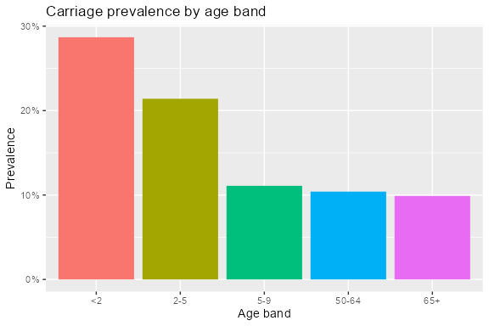

Observed serotype frequencies in carriers

Children <5 years

<2
serotype | n
6A | 19
15C | 16
21 | 16
19F | 15
15B | 14
23B | 14
23A | 13
3 | 12
11A | 10
19A | 9
6B | 6
18C | 5
10B | 3
10F | 3
27 | 3

2-5
serotype | n
3 | 15
23A | 13
15B | 12
15C | 11
23B | 11
6A | 11
6B | 11
11A | 10
21 | 10
19A | 9
19F | 9
27 | 4
18B | 2
2 | 2
22F | 2

Children 5-9 years
serotype | n
19F | 8
6A | 8
11A | 5
19A | 5
21 | 5
23A | 5
23B | 4
15B | 2
15C | 2
16F | 2
9V | 2
10D | 1
11B | 1
11D | 1
12F | 1

Adults 50-64 years
serotype | n
19A | 4
21 | 4
23B | 4
11A | 3
3 | 3
6B | 3
11I | 2
15B | 2
15C | 2
23A | 2
6A | 2
1 | 1
10A | 1
10F | 1
11B | 1

Adults 65+ years
serotype | n
11A | 4
21 | 4
3 | 4
15B | 3
15C | 3
23A | 3
6B | 3
19A | 2
28A | 2
29 | 2
6A | 2
10A | 1
12Fv | 1
16A | 1
18C | 1

Comparisons of serotype frequencies among age groups
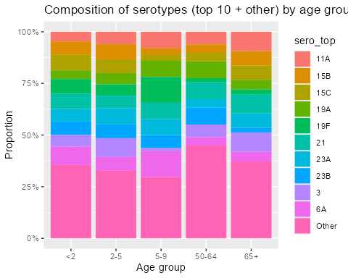

Comparisons of serotype frequencies Stratified by vaccine history (children)
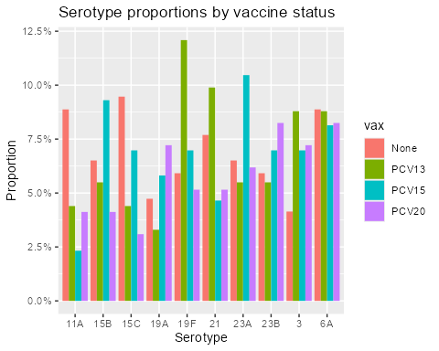

Comparisons of serotype frequencies Stratified by race/ethnicity
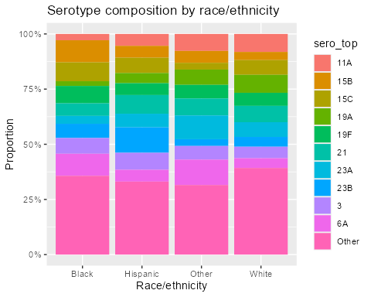

Comparisons of serotype frequencies Stratified by viral test result
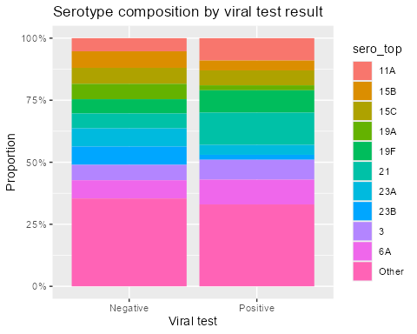

Nowcasting of serotype patterns in IPD
These are modeling outputs that combine the observed data with a published statistical model to generate predictions + uncertainty for frequency of serotypes causing invasive disease.

Appendix: Table of serotype data by age
To download as Csv.

