Southampton Solent University
Computer | Science & Engineering

What factors influence whether someone seeks mental health treatment?

Data Science COM618
Software Engineering BSc
2025
Daniel Weston

Tutor: Dr Taiwo Ayodele
Total wordcount not including title, contents, figures or references: 2135
Table of Contents
Introduction 3
Aim 3
Objectives 3
Methodology 4
Selection & Visualisation 4
Preparation 5
Exploration 7
Modelling 8
Results 9
Random Forest 9
XGBoost 10
Discussion 12
Conclusion 12
References 13

Table of Figures
Figure 1 Occupation Distribution 4
Figure 2 Gender Distribution 5
Figure 3 Correlation between stress and mood variables 5
Figure 4 Standard Deviation applied to dataset 6
Figure 5 Data de-duplication 6
Figure 6 Data mapping to binary 6
Figure 7 Sampling the dataset 6
Figure 8 Gender comparison of treatment and emotional struggles 7
Figure 9 Emotional Struggles by Days Spent Indoors 7
Figure 10 Random Forest Classification: Contributions to seeking mental health treatment 9
Figure 11 RF SHAP 9
Figure 12 Random Forest Confusion Matrix 10
Figure 13 RF Performance Metrics 10
Figure 14 XGBoost Classification: Contributions to seeking mental health treatment 10
Figure 15 XGBoost SHAP 11
Figure 16 XGBoost Confusion Matrix 11
Figure 17 XGBoost Performance Metrics 11

Introduction
Mental health among working-age populations has been sharply declining in recent years. According to Vriend (2025), “In 2023/24, almost 9 million people received NHS-prescribed anti-depressants” representing an increase of 2.2 million prescriptions since 2015/16. Similarly, the demand for services supporting public mental health has risen substantially; Vriend also reports that “in 2023, mental health services in England received a record 5 million referrals, an increase of 33% since 2019” These figures highlight a clear upward trend in the reporting, diagnosis, and treatment of mental health conditions. This pattern is further supported by NHS England (2025) data, which shows that common mental health conditions (CMHCs) among adults aged 16 to 64 increased from 15.5% in 1993 to 22.6% in 2023/24. This represents a compound average growth rate of approximately 1.23% per annum over 30 years, underscoring the rising prevalence of mental health issues in modern society and their growing importance in healthcare research.
Mental health has a significant impact on the economy. An Australian study conducted by Schofield et al. (2010) found that individuals experiencing mental health conditions were four times more likely to be unemployed than those without such conditions, either due to reluctance or inability to participate in the labour force. The study also reported that employees with mental health disorders demonstrated lower productivity levels and higher rates of absenteeism compared to their healthy counterparts. Furthermore, Schofield et al. highlighted the long-term financial consequences of mental illness, noting that “Both males and females who were out of the labour force due to depression or other mental health problems had at least 97% less savings and retirement income by age 65 that those who remained employed full-time.” These findings underscore the profound socio-economic implications of mental health challenges, not only for individuals but also for national productivity and economic sustainability.
Aim
To analyse a publicly available mental health dataset to identify patterns and predictive factors affecting mental health outcomes among working-age adults, using visualisation and modelling techniques to generate evidence-based insights into mental health trends.

Objectives
- Explain the “Mental Health Dataset” (Jikadara, 2023) from Kaggle, justifying its suitability and reliability for analysing factors influencing mental health.
- Preprocess the dataset by identifying and handling missing, duplicate, or inconsistent data, ensuring it is suitable for analysis and modelling.
- Conduct exploratory data analysis (EDA) using statistical and visualisation tools to identify key patterns and relationships between demographic, workplace, and mental health factors.
- Develop and evaluate a predictive to assess which factors most strongly influence mental health outcomes.
- Critically evaluate model performance, interpret results, and compare findings with existing literature on mental health and workplace well-being.
- Summarise insights and propose data-driven recommendations for improving mental health awareness, workplace support, and further research.

Methodology

Selection & Visualisation
The dataset used in this project is the Mental Health Dataset by Jikadara (2023), sourced from Kaggle (https://www.kaggle.com/datasets/bhavikjikadara/mental-health-dataset). It comprises 292,364 records from 36 countries, capturing a wide range of demographic and occupational variables alongside indicators related to mental health, including treatment-seeking behaviour, mood factors, and workplace support. This dataset was selected for its comprehensive coverage of factors influencing mental health and its clean, structured format, predominantly featuring binary and categorical variables. Such characteristics make it highly suitable for statistical analysis, visualisation, and predictive modelling, enabling exploration of relationships between demographic or workplace variables and mental health outcomes.
To understand the dataset’s composition and key characteristics, three initial visualisations were produced using Python’s Matplotlib and Seaborn libraries. These libraries were chosen for their flexibility in plotting categorical and binary variables and their ability to reveal patterns critical in healthcare data analysis.
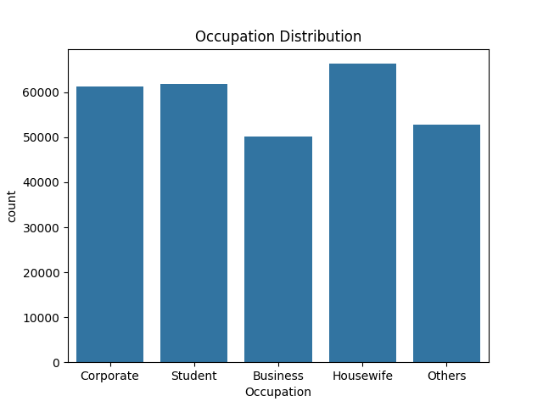
Figure 1 Occupation Distribution
Figure 1 illustrates the distribution of respondents across different occupations. Since this project focuses on working-age populations, the occupational spread provides essential context for examining workplace-related mental health issues. Occupation-specific patterns identified here will guide later analyses in understanding job-related stress and well-being.
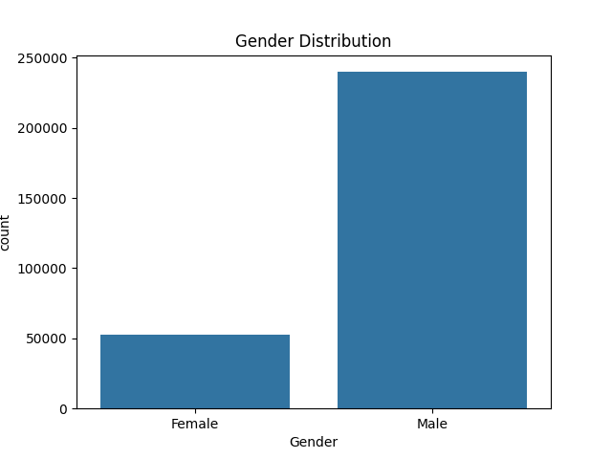
Figure 2 Gender Distribution
Figure 2 presents a notable sampling imbalance within the dataset, which may influence results and model performance. Recognising this bias early is crucial, as it informs data preparation and potential mitigation strategies to ensure the predictive model is robust and generalisable. Additionally, understanding gender distribution provides context when analysing stress, mood, and treatment-seeking behaviours.
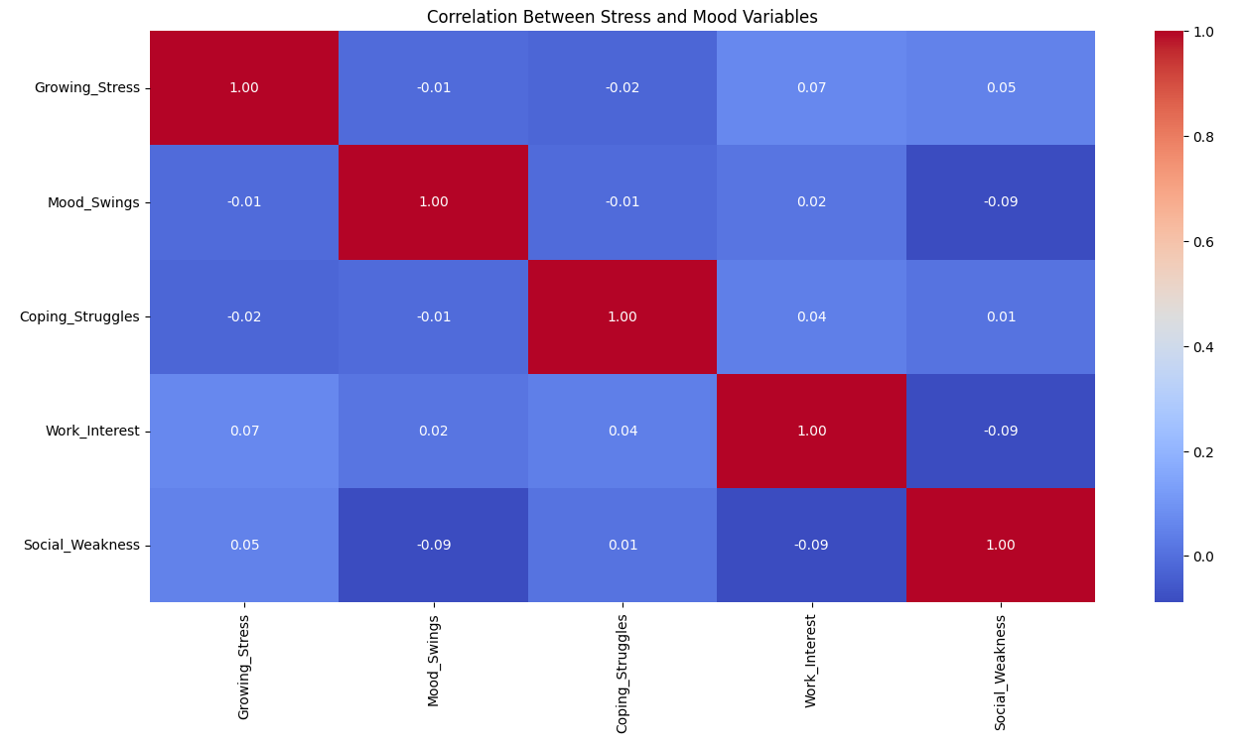
Figure 3 Correlation between stress and mood variables
Figure 3 shows the correlation between stress and mood variables. Preliminary visualisation indicates no strong linear relationship between the variables, these insights guide feature selection for later modelling stages, highlighting the need for more advanced predictive approaches. These initial analyses establish the dataset’s suitability and inform subsequent data preparation, including handling imbalances and potential biases. They also provide early insights into the patterns and relationships that will underpin the data analysis and predictive modelling stages within this project.

Preparation
From F. Ilyas and Chu (2019), “data collection and acquisition often introduce errors in data, e.g., missing values, typos, mixed formats, replicated entries for the same real-world entity, and violations of business and integrity rules” which leads me to the conclusion that data cleaning is a necessary introductory step into data science. Important features within cleaning include outlier detection, data deduplication, transformation and data repair – all applied to create a clean and useable dataset for analysis and prediction.
Data cleaning is a fundamental step in data science, as errors introduced during data collection can compromise the analytical and predictive performance of a project. According to F. Ilyas and Chu (2019), “data collection and acquisition often introduce errors in data, e.g., missing values, typos, mixed formats, replicated entries for the same real-world entity, and violations of business and integrity rules”. To ensure a reliable dataset, key cleaning processing include outlier detection, deduplication, transformation and data repair, which collectively create a consistent and usable dataset for analysis.
Figure 4 shows outlier detection that was performed using the standard deviation (z-score) method. As Bhandari (2022) notes, “values with a z score greater than 3 or less than -3 are often determined to be outliers”. Applying this approach allowed for the identification and removal of extreme values that could distort analysis.
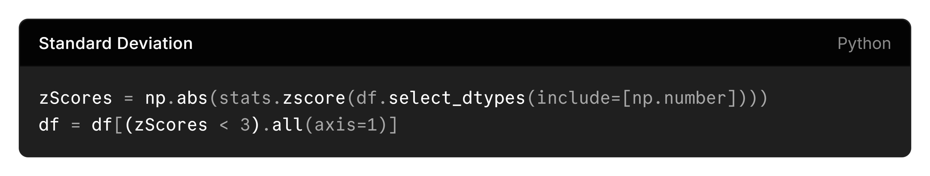
Figure 4 Standard Deviation applied to dataset
Data deduplication was applied to remove redundant entries, reducing bias and storage inefficiency, supported by Windows (n.d.) stating that it “is a feature that can help reduce the impact of redundant data on storage costs”. Using Python Pandas, duplicate rows were detected and removed efficiently, as shown in Figure 5.
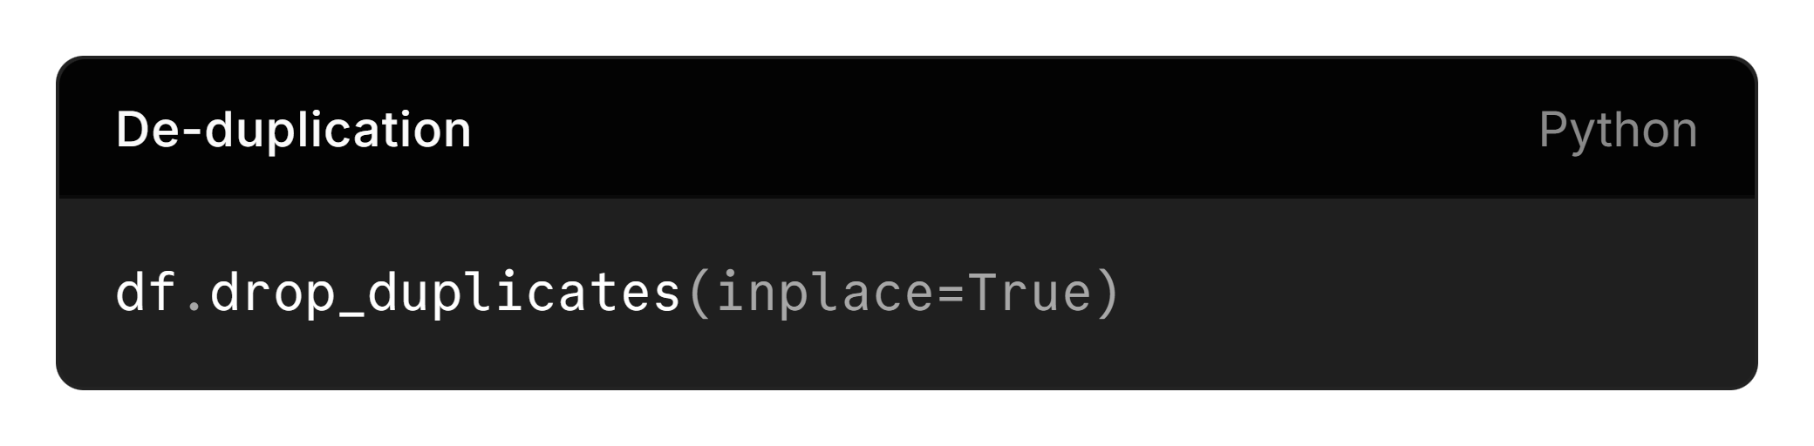
Figure 5 Data de-duplication
Data transformation, as part of Figure 6, involved me converting raw data into a unified format or structure (Hayes, Downie n.d.) which is then suitable for analysis. For example, “Yes” and “No” responses were mapped to binary value (1 and 0), while “Yes”, “No”, and “Maybe” responses were mapped to trinary representation (1, 0, 0,5), ensuring compatibility across the dataset.
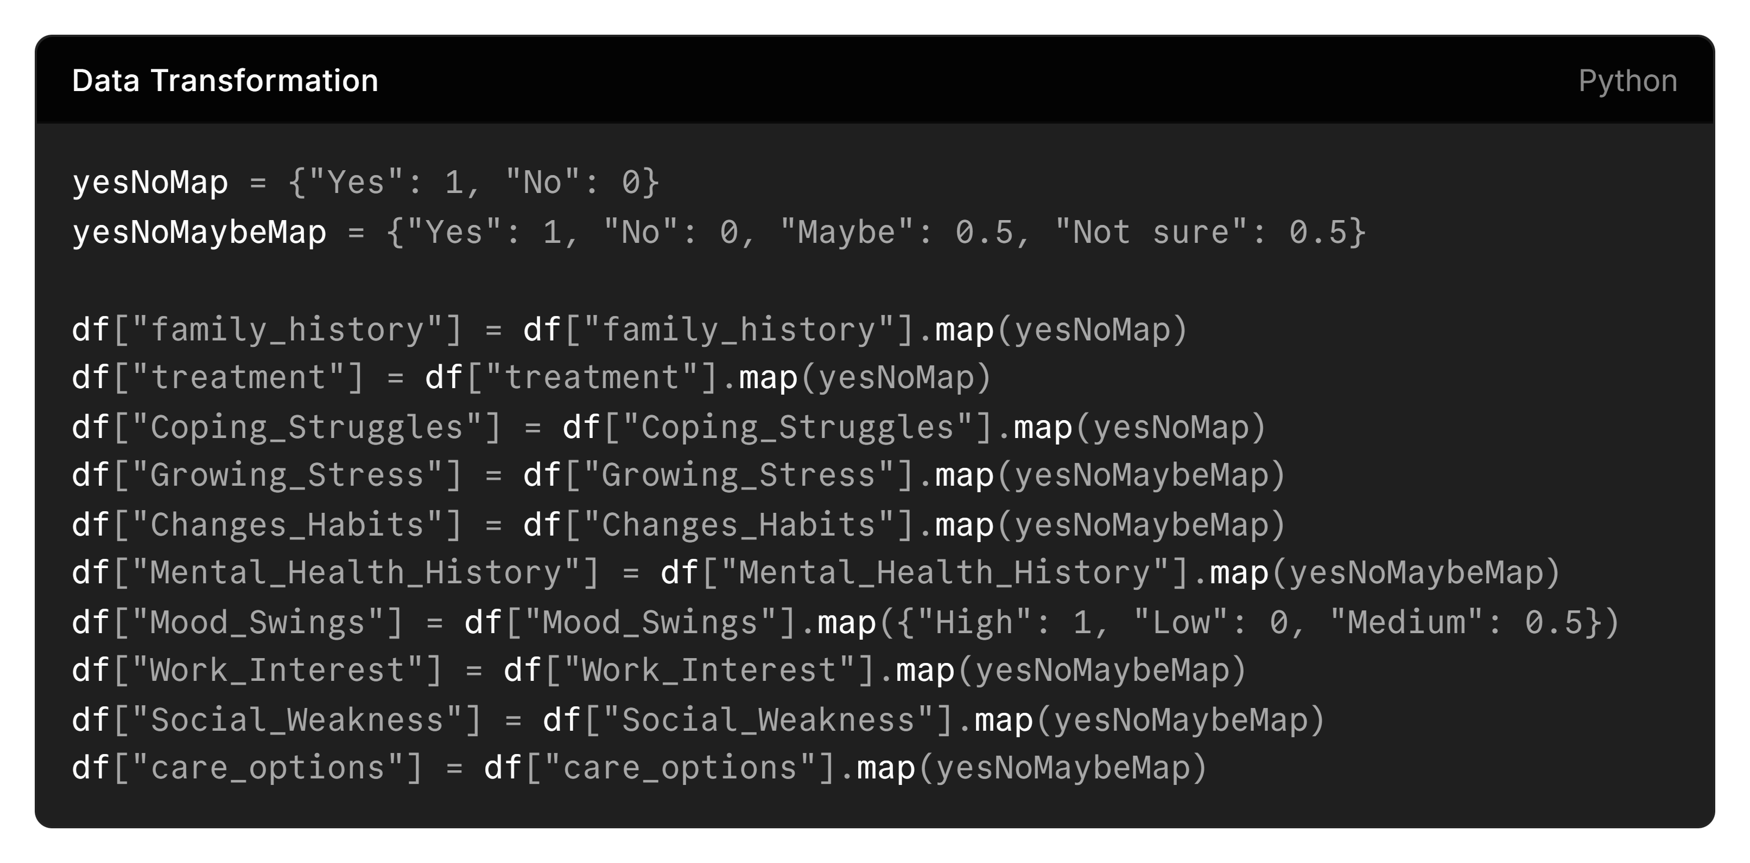
Figure 6 Data mapping to binary
Finally, in figure 7 to address gender imbalance and to reduce potential bias in predictive modelling, the dataset was sampled down to 80,000 entries, maintaining proportional representation across the demographic groups.
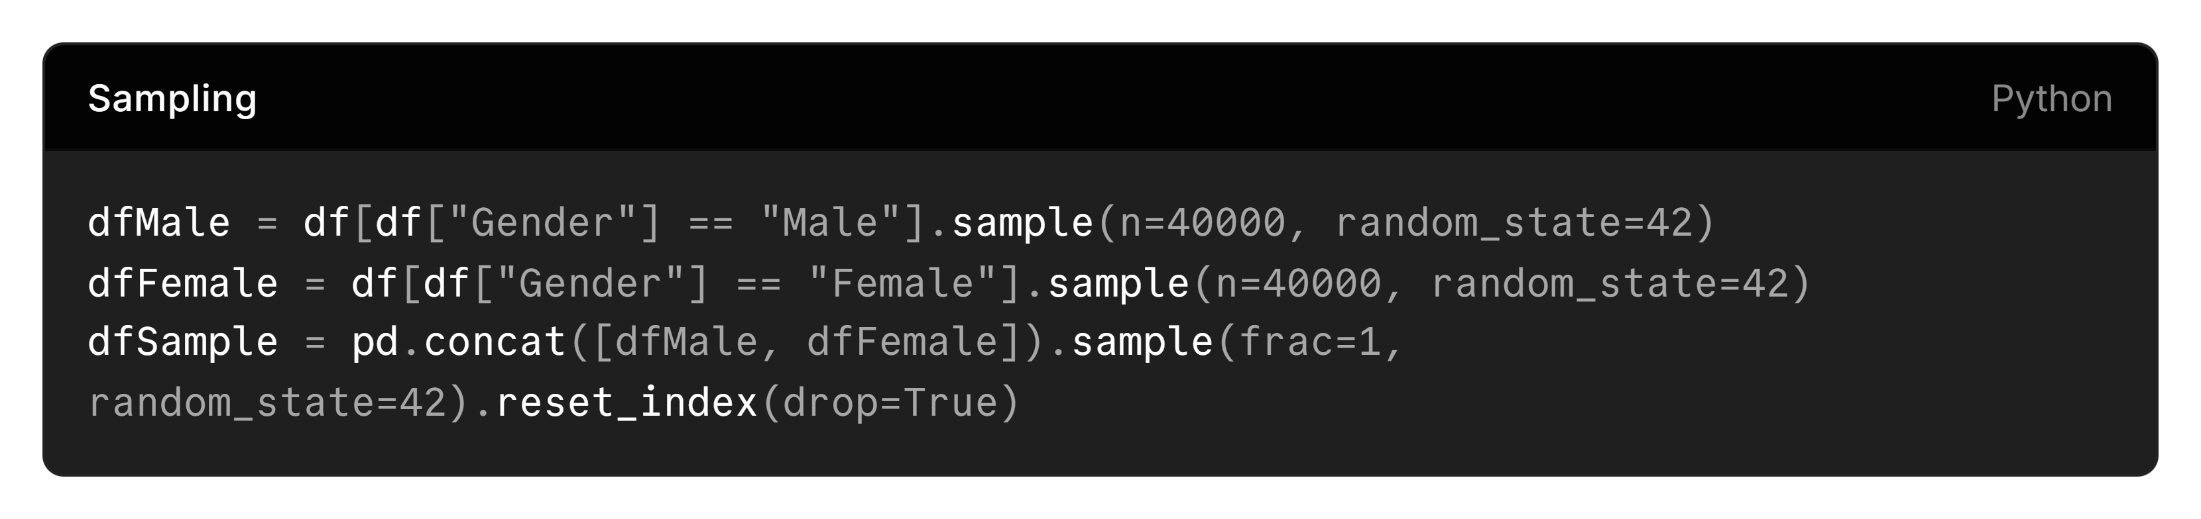
Figure 7 Sampling the dataset

Exploration
IBM says that “EDA helps determine how best to manipulate data source to get the answers you need, making it easier for data scientists to discover patterns” which means that I can find important trends within my data by visualising the comparison of statistics within my dataset.
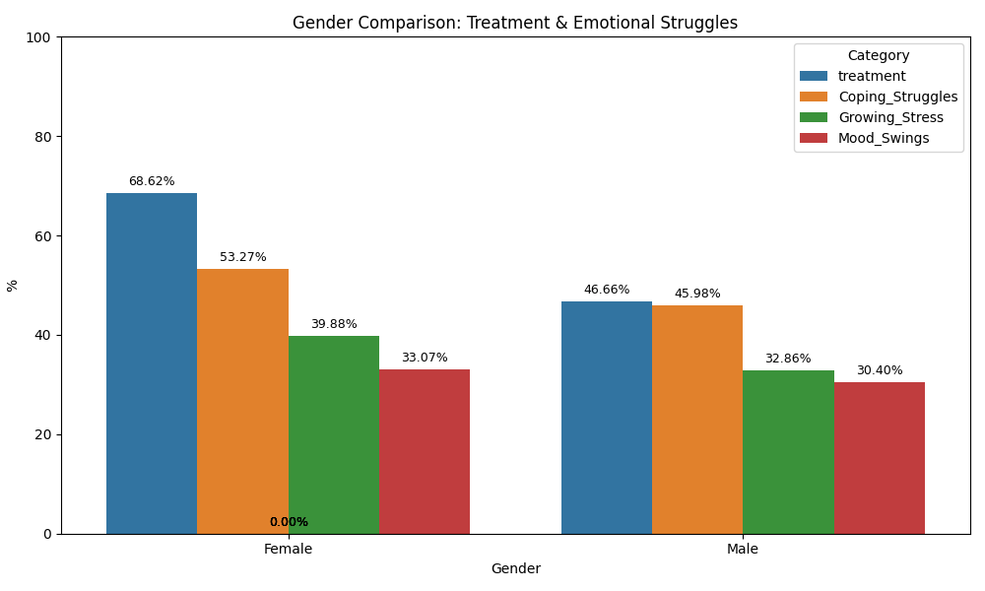
Figure 8 Gender comparison of treatment and emotional struggles
There is a clear trend here that males are less likely to go for treatment less than females, by approximately 22%, and that significantly more females will seek treatment which could lead to an increased risk of males undergoing suicide attempts as stated by the CALM charity who argue that 75% of suicides are male which links to a study by Méndez-Bustos et al., (2019) who claimed how there was a decrease of suicidal ideation rates in 95.7% through psychotherapeutic treatment, further supporting the argument that more treatment leads to a less likelihood of suicide.
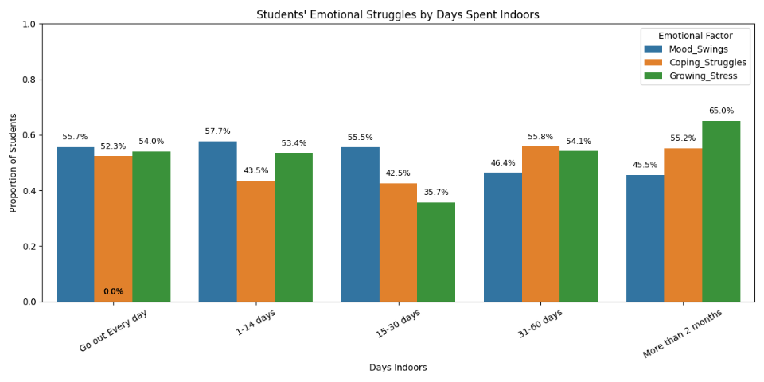
Figure 9 Emotional Struggles by Days Spent Indoors
It is apparent that spending long periods indoors seems associated with higher coping struggles and growing stress, particularly for students, which could indicate that extended isolation or limited outdoor activity might contribute to stress and difficulty coping. We can also see how mood swings are lowest for those spent indoors for over 2 months, however despite being the lowest it is still considerably high.

Modelling
“Too many people with mental illness do not seek professional help, but it is still unclear why individuals with clinically relevant mental health problems chose to deal with their mental health problem on their own” (Stolzenburg et al, 2018). A problem identified within the dataset is the opportunity to predict behaviour regarding seeking treatment and determine which variables most strongly contribute to this outcome.
What factors influence whether someone seeks mental health treatment?
To answer this question, Random Forest (RF) Classification will be especially useful in categorically predicting the most contributary factors in seeking mental health treatment. This is because RF “can be immune to redundant variables or variables with high correlation which may lead to overfitting in other learning algorithms” (KIRASICH, 2018). Similarly, XGBoost Classification is a “highly effective and widely used machine learning method” (CHEN & GUESTRIN, 2016) and may be better performing than Random Forest because as Chen further states, it “scales beyond billions of examples using far fewer resources than existing systems”
To create each model, I split them into training and test data at a split of 70%:30% before scaling them using standard deviation. To get the most optimal model, I have also used the Randomized Search model which tests each parameter at different levels before producing the “best” RF and XGBoost model.

Results

Random Forest
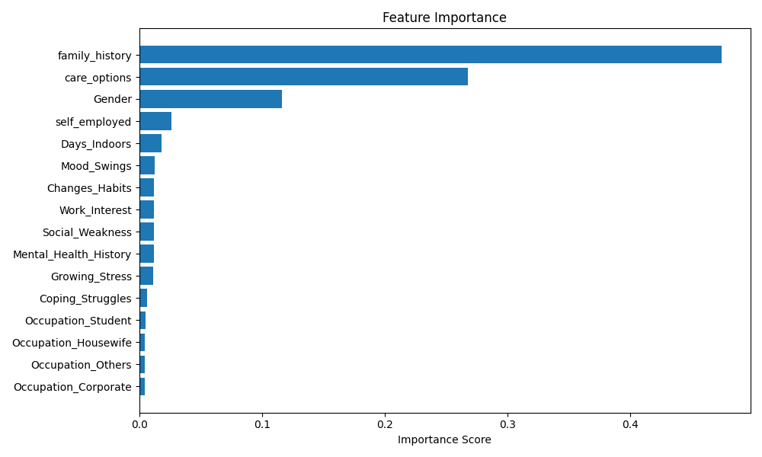
Figure 10 Random Forest Classification: Contributions to seeking mental health treatment
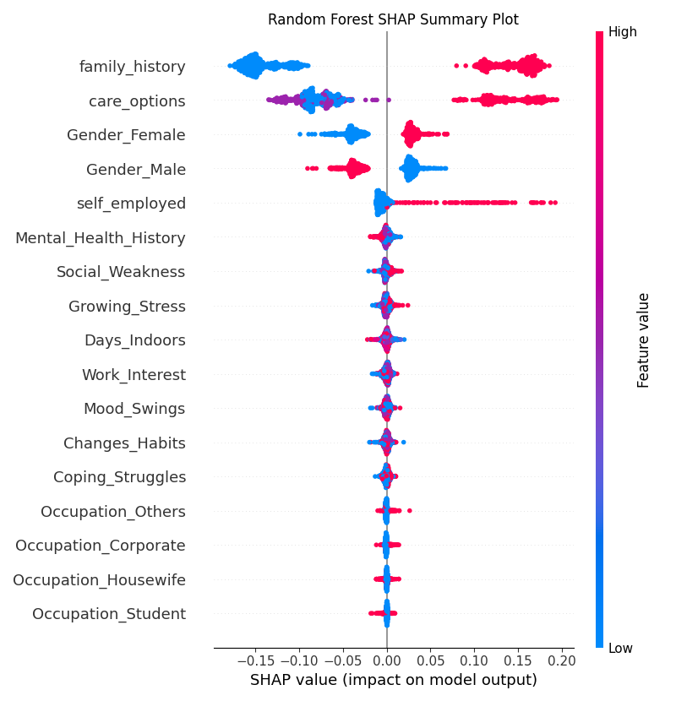
Figure 11 RF SHAP
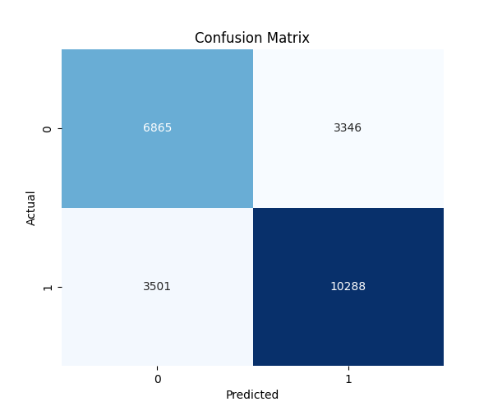
Figure 12 Random Forest Confusion Matrix
Accuracy | 71.3%
Precision | 71.0%
Recall | 71.0%
F1-Score | 71.0%
Figure 13 RF Performance Metrics

XGBoost
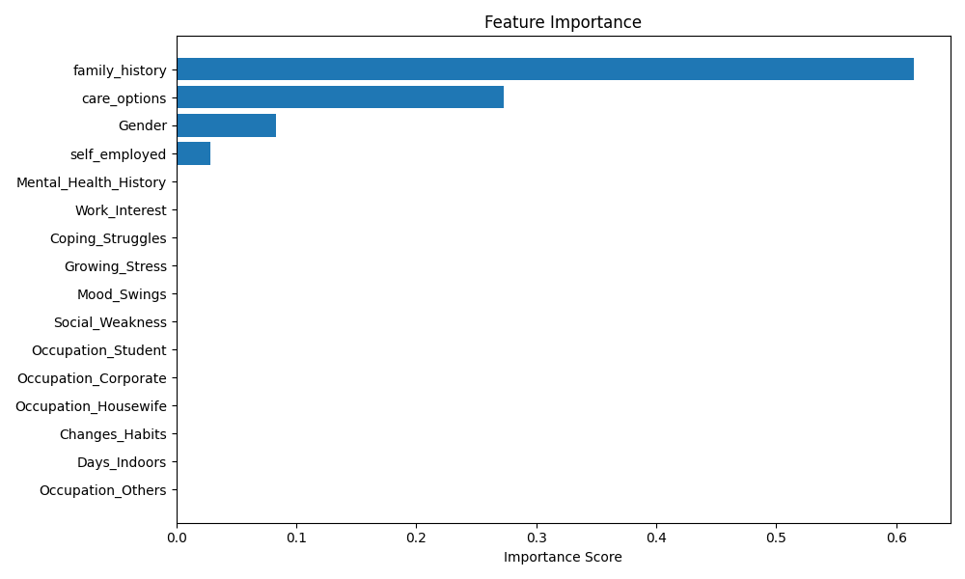
Figure 14 XGBoost Classification: Contributions to seeking mental health treatment
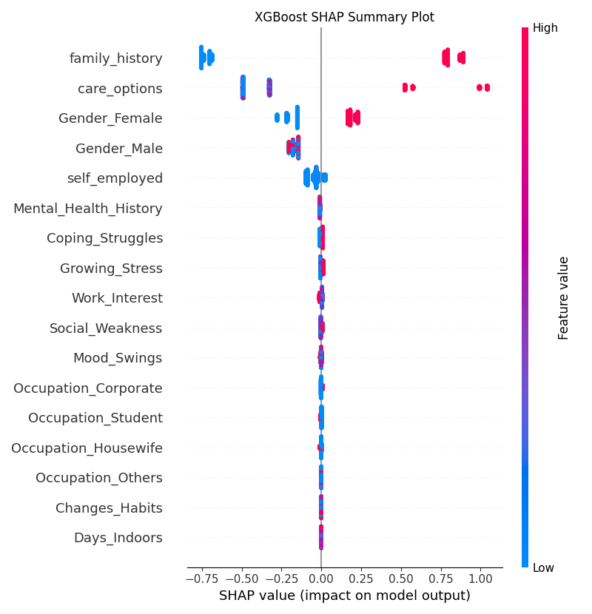
Figure 15 XGBoost SHAP
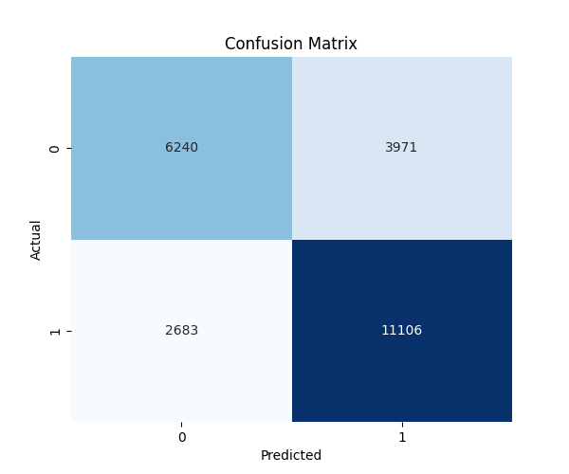
Figure 16 XGBoost Confusion Matrix
Accuracy | 72.3%
Precision | 72.0%
Recall | 71.5%
F1-Score | 71.5%
Figure 17 XGBoost Performance Metrics
Both the Random Forest (RF) and XGBoost models demonstrated comparable performance, with XGBoost yielding marginally superior results. Overall, both models achieved approximately 70% across each evaluation metric. Notably, the similarity in recall and precision between the two models is considered acceptable for exploratory research, as it indicates the models are capturing meaningful patterns rather than producing predictions based on random chance. Furthermore, Random Forest offered additional interpretability by highlighting the relative contributions of various features. Although these contributions were minor, the analysis provided valuable insights into which factors had a greater influence on the model outcomes.

Discussion
The analysis indicates that the strongest factors influencing whether an individual seeks mental health treatment are a family history of mental health conditions and knowledge of available care options. Gender and employment type (specifically self-employment) also show notable feature importance, whereas other factors—such as stress levels, mood fluctuations, or lifestyle choices—exhibit comparatively smaller effects. High values of the top factors—for example, having a family history of mental illness or being aware of care options—are associated with an increased likelihood of seeking treatment.
Interestingly, prior personal history of mental illness emerged as a weaker predictor than might be expected. While it could be assumed that individuals with past mental health issues would be more motivated to pursue treatment, the models suggest this is not consistently the case. This may reflect repeated patterns of response, such as continuing with therapy or choosing not to seek treatment, or perceptions that previous interventions were ineffective, which could reduce willingness to engage in care again.
These findings are consistent with existing research in this field. For example, Perich et al. (2025) reported that “students with a family history of mental illness were more likely to report clinically significant symptoms,” aligning with the present model’s finding that family history is the largest contributor to treatment-seeking behaviour. Similarly, Andrade et al. (2014) highlighted the “need for community campaigns aimed at increasing public awareness, raising mental health literacy,” which aligns with our model’s indication that increased knowledge about care options corresponds with higher likelihood of seeking treatment.

Conclusion
In conclusion, consistent with findings from the scholarly literature, a family history of mental health issues constitutes the most salient determinant of treatment-seeking behavior. Awareness of available mental health care resources further exerts a significant influence, highlighting the importance of informational accessibility in facilitating help-seeking. Additional factors, including gender and the degree of employer support, contribute to treatment-seeking to a more moderate extent. Conversely, other examined variables demonstrate comparatively limited impact. Collectively, these findings underscore the interplay of personal, social, and informational factors in shaping individuals’ engagement with mental health services, with implications for both policy and clinical practice.

References
ANDRADE, L., ALONSO, J., MNEIMMEH, Z., AL-HAMZAWI, A., BORGES, G., BROMET, E., BRUFFAERTS, R., DE GIROLAMO, G., DE GRAAF, R., FLORESCU, S., GUREJE, O., HINKOV, H., HU, C., HUANG, Y., HWAN, I., JIN, R., KARAM, E., KOVESS-MASFETY, V., LEVINSON, D., MATSCHINGER, H., O’NEILL, S., POSADA-VILLA, J., SAGAR, R., SAMPSON, N., SASU, C., STEIN, D., TAKESHIMA, T., VIANA, M., XAVIER, M. & KESSLER, R., 2014. Barriers to mental health treatment: Results from the WHO World Mental Health (WMH) surveys.
Available at: https://pmc.ncbi.nlm.nih.gov/articles/PMC4100460/.
BHARANDI, P., 2022. How to find outliers: Meaning, formula & examples.
Available at: https://www.scribbr.co.uk/stats/statistical-outliers/.
CALMZONE, n.d. The facts: Why we need to talk about suicide.
Available at: https://www.thecalmzone.net/thelastphoto/the-facts.
CHEN, T. & GUESTRIN, C., 2016. XGBoost: A scalable tree boosting system.
Available at: https://dl.acm.org/doi/abs/10.1145/2939672.2939785.
F. ILYAS, I. & CHU, X., 2019. Data cleaning. Association for Computing Machinery.
HAYES, M. & DOWNIE, A., n.d. What is data transformation? IBM.
Available at: https://www.ibm.com/think/topics/data-transformation.
JIKADARA, B., 2023. Exploring the landscape of mental well-being: A comprehensive dataset analysis. Kaggle.
Available at: https://www.kaggle.com/datasets/bhavikjikadara/mental-health-dataset.
KIRASICH, K., SMITH, T. & SADLER, B., 2018. Random forest vs logistic regression: Binary classification for heterogeneous datasets. SMU Data Science Review.
Available at: https://scholar.smu.edu/cgi/viewcontent.cgi?article=1041&context=datasciencereview.
MÉNDEZ-BUSTOS, P., CALATI, R., RUBIO-RAMÍREZ, F., OLIÉ, E., COURTET, P. & LOPEZ-CASTROMAN, J., 2019. Effectiveness of psychotherapy on suicidal risk: A systematic review of observational studies. PMC.
Available at: https://pmc.ncbi.nlm.nih.gov/articles/PMC6389707/pdf/fpsyg-10-00277.pdf.
MICROSOFT WINDOWS, n.d. Data deduplication overview.
Available at: https://learn.microsoft.com/en-us/windows-server/storage/data-deduplication/overview.
NHS ENGLAND, 2025. Adult psychiatric morbidity survey: Survey of mental health and wellbeing, England, 2023/4.
Available at: https://digital.nhs.uk/data-and-information/publications/statistical/adult-psychiatric-morbidity-survey/survey-of-mental-health-and-wellbeing-england-2023-24/common-mental-health-conditions.
PERICH, T. & ANDRIESSEN, K., 2025. The impact of family history of mental illness on mental health help seeking in university students. PubMed.
Available at: https://pubmed.ncbi.nlm.nih.gov/38832569/.
SCHOFIELD, D., KELLY, S., SHRESTHA, R., CALLANDER, E., PERCIVAL, R. & PASSEY, M., 2010. How depression and other mental health problems can affect future living standards of those out of the labour force. Taylor & Francis Online.
Available at: https://www.tandfonline.com/doi/full/10.1080/13607863.2011.556599?scroll=top&needAccess=true.
STOLZENBURG, S., FREITAG, S., EVANS-LACKO, S., SPEERFORCK, S., SCHMIDT, S. & SCHOMERUS, G., 2018. Individuals with currently untreated mental illness: Causal beliefs and readiness to seek help. PMC.
Available at: https://pmc.ncbi.nlm.nih.gov/articles/PMC6998972/.
VRIEND, M., 2025. Mental health trends among working-age people. Health Foundation. Available at: https://www.health.org.uk/reports-and-analysis/analysis/mental-health-trends-among-working-age-people.
IBM, n.d. What is exploratory data analysis (EDA)?
Available at: https://www.ibm.com/think/topics/exploratory-data-analysis.

