Can Bluetooth Audio Replace the Wire?

Dan Weston

Institute of Sound Recording, University of Surrey

Abstract

My abstract will be written here. It will be in 1 column that crosses the whole page.

Introduction

Millions of users around the world use networking daily to communicate with friends, family, and colleagues. Computers are able to connect in more ways than ever before, and with technology improving day by day, almost all consumer electronic devices have network capabilities.

Fixed connection networks are less susceptible to interference and are consequently more reliable than their wireless counterparts. However, wireless communications enable users to seamlessly connect personal computers to peripheral devices, without the constraints associated with wired connections.

Bluetooth and Wi-Fi are widely used wireless communications networks. The operational speed and distance of Wi-Fi is ten times faster than Bluetooth and both have similar costs. However, Bluetooth consumes much less energy than Wi-Fi, making it ideal for use in portable devices such as headphones, hard drives, wearables and cars, where batteries need to be kept as small as possible.

ZigBee is another low power wireless communications network, with a range 30 times greater than Bluetooth, however with just a quarter of the data speed it isn’t suitable for file transfers [Abinayaa and Jayan 2014]. It is mainly used for home automation systems, and is often found in remote controls.

Bluetooth is a Wireless Personal Area Network (WPAN), developed in 1994, by the Swedish mobile phone company Ericsson, with the intention of replacing cables connecting personal computers and peripheral devices [Bluetooth SIG 2001]. In 1998 IBM, Intel, Nokia and Toshiba joined the study forming the Bluetooth Special Interest Group (SIG), which now has over 30,000 member companies [Bluetooth SIG 2016b]. It is robust, has low power, low complexity and low cost [Bluetooth SIG 2001]. Bluetooth enables numerous devices such as personal computers, mobile phones and entertainment systems to communicate using low power, short distance wireless links [Verma et al. 2015].

Since its creation the development of Bluetooth has been continuous, allowing new capabilities such as stereo audio to be introduced [McClintock 2016]. It was one of the main technologies behind the audio steaming revolution, disconnecting inconvenient wires from between headsets and speakers, and phones and computers, giving users reliable, convenient access to their music anywhere [Bluetooth SIG 2016a].

Consumer demand for devices with the ability to receive transmitted audio via Bluetooth is increasing. A total of €1.6 billion was spent on Bluetooth enabled docking speakers in 2014. In the same year the Western European market purchased 7.6 million Bluetooth speakers. Sales of these devices continue to grow, up by 40 percent in the first six months of 2015, compared with the same period in 2014 [GfK Global 2015]. With such demand for Bluetooth devices, the quality of distributed audio and ability to prevent interference is of upmost importance. With manufacturers continuously developing ways of improving the system, will Bluetooth ever be able to replace the wire?

In section 2 we look at why Bluetooth is good. In section 3 we will discuss its suitability for audio transmission.

# Why Bluetooth?

**Universal**

Bluetooth is universal, making previously impossible connections between devices with various proprietary connectors and pin arrangements possible [Bisdikian 2001]. Devices such as headphones can connect to a mobile phone with the same ease as connecting to a laptop or tablet, irrelevant of manufacturer. Likewise, computer peripherals including keyboards, hard drives, printers and speakers can be easily connected, reducing the stress and cost of sourcing and utilising potentially expensive interconnect cables.

**Low power**

Battery technology isn’t advancing in line with other technologies as it is still poorly understood [Bullis 2015]. There have been improvements over the last decade, but they’ve largely come from frequent small advances.

Bluetooth’s nominal power consumption is around 100mW, whilst WiFi consumes 700mW [Lee et al. 2007]. Making Bluetooth ideal for portable devices with limited battery power. Bluetooth Low Energy, also known as Bluetooth Smart, was released in 2010 with the Bluetooth Core Specification version 4.0. Dementyev et al. [2013] found it has a nominal power consumption of 15mW, lower than standard Bluetooth. Why can’t it be used for audio?

**Mobility**

With the removal of cables, wireless devices give users the ability to move freely without disrupting connections. Bluetooth headphones have become a popular sports accessory, especially amongst runners, as wired headphone cables often get in the way when training and competing. The ability to move the source device, such as a smart phone, around the home is also very appealing to consumers. A common use case for Bluetooth is streaming music from a phone or computer whilst simultaneously using it for other applications.

**Quick easy installation & easy integration of new devices into networks**

Connecting a peripheral device to a personal computer is as simple as finding it from the computer and pairing the two devices. During this process the computer (verifier) sends a signal containing a random number (the challenge) to the peripheral device (claimant). The claimant then calculates a response, which is a function of the challenge, the claimant’s address and a secret key [Bluetooth SIG 2001]. Once this initial connection is established, the devices will be able to connect without the need for these 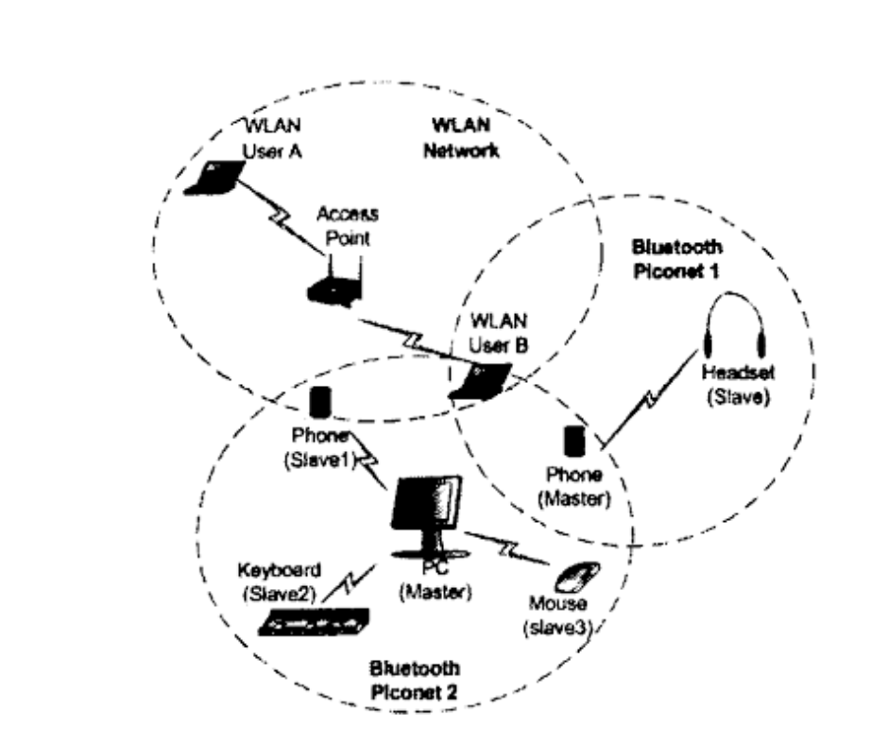installation steps. Connections may be made by turning on the peripheral device.

**Inexpenseve & In most personal computers**

Bluetooth chips replace are inexpensive when compared with the cost of the connectors and cables they replace, and therefore are attractive to manufacturers. This has led to hundreds of millions of Bluetooth equipped devices on the consumer market [Bluetooth SIG 2016a]. This abundance of Bluetooth technology in the world makes it very easy to incorporate new devices into consumer systems.

**Stereo Audio**

**Psychological studies showing wireless is better?**

# Suitability for Audio

Professional audio systems require deterministic low latencies, high sampling frequencies and bit depths, and most importantly reliability.

## Network Interference

Bluetooth operates in the unlicensed 2.4 GHz ISM (Industrial-Scientific-Medical) band, which is split into 79 1 MHz wide channels [IEEE 802.15.2 2003], and has an operational distance of 10-100m.

A physical radio channel is shared by a group of Bluetooth devices, known as a piconet. Each piconet compromises of a single master and up to seven slave devices [Bluetooth SIG 2001]. A larger network called a scatternet can be formed when two or more piconets connect through a bridge or relay device [Pinkumphi and Phonphoem 2009]. The systems are synchronised to a common clock and use a frequency hopping spread spectrum (FHSS) scheme to combat interference. In a FHSS the 79 frequencies of the ISM band are placed in an algorithmically determined pseudo-random order, based on the device address and master clock [IEEE 802.15.1 2005]. The system hops between these frequencies using a Time Division Duplex (TDD) method dividing each second into 1600 time slots (625µs per slot) [Pinkumphi and Phonphoem 2009]. The pattern is adaptive, whereby frequencies used by interfering devices may be excluded, this is known as advanced frequency hopping [Nagai et al. 2012].

### Coexisting Networks

The IEEE Std 802.11 [2005] states that the Wireless Local Area Network (WLAN) operational frequency should also be 2.4 GHz, and has a bandwidth that is roughly equal to 22 MHz [Chiasserini and Rao 2003]. As both the IEEE 802.11 and IEEE 802.15.1 standards specify an operational frequency of 2.4 GHz, there can often be interference when the two networks coexist in the same physical space [IEEE 802.15.2 2003]. Figure 1 shows the coexistence of two Bluetooth piconets and a WLAN. Co-channel interference occurs when two networks collide on the same frequency. As a result of this interference, network throughput decreases and retransmissions can cause severe delays. The packet error rate (PER) due to collisions, of a Bluetooth piconet may reach 10% if seven piconets coexist, and 27% when in the presence of a WLAN [Li 2007].

Factors that affect the interference level include; the separation of the wireless devices, the data traffic levels flowing over each network, the power level of each device, and the WLAN’s data. Different information types have varying levels of sensitivity to interference. There may also be interference from other wireless systems, such as cordless telephones and microwaves, which could result in severe performance degradation [Gehrmann et al. 2004].

Figure 1. Coexisting piconets and WLAN in an office scenario [Li 2007].

Bluetooth uses a FHSS scheme, while IEEE 802.11 either uses FHSS (IEEE 802.11 FH) or a direct sequence spread spectrum (DSSS) system (IEEE 802.11b) [Chiasserini and Rao 2003]. For Bluetooth networks the IEEE 802.11b represents a worse interferer than the IEEE 802.11 FH, because the Bluetooth packet size is so small meaning the PER for 802.15.1 in the presence of IEEE 802.11 FH is almost insignificant [IEEE 802.15.2 2003].

### Interference Reduction

Bluetooth uses ADP to remove channels that are being used by interfering devices. WLAN can also detect interference and defer transmission on channels when they are used by interfering devices [Nagai et al. 2012]. However, it has been found that these interference avoidance functions do not work effectively [Golmie, Chevrollier, et al. 2003; Chiasserini and Rao 2003].

The IEEE 802.15.2 standard specifies the use of alternating wireless medium access (AWMA) and packet traffic arbitration (PTA) to reduce interference between the IEEE 802.11 and IEEE 802.15.1 systems [IEEE 802.15.2 2003]. Many other interference reduction techniques have been suggested such as Li’s [2007] dual channel transmission technique (DCT), using a Bluetooth interference aware scheduling (BIAS) strategy or adaptive frequency hopping (AFH) mechanism both suggested by Golmie et al [2003], Chiasserini and Rao’s [2003] overlap avoidance schemes (OLA), and cooperative channel segmentation (CSS) as suggested by [Nagai et al. 2012]. Golmie, Van Dyck, et al. [2003] also suggested that limiting the WLAN power may reduce the interference in Bluetooth systems.

In AWMA, the WLAN and WPAN radios are located within the same physical unit, and thus a wired connection between the two radios exists. All WLAN devices connected to the same access point (AP) share a clock. As the WLAN and WPAN radios are physically connected they are able to share this clock. The AWMA mechanism utilises this so all WLAN-enabled devices connected to the same AP, have the same common WLAN and WPAN time intervals. This lets the devices restrict their WLAN and WPAN traffic to non-overlapping time intervals, resulting in zero WLAN/WPAN interference between them [IEEE 802.15.2 2003]. A major limitation of this technique is that it does not reduce interference when multiple APs are present, or when a WPAN device is not synchronised to an interfering WLAN AP. Another problem with this approach is the increased network latency [Li 2007]. Chiasserini and Rao [2003] also found the systems throughput decreases significantly as the number of devices operating in the unsilenced band increases.

Figure 3. Example of OLA transmission [Li 2007].

In the PTA mechanism, all attempts to transmit by the IEEE 802.11b or the IEEE 802.15.1 require approval. The PTA is able to predict collisions due to its knowledge of the duration of IEEE 802.11b activity and future IEEE 802.15.1 activity. A transmit request, that would result in a collision, may be rejected, as PTA has rules to prioritise transmissions depending on the packets priority [IEEE 802.15.2 2003]. Drawbacks???

With DCT simultaneous transmission of the same packet occurs on two separate channels. There is at least a 22MHz separation between the two channels to combat WLAN interference. It was shown that DCT can not completely avoid frequency collisions. Li [2007] developed an expectation maximisation algorithm, which estimates the hop timing and frequencies of the FHSS scheme. It is used in conjunction with DCT to resolve packet collisions. One major drawback of this joint method requires the use of an antenna array which is often not possible for devices with size constraints such as headphones. Any other drawbacks???

In the BIAS method, the master uses a predefined criterion, to continuously categorizes frequencies as good or bad. The master will transmit in a slot if it has verified that both the slave’s receiving frequency, and its own receiving frequency are ‘good’. If either of the frequencies are ‘bad’, the transmission slot is skipped and the procedure repeated at the next transmission opportunity [Golmie, Chevrollier, et al. 2003]. Golmie’s [2004] results show that BIAS eradicates packet loss due to interference, even when 75% of the frequency spectrum is occupied by other networks. One key limitation to this technique however, is increased network latency by an average of 1-5ms.

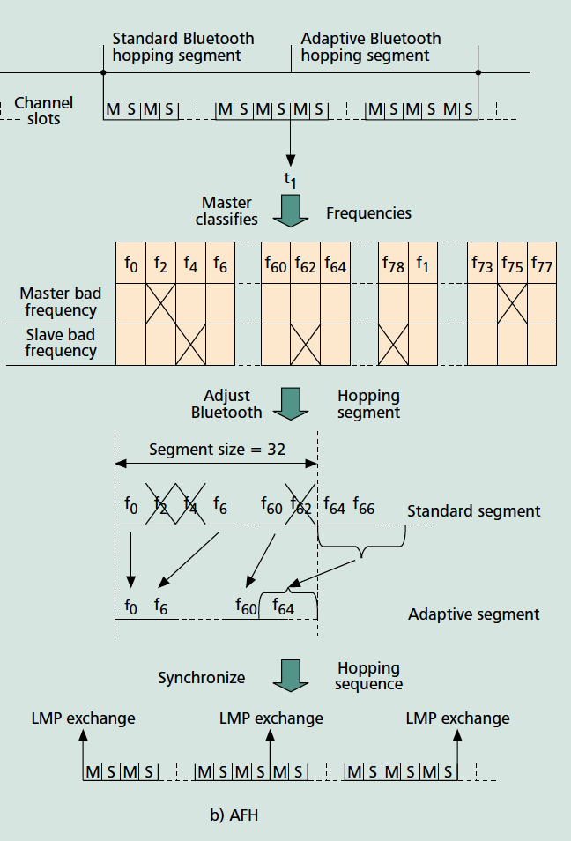The main idea for AFH, is to use BIAS but use an algorithm to adapt the frequency hopping sequence so that only ‘good’ frequencies are selected, thus preventing the need to postpone transmissions. The algorithm checks each frequency, and if ‘bad’ replaces it with a ‘good’ one, see 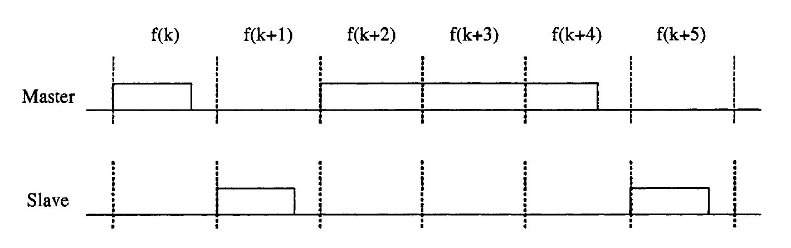Fig 2 [Golmie, Chevrollier, et al. 2003]. AFH has been demonstrated effective in dealing with static WLAN interference, improving throughput by up to 25%. However, it is not relevant for multiple co-located Bluetooth piconets, as channel frequencies are constantly changing and therefore, piconet hopping patterns are not known by one another [Li 2007]. Any other drawbacks???

The CSS algorithm builds on the AFH mechanism to avoid frequency overlap, sharing mutual interference channel information, and dividing operational channels between the Bluetooth and WLAN. The CCS block creates a new channel map by multiplying the Bluetooth AFH channel map by the current WLAN channel. It also takes any adjacent channel interference into consideration when creating the new map [Nagai et al. 2012]. Any drawbacks???

OLA assumes that the Bluetooth master has information about WLAN occupied frequency bands. The Bluetooth master will transmit a long packet on the current carrier frequency, if the next frequency falls into the 22 MHz WLAN band, eliminating co-channel interference (CCI) [Chiasserini and Rao 2003]. Fig. 3 shows this. Supposing frequency $f(k+3)$ lies in the WLAN band. Instead of transmitting a single-slot packet the master transmits a three-slot packet, avoiding transmission on $f\left(k+3\right)$ [Li 2007]. Chiasserini and Rao [2003] show that Bluetooth throughput is significantly improved when using OLA, and that it can reduce interference from microwave ovens. Any drawbacks???

## Audio Quality

Professionals in the audio industry require high bit depths and sampling frequencies. CD quality audio is 44.1kHz/16 bit, equivalent to a bit rate of 1.4Mbps. This is already higher than Bluetooth’s 1Mbps maximum data rate. High resolution audio requires a bit rate of 4.6Mbps as it uses a sampling frequency of 96 kHz/24 bit. Audio codecs are used to compress these large data files, so they can be transmitted over the Bluetooth network. However, this method can potentially lower the audio quality.

Acording to Sayood [2012] there are two data compression schemes, lossy and lossless. If losslessly compressed, the original data can be recovered exactly from the compressed data. This technique is generally used in applications where differences between the original and reconstructed data are not acceptable. In lossy compression techniques parts of the data are discarded, meaning encoded audio is not identical to the original file. Lossless compression generally obtains much higher compression ratios than lossless compression.

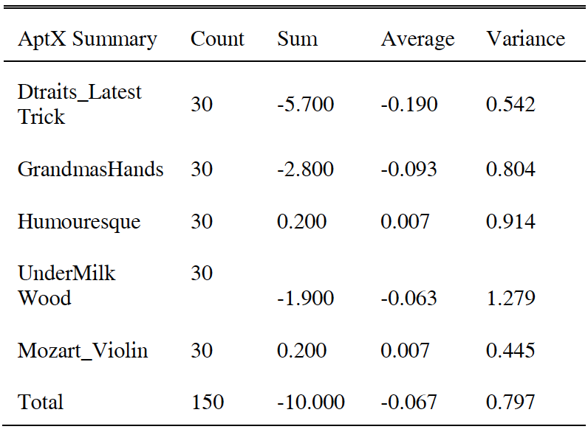Bluetooth uses the Advanced Audio Distribution Profile (A2DP), to stream stereo audio from a source device to headphones or speakers. To ensure interoperability, A2DP uses the mandatory low complexity subband codec (SBC) [Bluetooth SIG 2015]. McClintock [2016] states that one major drawback of the SBC codec is that for most implementations it delivers suboptimal audio performance. Optional codecs may be used instead, if supported by both source and sink devices. These include MPEG 1 & 2 Audio, MPEG 3 & 4 AAC, and ATRAC. Vendor specific codecs can also be used if certain information and parameters are defined [Bluetooth SIG 2015].

Table 2 AptX Performance [McClintock 2016]

**Optional Codecs**

Most audio files stored on phones or streamed using internet services are already compressed to MP3 or AAC files. SBC compression is often applied, on top of the compression already present in these files, by Bluetooth systems [Butterworth 2016]. If audio devices made use of these optional codecs, additional compression could be avoided, thus improving the quality of received audio [Bluetooth SIG 2015]. However, MP3 and AAC are lossy compression formats. MP3 bit rates vary but are usually around 256kbps, significantly lower than the 1.4Mbps rate required for lossless CD quality audio. These formats may be suitable for consumers, but aren’t acceptable for the professional industry.

**Vendor Specific Codecs**

Many vendor specific codecs have been developed to improve the audio quality transmitted over Bluetooth, including aptX, aptX HD, and LDAC. aptX HD claims ‘better than CD’ audio quality [McClintock 2016], Sony Corporation [2016] state LDAC has the ability to ‘maintain maximum bit depth and frequency of 96kHz/24bit audio’. Bluetooth 5 is also due to launch in early 2017, with quadrupled range, doubled speed and a 800% data broadcasting capacity [Bluetooth SIG 2016b].

**aptX**

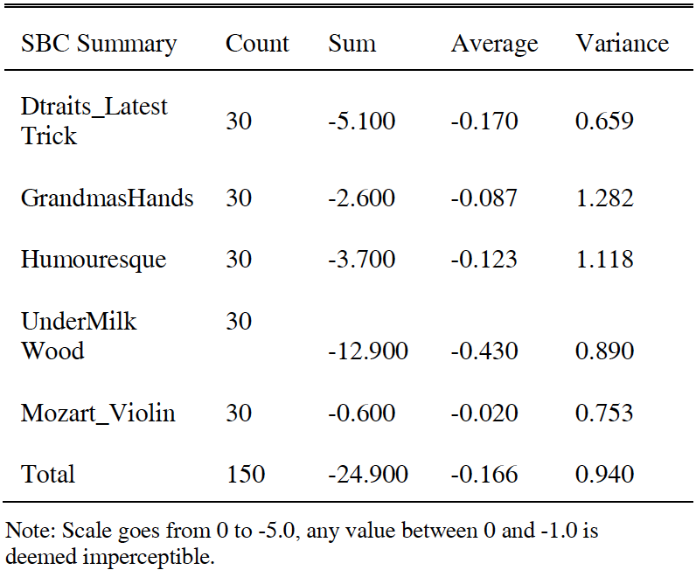AptX was initially used by broadcasters to store CD-quality audio on computer HDDs. It is a non-destructive compression algorithm, and supports 48 kHz/16 bit audio using adaptive differential pulse-code modulation, at a data rate of 354kbps [McClintock 2016]. It has subsequently become a popular professional audio standard and is used worldwide by more than 50,000 radio stations and cinemas. In 2009, the aptX codec started replacing SBC in Bluetooth products, and is now used in the majority of Bluetooth enabled wireless devices. It is estimated that there are now more than 1 billion aptX enabled smartphones, tablets, PCs and TVs, and over 50 million aptX Bluetooth headsets and speakers [Qualcomm Technologies International 2015].

Table 1 SBC Performance [McClintock 2016]

Salford University used the perceptual evaluation of audio quality (PEAQ) algorithm to evaluate the performance of aptX at 354kbps against SBC at 328kbps. A sample base of 30 listeners evaluated the formats. The results in Tables 1 and 2 show aptX outperformed SBC by a factor of 2.5 [McClintock 2016].

The aptX HD codec format, built on the previous aptX codec, was lauched in January 2016, and offers 48 kHz/24 bit audio. A pilot study was conducted by Salford University comparing aptX HD against 44.1 kHz/16 bit and 96 kHz/24 bit audio. For the test several pieces were commissioned and recorded at 96 kHz/24 bit. The content was then processed in 2 ways;

* down-sampled to 44.1 kHz/16 bit, and
* passed through an aptX HD encode/decode cycle.

Results indicated that over 50% of the participants could not hear a perceivable difference between aptX HD and the 96 kHz/24 bit content, but could hear differences between the 44.1 kHz/16 bit and 96 kHz/24 bit content [McClintock 2016]. It should be noted that this information was provided by the Director of aptX sales and marketing, and that the full study results are not yet available. Discussion about aptX and aptX HD.

**LDAC**

Sony’s LDAC, claims to have the highest audio quality out all of the codecs we have looked at so far, 96 kHz/24 bit. This is achieved by using a 990kbps transfer rate, three times greater than SBC and aptX. Ford [2015] shows that this is impossible, unless lossy compression is used. Current lossless techniques can achieve a roughly halved bit-rate. So for a 96 kHz/24 bit file, a 2.25Mbps data rate could theoretically be achieved using lossless compression. To get 96 kHz/24 bit into 990kbps would require a lossless compression that achieved 20% of the original file size, more than doubling the maximum compression factor achieved previously.

After questioning a Sony Asia Engineer [Ford 2015] explains that LDAC is in fact a lossy codec, as it can not fully reconstruct a 24-bit 96kHz signal. It works by trying to recreate the closest possible version of the 96 kHz/24 bit signal. It is also worth noting that LDAC adds to the bit-rate of A2DP, as the A2DP standard does not allow for such high data rates.

Even with its lossy compression LDAC still delivers the highest quality audio out of the codecs we have analysed.

## Network Latencies

Low deterministic latency is another requirement for most professional audio applications.

According to the European Broadcast Recommendation R37-2007 “The relative timing of the sound and vision components of a television signal” the boundaries are: Sound before picture ≤ 40 ms and Sound after picture ≤ 60 ms [EBU 2007].

# Conclusions

References

Abinayaa, V. and Jayan, Anagha, 2014: ‘Case Study on Comparison of Wireless Technologies in Industrial Applications’, *International Journal of Scientific and Research Publications*, 4, 2, (February).

Bisdikian, Chatschik, 2001: *An Overview of the Bluetooth Wireless Technology* (Thomas J. Watson Research Center P.O. Box 704 Yorktown Heights, NY 10598: IBM Corporation).

Bluetooth SIG, 2001: ‘Specifications of the Bluetooth System’, *Version 1.1*, (February).

Bluetooth SIG, 2015: ‘Advanced Audio Distribution Profile Specification’, *Version 1.3.1*, (July).

Bluetooth SIG, 2016a:‘Bluetooth is Everywhere Consumers Hang Out’, https://www.bluetooth.com/marketing-branding/markets/consumer-electronics, accessed 11/11/2016

Bluetooth SIG, 2016b:‘Bluetooth 5 announcement - Kirkland, Washington’, https://www.bluetooth.com/news/pressreleases/2016/06/16/-bluetooth5-quadruples-rangedoubles-speedincreases-data-broadcasting-capacity-by-800, accessed 04/11/2016

Bullis, Kevin, 2015:‘Why Electric Cars Don’t Have Better Batteries’, https://www.technologyreview.com/s/534866/why-we-dont-have-battery-breakthroughs/, accessed 09/11/2016

Butterworth, Brent, 2016:‘Fact or Fiction: Does Bluetooth Wireless Audio Reduce Sound Quality?’, https://www.lifewire.com/what-to-know-about-bluetooth-3134591, accessed 12/11/2016

Chiasserini, C.F. and Rao, R.R., 2003: ‘Coexistence mechanisms for interference mitigation in the 2.4-GHz ISM band’, *IEEE Transactions on Wireless Communications*, 2, 5, (September), pp.964–75.

Dementyev, Artem et al., 2013: ‘Power Consumption Analysis of Bluetooth Low Energy, ZigBee, and ANT Sensor Nodes in a Cyclic Sleep Scenario’, *Microsoft Research*, (April).

EBU Technical Recomendation R37-2007: *The relative timing of the sound and vision components of a television signal*

Ford, Jez, 2015:‘What is Sony LDAC, and how does it do it?’, http://www.avhub.com.au/news/sound-image/what-is-sony-ldac-and-how-does-it-do-it-408285, accessed 04/11/2016

Gehrmann, Christian, Persson, Joakim and Smeets, Ben, 2004: *Bluetooth Security* Artech House.

GfK Global, 2015:‘Bluetooth drives market for portable consumer electronics’, http://www.gfk.com/en-gb/insights/press-release/bluetooth-drives-market-for-portable-consumer-electronics/, accessed 09/11/2016

Golmie, N., Van Dyck, R.E., et al., 2003: ‘Interference Evaluation of Bluetooth and IEEE 802.11B Systems’, *Wirel. Netw.*, 9, 3, (May), pp.201–211.

Golmie, N., 2004: ‘Bluetooth Dynamic Scheduling and Interference Mitigation’, *ACM MONET*, 9, 1, (February).

Golmie, N., Chevrollier, N. and Rebala, O., 2003: ‘Bluetooth and WLAN coexistence: challenges and solutions’, *IEEE Wireless Communications*, 10, 6, (December), pp.22–9.

IEEE 802.11, 2005: ‘ISO/IEC Standard for Information Technology - Telecommunications and Information Exchange Between Systems - Local and Metropolitan Area Networks - Specific Requirements Part 11’, *11i-2003 Edition ISO/IEC 8802-11 IEEE Std 802.11 Second edition 2005-08-01 ISO/IEC 8802 11:2005(E) IEEE Std 802*, (January), pp.1–721.

IEEE 802.15.1, 2005: ‘IEEE Standard for Information technology– Local and metropolitan area networks– Specific requirements– Part 15.1a: Wireless Medium Access Control (MAC) and Physical Layer (PHY) specifications for Wireless Personal Area Networks (WPAN)’, *IEEE Std 802.15.1-2005 (Revision of IEEE Std 802.15.1-2002)*, (June), pp.1–700.

IEEE 802.15.2, 2003: ‘IEEE Recommended Practice for Information technology– Local and metropolitan area networks– Specific requirements– Part 15.2: Coexistence of Wireless Personal Area Networks with Other Wireless Devices Operating in Unlicensed Frequency Bands’, *IEEE Std 802.15.2-2003*, (August), pp.1–150.

Lee, J.S., Su, Y.W. and Shen, C.C., 2007: A Comparative Study of Wireless Protocols: Bluetooth, UWB, ZigBee, and Wi-Fi, *33rd Annual Conference of the IEEE Industrial Electronics Society, 2007. IECON 2007*.

Li, Jingli, 2007: *Robust Coexistence Methods for Frequency Hopped Wireless Networks*. University of Louisville).Google-Books-ID: 3Go1Ct2fW4MC.

McClintock, Jonny, 2016: Can Bluetooth ever Replace the Wire?, *AES Paris 2016*.

Nagai, Y. et al., 2012: Advanced wireless cooperation mechanisms for interference mitigation in the 2.4 GHz ISM band, *2012 IEEE Consumer Communications and Networking Conference (CCNC)*.

Pinkumphi, S. and Phonphoem, A., 2009: Real-time audio multicasting on Bluetooth network, *6th International Conference on Electrical Engineering/Electronics, Computer, Telecommunications and Information Technology, 2009. ECTI-CON 2009*.

Qualcomm Technologies International, 2015:‘25 years of Qualcomm® aptXTM’, https://www.aptx.com/history, accessed 12/11/2016

Sayood, Khalid, 2012: *Introduction to Data Compression*, Third Newnes).Google-Books-ID: Lhrge2YVpBwC.

Sony Corporation, 2016:‘LDAC’, http://www.sony.net/Products/LDAC/, accessed 04/11/2016

Verma, Madhvi, Singh, Satbir and Kaur, Baljit, 2015: ‘An Overview of Bluetooth Technology and its Communication Applications’, *International Journal of Current Engineering and Technology*, 5, 3, (June).