小麦叶片电导率/(dS -m1)

Electrical conductivity of wheat blade

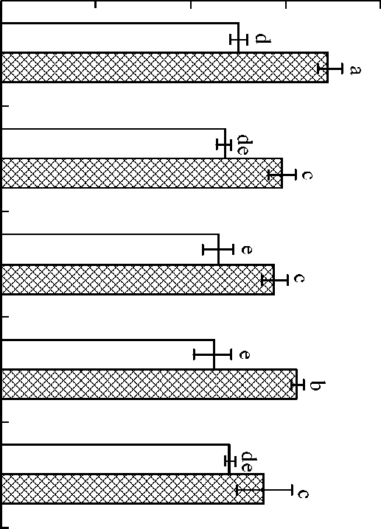

O 4

O O

i i

00 2 6

o o o

CK JKI JKII CZI cz = ^n Treafmenfs

□游4港 Joining sfage 因^礬港 Manure period