**تصميم نظام تحكم لخط الإنتاج**

The main focus on this task is to generate a controlling system to separate different boxes depending on their sizes. This document will explain in details all the components that should be used:

* **Sensor:**

Since tinkercad program was utilized in this task, all sensors were examined to help determining the best sensor that match this controlling process. **Ultrasonic distance sensor** is considered to be cheap, effective, and easy because it helps navigating the surrounding as it can measure 2cm to 400cm of non-contact objects. This can be done by basically using:

Process:

* Object detection:

It is important for the sensor to function if an object is placed on its designed area. For this reason, ultrasonic sensor can be utilized.

* 1. Its release of ultrasonic waves can detect the presence of an object.
  2. The waves will echo or bounce back to the sensor which is taken as an indicator to start the distinguishing process. [This can be seen in the video below:

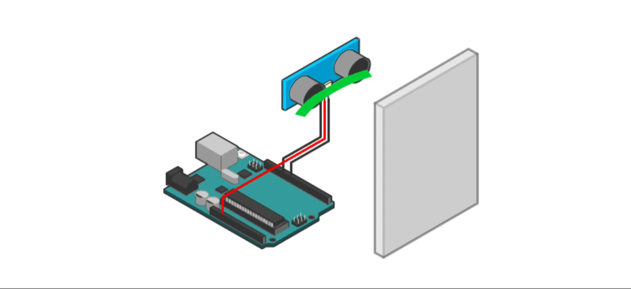

* Object size measurement:

The time difference between the transmission of the ultrasonic wave and the reception of the reflected wave should be calculated using the following equation; Since we know the speed of the sound wave, we can calculate the distance of the box.

With all that being explained, it is clear that the distance from the sensor to the box will vary depending on the box’s size. The larger the box is, the smaller the distance will be. A specific point, for example the red point shown in the picture below, can be taken as an indicator where the distance should be calculated. The picture below demonstrates this idea:

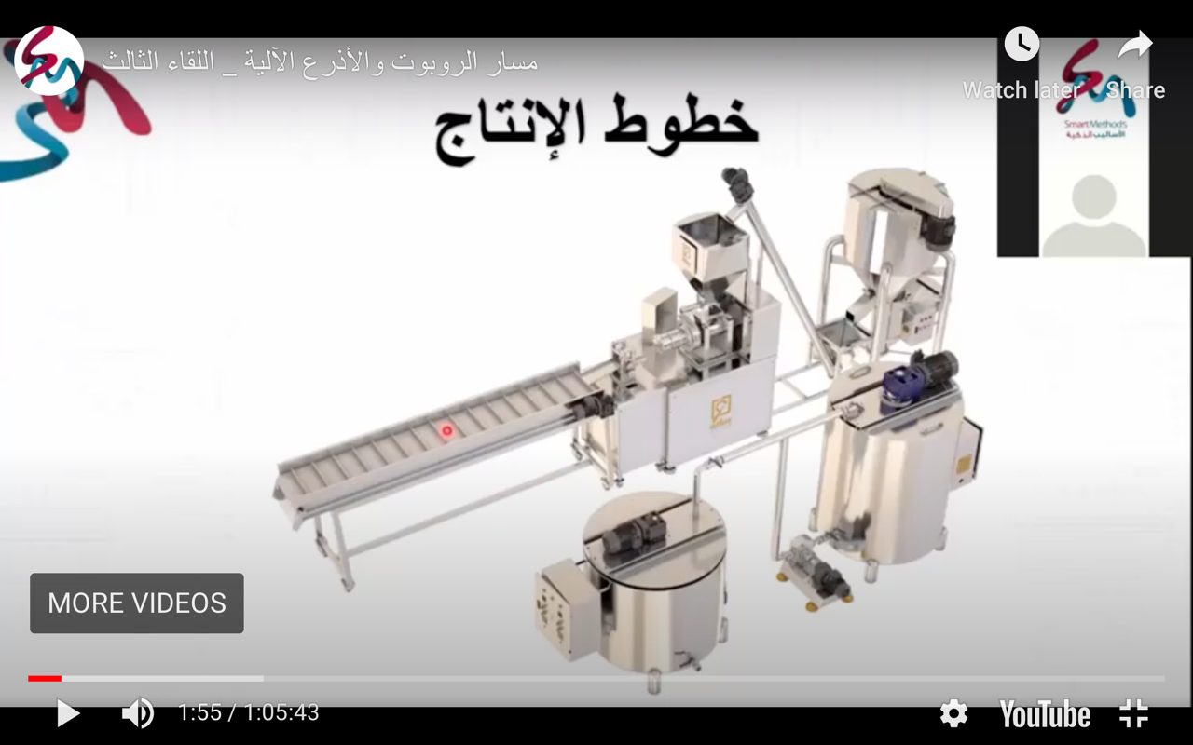

Ultrasonic Sensor

* **Controller:**

For easiness, **Arduino** will be used. It should be programmed to control the sensor in which, for example, distances will be specified in the code. Using if statement will help separating the boxes to the desired location or box.

* **Motors:**

**Servo motor** is considered to be the best in this process as the parts that move the boxes should be moved into specific ranges or angles.

* + One servo motor can fulfil this:
    - This will help reducing number of components and cost.
    - All 3 sizes of boxes can be controlled using if statement in the code later depending on the found distance value.
* **Design circuit:**

The circuit below was created using TinkerCad online simulation. A mini board was added to represent the boxes that coming from the other part of the moving device. A specific point should be marked to calculate the distance from the sensor to the box.

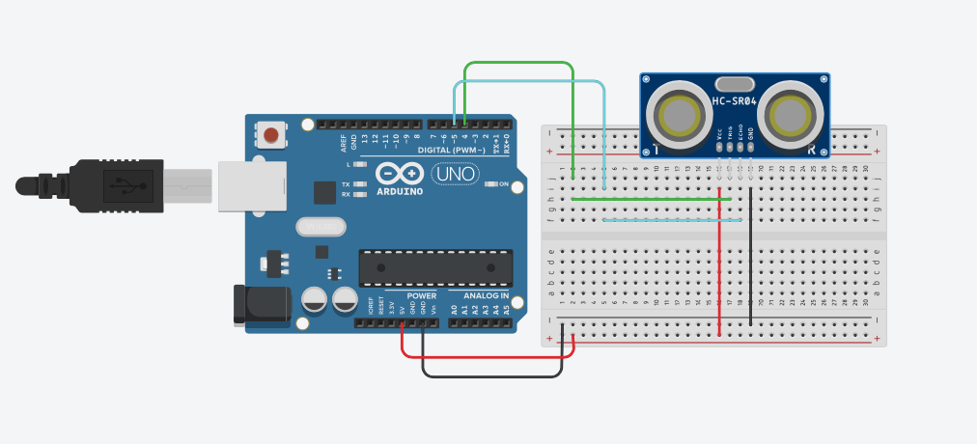

* **Write code:**

**Part1: Calculating the distances:**

int triggerPin = 4; //triggering on pin 7

int echoPin = 5; //echo on pin 8

void setup() {

Serial.begin(9600);

pinMode(triggerPin, OUTPUT); //defining pins

pinMode(echoPin, INPUT);

}

void loop() {

//triggering the wave(like blinking an LED)

digitalWrite(triggerPin, HIGH);

delay(10);

digitalWrite(triggerPin, LOW);

//a special function for listening and waiting for the wave

float duration = pulseIn(echoPin, HIGH);

//transforming the number to cm

float distance = (duration/2) / 29.1;

delay(1000);

Serial.print("The duration for the echo to go back is: ");

Serial.print(duration); //printing the numbers

Serial.println(" / ");

Serial.print("The distance from the sensor to the box is : ");

Serial.print(distance); //printing the numbers

Serial.print("cm"); //and the unit

Serial.println(" "); //just printing to a new line

}

**Part2: Controlling the boxes movement using one servo motor:**

#include <Servo.h>

int triggerPin = 4; //triggering on pin 7

int echoPin = 5; //echo on pin 8

Servo Servo1;

int SM1_pin = 11;

void setup() {

Serial.begin(9600);

pinMode(triggerPin, OUTPUT); //defining pins

pinMode(echoPin, INPUT);

Servo1.attach(SM1_pin);

}

void loop() {

//triggering the wave(like blinking an LED)

digitalWrite(triggerPin, HIGH);

delay(10);

digitalWrite(triggerPin, LOW);

//a special function for listening and waiting for the wave

float duration = pulseIn(echoPin, HIGH);

//transforming the number to cm

float distance = (duration/2) / 29.1;

delay(1000);

Serial.print("The duration for the echo to go back is: ");

Serial.print(duration); //printing the numbers

Serial.println(" / ");

Serial.print("The distance from the sensor to the box is : ");

Serial.print(distance); //printing the numbers

Serial.print("cm"); //and the unit

Serial.println(" "); //just printing to a new line

if (distance < 90){//largest box

Servo1.write(0);

delay(15);

}

else if (distance < 110 && distance > 90){//Middle box

Servo1.write(180);

delay(15);

}

else if (distance > 110 && distance > 120 ){//smallest box

Servo1.write(90);

delay(15);

}

}

* **Run the code.**

The black box was put as a reference to indicate the starting point for the process to start recording. Increasing the box size will result the distance to decrease and this can be seen in the results below.

