ThermaTank System Architecture
Drones and Robotics Club, MVP prototype

1. Overview
ThermaTank is a low-cost prototype that detects water leaks in a tank by listening to it. Four microphones capture the sound of a leak from several directions, and a piezo sensor captures the vibration of the tank wall. An ESP32 collects both signals and sends them to a Python analysis stage, which compares them against recorded normal and leak patterns. The result is shown on a dashboard as a suspicion score within seconds.
The system has four layers: sensing, acquisition, analysis, and presentation.
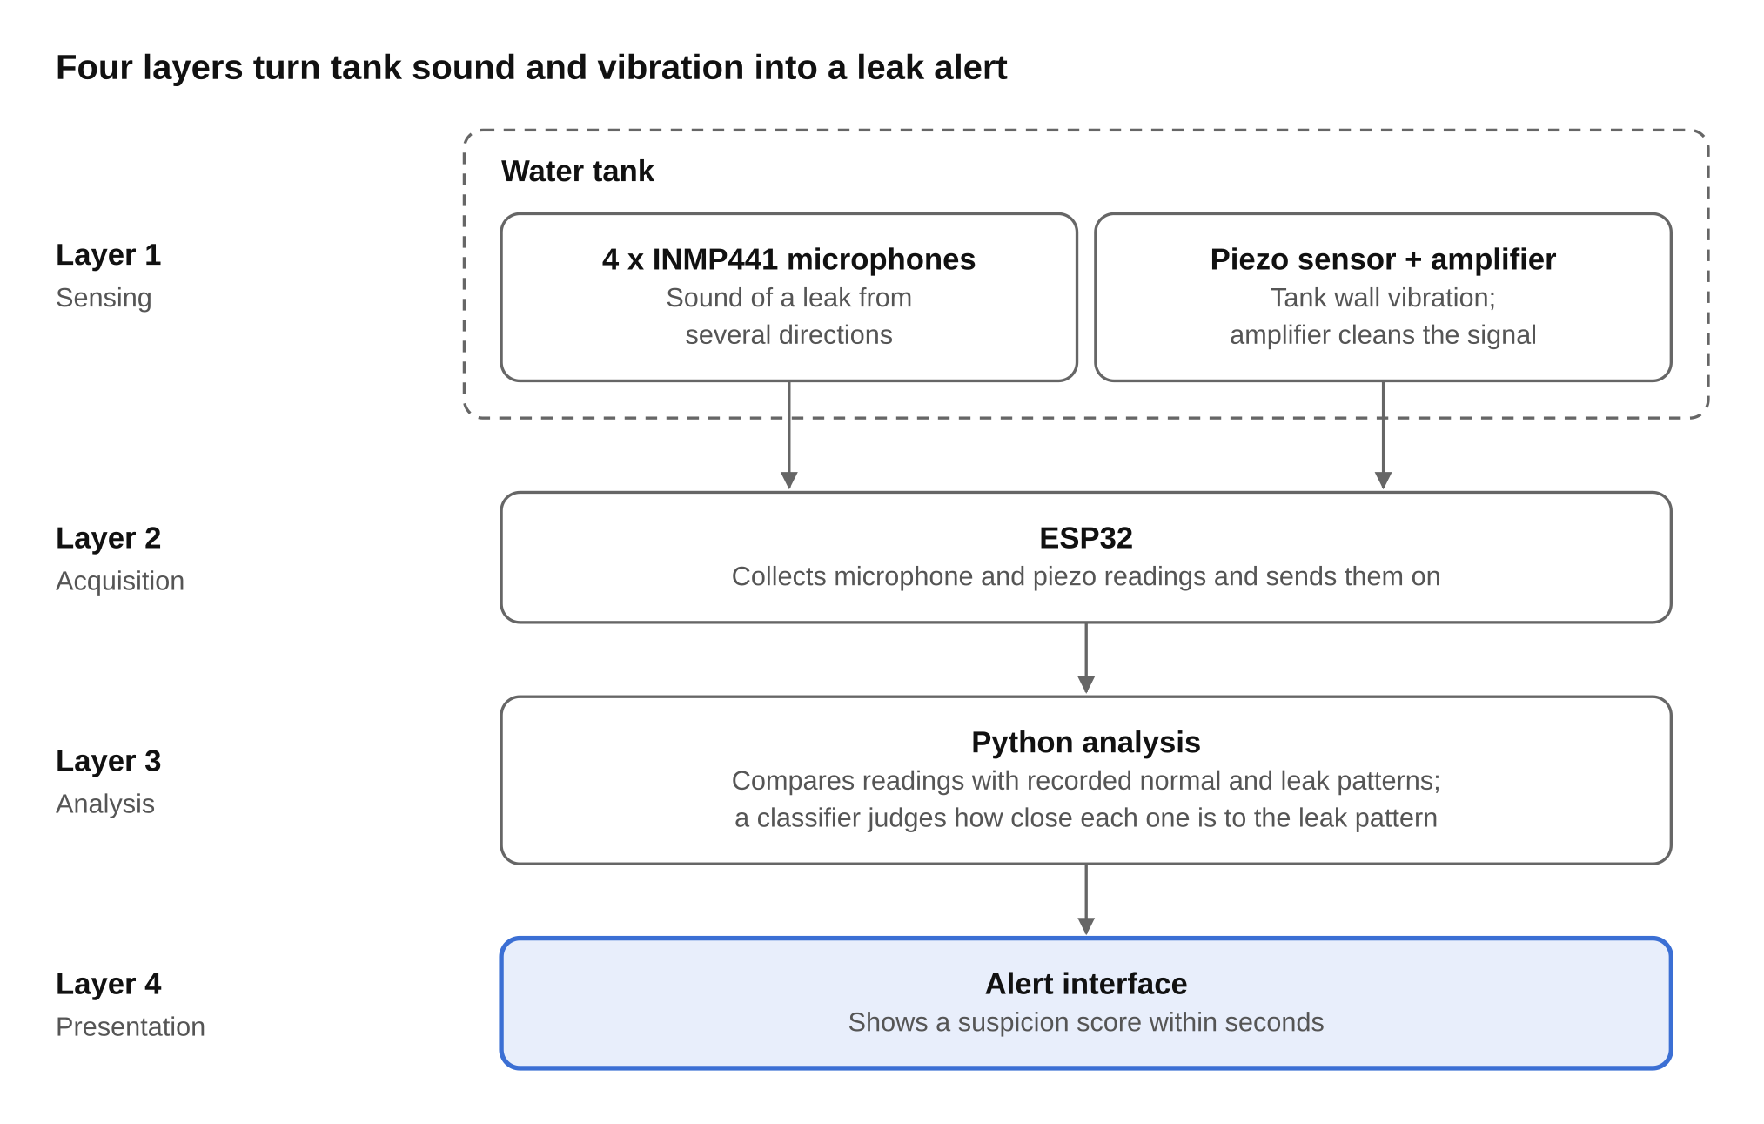
Readings flow one way: from the sensors to the ESP32, then to Python, then to the alert screen.

2. Layer 1: Sensing
This layer turns the physical behavior of the tank into electrical signals.
- 4 x INMP441 microphones are placed around the tank. Using several microphones lets the system capture the sound of a leak from more than one direction.
- Piezo sensor with a simple amplifier is attached to the tank wall. It picks up wall vibration, and the amplifier and filter clean and strengthen the weak signal before it reaches the ESP32.

3. Layer 2: Acquisition
The ESP32 is the single collection point of the system. It reads the four microphone streams and the piezo signal, groups them into readings, and sends them to the analysis stage. Keeping this layer simple means all heavy processing stays off the microcontroller.

4. Layer 3: Analysis
Python receives the readings and compares them against the patterns recorded during testing. The prototype runs a normal-versus-leak experiment on the tank, records both states, cleans the signal, and uses those recordings to build and test a classifier. For new readings, the classifier decides how close the signal is to the leak pattern.

5. Layer 4: Presentation
The alert interface displays the outcome as a suspicion score, within seconds of the signal being captured. This is also the screen used for the final demo.

6. Data Flow Summary
- The tank is tested in a normal state and then with a leak.
- The microphones capture nearby sound and the piezo captures wall vibration.
- The ESP32, with a simple amplifier, converts and collects the data.
- Python compares the patterns.
- The alert shows the suspicion score.

7. Success Criterion
The prototype is successful when the system repeatedly distinguishes the normal state from a leak on new recordings and displays the result within seconds.

8. Prototype Scope
The estimated hardware cost is about 400 SAR, covering the ESP32, four INMP441 microphones, the piezo sensor, the amplifier and filter, wiring and breadboard, and power, enclosure and mounting. The implementation plan runs 8 weeks: hardware setup (weeks 1-2), recording and signal cleaning (3-4), classifier building and testing (5-6), and interface, validation and demo (7-8).

