 | BUSINESS MODEL CANVAS · BADIRA  A self-adaptive framework for predicting the risk of pregnancy complications · Dana Al Mounayer & Jwdee Alimam · Effat University · StartSmart Challenge
 7 KEY PARTNERS  ▪ Hospitals: International Medical Center, Dr. Soliman Fakeeh Hospital and United Doctors Hospital — pilot sites and validation data.  ▪ Effat University — supervision, research infrastructure and lab access.  ▪ Ministry of Health and the Vision 2030 digital-health programmes — reach and integration.  ▪ Data holders: the NICHD DASH repository and the RAHMA study team.  ▪ SFDA — the regulatory pathway. StartSmart Universities Challenge — funding, mentorship and visibility.  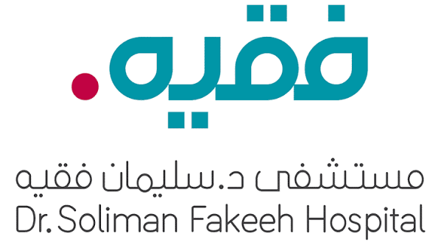 |  5 KEY ACTIVITIES  ▪ Build and maintain the self-adaptive framework: Woman Schema, Data Profiler, model-selection policy.  ▪ Obtain and govern clinical data — data use agreements, ethics approval, secure handling.  ▪ Clinical validation with partner hospitals, reporting detection rates together with their false-positive rates.  ▪ Regulatory work: the SFDA Software as a Medical Device pathway, and PDPL compliance.  ▪ Bilingual product design, clinic onboarding and training. |  1 VALUE PROPOSITIONS  ▪ Know your risk early, in your own language. BADIRA returns three signals together and never a bare number.  ▪ Honest about uncertainty. When the data is not enough, BADIRA says so and asks for more instead of guessing.  ▪ A bridge to the doctor, not a replacement. It produces a summary the woman can share at her next visit.  ▪ For clinics: a triage layer that flags high-risk pregnancies inside the 11–14 week window, while prevention still works.  ▪ What no competitor has: BADIRA adapts to the data. It profiles the dataset first and then chooses the model — so it works on Saudi data, not only on data borrowed from abroad.  EVERY RESULT CARRIES THREE THINGS TOGETHER  Risk — how high it is  Reliability — how sure we are  Time — by when it matters  “Know early. Act in time.” |  4 CUSTOMER RELATIONSHIPS  ▪ Get: free for the woman and introduced by her own clinic — no cost barrier at the moment she needs it.  ▪ Keep: a companion for the whole pregnancy, not a one-off test. The risk is recalculated as new information arrives.  ▪ Grow: the summary she brings to her doctor turns every user into a route into a new clinic.  ▪ Trust is the retention strategy: every prediction carries a confidence score, and BADIRA never claims a diagnosis. |  2 CUSTOMER SEGMENTS  ▪ User: pregnant women in Saudi Arabia and the Arab world — first pregnancy, known risk factors, or far from specialist care.  ▪ Paying customer: private clinics, maternity hospitals and antenatal units.  ▪ Institutional: health insurers, and Ministry of Health digital-health programmes under Vision 2030.  ▪ A multi-sided market: the woman uses BADIRA, the clinic pays for it, the insurer benefits from it.  ▪ Entry focus: private maternity clinics in Jeddah and Riyadh first, then Ministry of Health primary-care centres.
 |  6 KEY RESOURCES  ▪ Data — the hardest asset to obtain and the real moat: the NICHD DASH cohorts (HRA, LRA, nuMoM2b) and Saudi data (RAHMA).  ▪ The framework itself: the Woman Schema and the Data Profiler are the intellectual property.  ▪ People: the founding team, Dr. Naila Marir (academic supervisor) and Dr. Rania (clinical collaborator).  ▪ Secure cloud infrastructure that complies with the Personal Data Protection Law.  ▪ An Arabic-first health brand that women trust. |  |  3 CHANNELS  ▪ App Store and Google Play — bilingual Arabic/English from day one.  ▪ Referral at the clinic: the doctor introduces BADIRA at the first antenatal visit.  ▪ Integration with Ministry of Health platforms (Sehhaty) and hospital records.  ▪ Awareness campaigns with health influencers — necessary, because only about 27% of Saudi women know what preeclampsia is.
 9 COST STRUCTURE  ▪ AI development and maintenance — the largest ongoing cost.  ▪ Data acquisition, secure hosting, and privacy and security compliance.  ▪ Clinical advisory team and validation studies.  ▪ SFDA regulatory submission and certification.  ▪ Marketing, clinic partnerships and onboarding.  ▪ Through Senior Project I these are carried by the university; they become real costs at commercialisation. |  |  8 REVENUE STREAMS  ▪ Clinic subscription (primary): an annual licence per clinic, or a per-patient screening fee.  ▪ Insurer partnerships, paid against prevented severe cases — one preeclampsia admission costs far more than screening a whole clinic.  ▪ Freemium for women: the core risk signal free; the full pregnancy timeline and doctor-ready reports paid.  ▪ Grants: Ministry of Health digital-health funding, and research and innovation grants.  ▪ Free during the pilot. Revenue begins only after clinical validation — we do not sell an unvalidated prediction.
Filled in the canvas order: 1 Value Propositions → 2 Customer Segments → 3 Channels → 4 Customer Relationships → 5 Key Activities → 6 Key Resources → 7 Key Partners → 8 Revenue Streams → 9 Cost Structure

