SENIOR PROJECT I · PROJECT PROPOSAL
BADIRA | بادرة
Profile-Guided Trustworthy Survival Intelligence for Women’s Health
A self-adaptive framework for predicting the risk of pregnancy complications

Students | Dana Al Mounayer · Jwdee Alimam
Supervisor | Dr. Naila Marir — College of Engineering, Effat University
Clinical collaborator | Dr. Rania
Programme | Senior Project I. The project is also entered in the StartSmart Universities Challenge, where it has qualified for the final round.
Clinical tasks | Preeclampsia (first), then preterm birth, then gestational diabetes
Date | 24 September 2026

1. Executive Summary
BADIRA is a self-adaptive framework for predicting the risk of pregnancy complications. Its central claim is not that it predicts one condition well, but that it can determine, from the measured characteristics of whatever data is available, which model and configuration that data actually supports — and then say how far the resulting prediction should be trusted.
The framework proceeds in a defined sequence. A standardized Woman Schema organizes what is known about each woman. Data is collected against that schema. A Data Profiler then measures the training data along six dimensions — imbalance, missingness mechanism, distribution shift, temporal structure, scale, and sensitivity to perturbation. BADIRA combines the schema and the profile to select the model and prediction settings. The selected model predicts risk over time and returns three outputs together: the risk, a confidence score, and an explanation of why the prediction should be trusted.
The framework will be tested first on preeclampsia, then extended to preterm birth and gestational diabetes. Testing across three different clinical tasks is not scope expansion — it is the evaluation of whether the framework is genuinely adaptive.
This proposal sets out the problem the framework addresses, its architecture, the clinical grounding for the first task, the data strategy, the work plan, and the criteria by which the project should be judged.

2. Project Background

2.1 The prediction problem in pregnancy
Pregnancy complications such as preeclampsia, preterm birth and gestational diabetes share a structure that makes them difficult to model. Each is relatively rare, producing severe class imbalance. Each is recorded across pregnancy rather than at a single moment, so the data has a temporal structure that a static model discards. Each is defined by clinical criteria that have changed over time and differ between guidelines, so the outcome label itself is not a fixed quantity. And each is recorded in datasets collected from different populations, under different protocols, with different patterns of missing information.
A prediction model built without accounting for these properties will report a figure that does not survive contact with a different dataset. This is a widely observed failure in clinical machine learning, and it is the problem BADIRA is designed to address.

2.2 The research gap
Conventional practice fixes a model architecture and then hopes the available data suits it. When it does not — when the positive class is too rare, when missingness is not random, when the training population differs from the deployment population — the consequences appear as degraded performance that is difficult to attribute and easy to overlook.
BADIRA inverts that order. The data is profiled first, and the measured characteristics of the data determine which model and which settings are selected. This is the sense in which the framework is self-adaptive, and it is the reason a single framework can serve three different clinical prediction tasks.
The framework treats data quality not as a preprocessing step to be completed and forgotten, but as a first-class input to the modelling decision — and as evidence that can be reported alongside the prediction.

2.3 Why this problem is worth working on
Four figures explain the motivation. Each is stated below with what it actually means.
The number | What it means in practice
16% | 16% of all maternal deaths worldwide are caused by high blood pressure disorders in pregnancy. That was roughly 42,000 women in 2023, making it the second most common cause of maternal death in the world.
4.80% | Under five per cent of pregnancies in Saudi Arabia develop preeclampsia — about one woman in every twenty-one.
27% | Only about a quarter of Saudi women know what preeclampsia is. Put the other way: roughly three in four have never heard of the condition that affects one in twenty-one of them.
> 60% | When preventive treatment is started early, severe (preterm) preeclampsia falls by more than 60%. The treatment is inexpensive and taken by mouth — but it only works if the woman is identified as high-risk early, before about sixteen weeks of pregnancy.
Taken together: the condition is common, it is dangerous, and we already know how to reduce it — but most women have never heard of it, and the prevention only works if she is identified early enough. The missing step is knowing who is at risk, early. That is a prediction problem, and it is the problem this project addresses.

2.4 The clinical pathway for the first task
Preeclampsia is the first clinical task, and its care pathway determines where a prediction can legitimately sit. Two risk decisions are made, both in the first trimester, before any diagnosis is possible.
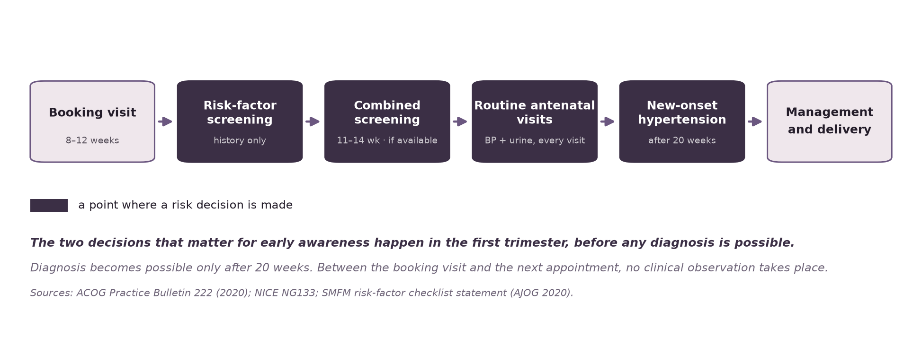
Figure 1. The antenatal care pathway for preeclampsia, with the points at which a risk decision is made.

2.5 Risk and diagnosis are different claims
A prediction made at 11–14 weeks is a statement about probability, not a diagnosis. Preeclampsia cannot be diagnosed before 20 weeks under any guideline. This distinction constrains what the framework may output and how that output may be described.
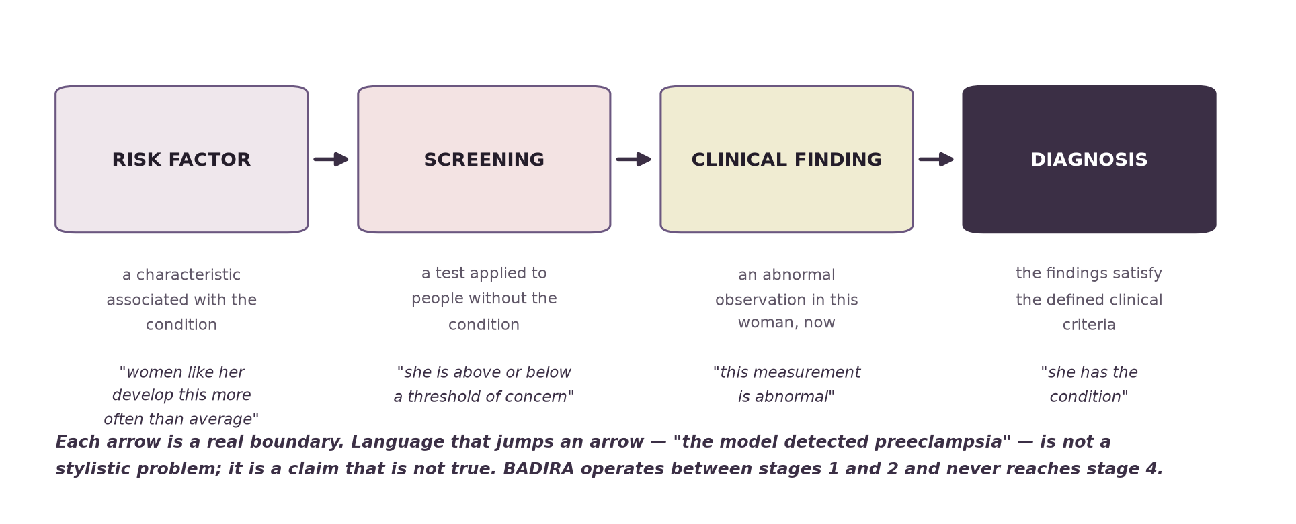
Figure 2. Four distinct stages. BADIRA operates at the screening stage and never reaches diagnosis.

3. The Proposed Framework

3.1 Master definition
BADIRA is a self-adaptive framework for predicting the risk of pregnancy complications. It builds a standardized Woman Schema, profiles the available training data, uses both to select a suitable model and prediction settings, and returns a risk prediction over time together with a confidence score and an explanation of why the prediction is trustworthy.

3.2 Architecture and pipeline
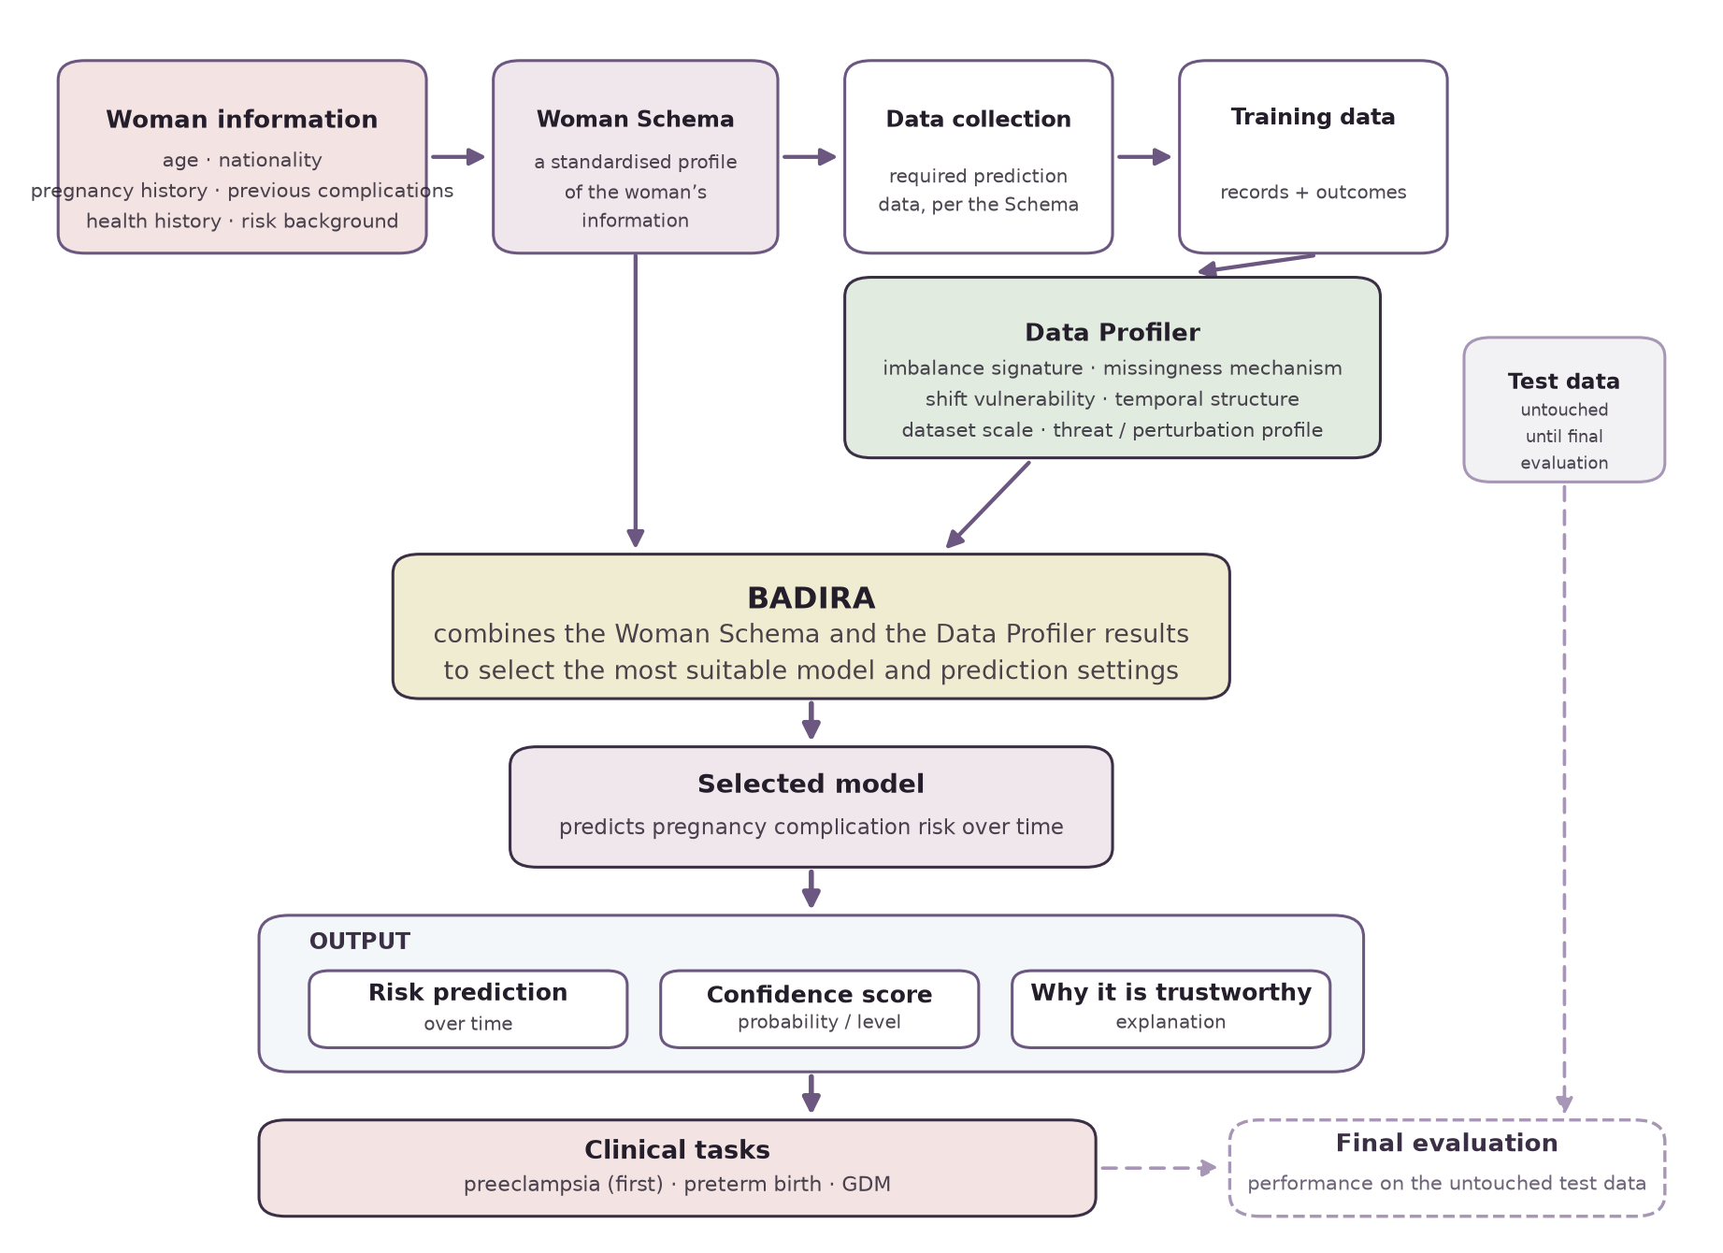
Figure 3. The BADIRA pipeline, from available information to final evaluation on untouched test data.

3.3 Self-adaptation
The framework’s adaptive behavior is a closed loop rather than a single decision. A new dataset, or a new clinical task, re-enters the loop at the profiling stage and may produce a different model selection.
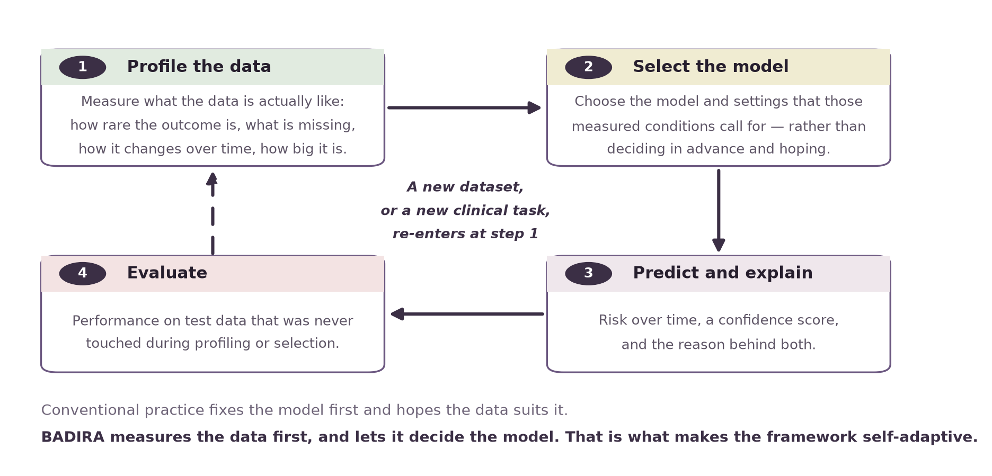
Figure 4. The self-adaptation loop. Measured data characteristics drive model selection.

3.4 The Woman Schema
The Woman Schema standardizes what is known about each woman, across six profiling dimensions, before any model is chosen. The six dimensions are basic information, pregnancy history, previous complications, health history, the current pregnancy and risk background. The schema defines both what the framework requires of a dataset and what it can accept when a field is unavailable; every clinical field corresponds to a factor in published risk criteria.

3.5 The Data Profiler
The Data Profiler is the component that makes the framework adaptive. It measures the training data along six dimensions, and its output is the evidence on which model selection rests.
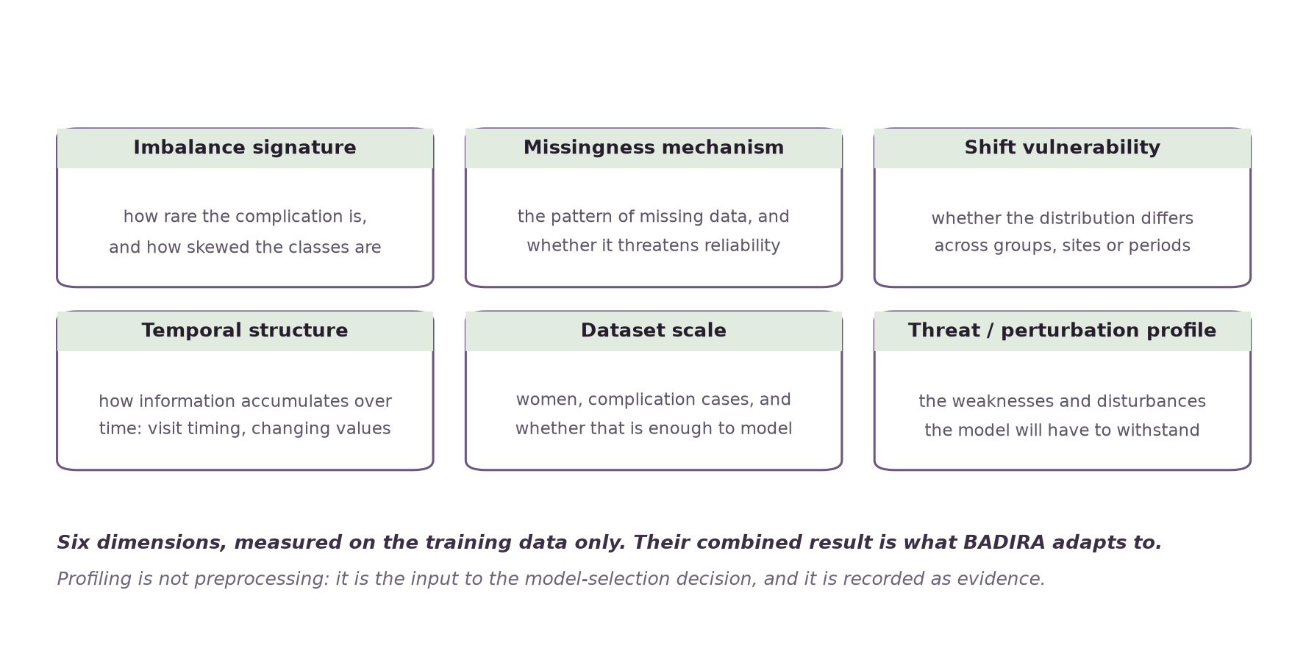
Figure 5. The Data Profiler: six dimensions measured on the training data.
Dimension | Why it changes the modelling decision
Imbalance signature | Determines whether resampling, cost-sensitive learning or threshold adjustment is required, and makes accuracy an inappropriate evaluation metric.
Missingness mechanism | Distinguishes data missing at random from data missing for a reason. The second case can bias a model in ways imputation will not correct.
Shift vulnerability | Predicts how far performance will transfer to a different population, site or period — the central question for a model trained abroad and deployed locally.
Temporal structure | Determines whether a time-to-event model is appropriate and what the prediction horizon can be. Information that accumulates across visits cannot be modelled as a single snapshot.
Dataset scale | The number of complication cases, not the number of women, sets the ceiling on model complexity.
Threat / perturbation profile | Identifies which inputs the prediction is most sensitive to, and therefore where measurement error or adversarial variation would do most damage.

3.6 Outputs
The framework returns three things together. Reporting a risk without a confidence score and an explanation would be a weaker output than reporting nothing, because it invites a confidence the model has not earned.
Output | What it is
Risk prediction over time | A trajectory rather than a single figure. Because information accumulates across pregnancy and the outcome has a timing as well as an occurrence, the prediction is framed as time to event.
Confidence score | A statement of how far the prediction should be trusted, derived from the data profile and the model’s own calibration.
Explanation | The basis for the prediction, expressed so that a clinician can interrogate it and a non-specialist can follow it.

3.7 The data separation rule
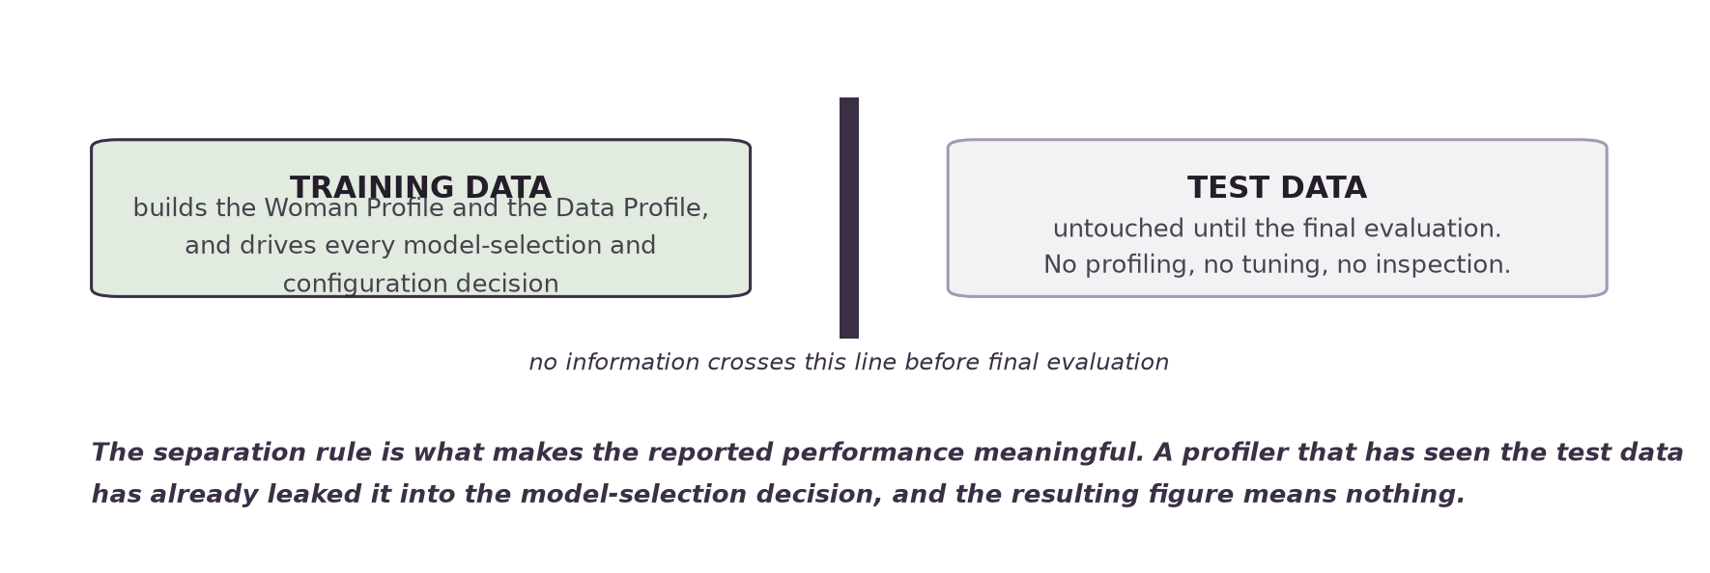
Figure 6. Training data builds the profiles and drives every configuration decision. Test data is untouched.
This rule is what makes the reported performance meaningful. Because BADIRA uses the data profile to select the model, any contact with the test data would leak into the model-selection decision itself.

4. Goals and Objectives

4.1 Main goal
To build a self-adaptive prediction framework that can understand the quality of the available data, select a suitable prediction model, predict pregnancy complication risk over time, provide a confidence score, explain why the prediction is trustworthy, and work across different pregnancy complications.

4.2 Objectives
# | Objective | Success indicator
O1 | Define the Woman Schema and validate it against published clinical risk criteria | Schema reviewed by the clinical collaborator and mapped to the SMFM risk-factor checklist
O2 | Implement the Data Profiler across all six dimensions | Profiler produces a reproducible profile report for any candidate dataset
O3 | Define and implement the model-selection policy that maps a data profile to a model and configuration | Selection decisions are reproducible and justified by the profile, not chosen by hand
O4 | Obtain a dataset with sufficient schema coverage and complication case count | Executed data use agreement and data in hand
O5 | Produce risk-over-time predictions with a confidence score and an explanation | All three outputs generated together for the preeclampsia task
O6 | Evaluate on untouched test data and report performance honestly | Detection rate reported with its false-positive rate and the population trained on
O7 | Demonstrate adaptability by repeating the process for preterm birth and GDM | The framework runs end to end on all three tasks without redesign

5. The Three Clinical Tasks
The same framework is applied to all three complications. What changes is the data and the prediction target.
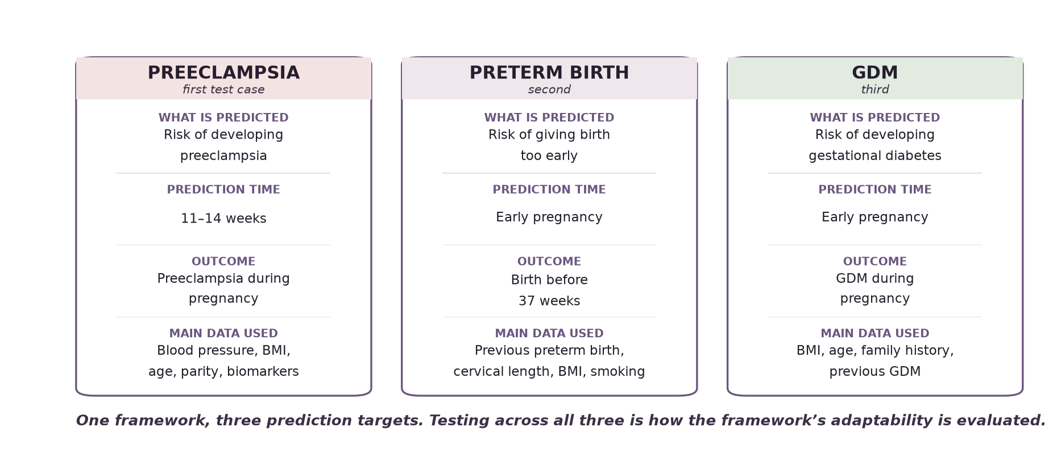
Figure 7. The three clinical tasks. Preeclampsia is the first test case.

6. Project Deliverables
Deliverable | Description
Woman Schema specification | The standardised profile structure, with every field traced to a published clinical risk criterion.
Data Profiler | An implemented component producing a reproducible six-dimension profile of any candidate dataset.
Model-selection policy | The documented mapping from data profile to model family and configuration.
Prediction module | A time-to-event model producing risk over time, a confidence score and an explanation.
Evaluation report | Performance on untouched test data for each clinical task, with limitations stated.
Working prototype | A bilingual Arabic/English mobile-first interface demonstrating how the framework’s outputs are presented to a non-specialist user.
A working bilingual prototype has already been built and is publicly deployed. It demonstrates the three product stages and the presentation of the framework’s outputs, with the risk reading currently shown as a clearly labelled simulation because no model is yet connected. The prototype is a demonstration of the interface, not of the framework; the framework is the subject of this proposal.

7. Methodology

7.1 Data acquisition
Candidate datasets are assessed on two criteria that pull in opposite directions: how much of the Woman Schema each can fill, and how many actual complication cases it contains. Row count is not sample size.
Dataset | Women | Cases (est.) | Assessment
MFMU HRA (NICHD) | 2,539 | High — enriched | Randomised trial, four high-risk strata including 606 women with previous preeclampsia. Adjudicated outcome.
MFMU LRA (NICHD) | 3,135 | Moderate | Randomised trial, normotensive nulliparous, enrolled 13–26 weeks. Adjudicated outcome.
nuMoM2b (NICHD) | 10,037 | Several hundred+ | Three antenatal visits plus delivery, so genuine temporal structure. Nulliparous by design, so six schema fields are structurally absent.
RAHMA | 14,568 | ~175 | Saudi, three Riyadh hospital types. Best population match; 1.2% preeclampsia. Access measured in years.
Mutaba'ah (UAE) | 13,000+ | Unknown | Arab population recruited at approximately 12 weeks. Collaboration request required.
The three NICHD datasets are held in one repository and can be requested through a single application and data use agreement. They are also profile-diverse, which is useful in itself: a framework that claims to adapt to data conditions should be demonstrated on datasets whose conditions actually differ.

8. Project Timeline
Phase | Activity | Output | Status
Phase 1 | Clinical grounding, schema definition, dataset scouting | Clinical task specification; Woman Schema; ranked dataset shortlist | In progress
Phase 2 | Data access; Data Profiler implementation | Executed data use agreement; profiler producing reproducible profile reports | Next
Phase 3 | Model-selection policy and prediction module | Selection policy; time-to-event model; confidence and explanation outputs | Planned
Phase 4 | Evaluation and extension to further tasks | Evaluation report for preeclampsia; pipeline repeated for preterm birth and GDM | Planned

9. Feasibility Assessment
BADIRA is a Senior Project I research framework, not a product being taken to market. Feasibility is therefore assessed against what a two-student team, supervised at Effat University, can build, run and defend within one academic year. Each dimension below carries a verdict and the evidence behind it.
Dimension | Verdict | Assessment
Technical | Feasible | Every component is standard supervised learning and survival analysis in Python. The model-selection policy is a set of rules over measured profile values, not a learned meta-model, so it can be inspected and reproduced. The models are tabular and train on a laptop; no specialised hardware is required. The output layer is already proven by a working bilingual prototype.
Economic | Feasible | No external funding is needed. The datasets pursued are free for academic research, the software stack is open source, and prototype hosting is on a free tier. The cost is student time, which the Senior Project I credit already allocates.
Legal and ethical | Feasible for research use | The datasets are de-identified at source and are released under a data use agreement and university ethics clearance rather than purchase. BADIRA reports risk, not diagnosis, and is not being deployed as a medical device. Any future clinical deployment in Saudi Arabia would fall under SFDA rules for Software as a Medical Device and under the Personal Data Protection Law; both are recorded here as conditions on deployment, which is outside the scope of this project.
Operational | Feasible | Two students, an academic supervisor (Dr. Naila Marir) and a clinical collaborator (Dr. Rania) cover the technical and clinical review the framework needs. Clinical definitions are taken from published guidelines and checked by the collaborator, so no clinical judgement rests on the students alone.
Schedule | Feasible, but tight | The four phases in section 8 fit the academic year. The critical path is data access: the data use agreement is the only step whose timing is not under the team’s control. Three applications are therefore run in parallel, and the Data Profiler and selection policy are developed on public data while they are pending.

9.1 Resources and cost
Resource | Source | Cost
Datasets | NICHD DASH repository and RAHMA, under academic data use agreements | None
Software | Python, scikit-learn, lifelines, React — all open source | None
Compute | Student machines; university lab if a larger run is needed | None
Prototype hosting | Free deployment tier | None
Supervision and clinical review | Effat University and the clinical collaborator | In kind
Student effort | Two students across two semesters | In kind
The project requires no purchase and no external funding. This is what makes the schedule risk, rather than the budget, the dimension worth watching.

9.2 Overall verdict
The project is feasible as scoped. No dimension returns a blocking result. The one real risk is schedule, and only through data access; the mitigations are set out in section 11. The recommendation is to proceed.

10. Success Criteria
# | Criterion | How it is measured
1 | The Data Profiler produces a reproducible profile, and the model selected is demonstrably a consequence of that profile | Selection decisions reproduce from the recorded profile without human intervention
2 | The framework runs end to end on a second and third clinical task without redesign | Preterm birth and GDM pipelines completed
3 | Every prediction is accompanied by a confidence score and an explanation | No output path produces a risk figure alone
4 | Reported performance is paired with its false-positive rate and the population trained on | The evaluation report
5 | The test partition is demonstrably untouched until final evaluation | Documented data handling; profiling and selection logs predate any test access
6 | The system never asserts a diagnosis, in either language | Review of all output language against the boundaries in section 2.5
Criterion 2 is the one that decides whether this is a framework or a single model with extra steps. It is the reason three clinical tasks are in scope.

11. Risks and Mitigations
Risk | Likelihood | Mitigation
Data access is not granted within the project timeframe | High | Three independent routes opened in parallel. The Data Profiler and selection policy can be developed and tested on openly available clinical data in the meantime.
Too few complication cases for a stable model | Medium | Case count is assessed before application, not after. Trial cohorts with enriched populations are prioritised, and case count is a profiled dimension in its own right.
Label definitions differ between datasets and eras | High | Label definition is recorded as part of the data profile. Pre-2013 preeclampsia labels required proteinuria and are not equivalent to modern labels.
A model trained on a non-Saudi population transfers poorly | High | Shift vulnerability is an explicit profiling dimension rather than an afterthought. The limitation is reported, not concealed.
The framework works for preeclampsia but does not generalise | Medium | This is a legitimate negative result and will be reported as one. The profiling dimensions were chosen to be task-independent for this reason.
Scope expands beyond the three defined tasks | Low | Scope is fixed at three complications for the duration of Senior Project I.

12. Ethical Considerations
- BADIRA produces a risk prediction, not a diagnosis. Preeclampsia cannot be diagnosed before 20 weeks under any guideline, and the framework predicts at 11–14 weeks. Output language is constrained accordingly.
- A prediction is never presented without a confidence score. Presenting a risk figure alone would invite a confidence the model has not earned, which in this clinical setting is a foreseeable harm.
- Where the framework cannot support a reliable prediction for a given woman or dataset, it must say so. A framework built around honest uncertainty that conceals it in practice would fail its own premise.

13. Conclusion
BADIRA addresses a problem that is both clinical and methodological. Clinically, pregnancy complications are common, consequential and — where risk is identified early enough — partly preventable. Methodologically, the datasets available for predicting them differ so much in imbalance, missingness, temporal structure and population that a model built for one will rarely transfer to another.
The framework’s response is to make data quality an explicit, measured input to the modelling decision rather than an assumption, and to return the resulting uncertainty to the user rather than hiding it behind a single number. Testing across preeclampsia, preterm birth and gestational diabetes is how that claim will be evaluated.
On the evidence in section 9, the project is feasible and the recommendation is to proceed. It is technically and operationally within reach for the team, it requires no external funding, and it raises no legal barrier to research use. The single condition is data access, which is being pursued through three independent routes while the components that do not depend on it are built.

14. References
- [1] Amaral LM, et al. Preeclampsia. In: StatPearls. Treasure Island (FL): StatPearls Publishing; 2024. ncbi.nlm.nih.gov/books/NBK570611
- [2] Mitrogiannis I, et al. Risk factors for preterm birth: an umbrella review of meta-analyses of observational studies. BMC Medicine 2023;21:490. PMC10720103
- [3] Kunarathnam V, Vadakekut ES, Mahdy H. Gestational Diabetes. In: StatPearls. Treasure Island (FL): StatPearls Publishing; 2025. ncbi.nlm.nih.gov/books/NBK545196
- [4] He H, Garcia EA. Learning from imbalanced data. IEEE Transactions on Knowledge and Data Engineering 2009;21(9):1263–1284. doi.org/10.1109/TKDE.2008.239
- [5] Rubin DB. Inference and missing data. Biometrika 1976;63(3):581–592. doi.org/10.1093/biomet/63.3.581
- [6] Little RJA, Rubin DB. Statistical Analysis with Missing Data. 3rd ed. Hoboken (NJ): Wiley; 2019. doi.org/10.1002/9781119482260
- [7] Fine JP, Gray RJ. A proportional hazards model for the subdistribution of a competing risk. Journal of the American Statistical Association 1999;94(446):496–509. doi.org/10.1080/01621459.1999.10474144
- [8] American College of Obstetricians and Gynecologists. Gestational Hypertension and Preeclampsia. Practice Bulletin No. 222. Obstet Gynecol 2020;135(6):e237–e260.
- [9] National Institute for Health and Care Excellence. Hypertension in pregnancy: diagnosis and management. NG133. 2019, updated 2023.
- [10] Brown MA, Magee LA, Kenny LC, et al. Hypertensive Disorders of Pregnancy: ISSHP Classification, Diagnosis, and Management Recommendations. Hypertension 2018;72(1):24–43.
- [11] Combs CA, Montgomery DM. SMFM Special Statement: Checklists for preeclampsia risk-factor screening. AJOG 2020.
- [12] O’Gorman N, Wright D, Poon LC, et al. Multicenter screening for pre-eclampsia by maternal factors and biomarkers at 11–13 weeks’ gestation. Ultrasound Obstet Gynecol 2017.
- [13] Rolnik DL, Wright D, Poon LC, et al. Aspirin versus placebo in pregnancies at high risk for preterm preeclampsia. N Engl J Med 2017;377:613–622.

