

**ENCS3330 QZ1 Name : ID:**

**Problem 1.** Find the output voltage, Vo, for the pFET shown to the right for the following cases.

Assume Vg = 0V and Vtp = -0.6V and Vi = 1.5V

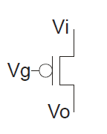Here Vi-Vg = 1.5 > |Vtp|, so Vo = Vi = 1.5V

**Problem 2**

Given the chart below **for NMOS** transistor.

1. Mark VGS in the right order. Given that Vgs= 3v, Vgs =2v, Vgs= 1v. Vgs= 0v
2. Mark the main three regions for the transistors
3. For the line in the middle what is the relation of VDS to VGS, VT ?

