Homework 2 - Exercise 2A: Improving Weak Prompts

A) Weak Prompt: Explain regression
Improved Prompt:
Explain regression in data analysis in simple terms for a beginner. Include:
- A clear definition
- An example using real-world data (like studying and grades)
- The difference between linear and multiple regression
- When regression is useful
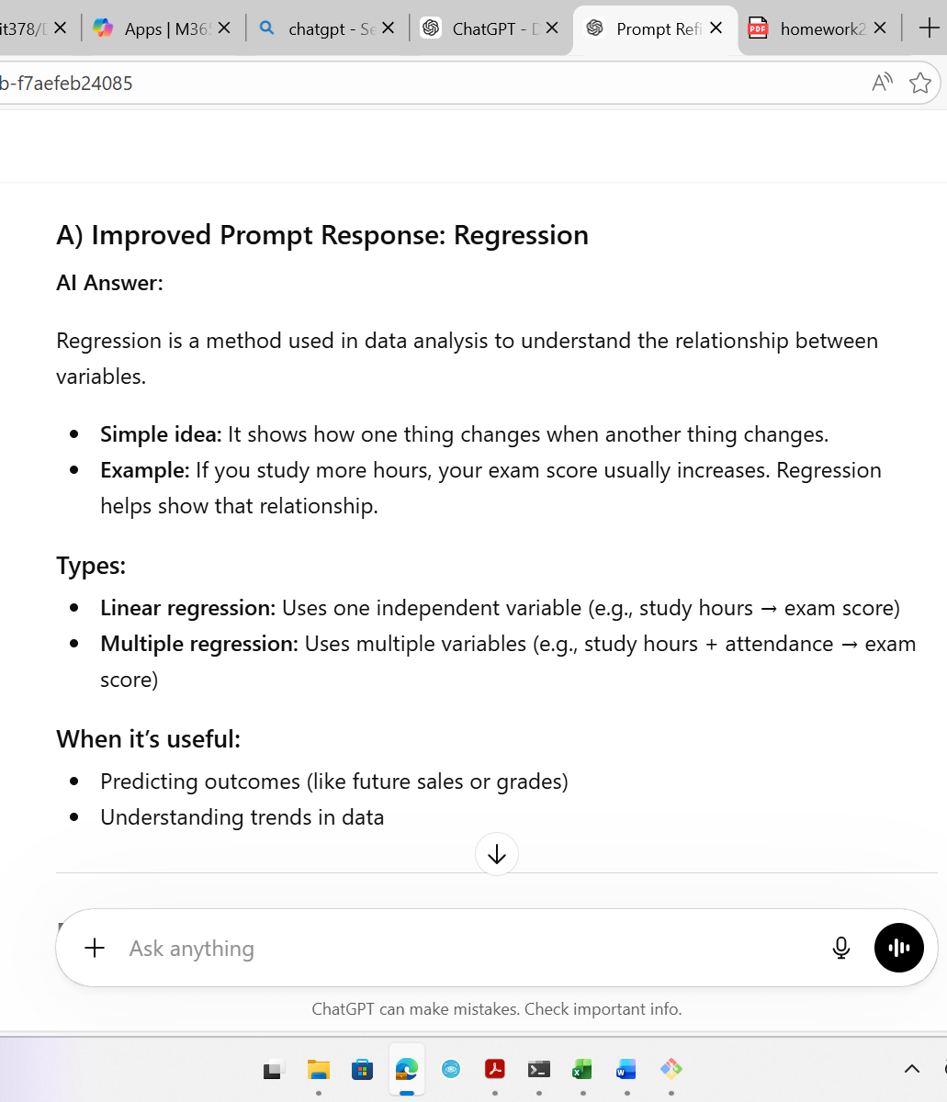
Why this prompt is stronger:
This prompt is more specific because it asks for a beginner-friendly explanation, examples, and key concepts. It guides the AI to give a clearer and more detailed response instead of something vague.

B) Weak Prompt: Help me understand SQL
Improved Prompt:
Teach me the basics of SQL for beginners. Include:
- What SQL is used for
- Basic commands (SELECT, INSERT, UPDATE, DELETE)
- A simple example query
- When SQL is used in real life
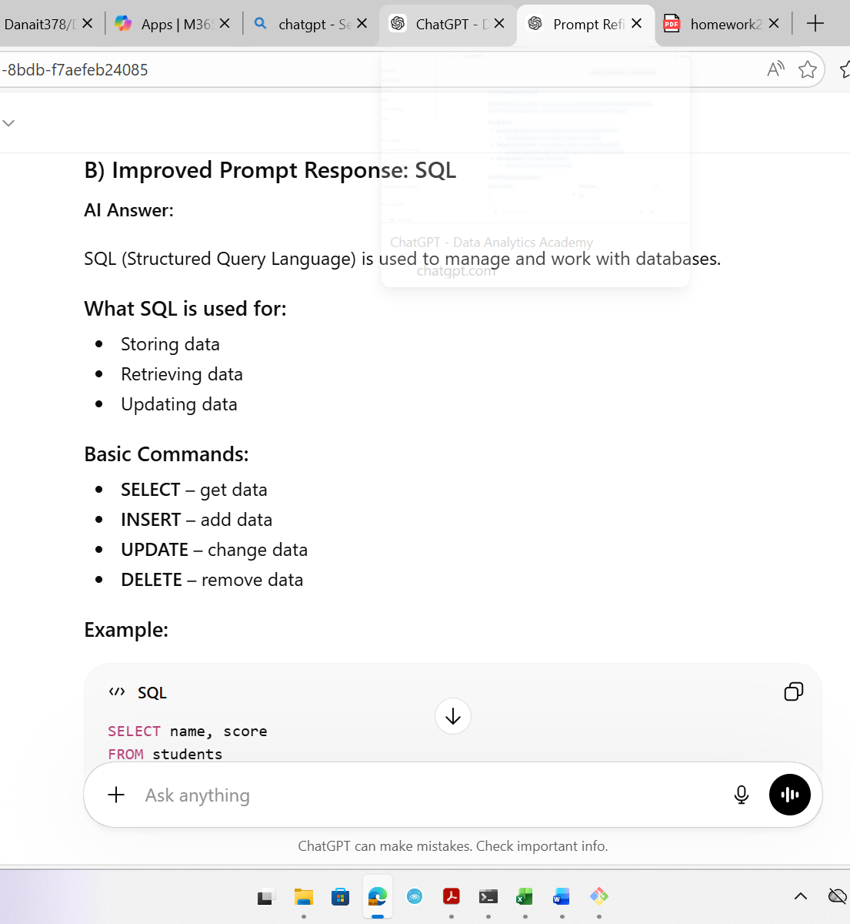
Why this prompt is stronger:
This prompt clearly defines what parts of SQL to focus on and asks for examples. It helps the AI give structured and useful information instead of a general explanation.

C) Weak Prompt: Create a dataset
Improved Prompt:
Create a small sample dataset in table format with 10 rows about student performance. Include columns for Name, Study Hours, Attendance (%), and Exam Score. Make the data realistic.
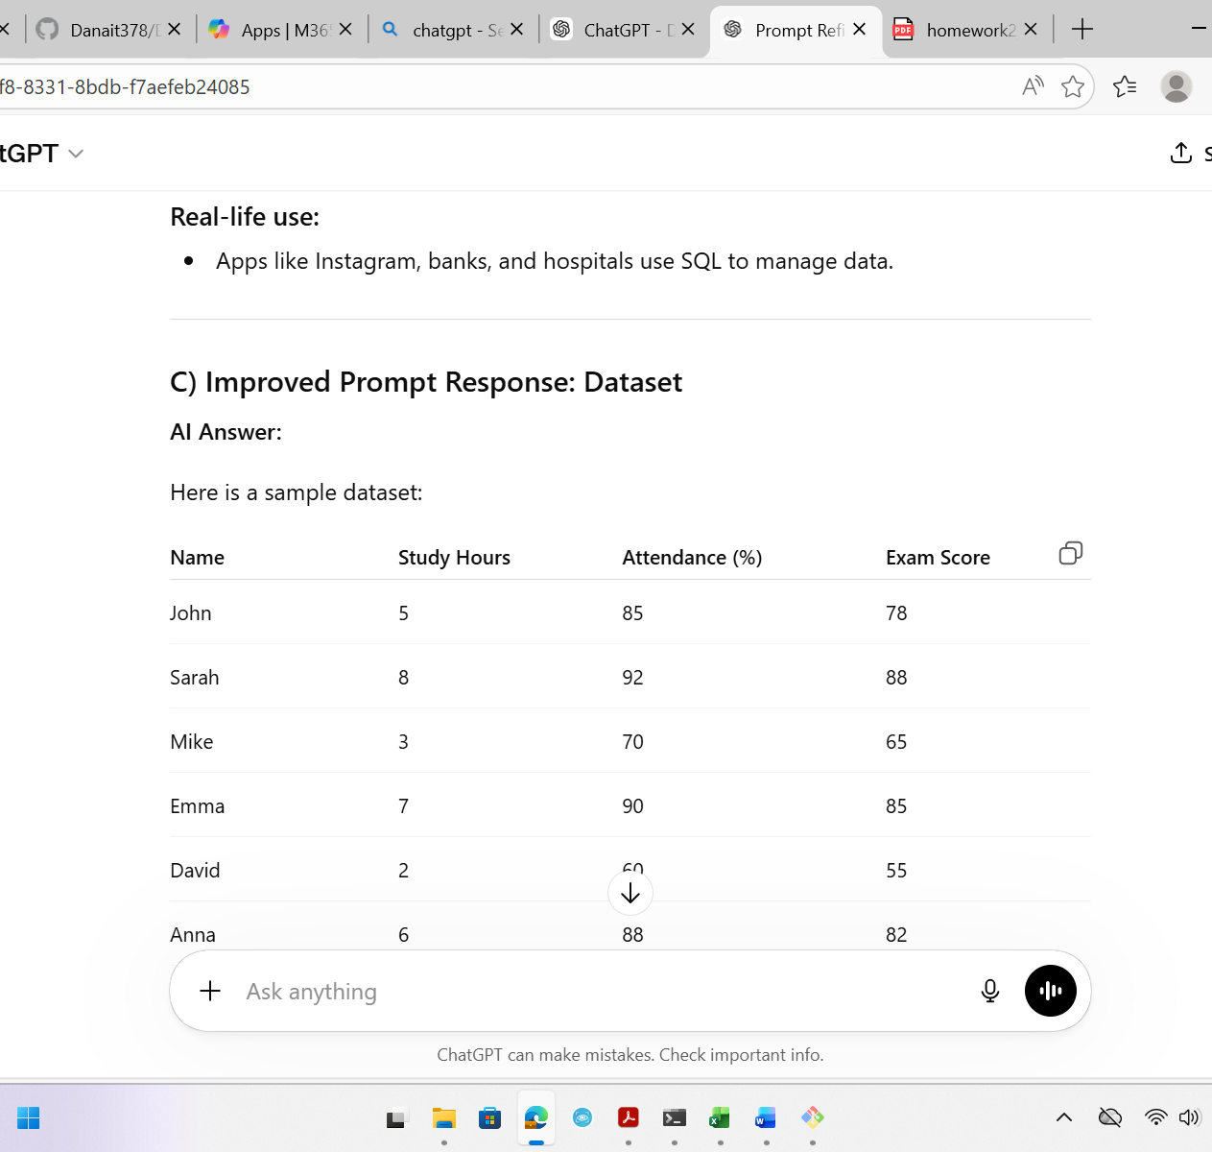
Why this prompt is stronger:
This prompt specifies the size, topic, columns, and format of the dataset. This ensures the AI generates exactly what is needed instead of something unclear or incomplete.

