COMPILER DESIGN LAB – 2
Comment Identification from File and Tokenization.
Name: SreeDananjay S
Registration Number: 21BAI1807
Date: 08-01-2024
Slot: L31+L32
Course Code: BCSE307P
Programme: Bachelor of Technology in Computer Science and Engineering with Specialization in Artificial Intelligence and Machine Learning
School: School of Computer Science and Engineering(SCOPE)

Q1) Write a program to identify single and multi-line comments from a file given as an input to a C program.
Code:
#include <stdio.h>
#include <string.h>
#include <stdlib.h>

FILE* fptr;

int hasSingleLineComment(const char *line) {
return (strstr(line, "//") != NULL);
}

int hasMultiLineCommentStart(const char *line) {
return (strstr(line, "/*") != NULL);
}

int hasMultiLineCommentEnd(const char *line) {
return (strstr(line, "*/") != NULL);
}

void processComment(char *line) {
if (hasSingleLineComment(line)) {
printf("Single line comment: %s", line);
} else if (hasMultiLineCommentStart(line)) {
printf("Multi-line comment start: %s", line);

// Check if the multi-line comment ends on the same line
if (hasMultiLineCommentEnd(line)) {
printf("Multi-line comment end on the same line.\n");
} else {
// Continue reading lines until the multi-line comment ends
do {
if (fgets(line, 1024, fptr) == NULL) {
printf("Error: Multi-line comment does not end within the file.\n");
return; // Break out of the loop if the end of file is reached
}
printf("%s", line);
} while (!hasMultiLineCommentEnd(line));
printf("Multi-line comment end found.\n");
}
}
}

int main(){

fptr = fopen("textFile.txt","r");

char *inputString;
inputString = malloc(1024 * sizeof(char));

while(fgets(inputString,1024,fptr) != NULL){
processComment(inputString);
}

fclose(fptr);

return 0;
}
Input and Output:
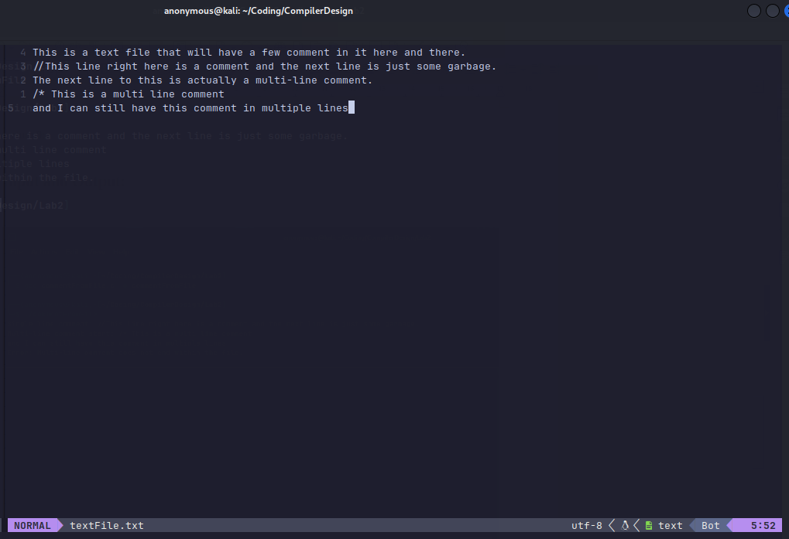
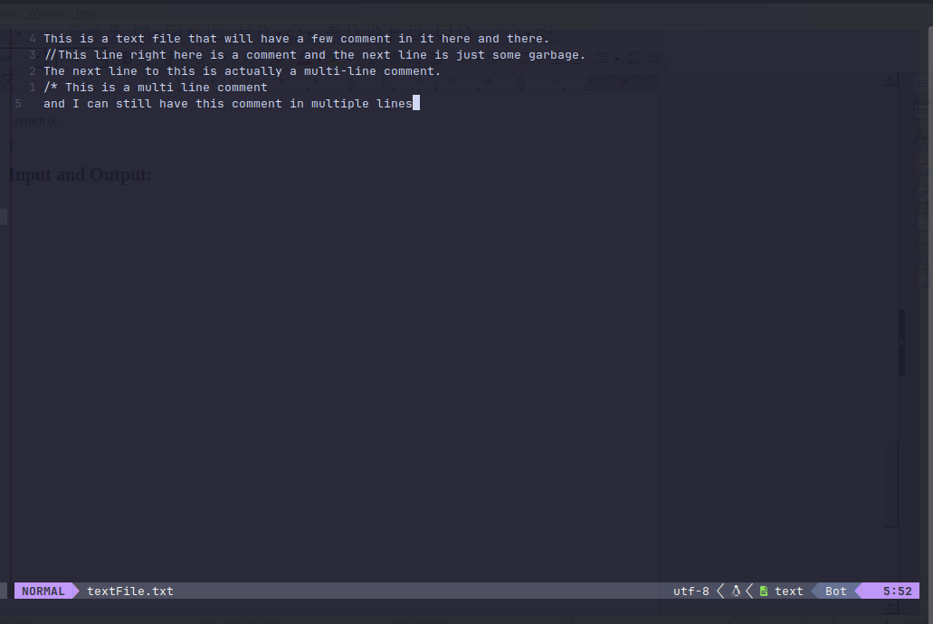
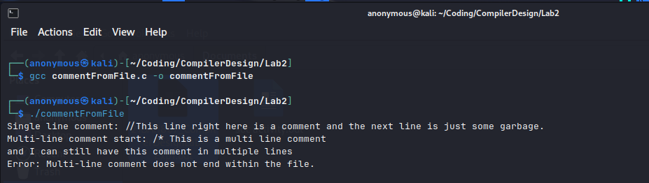
Q2) Write a C program to tokenize a given C program into operators, identifier, keywords and variables.
Code:
#include <stdio.h>
#include <stdlib.h>
#include <string.h>
#include <ctype.h>

#define MAX_LINE_LENGTH 1024

int hasSingleLineComment(const char *line) {
return (strstr(line, "//") != NULL);
}

int hasMultiLineCommentStart(const char *line) {
return (strstr(line, "/*") != NULL);
}

int hasMultiLineCommentEnd(const char *line) {
return (strstr(line, "*/") != NULL);
}

// Function to check if a token is a keyword
int isKeyword(const char *token) {
// Add more keywords as needed
const char *keywords[] = {"int", "char", "if", "else", "while", "for"};
int numKeywords = sizeof(keywords) / sizeof(keywords[0]);

for (int i = 0; i < numKeywords; i++) {
if (strcmp(token, keywords[i]) == 0) {
return 1; // It's a keyword
}
}

return 0; // Not a keyword
}

// Function to check if a token is a valid identifier
int isValidIdentifier(const char *token) {
if (!isalpha(token[0]) && token[0] != '_') {
return 0; // Invalid identifier
}

for (int i = 1; i < strlen(token); i++) {
if (!isalnum(token[i]) && token[i] != '_') {
return 0; // Invalid identifier
}
}

return 1; // Valid identifier
}

// Function to classify and print the category of a token
void classifyToken(char *token) {
if (isKeyword(token)) {
printf("Keyword: %s\n", token);
} else if (isValidIdentifier(token)) {
printf("Identifier: %s\n", token);
} else if (isdigit(token[0])) {
printf("Constant: %s\n", token);
} else if (ispunct(token[0])) {
printf("Operator: %s\n", token);
} else if (token[0] == '#') {
printf("Preprocessor Directive: %s\n", token);
} else {
printf("Invalid: %s\n", token);
}
}

// Function to tokenize a given line
void tokenizeLine(char *line) {
char *token = strtok(line, " \t\n"); // Tokenize based on space, tab, and newline

while (token != NULL) {
classifyToken(token);
token = strtok(NULL, " \t\n");
}
}

int main() {
FILE *fptr;
char line[MAX_LINE_LENGTH];

// Open the C file for reading
fptr = fopen("commentFromFile.c", "r");

if (fptr == NULL) {
printf("Error opening file.\n");
return 1;
}

// Read and tokenize each line in the file
while (fgets(line, MAX_LINE_LENGTH, fptr) != NULL) {
tokenizeLine(line);
}

fclose(fptr);

return 0;
}

Input and Output:
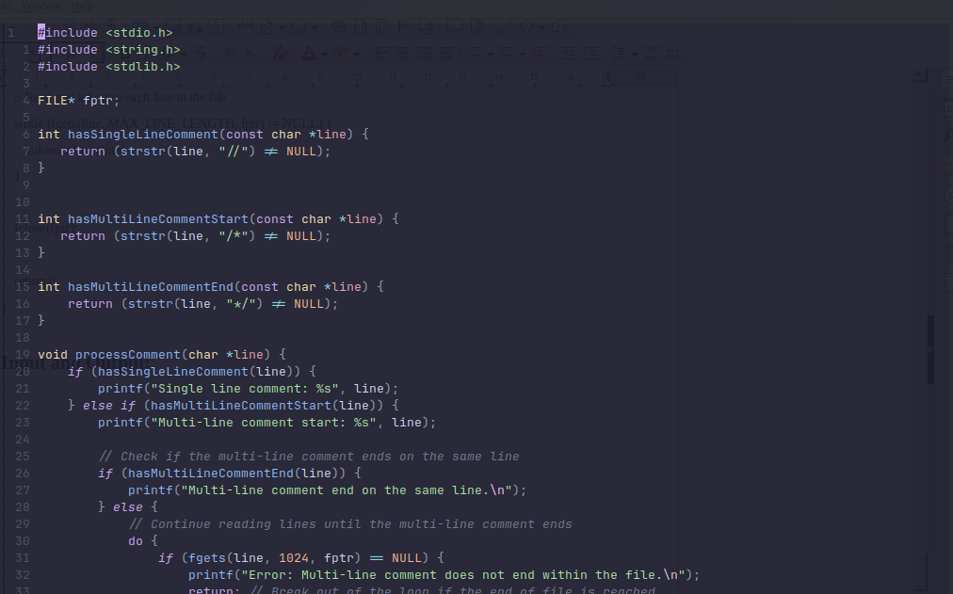
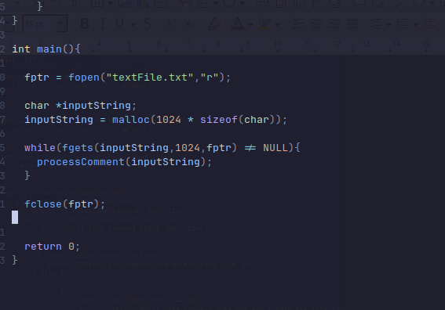
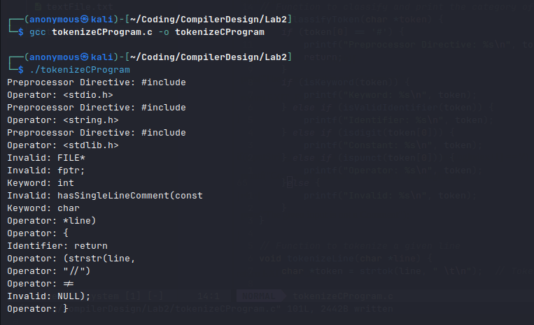

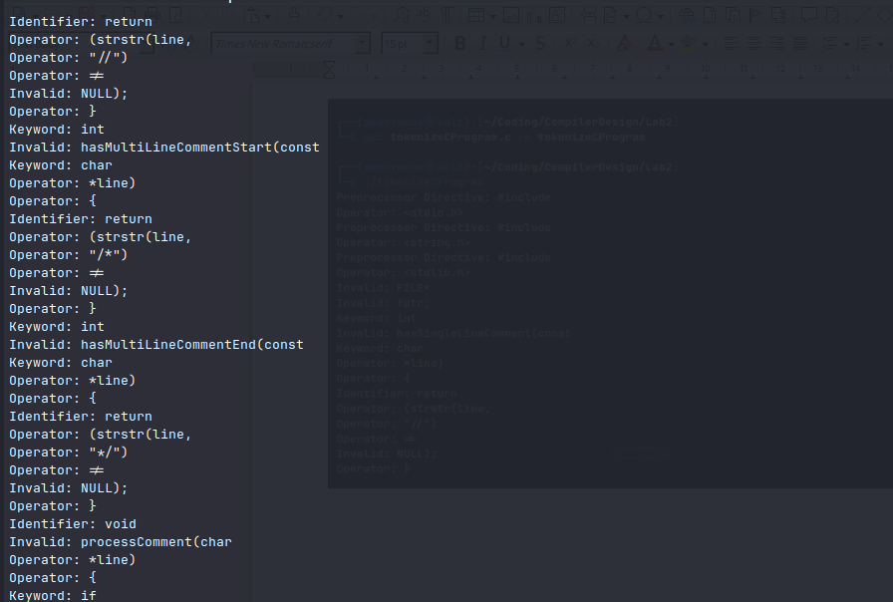

Result:
Thus, programs for the given 2 questions have been written and successfully verified.

