# **Week -1 Hands On Practice**

1. Design Patterns and Principles

**Exercise 1: Implementing the Singleton Pattern**

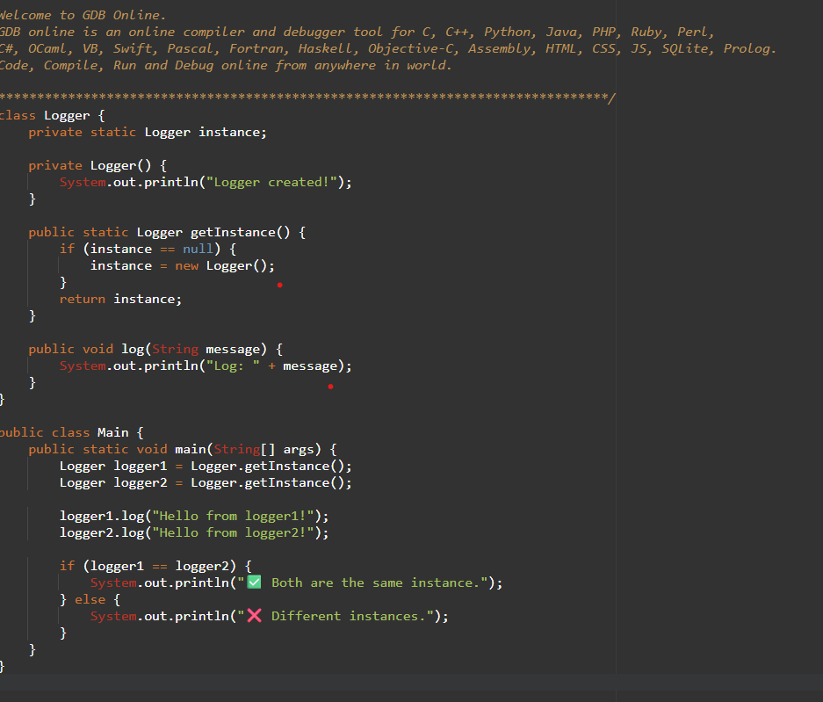

Output

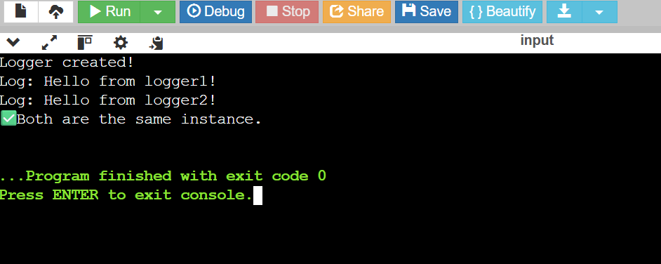

**Exercise 2: Implementing the Factory Method Pattern**

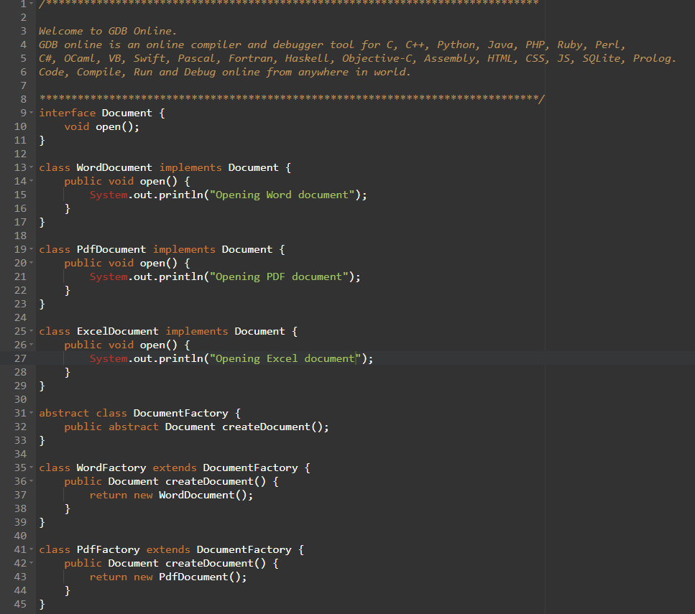

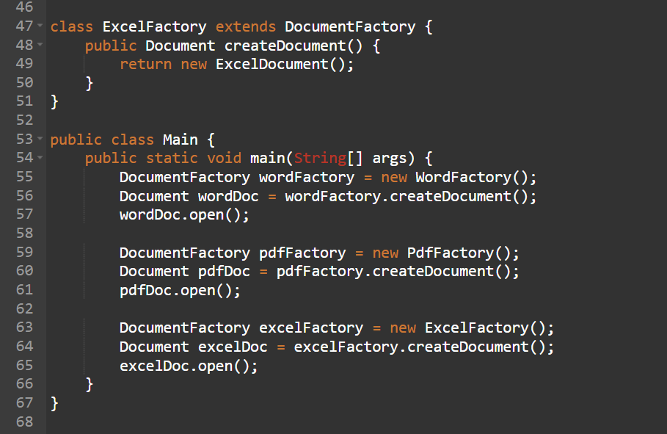

**Output**

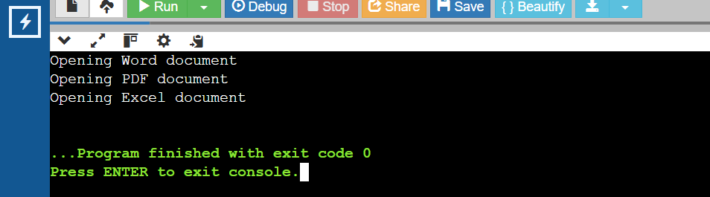

2)Algorithm And Data Structures

**Exercise 2: E-commerce Platform Search Function**

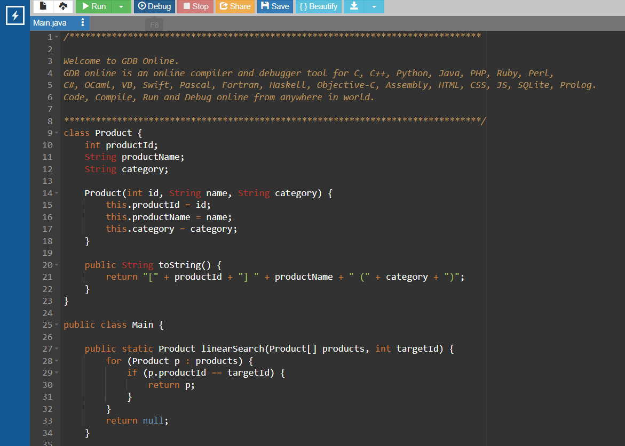

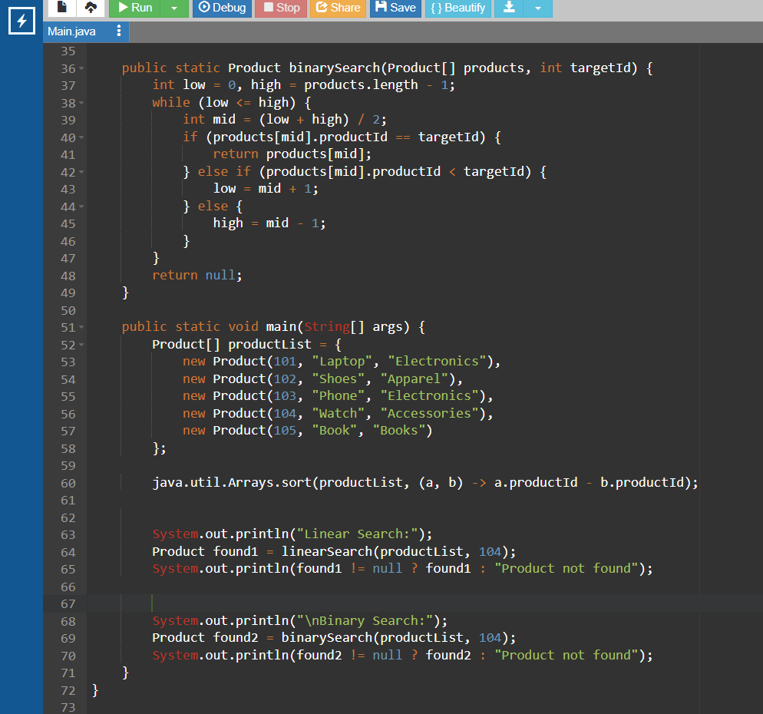

**Output**

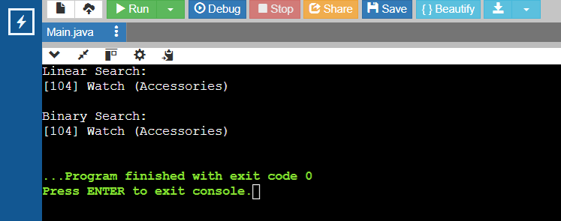

**Analysis**

| **Search Type** | **Time Complexity** |
| --- | --- |
| Linear Search | O(n) |
| Binary Search | O(log n) |

**Conclusion**

* **Linear search** when data is small or unsorted.
* **Binary search** when data is large and already sorted.
* For e-commerce with lots of products, **Binary Search** is better

**Exercise 7: Financial Forecasting**

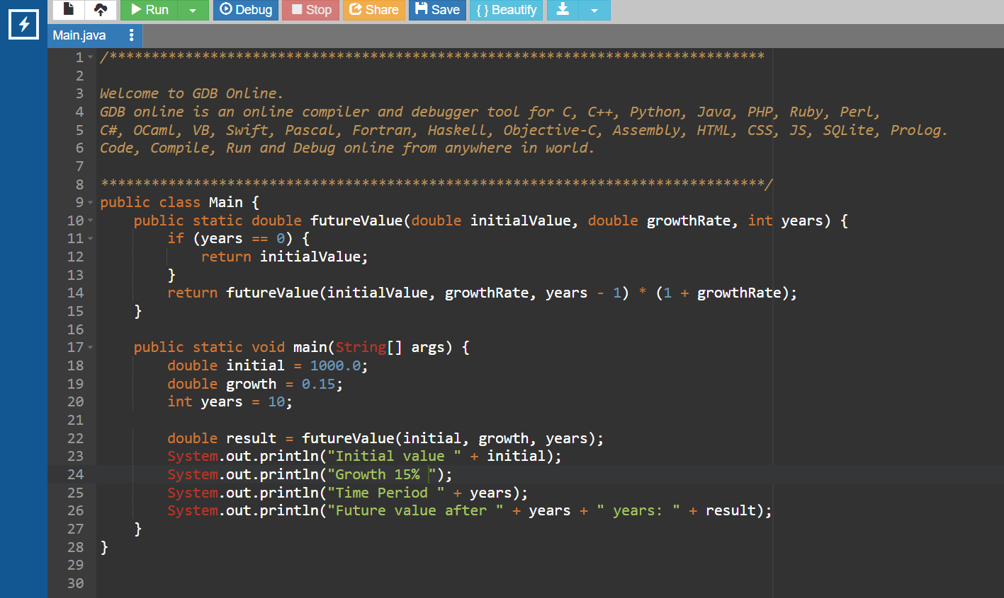

Output

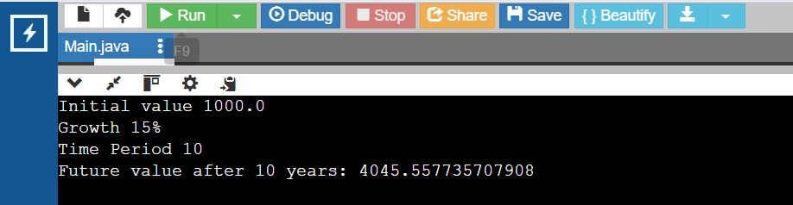

### ****Time Complexity****

Each recursive call does **one multiplication**, and there are n calls . **Time Complexity = O(n)**  
 **Space Complexity = O(n)**