Exercise 1: Control Structures

Scenario 1

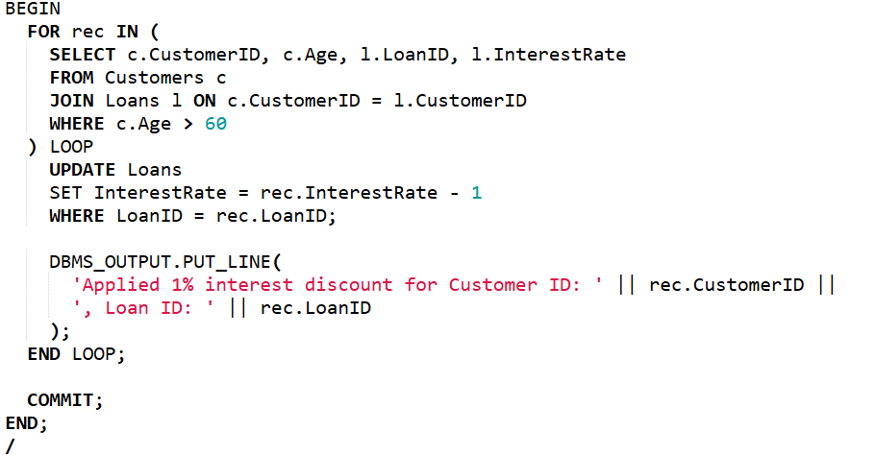

OUTPUT:



Scenario 2

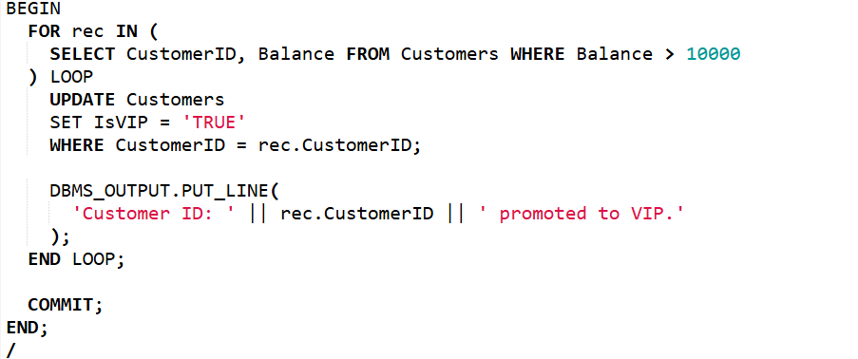

OUTPUT:



Scenario 3

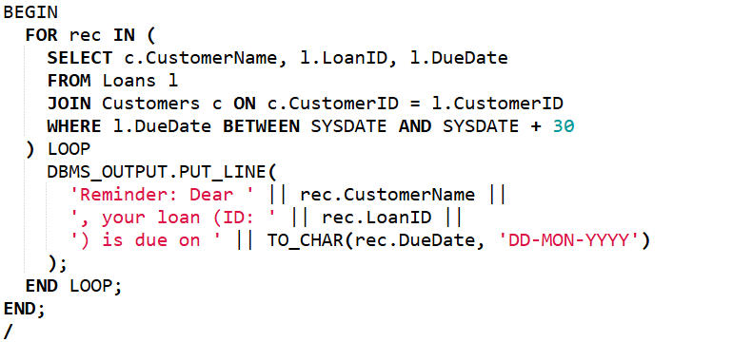

OUTPUT:



**Exercise 3: Stored Procedures**

Scenario 1

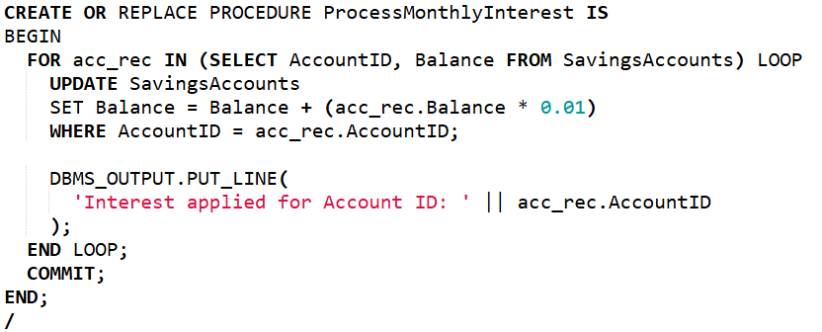

OUTPUT:



Scenario 2:

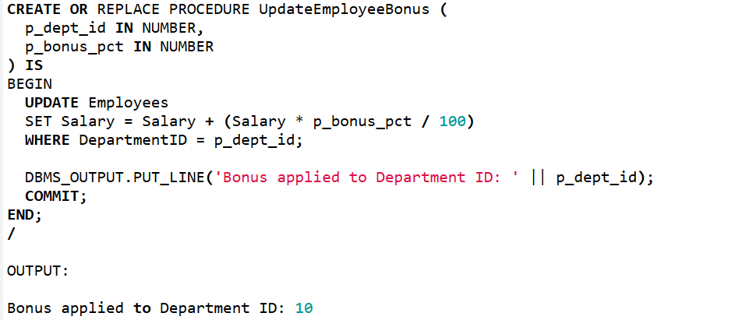

Scenario 3: 