EDGE-AI SMART ATTENDANCE AND LECTURE NOTIFICATION DEVICE

AKINTOLA, Peace Daniel
MTE/2020/1027

30th JULY, 2026

EDGE-AI SMART ATTENDANCE AND LECTURE NOTIFICATION DEVICE

BY

AKINTOLA, Peace Daniel
MTE/2020/1027

A THESIS SUBMITTED TO THE DEPARTMENT OF MECHATRONICS ENGINEERING,

FACULTY OF ENGINEERING,

IN PARTIAL FULFILLMENT OF THE REQUIREMENTS FOR THE AWARD OF THE DEGREE OF BACHELOR OF ENGINEERING (B.ENG.) IN MECHATRONICS ENGINEERING.

JULY 2026

DECLARATION
I, AKINTOLA, Peace Daniel (Matriculation Number: MTE/2020/1027), declare that this thesis titled "Smart Attendance and Lecture Notification System based on embedded Edge Artificial Intelligence" is a record of my original research work carried out in the Department of Mechatronics Engineering, Faculty of Engineering.
I further declare that this work has not been previously submitted in part or in full for the award of any degree or diploma in this or any other institution. All sources of information and literature used have been appropriately acknowledged by means of references.
AKINTOLA, Peace Daniel

Date: _____________________
CERTIFICATION

DEDICATION

This project is dedicated to Jesus.
ACKNOWLEDGEMENTS

First and foremost, I return all glory to the Holy Ghost for divine inspiration, wisdom, and strength throughout this project.
I would like to express my profound gratitude to my supervisor, Professor Adekunle, for making this project possible and for his exceptional supervision and guidance during the research and development process. I also appreciate the Department of Mechatronics Engineering for granting me the opportunity to undertake this research.
My deepest appreciation goes to my family: Engineer Akintola Temitope (M.Sc.), Mrs. Akintola Olubisi, Mr. Praise Akintola, and Miss Precious Akintola, for their relentless encouragement, constant follow-up, heartfelt prayers, and invaluable financial support.
I am also immensely grateful to Papasam, Moses Adamson, and Orega for their continuous support. A special note of thanks goes to DLCF Ikole for providing the consistent electrical power supply necessary for the development of this system, and to Nelson for his strict and unwavering motivation. Finally, I want to thank my 100-level and 200-level sisters for their encouragement and support throughout this journey.

CONTENT | Page
Title Page | i
Declaration | ii
Certification | iii
Dedication | iv
Acknowledgements | v
Table of Contents | vi
List of Tables | ix
List of Figures | x
List of Abbreviations | xi
Abstract | xiii
CHAPTER ONE: INTRODUCTION
Section | Page
1.1 Background of the Study | 1
1.2 Statement of the Problem | 4
1.3 Aim and Objectives of the Study | 6
1.4 Justification of the Study | 7
1.5 Scope of the Study | 9
CHAPTER TWO: LITERATURE REVIEW
Section | Page
2.1 Introduction | 10
2.2 Attendance Management Systems | 13
2.2.1 Evolution of Attendance Management Systems | 15
2.2.2 Classification of Attendance Management Systems | 18
2.3 Biometric Authentication Technologies | 22
2.4 Face Recognition Technology | 28
2.4.1 Evolution of Face Recognition Technology | 30
2.4.2 Operational Stages of a Face Recognition System | 34
2.4.3 Advantages and Challenges of Face Recognition | 38
2.5 Deep Learning in Face Recognition | 42
2.6 Facial Embeddings and Representative Template Generation | 47
2.7 Edge Artificial Intelligence | 53
2.8 Embedded AI Platforms for Edge Inference | 59
2.9 Hybrid Edge–Cloud Architecture for Intelligent Attendance Systems | 65
2.10 Empirical Review | 71
2.10.1 RFID-Based Attendance Management Systems | 72
2.10.2 Fingerprint-Based Attendance Systems | 74
2.10.3 Face Recognition Attendance Systems | 76
2.10.4 Edge AI-Based Intelligent Recognition Systems | 78
2.10.5 Hybrid Edge–Cloud Attendance Systems | 80
2.10.6 Research Gap | 82
2.11 Theoretical Framework | 84
2.12 Summary of Literature Review | 87
CHAPTER THREE: MATERIALS AND METHODS
Section | Page
3.1 Introduction | 89
3.2 System Requirements | 90
3.2.1 Hardware Requirements | 90
3.2.2 Software Requirements | 92
3.3 System Design | 94
3.3.1 Overall System Architecture | 95
3.3.2 Functional Architecture | 96
3.3.3 Operational Flowchart | 97
3.3.4 Hardware Design | 98
3.3.5 Software Design | 103
3.4 Representative Facial Template Enrolment Algorithm | 107
3.5 Attendance Verification Algorithm | 110
3.6 Database Design | 112
3.7 Cloud Synchronization and Telegram Integration | 115
3.8 Security Architecture | 118
3.9 System Testing and Validation | 120
3.10 Bill of Engineering Materials | 123
CHAPTER FOUR: RESULTS AND DISCUSSION
Section | Page
4.1 Introduction | 126
4.2 System Implementation | 127
4.3 Student Enrolment Results | 128
4.4 Facial Recognition Performance | 131
4.5 Attendance Database Evaluation | 134
4.6 Cloud Communication Evaluation | 137
4.7 Overall System Performance | 140
4.8 Discussion of Results | 142
CHAPTER FIVE: CONCLUSION AND RECOMMENDATIONS
Section | Page
5.1 Summary | 145
5.2 Conclusion | 147
5.3 Contributions of the Study | 149
5.4 Limitations of the Study | 150
5.5 Recommendations for Future Work | 151
Section | Page
References | 153
Appendices | 165

LIST OF TABLES
Table | Page
Table 3.1 Hardware Materials Used | 46
Table 3.2 Software Materials Used | 48
Table 3.3 SQLite Database Tables and Their Functions | 66
Table 3.4 Functional Test Cases and Expected Outcomes | 73
Table 3.5 Summary of System Validation Results | 75
Table 3.6 Bill of Engineering Materials and Evaluation | 76
Table 4.1 Summary of Experimental Evaluation | 79
Table 4.2 Typical Enrollment Outcomes | 81
Table 4.3 Facial Recognition Evaluation Summary | 84
Table 4.4 Attendance Database Evaluation | 86
Table 4.5 Cloud Communication Evaluation | 88
Table 4.6 System Performance Summary | 90

LIST OF FIGURES
Figure | Page
Figure 3.1 Overall System Architecture | 50
Figure 3.2 Functional Architecture of the Proposed System | 51
Figure 3.3 Operational Flowchart of the Proposed System | 52
Figure 3.4 Hardware Block Diagram of the Proposed System | 53
Figure 3.5 Software Architecture of the Proposed System | 58
Figure 3.6 Flowchart of the Representative Facial Template Enrollment Algorithm | 62
Figure 3.7 Facial Recognition and Attendance Verification Workflow | 64
Figure 3.8 Entity Relationship Diagram (ERD) of the Attendance Database | 66
Figure 3.9 Cloud Synchronization and Telegram Communication Workflow | 69
Figure 3.10 Security Architecture of the Proposed Attendance Management System | 71
Figure 4.1 Student Enrollment Interface | 80
Figure 4.2 Live Enrollment Progress Showing Sample Acquisition | 80
Figure 4.3 Enrollment Quality Result | 81
Figure 4.4 Successful Face Detection and Recognition | 82
Figure 4.5 Attendance Successfully Recorded | 82
Figure 4.6 Unknown User Detection | 83
Figure 4.7 Registered Users Database | 85
Figure 4.8 Attendance Records Stored in SQLite | 85
Figure 4.9 Enrollment Metadata Stored in the Database | 86
Figure 4.10 Successful Cloud Synchronization | 87
Figure 4.11 Telegram Bot Conversation | 87
Figure 4.12 Generated CSV Attendance Report | 88
Figure 4.13 Main Operational Interface During Attendance Verification | 89
Figure 4.14 Successful Recognition Display | 89

LIST OF ABBREVIATIONS

- AI — Artificial Intelligence
- API — Application Programming Interface
- B.Eng. — Bachelor of Engineering
- CNN — Convolutional Neural Network
- COMNETSAT — Communication, Networks and Satellite (Conference)
- CSV — Comma-Separated Values
- Edge AI — Edge Artificial Intelligence
- ERD — Entity Relationship Diagram
- ESP-DL — Espressif Deep Learning
- ESP-IDF — Espressif IoT Development Framework
- FAR — False Acceptance Rate
- FRR — False Rejection Rate
- FreeRTOS — Free Real-Time Operating System
- GPU — Graphics Processing Unit
- GUI — Graphical User Interface
- HOG — Histogram of Oriented Gradients
- IDE — Integrated Development Environment
- IoT — Internet of Things
- ISO/IEC — International Organization for Standardization / International Electrotechnical Commission
- LBP — Local Binary Patterns
- LDA — Linear Discriminant Analysis
- LVGL — Light and Versatile Graphics Library
- NFC — Near Field Communication
- NIST — National Institute of Standards and Technology
- PCA — Principal Component Analysis
- PSRAM — Pseudo Static Random Access Memory
- PVC — Polyvinyl Chloride
- QR — Quick Response
- RFID — Radio Frequency Identification
- SIFT — Scale-Invariant Feature Transform
- SoC — System-on-Chip
- SQLite — Structured Query Language Lite (embedded relational database)
- TinyML — Tiny Machine Learning
ABSTRACT
Conventional attendance management systems used in many educational institutions are often characterized by manual record keeping, susceptibility to impersonation, dependence on continuous Internet connectivity, and concerns regarding the privacy of biometric data in cloud-based facial recognition systems. This study aimed to design and implement a Smart Attendance and Lecture Notification System based on embedded Edge Artificial Intelligence to provide a secure, reliable, and privacy-conscious attendance management solution for higher educational institutions. The system was developed using the Elecrow CrowPanel Advanced ESP32-P4 AI development board, incorporating the ESP-DL deep learning framework, the factory-installed SC2336 camera module, a local SQLite database, an 8 GB microSD card for model and database storage, a Telegram Bot for remote communication, and a 10,000 mAh rechargeable lithium-ion battery for portable operation. A statistically robust representative facial template enrollment methodology was implemented, in which thirty validated facial samples were processed using adaptive outlier filtering, K-Means pose clustering, and weighted embedding synthesis to generate a representative biometric template for each user. Experimental evaluation involved the enrollment of seven students and one lecturer, with more than one hundred recognition trials conducted under indoor and natural lighting conditions. Recognition confidence values generally ranged from 63% to 78%, with only one temporary misrecognition observed during testing, which was automatically corrected during the subsequent recognition cycle. The average recognition time ranged from approximately 2 to 9 seconds. The system successfully performed local facial recognition, attendance verification, duplicate attendance prevention, lecture schedule synchronization, and Telegram-based report generation while ensuring that biometric data remained on the embedded device. The study concludes that embedded Edge AI provides a practical, low-cost, and privacy-preserving approach to intelligent attendance management and demonstrates the feasibility of deploying facial recognition applications on resource-constrained embedded platforms.

CHAPTER ONE
INTRODUCTION
1.1 Background of the Study
Attendance management is an essential administrative activity in educational institutions because it provides an official record of students' participation in academic activities. Attendance records are commonly used to monitor class participation, determine eligibility for examinations, evaluate student commitment, and support institutional decision-making. Traditionally, attendance has been recorded manually using paper registers or attendance sheets. Although widely adopted, these methods are often time-consuming, susceptible to human error, and vulnerable to impersonation and proxy attendance.
Advances in information and communication technology have led to the development of automated attendance systems based on technologies such as Radio Frequency Identification (RFID), Quick Response (QR) codes, fingerprint recognition, and facial recognition. Among these technologies, facial recognition has gained considerable attention because it enables contactless identity verification without requiring users to carry identification cards or physically interact with the attendance device. Recent developments in artificial intelligence and deep learning have further improved the accuracy and practical application of facial recognition systems.
Despite these advancements, many facial recognition attendance systems depend on cloud computing for biometric processing. Such systems often require reliable Internet connectivity, introduce communication delays, and raise privacy concerns due to the transmission and storage of biometric data on remote servers. These limitations reduce their suitability for environments where network availability is inconsistent or where user privacy is a major concern.
The emergence of Edge Artificial Intelligence (Edge AI) has provided an alternative solution by enabling intelligent processing directly on embedded devices. In Edge AI systems, facial detection, feature extraction, and recognition are performed locally, thereby reducing network dependence, improving response time, and protecting users' biometric information. Recent embedded platforms, such as the Elecrow CrowPanel Advanced ESP32-P4, now provide sufficient computational capability to support artificial intelligence applications while maintaining relatively low power consumption and cost.
This study therefore presents the design and implementation of a Smart Attendance and Lecture Notification System based on the Elecrow CrowPanel Advanced ESP32-P4. The system performs facial recognition locally using the ESP-DL framework, stores attendance records in a local SQLite database, synchronizes lecture schedules with a cloud server, and provides remote administrative communication through a Telegram Bot. To improve recognition reliability, the study also implements a representative facial template enrollment methodology that generates a robust biometric template from multiple validated facial samples. The proposed system aims to provide a secure, privacy-conscious, portable, and cost-effective attendance management solution suitable for higher educational institutions.

1.2 Statement of the Problem
Attendance management remains an important component of academic administration in higher educational institutions. Despite the increasing adoption of digital technologies, many institutions continue to rely on manual attendance recording methods, which are often inefficient, time-consuming, and susceptible to errors. Manual attendance registers also create opportunities for impersonation and proxy attendance, thereby compromising the accuracy and integrity of attendance records.
Although automated attendance systems based on RFID cards, QR codes, and fingerprint recognition have been developed to address these challenges, they possess inherent limitations. RFID cards and QR codes can be exchanged among students, enabling unauthorized attendance registration, while fingerprint-based systems require physical contact with sensing devices, which may reduce convenience and increase maintenance requirements in environments with frequent use.
Facial recognition technology offers a contactless alternative for attendance verification. However, many existing facial recognition attendance systems rely on cloud computing for biometric processing and storage. This dependence on cloud infrastructure introduces challenges such as increased response time, continuous Internet connectivity requirements, recurring operational costs, and concerns regarding the privacy and security of users' biometric information.
Furthermore, many embedded facial recognition systems reported in the literature utilize relatively simple enrollment procedures that generate biometric templates from a single facial image or feature vector. Such approaches may reduce recognition reliability because temporary variations in lighting conditions, facial pose, image quality, or facial expression during enrollment can influence the quality of the stored template.
These limitations highlight the need for an attendance management system that performs facial recognition locally on an embedded platform, protects users' biometric information by minimizing cloud dependence, and improves recognition reliability through a more robust enrollment methodology. Therefore, this study develops a Smart Attendance and Lecture Notification System based on the Elecrow CrowPanel Advanced ESP32-P4 that integrates embedded Edge AI facial recognition, representative facial template generation, local database management, and cloud-assisted administrative services to provide a secure, reliable, and privacy-conscious attendance management solution for higher educational institutions.

1.3 Aim and Objectives of the Study
Aim of the Study
The aim of this study is to design and implement a Smart Attendance and Lecture Notification System based on embedded Edge Artificial Intelligence for secure, reliable, and privacy-conscious attendance management in higher educational institutions.
Objectives of the Study
The specific objectives of this study are to:
- Design and develop a portable embedded attendance management system using the Elecrow CrowPanel Advanced ESP32-P4 platform.
- Implement an embedded facial recognition system capable of performing local face detection, feature extraction, and identity verification without transmitting biometric data to cloud servers.
- Develop a representative facial template enrollment methodology that generates robust biometric templates from multiple validated facial samples to improve recognition reliability.
- Design and implement a local SQLite database for managing user information, biometric templates, lecture schedules, and attendance records.
- Integrate cloud-based lecture schedule synchronization and Telegram Bot communication to support remote administration and attendance reporting.
- Evaluate the performance of the developed system with respect to facial recognition accuracy, recognition time, attendance management, system stability, and overall functionality under practical operating conditions.

1.4 Justification of the Study
The increasing adoption of digital technologies in education has created the need for attendance management systems that are accurate, secure, efficient, and capable of protecting users' personal information. Conventional attendance methods and many existing automated systems still experience challenges such as attendance impersonation, dependence on continuous Internet connectivity, and concerns regarding the security of biometric data. These limitations justify the development of improved attendance management solutions that leverage recent advances in embedded artificial intelligence.
This study is justified because it demonstrates the practical application of Edge Artificial Intelligence for attendance management using a low-cost embedded platform. By performing facial recognition locally on the attendance terminal, the developed system minimizes dependence on cloud computing while protecting users' biometric information from unnecessary transmission over the Internet. This approach enhances data privacy, improves operational reliability, and allows attendance verification to continue even when network connectivity is unavailable.
The study also contributes to knowledge by introducing a representative facial template enrollment methodology that improves the reliability of facial recognition through the use of multiple validated facial samples rather than a single enrollment image. In addition, the integration of local database management, lecture schedule synchronization, and Telegram-based administrative communication into a single portable device demonstrates the feasibility of developing affordable smart attendance systems suitable for higher educational institutions.
The outcome of this research is expected to benefit educational institutions, lecturers, students, researchers, and embedded systems developers by providing a practical reference for the design and implementation of intelligent attendance management systems based on Edge AI.

1.5 Scope of the Study
This study covers the design, implementation, and evaluation of a Smart Attendance and Lecture Notification System based on the Elecrow CrowPanel Advanced ESP32-P4 embedded platform. The study includes the development of a local facial recognition system using the ESP-DL framework, representative facial template generation, attendance verification, duplicate attendance prevention, local SQLite database management, lecture schedule synchronization, Telegram Bot communication, and a touchscreen graphical user interface.
The experimental evaluation of the developed prototype was conducted using enrolled participants under indoor artificial lighting and natural daylight conditions. The evaluation focused on system functionality, facial recognition performance, attendance management, database operation, cloud synchronization, recognition response time, and overall system performance.
The study is limited to single-face recognition, where only one individual is processed at a time during attendance verification. Comprehensive large-scale classroom deployment, battery endurance characterization, and recognition performance under conditions involving facial accessories, severe illumination variations, or large user populations are beyond the scope of this research and are recommended for future work.

CHAPTER TWO

LITERATURE REVIEW
2.1 Introduction
The increasing digital transformation of educational institutions has accelerated the adoption of intelligent technologies for automating academic and administrative processes. Among these processes, attendance management remains fundamental because it supports institutional record keeping, monitors student participation, determines examination eligibility, and provides data for evaluating academic engagement. While attendance recording has traditionally been performed manually using paper registers or sign-in sheets, the growing student population in higher education institutions and the demand for efficient record management have exposed the limitations of conventional methods. These limitations include excessive time consumption, transcription errors, poor record organization, difficulty in retrieving historical records, and vulnerability to attendance fraud. Consequently, researchers have devoted considerable attention to the development of automated attendance management systems that improve accuracy, efficiency, security, and accessibility while reducing administrative workload (Anshari et al., 2021; Akbar et al., 2025).
Early electronic attendance systems relied primarily on credential-based technologies such as barcodes, magnetic cards, Quick Response (QR) codes, and Radio Frequency Identification (RFID). These systems successfully automated attendance recording and reduced manual documentation but remained susceptible to impersonation because authentication depended on transferable credentials rather than direct verification of an individual's identity. To address this limitation, researchers increasingly investigated biometric authentication techniques that identify individuals using unique physiological or behavioural characteristics, including fingerprints, iris patterns, voice characteristics, palm veins, and facial features. Among these modalities, facial recognition has emerged as one of the most promising solutions for educational environments because it enables contactless authentication using conventional imaging devices while requiring minimal user interaction (Jain et al., 2016; Anshari et al., 2021; Boutros et al., 2022).
The rapid advancement of artificial intelligence, particularly deep learning, has significantly improved the reliability and practicality of facial recognition systems. Contemporary recognition models are capable of learning highly discriminative facial representations that remain robust under variations in illumination, facial expression, pose, and partial occlusion. These advances have facilitated the deployment of facial recognition across numerous application domains, including surveillance, border control, financial services, healthcare, and smart education. At the same time, developments in lightweight neural network architectures and embedded computing platforms have enabled sophisticated recognition algorithms to execute directly on resource-constrained devices, reducing dependence on centralized cloud infrastructure and enabling real-time inference at the network edge (Deng et al., 2019; Deng et al., 2020; Guo & Zhang, 2019).
The emergence of Edge Artificial Intelligence (Edge AI) has further transformed the design of intelligent attendance systems by relocating computationally intensive tasks from centralized cloud servers to embedded devices positioned close to the source of data generation. This distributed computing paradigm improves response time, reduces communication overhead, enhances system resilience during network interruptions, and strengthens privacy by limiting the transmission of sensitive biometric information. Consequently, recent research increasingly advocates hybrid Edge–Cloud architectures in which local devices perform biometric processing while cloud services support coordination, scheduling, remote monitoring, and system administration (Shi et al., 2016; Deng et al., 2020; Zhou et al., 2019).
Despite these technological advances, existing attendance management systems continue to exhibit important limitations. Many credential-based systems remain vulnerable to proxy attendance, numerous facial recognition implementations depend heavily on cloud-based biometric processing, and relatively few embedded solutions combine efficient facial template management with privacy-preserving cloud synchronization. Furthermore, limited attention has been given to attendance systems that retain biometric templates and attendance records entirely on local embedded devices while using cloud infrastructure solely for coordination, transient schedule synchronization, and authorized report delivery. These limitations indicate that opportunities remain for developing attendance management systems that simultaneously improve recognition reliability, operational efficiency, privacy protection, and network independence.
This chapter critically reviews the body of knowledge underpinning the proposed Edge AI Facial Recognition Attendance and Lecture Notification System. The review examines the evolution of attendance management systems, biometric authentication technologies, facial recognition, deep learning, facial embeddings and representative template generation, Edge Artificial Intelligence, embedded AI platforms, and hybrid Edge–Cloud architectures. It further evaluates representative empirical studies, identifies existing research gaps, and presents the theoretical framework that informs the design and implementation of the proposed system. Collectively, the reviewed literature establishes the conceptual and technological foundation upon which the present study is developed.

2.2 Attendance Management Systems
Attendance management refers to the systematic process of recording, monitoring, storing, and analysing the presence or absence of individuals within an institution or organisation. In educational settings, attendance management serves as an important administrative function that enables lecturers and institutional authorities to monitor student participation, enforce attendance policies, determine eligibility for assessments, and maintain accurate academic records. Beyond administrative documentation, attendance records provide valuable information for evaluating student engagement, identifying absenteeism trends, and supporting institutional decision-making. Consequently, an effective attendance management system contributes not only to operational efficiency but also to improved academic governance and student accountability (Sarker et al., 2021; Akbar et al., 2025).
The growing complexity of educational administration has significantly influenced the evolution of attendance management systems. Increasing student enrolment, larger class sizes, and the demand for digital record management have exposed the limitations of traditional attendance methods and accelerated the adoption of automated solutions. As information and communication technologies continue to advance, attendance management has evolved from simple manual record keeping to intelligent systems capable of real-time identity verification, automated report generation, and remote administrative access. This evolution reflects a broader trend towards digital transformation within higher education, where administrative processes are increasingly integrated with institutional information systems and cloud-based services (Anshari et al., 2021; Sarker et al., 2021).

2.2.1 Evolution of Attendance Management Systems
The earliest attendance management systems relied entirely on manual documentation. Lecturers recorded attendance by calling students' names or circulating attendance sheets during classroom sessions. Although these methods required minimal technological infrastructure, they became increasingly inefficient as student populations grew. Manual attendance recording consumed valuable instructional time, increased the likelihood of transcription errors, complicated long-term record storage, and made the retrieval of historical attendance records laborious. Furthermore, manual systems provided little protection against dishonest practices such as proxy attendance and unauthorized alteration of attendance records.
To improve efficiency, educational institutions gradually adopted electronic attendance systems. Early digital implementations employed technologies such as barcode scanners, magnetic stripe cards, QR codes, and Radio Frequency Identification (RFID) to automate attendance capture. Compared with manual methods, these systems reduced paperwork, accelerated attendance processing, simplified record management, and facilitated integration with institutional databases. Automated report generation also enabled lecturers and administrators to monitor attendance more efficiently while reducing routine administrative tasks (Akbar et al., 2025).
Despite these improvements, credential-based attendance systems retained an inherent weakness: authentication depended on possession of a credential rather than verification of the individual presenting it. Students could exchange identification cards, share RFID tags, or present another person's credential to obtain fraudulent attendance records. As a result, although electronic systems improved operational efficiency, they did not fully address the problem of attendance fraud. This limitation prompted researchers to investigate biometric authentication technologies capable of verifying identity directly rather than relying on transferable credentials (Jain et al., 2016; Anshari et al., 2021).
Recent advances in artificial intelligence have further transformed attendance management by enabling biometric recognition systems to operate with greater accuracy and reliability. Deep learning algorithms have substantially improved facial recognition performance, allowing attendance systems to function effectively under realistic classroom conditions where variations in lighting, facial expression, viewing angle, and appearance are unavoidable. At the same time, improvements in embedded computing and lightweight AI models have enabled these recognition capabilities to execute on compact, energy-efficient devices positioned close to the point of data acquisition. Consequently, modern attendance systems increasingly combine biometric authentication, embedded intelligence, and networked communication to deliver secure and efficient attendance management.

2.2.2 Classification of Attendance Management Systems
Attendance management systems can generally be classified into manual, credential-based electronic, and biometric systems according to the method used to establish attendance.
Manual attendance systems depend entirely on human observation and documentation. Attendance is recorded by instructors using printed registers or attendance sheets, after which the records are stored manually or transcribed into electronic databases. While these systems require minimal financial investment, they are susceptible to recording errors, delayed data processing, document loss, and fraudulent attendance practices. Their effectiveness also decreases considerably in large classrooms where recording attendance individually becomes increasingly time-consuming.
Credential-based electronic attendance systems automate attendance recording through identifiers such as RFID cards, QR codes, Near Field Communication (NFC) devices, Bluetooth beacons, or mobile applications. These systems reduce administrative workload and improve data accessibility by automatically storing attendance records in digital databases. However, because authentication is based on possession of an external credential, they remain vulnerable to credential sharing, duplication, or unauthorized use. Consequently, the recorded attendance reflects successful credential authentication rather than confirmed personal identity (Akbar et al., 2025).
Biometric attendance systems authenticate individuals using unique physiological or behavioural characteristics instead of transferable credentials. Fingerprint recognition, iris recognition, palm vein recognition, voice recognition, and facial recognition are among the biometric modalities investigated for attendance management. These systems significantly reduce opportunities for impersonation because authentication is directly linked to the individual. Recent developments in computer vision and deep learning have further increased the practicality of facial recognition by enabling accurate, contactless authentication using conventional digital cameras, making it particularly attractive for educational environments (Anshari et al., 2021; Boutros et al., 2022).
Although biometric systems generally provide stronger identity assurance than manual or credential-based alternatives, their effectiveness depends on several factors, including recognition accuracy, computational efficiency, environmental conditions, user acceptance, and secure management of biometric information. Consequently, contemporary research increasingly focuses not only on improving recognition algorithms but also on developing privacy-preserving architectures that balance operational efficiency with responsible handling of sensitive biometric data.

Critical Analysis
The reviewed literature demonstrates that attendance management systems have evolved from simple record-keeping mechanisms into intelligent identity verification platforms. While manual systems remain inexpensive, they are inefficient and prone to human error. Credential-based electronic systems improve administrative efficiency but continue to suffer from impersonation because they authenticate transferable credentials rather than individuals. Biometric systems address this limitation by verifying inherent human characteristics, thereby providing stronger identity assurance. Nevertheless, the growing use of biometric technologies has introduced new challenges relating to computational requirements, privacy protection, and secure management of biometric information. These challenges have encouraged the development of distributed architectures that combine embedded intelligence with selective cloud services to achieve both operational efficiency and responsible data management.

Relevance to the Present Study
The proposed study builds upon the evolution of attendance management systems by implementing a facial recognition solution that performs identity verification directly on an embedded Edge AI device. Unlike credential-based systems, attendance authentication is based on biometric identity rather than transferable tokens. Furthermore, the system minimizes the exposure of sensitive biometric information by retaining facial templates and attendance records on the local device while employing cloud services only for lecture schedule synchronization, lecturer interaction, and authorized report delivery. This architectural approach seeks to combine the administrative advantages of connected attendance systems with the privacy and reliability benefits of local biometric processing.

2.3 Biometric Authentication Technologies
The increasing demand for reliable identity verification has made biometric authentication one of the most widely adopted security technologies in modern information systems. Unlike conventional authentication methods that depend on knowledge-based credentials such as passwords or possession-based credentials such as identity cards and access tokens, biometric authentication verifies an individual's identity using unique physiological or behavioural characteristics. Because these characteristics are inherently associated with the user, biometric systems provide stronger identity assurance and are considerably more resistant to impersonation, credential sharing, and unauthorized access than traditional authentication methods (Jain et al., 2016; ISO/IEC 2382-37:2022).
Biometric authentication has found widespread application across numerous sectors, including border control, financial services, healthcare, mobile device security, law enforcement, and educational administration. In higher education, biometric technologies are increasingly being incorporated into attendance management systems to improve the accuracy of attendance records, reduce administrative workload, and discourage fraudulent attendance practices. The growing acceptance of biometric authentication in educational institutions has been driven by improvements in recognition accuracy, declining hardware costs, and advances in artificial intelligence that enable reliable identity verification under practical operating conditions (Anshari et al., 2021; Boutros et al., 2022).
A typical biometric authentication system consists of four principal stages: data acquisition, feature extraction, template generation, and identity matching. During enrolment, a sensing device captures the user's biometric sample, after which relevant distinguishing characteristics are extracted and converted into a digital template for storage. During authentication, a newly acquired biometric sample undergoes the same feature extraction process before being compared with the stored template. Authentication is granted when the similarity between the two satisfies the system's acceptance criterion. Consequently, the performance of a biometric system depends not only on the uniqueness of the biometric trait but also on the quality of sensing, feature representation, template management, and matching algorithms employed.
Biometric characteristics are generally classified as either physiological or behavioural. Physiological biometrics are derived from relatively stable physical attributes such as fingerprints, facial features, iris patterns, retinal blood vessels, palm veins, and hand geometry. Behavioural biometrics, on the other hand, are based on learned patterns of human activity, including voice characteristics, gait, typing dynamics, and handwritten signatures. Although behavioural biometrics continue to attract research interest because of their unobtrusive nature, physiological biometrics generally offer greater permanence and are therefore more commonly employed in high-assurance authentication systems (Jain et al., 2016).
Among the various physiological biometric modalities, fingerprint recognition remains one of the most mature and widely deployed technologies. Fingerprint systems generally achieve high recognition accuracy and benefit from decades of algorithmic refinement and commercial development. Nevertheless, they require direct physical contact with the sensing surface, making them susceptible to hygiene concerns, sensor contamination, wear, and reduced performance when fingers are wet, dirty, or physically damaged. These limitations became particularly significant during the COVID-19 pandemic, when organizations increasingly favoured contactless authentication technologies.
Iris recognition is widely regarded as one of the most accurate biometric modalities because iris patterns remain highly distinctive throughout an individual's lifetime. However, iris recognition systems typically require specialized near-infrared imaging equipment and controlled image acquisition conditions, increasing deployment costs and reducing their practicality for large-scale classroom attendance applications. Similarly, palm vein recognition offers excellent resistance to spoofing but depends on dedicated imaging hardware that is generally unsuitable for low-cost educational deployments.
Facial recognition has emerged as one of the most practical biometric technologies for attendance management because it combines contactless operation with relatively inexpensive hardware requirements. Unlike fingerprint or iris recognition, facial authentication can be performed using conventional digital cameras without requiring physical interaction between users and sensing devices. This allows attendance verification to occur naturally as students approach the system, improving user convenience while minimizing classroom disruption. Recent advances in deep learning have further enhanced the robustness of facial recognition under varying illumination, facial expressions, ageing, and moderate pose variations, making it increasingly suitable for unconstrained educational environments (Anshari et al., 2021; Deng et al., 2019; Guo & Zhang, 2019).
Despite these advantages, biometric authentication systems continue to present important technical and ethical challenges. Recognition accuracy may be influenced by environmental conditions, sensor quality, presentation attacks, demographic variation, and computational constraints. In addition, unlike passwords or identity cards, biometric characteristics cannot simply be replaced if compromised. This places considerable emphasis on secure template storage, controlled access, responsible data governance, and compliance with privacy regulations. Contemporary standards and guidelines therefore recommend minimizing unnecessary transmission of biometric data, protecting stored biometric templates, and limiting access to authorized personnel throughout the biometric system lifecycle (ISO/IEC 24745:2022; NIST, 2024).
Recent research has consequently shifted beyond improving recognition accuracy alone to addressing broader issues of privacy, security, and deployment efficiency. Rather than transmitting biometric data continuously to centralized servers, modern biometric architectures increasingly perform authentication locally while reserving cloud infrastructure for functions that do not require direct access to sensitive biometric information. This trend aligns with the broader adoption of Edge AI and privacy-preserving computing, both of which have become central themes in the design of intelligent attendance management systems.

Critical Analysis
The reviewed literature consistently demonstrates that biometric authentication provides a more reliable mechanism for identity verification than credential-based approaches because authentication is based on intrinsic human characteristics rather than transferable objects. However, no biometric modality is universally optimal. Fingerprint and iris recognition offer high recognition accuracy but often require user cooperation or specialized hardware, limiting their practicality in many educational settings. Facial recognition provides a more balanced solution by combining contactless operation, user convenience, and compatibility with affordable imaging devices. Nevertheless, its effectiveness depends on robust recognition algorithms, secure template management, and privacy-conscious system design. Consequently, contemporary research increasingly emphasizes integrated solutions that combine accurate biometric recognition with responsible handling of sensitive personal information.

Relevance to the Present Study
The present study adopts facial recognition as the primary authentication mechanism because it provides an effective balance between recognition performance, deployment cost, scalability, and user convenience for classroom attendance management. Consistent with current privacy-oriented research, biometric templates are maintained exclusively within the embedded device rather than continuously replicated to external servers. Cloud communication is restricted to operational functions such as lecture schedule synchronization and lecturer-requested attendance report delivery. By separating biometric authentication from cloud coordination, the proposed architecture seeks to strengthen privacy while preserving the flexibility and accessibility expected of modern intelligent attendance systems.

2.4 Face Recognition Technology
Facial recognition is a biometric identification technology that verifies or establishes an individual's identity by analysing distinctive facial characteristics extracted from digital images or video streams. Over the past decade, it has become one of the fastest-growing biometric technologies due to advances in artificial intelligence, computer vision, and embedded computing. Compared with other biometric modalities, facial recognition offers the unique advantage of performing identity verification without requiring physical contact or active user participation, making it particularly suitable for applications such as attendance management, access control, surveillance, banking, healthcare, and smart city systems (Anshari et al., 2021; Guo & Zhang, 2019; Boutros et al., 2022).
Unlike traditional identification methods that depend on passwords, identity cards, or RFID tags, facial recognition authenticates the individual directly. This significantly reduces opportunities for impersonation because authentication is based on biological characteristics that are considerably more difficult to duplicate or transfer than physical credentials. In educational environments, contactless authentication also improves user convenience by allowing attendance to be recorded naturally as students enter a classroom without interrupting teaching activities or requiring interaction with dedicated scanning devices (Akbar et al., 2025; Anshari et al., 2021).

2.4.1 Evolution of Face Recognition Technology
The development of facial recognition technology can be broadly divided into three generations: traditional feature-based methods, machine learning approaches, and deep learning-based recognition systems.
Early facial recognition systems relied primarily on handcrafted feature extraction techniques. Researchers manually designed algorithms to describe facial characteristics using geometric relationships between facial landmarks or local image descriptors. Representative techniques included Eigenfaces based on Principal Component Analysis (PCA), Fisherfaces using Linear Discriminant Analysis (LDA), Local Binary Patterns (LBP), Scale-Invariant Feature Transform (SIFT), and Histogram of Oriented Gradients (HOG). These approaches demonstrated promising performance under controlled laboratory conditions but were highly sensitive to changes in illumination, facial expression, image resolution, ageing, and head orientation. Consequently, their practical deployment in unconstrained environments remained limited (Zhao et al., 2003; Turk & Pentland, 1991; Ahonen et al., 2006).
The second stage introduced machine learning techniques that improved classification performance by learning decision boundaries from labelled training data. Although these methods outperformed purely handcrafted approaches in many scenarios, their effectiveness remained constrained by the quality of manually engineered features. The inability to automatically learn increasingly complex facial representations limited recognition performance under real-world operating conditions.
The emergence of deep learning fundamentally changed the field of facial recognition. Instead of relying on manually designed descriptors, deep convolutional neural networks automatically learn hierarchical facial representations directly from large-scale image datasets. This capability enabled recognition systems to distinguish subtle identity-related characteristics while becoming increasingly robust to variations in lighting, pose, facial expression, ageing, accessories, and partial occlusion. Landmark contributions such as DeepFace, FaceNet, VGGFace, ArcFace, CosFace, and MagFace established new performance benchmarks and continue to influence contemporary facial recognition research (Taigman et al., 2014; Schroff et al., 2015; Cao et al., 2018; Deng et al., 2019; Meng et al., 2021).

2.4.2 Operational Stages of a Face Recognition System
Although implementation strategies vary across different algorithms and hardware platforms, most contemporary facial recognition systems follow a common processing pipeline consisting of four principal stages: face detection, face alignment, feature extraction, and identity matching.
The first stage, face detection, determines whether one or more human faces are present within the captured image and identifies their locations. Effective face detection is essential because subsequent recognition accuracy depends heavily on the quality of the detected facial region. Modern detection algorithms are capable of identifying faces under varying lighting conditions, multiple viewing angles, and moderate occlusions while operating in real time on both desktop and embedded platforms.
Following detection, the facial image undergoes face alignment. During this stage, facial landmarks such as the eyes, nose, and mouth are identified and used to normalize the orientation, scale, and position of the face. Alignment reduces intra-class variation introduced by differences in camera angle or head posture, thereby improving the consistency of the subsequent feature extraction process.
The aligned facial image is then processed by a feature extraction model that converts the face into a compact numerical representation capturing its distinguishing characteristics. Rather than storing complete facial images, contemporary recognition systems operate on these numerical representations because they provide greater computational efficiency while preserving discriminative identity information. The representation generated during this stage forms the basis for biometric comparison and template management in modern facial recognition systems (Schroff et al., 2015; Deng et al., 2019).
Finally, the extracted facial representation is compared with previously enrolled templates stored within the recognition database. A similarity metric evaluates the degree of correspondence between the newly extracted representation and existing templates. If the similarity exceeds a predefined recognition threshold, the identity is accepted; otherwise, the face is classified as unknown. The choice of similarity threshold directly influences the trade-off between False Acceptance Rate (FAR) and False Rejection Rate (FRR), making threshold selection an important aspect of practical system design (ISO/IEC 19795-1:2021).

2.4.3 Advantages and Challenges of Face Recognition
The popularity of facial recognition in attendance management arises from several practical advantages. First, it enables completely contactless authentication, improving hygiene, user comfort, and operational convenience. Second, it requires only standard digital cameras, reducing deployment costs compared with biometric modalities requiring specialized sensing equipment. Third, attendance verification can occur passively without requiring students to present identification cards or interact physically with scanning devices. These characteristics make facial recognition particularly suitable for classrooms, lecture theatres, and other educational environments where rapid processing of large numbers of individuals is required (Anshari et al., 2021; Boutros et al., 2022).
Despite these advantages, facial recognition remains an active area of research because recognition performance can still be influenced by environmental and operational factors. Variations in illumination, facial occlusion caused by masks or accessories, significant pose changes, motion blur, low image resolution, and demographic diversity may affect recognition accuracy if not adequately addressed by the underlying algorithms. Furthermore, increasing deployment of facial recognition has intensified concerns regarding biometric privacy, informed consent, template security, algorithmic bias, and responsible use of personal data. Consequently, contemporary research extends beyond improving recognition accuracy to include fairness, explainability, privacy-preserving computation, secure template protection, and efficient deployment on resource-constrained Edge AI platforms (NIST, 2024; ISO/IEC 24745:2022).

Critical Analysis
The literature demonstrates that facial recognition has evolved from handcrafted feature engineering to highly accurate deep learning-based systems capable of operating under realistic environmental conditions. This evolution has significantly expanded the applicability of facial recognition beyond controlled laboratory environments into practical deployments such as attendance management. Nevertheless, high recognition accuracy alone does not guarantee an effective attendance system. Reliable operation also depends on efficient implementation, robust template management, secure handling of biometric information, and the ability to execute recognition algorithms within the computational constraints of embedded hardware. These considerations have become increasingly important as educational institutions seek scalable solutions that balance recognition performance with privacy and operational efficiency.

Relevance to the Present Study
Facial recognition forms the core authentication mechanism of the proposed attendance management system because it combines strong identity verification with contactless operation and compatibility with low-cost imaging hardware. Unlike many existing systems that depend on centralized cloud-based recognition, the proposed architecture performs facial recognition locally on an embedded Edge AI platform. This design minimizes unnecessary transmission of biometric information, reduces dependence on continuous Internet connectivity, and supports real-time attendance verification while preserving user privacy. The next section examines how advances in deep learning have enabled the high recognition accuracy that makes such embedded facial recognition systems practical for contemporary educational environments.

2.5 Deep Learning in Face Recognition
The remarkable progress achieved in facial recognition over the past decade is largely attributable to advances in deep learning. Traditional facial recognition algorithms depended on manually engineered features, requiring researchers to determine which facial characteristics were most suitable for distinguishing one individual from another. Although these methods achieved reasonable performance under controlled conditions, they struggled to cope with the variations commonly encountered in real-world environments. Deep learning fundamentally changed this paradigm by enabling computer models to learn discriminative facial representations automatically from large-scale datasets rather than relying on handcrafted descriptors. As a result, deep learning has become the dominant approach in contemporary face recognition research and commercial biometric applications (LeCun et al., 2015; Guo & Zhang, 2019; Boutros et al., 2022).
Deep learning refers to a class of machine learning techniques that employ artificial neural networks containing multiple hidden layers to model complex patterns within data. Unlike conventional machine learning algorithms, which typically require manual feature engineering, deep neural networks progressively learn hierarchical feature representations directly from raw input data. Lower network layers identify simple image characteristics such as edges and textures, while deeper layers combine these elementary features into increasingly abstract representations capable of distinguishing subtle differences between individual faces. This hierarchical learning capability enables deep learning models to achieve significantly higher recognition accuracy than traditional computer vision techniques (LeCun et al., 2015).
Among the various deep learning architectures, Convolutional Neural Networks (CNNs) have become the foundation of modern facial recognition systems. CNNs are specifically designed to process image data by automatically extracting spatial features through successive convolution, activation, and pooling operations. Their architecture allows them to learn robust visual representations while reducing sensitivity to translation, scale variation, and local image distortions. Compared with traditional feature engineering methods, CNNs eliminate the need for manually designed descriptors, allowing the recognition model to optimize feature extraction directly from training data. This capability has enabled facial recognition systems to operate successfully under varying illumination conditions, facial expressions, moderate pose changes, ageing effects, and partial occlusions (Goodfellow et al., 2016; Guo & Zhang, 2019).
Several landmark deep learning models have significantly influenced the evolution of facial recognition. DeepFace, developed by Taigman et al. (2014), demonstrated that deep neural networks could approach human-level performance on large-scale facial verification tasks, providing early evidence of the effectiveness of deep learning for face recognition. Subsequently, FaceNet introduced a metric-learning approach in which facial images are mapped into a compact Euclidean embedding space, allowing similarity between faces to be measured using embedding distances rather than direct image comparison (Schroff et al., 2015). This representation greatly improved recognition efficiency while supporting scalable biometric databases.
Subsequent research focused on improving the discriminative capability of learned facial representations through more effective loss functions. ArcFace, proposed by Deng et al. (2019), introduced an additive angular margin loss that increases inter-class separability while reducing intra-class variation, thereby improving recognition accuracy across diverse datasets. Other influential models, including CosFace (Wang et al., 2018) and MagFace (Meng et al., 2021), further refined feature learning by optimizing angular discrimination and incorporating feature quality assessment into the training process. Collectively, these advances established the theoretical and practical foundations of contemporary facial recognition systems.
While recognition accuracy has improved substantially, deploying deep learning models on embedded hardware presents additional challenges. High-performance recognition networks often contain millions of trainable parameters and require considerable computational resources, memory capacity, and energy consumption. These requirements can exceed the capabilities of low-power embedded devices commonly used in IoT applications. Consequently, recent research has focused on lightweight neural network architectures, model compression, quantization, pruning, knowledge distillation, and hardware-aware optimization techniques that preserve recognition accuracy while reducing computational complexity (Han et al., 2016; Deng et al., 2020).
These developments have accelerated the emergence of Edge AI, where deep learning inference is executed directly on embedded devices instead of relying entirely on centralized cloud servers. Performing inference locally reduces communication latency, improves system responsiveness, supports operation during temporary network interruptions, and minimizes the transmission of sensitive biometric information across public networks. This shift has become particularly important for privacy-sensitive applications such as attendance management, where biometric authentication must often be completed in real time while protecting personal data (Shi et al., 2016; Deng et al., 2020).
It is important to distinguish between model training and model inference within deep learning-based facial recognition systems. Training involves learning the neural network parameters from large annotated datasets through computationally intensive optimization processes that typically require powerful Graphics Processing Units (GPUs) or dedicated AI accelerators. Once training is completed, the optimized model is deployed for inference, where it processes new facial images to generate recognition results. Embedded attendance systems generally perform inference only, while the computationally expensive training phase is completed offline before deployment. This separation enables sophisticated recognition models to operate efficiently on resource-constrained embedded platforms without requiring continuous retraining (Goodfellow et al., 2016; Guo & Zhang, 2019).

Critical Analysis
The literature clearly demonstrates that deep learning has transformed facial recognition from a laboratory-oriented research problem into a mature technology capable of supporting real-world biometric applications. CNN-based models have consistently outperformed traditional handcrafted feature extraction techniques by automatically learning highly discriminative facial representations from large datasets. Nevertheless, achieving high recognition accuracy alone does not guarantee successful deployment in embedded attendance systems. Practical implementation also requires computational efficiency, optimized inference, and careful consideration of hardware limitations. These requirements have driven the development of lightweight recognition models and Edge AI frameworks that make embedded facial recognition increasingly feasible.

Relevance to the Present Study
The proposed attendance management system leverages the advances of deep learning by employing an optimized facial recognition model capable of performing inference directly on an embedded Edge AI platform. Rather than executing computationally intensive training during operation, the deployed system utilizes a pretrained recognition model to extract robust facial representations for real-time authentication. This approach combines the recognition accuracy offered by modern deep learning techniques with the efficiency required for embedded deployment. The facial representations generated during inference form the basis of the representative templates used for identity matching, which are discussed in the following section on facial embeddings and template representation.

2.6 Facial Embeddings and Representative Template Generation
The effectiveness of a modern facial recognition system depends not only on its ability to detect faces but also on how facial information is represented for identity comparison. Earlier facial recognition systems relied on direct image comparison or handcrafted descriptors, approaches that were highly sensitive to variations in illumination, facial expression, pose, and image quality. Contemporary deep learning systems overcome these limitations by transforming each detected face into a compact numerical representation known as a facial embedding. Rather than comparing facial images pixel by pixel, modern recognition algorithms compare these numerical representations, enabling faster and more reliable identity verification across diverse operating conditions (Schroff et al., 2015; Deng et al., 2019; Guo & Zhang, 2019).
A facial embedding is a high-dimensional feature vector generated by a trained deep neural network. Each element within the vector captures latent facial characteristics that, when considered collectively, distinguish one individual from another. Although the numerical values themselves have no direct physical meaning, the embedding occupies a position within a learned feature space where images belonging to the same individual are located close together, while images belonging to different individuals are separated by greater distances. This geometric organization enables recognition systems to determine facial similarity using distance metrics such as Euclidean distance or cosine similarity instead of comparing complete facial images (Schroff et al., 2015; Deng et al., 2019).
Embedding-based representation offers several advantages over storing facial photographs directly. First, embeddings require considerably less storage space than high-resolution images, making them suitable for embedded devices with limited memory resources. Second, numerical feature vectors simplify similarity computation, enabling rapid identity matching even when the database contains hundreds or thousands of enrolled users. Third, storing embeddings instead of raw facial images provides an additional layer of privacy because the original facial appearance cannot be directly reconstructed from the feature vector using conventional methods. Consequently, most contemporary face recognition systems retain numerical representations rather than complete facial images during routine authentication (ISO/IEC 24745:2022; Guo & Zhang, 2019).
A fundamental objective during model training is to learn an embedding space with strong discriminative properties. Metric-learning techniques seek to minimize the distance between embeddings belonging to the same individual while simultaneously maximizing the separation between embeddings of different individuals. FaceNet achieved this objective through the introduction of triplet loss, which optimizes the relative distances among anchor, positive, and negative facial samples (Schroff et al., 2015). Subsequent models, including ArcFace and CosFace, refined this principle by introducing angular margin-based loss functions that further improve class separation and recognition accuracy (Wang et al., 2018; Deng et al., 2019). These advances have established embedding learning as the foundation of modern face recognition.
While the generation of facial embeddings has been extensively investigated, an equally important consideration is how these embeddings are represented and managed after enrolment. A single individual's facial appearance naturally varies because of changes in illumination, facial expression, hairstyle, camera viewpoint, ageing, and minor environmental differences. Consequently, relying on a single facial sample during enrolment may reduce recognition robustness when future observations differ from the original image. To address this challenge, researchers have explored various template representation strategies, including multiple-template storage, prototype-based representation, template aggregation, and clustering techniques. Rather than relying exclusively on one facial sample, these approaches seek to represent an individual's identity using information derived from multiple observations, thereby improving recognition stability under varying acquisition conditions (Jain et al., 2016; Boutros et al., 2022).
Template aggregation has become particularly attractive for embedded recognition systems because it offers a practical compromise between recognition robustness and storage efficiency. Instead of storing every captured facial sample, representative templates summarize information obtained from multiple enrolment images while reducing memory consumption and computational overhead during identity matching. Prototype learning and centroid-based representations have similarly been investigated in pattern recognition and machine learning to improve class representation while reducing redundancy within feature databases. Although the specific implementation differs across applications, these studies collectively demonstrate that representative feature modelling can improve both computational efficiency and recognition reliability, especially in resource-constrained environments (Bishop, 2006; Jain et al., 2016).
Recent developments have also highlighted the role of clustering techniques in biometric template management. Clustering groups feature vectors with similar characteristics before representative features are generated, thereby reducing the influence of outliers and improving the consistency of stored templates. By identifying natural groupings within multiple observations of the same individual, clustering-based approaches can preserve meaningful variations in facial appearance while avoiding unnecessary duplication of highly similar feature vectors. Such techniques have received increasing attention in embedded AI applications where memory capacity, processing speed, and energy efficiency remain important design constraints (Xu & Tian, 2015; Boutros et al., 2022).
In parallel with improvements in template representation, researchers have emphasized the importance of secure biometric template protection. Because biometric characteristics are permanent and cannot be changed in the same manner as passwords, unauthorized disclosure of biometric templates may have long-term privacy implications. International standards therefore recommend protecting stored templates through appropriate access control, secure storage mechanisms, and minimizing unnecessary transmission of biometric information. These recommendations have become particularly important for cloud-connected biometric systems, where sensitive data may otherwise be exposed during network communication (ISO/IEC 24745:2022; NIST, 2024).
The growing adoption of Edge AI has reinforced this trend by enabling facial embeddings and recognition templates to remain on local embedded devices rather than being continuously synchronized with remote servers. Local template management reduces communication overhead, improves authentication speed, and limits the exposure of sensitive biometric information. Consequently, many contemporary Edge AI architectures advocate performing identity matching locally while restricting cloud communication to non-sensitive operational functions, thereby balancing recognition performance with privacy and efficient resource utilization (Deng et al., 2020; Shi et al., 2016).

Critical Analysis
The literature demonstrates that facial embeddings have become the standard representation for modern face recognition because they provide compact, discriminative, and computationally efficient feature representations. Nevertheless, embedding generation alone does not determine overall system performance. The strategy used to organize, represent, protect, and compare these embeddings significantly influences recognition accuracy, storage requirements, and computational efficiency. Recent research therefore extends beyond feature extraction to include template aggregation, representative feature modelling, clustering, and privacy-preserving template management. These developments are particularly relevant for embedded facial recognition systems where memory resources, processing capability, and biometric privacy must be carefully balanced.

Relevance to the Present Study
The proposed attendance management system adopts an embedding-based recognition framework consistent with contemporary deep learning practice. During enrolment, multiple facial embeddings are acquired for each individual and organized into representative templates through an internal clustering and aggregation process. Rather than storing every captured embedding, the system retains representative templates that summarize consistent facial characteristics while reducing storage redundancy and improving matching efficiency. Importantly, these biometric templates remain exclusively within the embedded device and are not continuously replicated to cloud infrastructure, aligning the proposed architecture with current recommendations on privacy-preserving biometric template management. The following section examines the broader concept of Edge Artificial Intelligence, which provides the computational framework enabling such local biometric processing on embedded devices.

2.7 Edge Artificial Intelligence
The rapid growth of the Internet of Things (IoT) has resulted in billions of interconnected devices continuously generating large volumes of data. Traditionally, these devices transmitted raw data to centralized cloud servers where storage, analysis, and decision-making were performed. Although cloud computing provides virtually unlimited computational resources and storage capacity, this centralized approach introduces several practical challenges, including communication latency, bandwidth consumption, dependence on reliable Internet connectivity, increased operational costs, and concerns regarding data privacy. These limitations have encouraged researchers to investigate alternative computing paradigms capable of processing data closer to where it is generated (Shi et al., 2016; Satyanarayanan, 2017).
Edge Artificial Intelligence (Edge AI) represents the convergence of artificial intelligence and edge computing, enabling AI models to execute directly on devices located at or near the source of data generation. Instead of transmitting raw sensor data to remote cloud servers for analysis, Edge AI performs inference locally on embedded processors, microcontrollers, or specialized AI accelerators. This distributed computing paradigm significantly reduces communication delays while allowing intelligent systems to operate with greater autonomy and responsiveness. As a result, Edge AI has become a key enabling technology for real-time applications such as autonomous vehicles, industrial automation, healthcare monitoring, smart surveillance, robotics, precision agriculture, and intelligent educational systems (Deng et al., 2020; Zhou et al., 2019).
Unlike conventional cloud-based AI systems, Edge AI separates the computationally intensive model training phase from the operational inference phase. Neural networks are typically trained offline using high-performance computing platforms equipped with powerful Graphics Processing Units (GPUs). Once training has been completed, the optimized model is deployed to edge devices where it performs inference on newly acquired data. This distinction allows sophisticated AI models to execute efficiently on resource-constrained hardware without requiring continuous access to cloud computing infrastructure (Goodfellow et al., 2016; Deng et al., 2020).
One of the principal advantages of Edge AI is low-latency decision making. Because data processing occurs locally, intelligent systems can respond almost immediately without waiting for network transmission or cloud processing. This characteristic is particularly important in applications where delayed responses may reduce system effectiveness or compromise operational performance. In attendance management systems, for example, local facial recognition enables students to be authenticated immediately as they appear before the camera, avoiding delays associated with uploading images to remote servers for analysis.
Edge AI also contributes significantly to network efficiency. Continuous transmission of images, video streams, or sensor data to cloud servers consumes considerable bandwidth and increases communication costs. By processing information locally, only essential results or operational data need to be transmitted across the network. This reduction in communication overhead becomes increasingly important as the number of deployed IoT devices continues to grow (Shi et al., 2016).
Another important advantage of Edge AI is its contribution to privacy and data security. Many intelligent systems process highly sensitive information, including biometric data, medical records, financial transactions, and industrial process information. Performing inference locally reduces unnecessary exposure of sensitive data by limiting transmission across external networks. Rather than uploading raw biometric images for remote processing, an Edge AI system can complete authentication on the local device while transmitting only operational information required for system coordination. This approach aligns with contemporary privacy principles that encourage minimizing the movement of sensitive personal data whenever possible (ISO/IEC 24745:2022; NIST, 2024).
Edge AI further improves system reliability by reducing dependence on continuous Internet connectivity. Cloud-based AI systems may become partially or completely unavailable during network interruptions, preventing timely execution of intelligent functions. In contrast, Edge AI devices continue performing local inference even when communication with cloud infrastructure is temporarily unavailable. Synchronization with remote services can then occur automatically once connectivity is restored. This capability has become particularly valuable in environments where network availability cannot always be guaranteed, including rural educational institutions, industrial facilities, and remote monitoring applications (Satyanarayanan, 2017; Deng et al., 2020).
Despite these advantages, implementing artificial intelligence on embedded hardware presents significant engineering challenges. Most embedded devices possess substantially lower computational capability, memory capacity, and energy resources than desktop computers or cloud servers. Consequently, deploying deep learning models on such platforms requires careful optimization to balance recognition accuracy with computational efficiency. Researchers have therefore investigated lightweight neural network architectures, parameter pruning, quantization, model compression, knowledge distillation, and hardware-aware optimization techniques that reduce computational complexity while preserving acceptable inference performance (Han et al., 2016; Howard et al., 2019; Tan & Le, 2019).
The growing maturity of these optimization techniques has accelerated the adoption of Edge AI across numerous application domains. Intelligent cameras now perform object detection without continuous cloud communication, wearable healthcare devices analyse physiological signals locally, industrial equipment predicts faults in real time, and agricultural monitoring systems process environmental data directly in the field. Similarly, educational technologies increasingly employ Edge AI to perform local biometric authentication, classroom monitoring, and intelligent learning support while reducing dependence on centralized computing infrastructure.
Although Edge AI minimizes reliance on cloud computing, it does not eliminate the role of cloud services altogether. Contemporary intelligent systems increasingly adopt hybrid Edge–Cloud architectures, where computational responsibilities are distributed according to their characteristics. Time-critical inference is executed locally at the edge, while cloud infrastructure provides services such as centralized management, long-term analytics, software updates, backup, and communication with remote users. This complementary relationship enables intelligent systems to exploit the strengths of both paradigms instead of treating them as competing technologies (Shi et al., 2016; Deng et al., 2020; Zhou et al., 2019).

Critical Analysis
The literature consistently demonstrates that Edge AI addresses many of the limitations associated with centralized cloud-based artificial intelligence by relocating inference closer to the source of data generation. Reduced latency, lower bandwidth consumption, improved operational reliability, and enhanced privacy have established Edge AI as an important paradigm for intelligent embedded systems. Nevertheless, effective deployment requires careful optimization because embedded devices operate under stringent constraints relating to memory capacity, processing capability, and energy consumption. Consequently, successful Edge AI implementations depend not only on accurate AI models but also on efficient hardware–software co-design and intelligent allocation of computational tasks between edge devices and cloud infrastructure.

Relevance to the Present Study
The proposed attendance management system adopts the principles of Edge AI by performing facial detection, feature extraction, and identity recognition directly on the embedded device. This enables real-time attendance verification without requiring continuous cloud-based biometric processing. Consistent with privacy-preserving Edge AI architectures, biometric templates and attendance records remain stored locally, while cloud communication is restricted to operational services such as lecture schedule synchronization, lecturer interaction through Telegram, and on-demand transmission of attendance reports. This separation of responsibilities allows the system to benefit from the responsiveness and privacy of local inference while retaining the flexibility offered by cloud-assisted coordination.

2.8 Embedded AI Platforms for Edge Inference
The successful deployment of Edge Artificial Intelligence depends not only on efficient algorithms but also on the availability of embedded computing platforms capable of executing AI models under strict constraints of processing power, memory capacity, energy consumption, and physical size. Unlike desktop computers and cloud servers, embedded AI platforms are designed to operate with limited computational resources while maintaining real-time performance and high system reliability. Recent advances in semiconductor technology, hardware acceleration, and software optimization have significantly expanded the capabilities of embedded systems, making them suitable for applications that previously required conventional computing infrastructure (Deng et al., 2020; Zhou et al., 2019).
An embedded AI platform integrates hardware and software components that collectively support intelligent data processing at the edge of the network. Typical hardware components include microcontrollers, microprocessors, embedded System-on-Chip (SoC) devices, memory subsystems, communication interfaces, imaging sensors, and dedicated AI accelerators where available. The accompanying software stack generally comprises operating systems or firmware, deep learning inference libraries, communication protocols, and application software responsible for device control and user interaction. The effectiveness of an embedded AI platform therefore depends on the close integration of hardware capabilities with optimized software frameworks.
The choice of embedded hardware is largely determined by application requirements. High-performance platforms such as the NVIDIA Jetson family, Google Coral devices, Raspberry Pi coupled with external AI accelerators, and Intel Movidius-based systems provide substantial computational capability for complex computer vision tasks but generally require higher power consumption and larger physical footprints (NVIDIA, 2024; Google, 2024). These platforms are particularly suitable for robotics, autonomous navigation, industrial automation, and advanced surveillance systems where computational demand is high.
In contrast, recent generations of AI-enabled microcontrollers have made intelligent inference possible on compact, low-power embedded devices. Manufacturers have increasingly incorporated enhanced processing architectures, larger memory capacities, vector instruction sets, and optimized digital signal processing capabilities into microcontroller families, enabling execution of lightweight deep learning models directly on embedded hardware. These developments have given rise to the field commonly referred to as TinyML, where machine learning inference is performed on ultra-low-power microcontrollers operating with limited memory and computational resources (Warden & Situnayake, 2019; Banbury et al., 2021).
TinyML has attracted considerable research attention because it enables intelligent sensing devices to perform local inference while consuming only a fraction of the energy required by conventional computing platforms. Applications include environmental monitoring, predictive maintenance, wearable healthcare devices, smart agriculture, intelligent transportation, and embedded vision systems. By minimizing communication with cloud infrastructure, TinyML improves system responsiveness, reduces bandwidth utilization, and extends battery life, making it particularly attractive for distributed IoT deployments (Banbury et al., 2021).
The rapid adoption of embedded AI has also stimulated the development of specialized software frameworks that simplify deployment of trained neural networks on resource-constrained hardware. TensorFlow Lite for Microcontrollers, CMSIS-NN, TensorFlow Lite, OpenVINO, ONNX Runtime, and vendor-specific inference libraries enable optimized execution of neural networks while minimizing memory usage and computational overhead (David et al., 2021; Arm, 2024). These frameworks provide model optimization techniques such as quantization, operator fusion, and memory scheduling, allowing embedded devices to achieve practical inference speeds despite limited hardware resources.
Within the family of embedded AI microcontrollers, the ESP32 series has become one of the most widely adopted platforms for IoT-based intelligent systems due to its combination of wireless connectivity, low power consumption, affordability, and active software ecosystem. Successive generations of ESP32 devices have introduced improved processing capability, expanded memory configurations, enhanced security features, and support for embedded AI applications. In particular, the ESP32-P4 incorporates vector instructions for accelerating neural network inference, making it more suitable for computer vision applications than earlier members of the ESP32 family (Espressif Systems, 2024).
To support AI deployment on ESP32 devices, Espressif developed the ESP-DL framework, an embedded deep learning library designed specifically for executing neural network inference on ESP32 microcontrollers. ESP-DL provides optimized implementations of computer vision models while supporting efficient execution within the memory and computational constraints of embedded hardware. The framework includes support for face detection, facial feature extraction, image classification, object detection, and other AI applications, enabling developers to deploy intelligent vision systems without relying on continuous cloud-based inference (Espressif Systems, 2024).
Recent studies demonstrate that optimized embedded AI platforms can achieve recognition performance suitable for practical biometric applications while maintaining relatively low power consumption and compact hardware configurations. However, successful deployment depends on careful balancing of recognition accuracy, inference speed, memory utilization, and energy efficiency. Increasing model complexity may improve recognition accuracy but can also exceed available computational resources, resulting in slower response times or excessive memory consumption. Consequently, embedded AI research increasingly emphasizes model optimization and application-specific system design rather than maximizing recognition accuracy alone (Banbury et al., 2021; Deng et al., 2020).
Another important consideration is long-term system maintainability. Embedded AI platforms must support reliable operation under continuous use while allowing firmware updates, security improvements, and software maintenance throughout the device lifecycle. Secure boot mechanisms, encrypted communication, authenticated firmware updates, and hardware security features have therefore become increasingly important components of modern embedded AI platforms, particularly for applications involving sensitive biometric information (Espressif Systems, 2024; NIST, 2024).

Critical Analysis
The literature demonstrates that embedded AI platforms have evolved from simple sensing devices into capable intelligent computing systems that can execute sophisticated deep learning models locally. While high-performance embedded computers provide considerable computational capability, their power requirements and cost often limit their suitability for large-scale educational deployments. AI-enabled microcontrollers and TinyML platforms provide a more practical alternative by balancing computational efficiency, affordability, energy consumption, and wireless connectivity. Nevertheless, achieving reliable biometric recognition on such platforms requires careful optimization of both hardware and software to operate within limited computational resources.

Relevance to the Present Study
The proposed attendance management system adopts an embedded AI architecture based on the ESP32-P4, leveraging its integrated wireless communication, improved vector-processing capability, and compatibility with the ESP-DL inference framework. Rather than depending on external cloud servers for biometric processing, facial detection, feature extraction, and recognition are executed directly on the embedded device. This design aligns with current trends in embedded AI and TinyML, where optimized inference frameworks enable intelligent applications to operate efficiently on low-power hardware while preserving user privacy and reducing communication latency. The next section examines how embedded AI platforms can be integrated with cloud services to form hybrid Edge–Cloud architectures capable of balancing local intelligence with centralized coordination.

2.9 Hybrid Edge–Cloud Architecture for Intelligent Attendance Systems
The increasing complexity of intelligent applications has demonstrated that neither purely centralized cloud computing nor completely isolated edge computing is universally sufficient for modern IoT deployments. Cloud computing provides extensive computational resources, large-scale storage, centralized management, and powerful analytical capabilities. However, cloud-dependent systems often experience limitations associated with communication latency, network reliability, bandwidth requirements, and the transmission of sensitive data to external servers. Conversely, edge-based systems provide rapid local decision-making and improved privacy but are constrained by limited processing capability, storage capacity, and energy availability. These complementary strengths have encouraged the development of hybrid Edge–Cloud architectures, where computational responsibilities are distributed between local devices and cloud infrastructure according to application requirements (Shi et al., 2016; Satyanarayanan, 2017; Deng et al., 2020).
A hybrid Edge–Cloud architecture typically assigns time-sensitive and privacy-sensitive operations to edge devices while reserving cloud resources for computationally intensive, non-critical, or administrative functions. In such systems, edge devices perform real-time sensing, preliminary processing, feature extraction, and immediate decision-making, whereas cloud platforms provide services such as data aggregation, remote monitoring, analytics, software management, and user communication. This distributed approach reduces unnecessary data movement while maintaining the scalability and accessibility benefits associated with cloud computing (Zhou et al., 2019; Deng et al., 2020).
The application of hybrid Edge–Cloud architectures has become increasingly relevant in artificial intelligence-driven systems. Deep learning models often require substantial computational resources during training, making cloud-based environments advantageous for model development and optimization. However, once trained, many AI applications require immediate inference responses that cannot always tolerate the delay introduced by cloud communication. Edge–Cloud systems address this challenge by deploying trained models at the edge for real-time inference while maintaining cloud infrastructure for centralized coordination and management. This approach has become particularly important in computer vision applications where continuous transmission of image or video data would introduce unnecessary bandwidth consumption and privacy concerns (Deng et al., 2020; Zhou et al., 2019).
In biometric authentication systems, the advantages of hybrid architectures are especially significant because biometric information represents sensitive personal data. Traditional cloud-based biometric systems often transmit facial images or biometric representations to remote servers for processing and storage. Although this approach simplifies centralized management, it introduces additional privacy risks because sensitive information must traverse communication networks and remain accessible within cloud infrastructure. Privacy-oriented research increasingly recommends minimizing the transmission and storage of biometric data by performing authentication locally whenever possible while restricting cloud interaction to essential operational functions (ISO/IEC 24745:2022; NIST, 2024).
Attendance management systems provide a practical example of where hybrid Edge–Cloud design offers significant benefits. An intelligent attendance system requires rapid identity verification during classroom sessions, but lecturers and administrators may also require remote access to attendance reports, scheduling information, and system status. A fully cloud-based solution may provide convenient remote accessibility but introduces dependence on network availability and exposes biometric processing to external infrastructure. Conversely, a completely isolated edge-based system may protect privacy but limit administrative convenience and remote management capabilities. A hybrid architecture provides a balance by allowing local biometric authentication while using cloud services for controlled communication and administrative operations.
Recent IoT-based attendance systems have increasingly incorporated cloud platforms and messaging services to improve accessibility. For example, Akbar et al. (2025) developed an IoT-based attendance system integrating RFID sensors with Telegram communication, demonstrating how cloud-connected services can improve lecturer interaction and attendance reporting. However, because the system relies on RFID authentication, it does not address the privacy and impersonation challenges associated with biometric identity verification. This highlights an important research opportunity: combining the communication advantages of cloud-connected attendance systems with the stronger identity assurance provided by locally processed biometrics.
A critical design consideration in hybrid Edge–Cloud systems is determining which data and functions should remain local and which should be synchronized with cloud infrastructure. This decision depends on factors such as sensitivity, processing requirements, latency constraints, and operational necessity. Data requiring immediate processing or containing sensitive personal information is generally better handled at the edge, whereas information required for coordination, reporting, or remote management may be transmitted to cloud services. This principle is consistent with the concept of data minimization, where systems collect, process, and transmit only the information necessary for achieving their intended purpose.
Another important aspect of hybrid architectures is intermittent connectivity management. Unlike traditional cloud-centric systems that assume continuous network availability, edge-enabled systems can continue operating during temporary communication failures. Once connectivity is restored, synchronization mechanisms can update cloud services with required information while maintaining system consistency. This capability is particularly valuable in educational environments where network reliability may vary across campuses or lecture locations. By separating local operational functionality from cloud communication, hybrid architectures improve resilience and reduce dependence on constant Internet access.
Security remains a central consideration in the design of Edge–Cloud systems. Distributed architectures introduce additional attack surfaces because communication occurs between multiple computing layers. Secure authentication, encrypted communication, access control, secure storage, and trusted firmware mechanisms are therefore necessary to protect both local devices and cloud services. For biometric applications, these measures become even more critical because compromised biometric information may have long-term consequences compared with conventional credentials that can simply be replaced (ISO/IEC 24745:2022; NIST, 2024).

Critical Analysis
The literature indicates that hybrid Edge–Cloud architectures provide an effective strategy for addressing the limitations of both centralized cloud computing and isolated edge computing. By distributing computational responsibilities according to operational requirements, these architectures achieve a balance between responsiveness, scalability, privacy, and resource efficiency. However, many existing intelligent attendance systems still rely heavily on cloud-based storage and processing, particularly for biometric operations. This creates unresolved concerns regarding privacy, network dependence, and secure management of sensitive identity information. Therefore, future attendance systems require architectures that preserve the convenience of cloud connectivity while ensuring that sensitive biometric processing remains under local control.

Relevance to the Present Study
The proposed attendance management system adopts a privacy-oriented hybrid Edge–Cloud architecture. Unlike conventional systems that replicate complete attendance databases or biometric information to cloud servers, the proposed design retains student identities, facial embeddings, and attendance records locally on the embedded device. Cloud infrastructure is used selectively for functions that do not require direct access to sensitive biometric information, including schedule synchronization, lecturer communication through Telegram, and on-demand delivery of attendance reports in CSV format. Temporary schedule information is synchronized between the device and cloud service and automatically becomes irrelevant after the associated time period, while permanent attendance records remain securely stored on the local device. This architecture combines the real-time performance and privacy advantages of Edge AI with the accessibility benefits of cloud-assisted administration.

2.10 Empirical Review
Empirical studies provide practical evidence of how attendance management systems have been designed, implemented, and evaluated under real-world conditions. Unlike theoretical discussions, empirical investigations demonstrate the effectiveness, limitations, and operational challenges associated with different technologies and architectural approaches. The review of empirical literature is therefore essential for identifying existing research trends, comparing alternative design strategies, and establishing the research gap addressed by the present study. The studies reviewed in this section were selected based on their relevance to attendance management, biometric authentication, facial recognition, Edge AI, IoT integration, and cloud-assisted educational systems.

2.10.1 RFID-Based Attendance Management Systems
Before the widespread adoption of computer vision, RFID technology was among the most extensively investigated approaches for automated attendance management because of its simplicity, affordability, and ease of deployment. Numerous researchers demonstrated that RFID significantly reduces the administrative workload associated with manual attendance recording while improving the accuracy and accessibility of attendance records.
Akbar et al. (2025) developed an IoT-based attendance management system that combines RFID authentication with Telegram integration for lecturer interaction. The proposed system enables lecturers to initiate attendance sessions remotely and receive attendance reports through Telegram while attendance records are maintained within the system database. Experimental evaluation demonstrated improved administrative efficiency and simplified attendance monitoring. Nevertheless, because authentication depends on RFID credentials rather than biometric identity verification, the system remains susceptible to credential sharing and proxy attendance.
Similarly, several earlier RFID-based attendance systems reported improvements in record management, report generation, and classroom efficiency. However, a common limitation observed across these studies is that successful authentication merely confirms possession of an RFID tag rather than the presence of its legitimate owner. Consequently, although RFID remains attractive because of its relatively low implementation cost and mature technological ecosystem, its inability to prevent impersonation limits its suitability for applications requiring strong identity assurance.
The literature therefore suggests that RFID-based attendance systems are effective for administrative automation but insufficient for applications where attendance integrity is a primary requirement.

2.10.2 Fingerprint-Based Attendance Systems
Fingerprint recognition has historically been one of the most widely deployed biometric technologies for attendance management because of its high recognition accuracy and long history of commercial deployment. Numerous educational institutions adopted fingerprint authentication to eliminate credential sharing while maintaining relatively straightforward enrolment procedures.
Empirical investigations consistently report that fingerprint systems significantly reduce proxy attendance compared with manual and RFID-based approaches. Their mature recognition algorithms and relatively inexpensive hardware have contributed to widespread adoption in educational environments. However, several studies also identify practical limitations associated with fingerprint-based attendance systems. Authentication requires direct physical interaction with the sensing surface, resulting in slower throughput during large classroom attendance sessions. Recognition accuracy may also deteriorate when fingerprints are affected by dirt, moisture, physical injury, or sensor contamination. Furthermore, concerns regarding hygiene became increasingly significant following the COVID-19 pandemic, encouraging institutions to explore contactless biometric alternatives.
These findings indicate that while fingerprint recognition provides stronger authentication than credential-based systems, operational convenience and user experience remain important considerations when selecting biometric technologies for large-scale classroom deployments.

2.10.3 Face Recognition Attendance Systems
Recent empirical research demonstrates a clear transition from contact-based biometric systems toward contactless facial recognition. Improvements in deep learning have enabled facial recognition systems to achieve high recognition accuracy while allowing attendance verification to occur naturally without requiring physical interaction between students and sensing devices.
Anshari et al. (2021) conducted a systematic review of facial recognition technologies for identification and verification in attendance management systems. Their review concluded that deep learning has substantially improved recognition robustness compared with traditional computer vision techniques and identified facial recognition as one of the most promising technologies for future attendance applications. The authors also emphasized the importance of balancing recognition accuracy with privacy, computational efficiency, and deployment constraints.
Numerous empirical studies employing convolutional neural networks, FaceNet, ArcFace, and related deep learning models have reported recognition accuracies exceeding 95% under controlled experimental conditions. Nevertheless, several authors caution that laboratory performance does not necessarily translate directly to real-world deployments. Recognition accuracy may decline under poor illumination, significant head pose variation, facial occlusion, low-resolution imaging, or crowded classroom environments. Consequently, practical attendance systems require not only accurate recognition algorithms but also careful system optimization and robust image acquisition procedures.
Another recurring observation concerns cloud dependency. Many reported facial recognition systems perform either partial or complete biometric processing on centralized servers. Although this simplifies computational requirements for local devices, it introduces communication latency, dependence on continuous Internet connectivity, and additional privacy concerns arising from the transmission and storage of sensitive biometric information.

2.10.4 Edge AI-Based Intelligent Recognition Systems
The emergence of Edge AI has significantly influenced recent research into intelligent recognition systems. Rather than relying exclusively on centralized cloud infrastructure, researchers increasingly deploy optimized deep learning models directly on embedded devices capable of performing local inference.
Deng et al. (2020) observed that combining edge computing with artificial intelligence reduces response latency, decreases bandwidth consumption, improves operational reliability, and enhances privacy by limiting unnecessary transmission of sensitive information. Similar findings have been reported across embedded vision applications involving intelligent surveillance, autonomous systems, industrial inspection, and biometric authentication.
TinyML-based implementations further demonstrate that appropriately optimized neural networks can execute successfully on low-power embedded hardware despite limited computational resources. These studies collectively indicate that embedded AI has matured sufficiently to support practical computer vision applications beyond laboratory environments.
However, empirical studies also emphasize that embedded deployment requires careful optimization of neural network architecture, memory usage, and inference efficiency. Increasing model complexity does not necessarily improve practical system performance if computational requirements exceed available hardware resources.

2.10.5 Hybrid Edge–Cloud Attendance Systems
A growing number of researchers have investigated hybrid architectures that combine embedded intelligence with cloud-based services. These systems typically assign time-critical operations to edge devices while reserving cloud infrastructure for centralized management, analytics, remote communication, and long-term storage.
Empirical evidence consistently indicates that hybrid architectures outperform purely cloud-based systems in terms of responsiveness and network efficiency while maintaining the accessibility advantages associated with remote administration. Nevertheless, a careful examination of the literature reveals that many existing systems continue to synchronize substantial portions of their operational databases—including biometric information—with centralized cloud infrastructure.
Although this architecture simplifies centralized administration, it introduces additional concerns relating to privacy, cybersecurity, regulatory compliance, and dependence on continuous Internet connectivity. Few empirical studies investigate architectures in which biometric templates remain permanently on embedded devices while cloud communication is restricted exclusively to operational coordination and user interaction.

2.10.6 Research Gap
The reviewed empirical studies clearly demonstrate substantial progress in attendance management technologies. Manual attendance systems have largely been replaced by automated electronic solutions, while biometric authentication has significantly reduced opportunities for impersonation. Deep learning has further improved facial recognition performance, and Edge AI has enabled intelligent inference on compact embedded devices.
Despite these advances, four important research gaps remain evident.
First, many attendance systems continue to rely on transferable credentials or centralized biometric processing, leaving either identity assurance or privacy insufficiently addressed.
Second, although embedded facial recognition has received increasing attention, relatively few studies investigate efficient biometric template management strategies suitable for resource-constrained embedded devices.
Third, most cloud-connected attendance systems replicate substantial portions of their operational databases—including biometric information or attendance records—to centralized infrastructure, thereby increasing privacy exposure and network dependence.
Finally, while messaging platforms such as Telegram have been incorporated into attendance management for administrative communication, very few systems integrate privacy-preserving Edge AI, local biometric processing, selective cloud synchronization, and lecturer-driven report generation into a unified attendance architecture.
These gaps collectively justify the present study, which proposes an Edge AI Facial Recognition Attendance and Lecture Notification System that performs facial recognition entirely on an embedded device, retains biometric templates and attendance records locally, synchronizes only temporary scheduling information with the cloud, and delivers attendance reports to lecturers on demand through Telegram without permanently replicating sensitive biometric data to external servers.
2.11 Theoretical Framework
A theoretical framework provides the conceptual foundation upon which a research study is designed, implemented, and evaluated. It identifies the theories and established principles that explain the relationships among the variables under investigation while providing a logical basis for the proposed system architecture. In engineering research, particularly in intelligent embedded systems, theoretical frameworks facilitate the integration of concepts from computer vision, artificial intelligence, embedded computing, IoT, and information systems into a coherent design methodology. The present study draws primarily on the Edge Computing Paradigm, supported by principles of Biometric Recognition Theory and Deep Representation Learning. Together, these frameworks explain why local biometric processing, deep learning-based facial recognition, and selective cloud synchronization constitute an effective architecture for intelligent attendance management.

2.11.1 Edge Computing Paradigm
The Edge Computing Paradigm, introduced and formalized by Shi et al. (2016), proposes that computational tasks should be performed as close as possible to the source of data generation rather than relying exclusively on centralized cloud servers. The underlying principle is that reducing the physical and logical distance between data acquisition and computation minimizes communication latency, lowers bandwidth consumption, improves operational reliability, and enhances privacy.
Within this paradigm, intelligent devices positioned at the network edge perform time-sensitive processing while cloud infrastructure provides complementary services that do not require immediate execution. Rather than replacing cloud computing, edge computing redistributes computational responsibilities according to application requirements. Tasks requiring instantaneous decision-making or involving sensitive information are executed locally, whereas centralized infrastructure supports long-term storage, system coordination, software management, and remote accessibility (Satyanarayanan, 2017; Deng et al., 2020).
For attendance management, this paradigm provides a strong theoretical justification for performing facial detection, feature extraction, and identity recognition directly on the embedded device. Since biometric authentication is highly sensitive and requires immediate response, executing these operations locally improves recognition speed while minimizing exposure of sensitive biometric information. Conversely, non-critical functions such as lecture schedule synchronization, lecturer communication, and on-demand report delivery can be delegated to cloud infrastructure without affecting authentication performance.
The proposed attendance management system closely aligns with the Edge Computing Paradigm by assigning computational tasks according to their operational characteristics. Facial recognition, biometric template storage, and attendance logging remain entirely within the embedded device, while the cloud serves primarily as a communication and coordination platform through Telegram integration. This architectural separation directly reflects the principles advocated by contemporary Edge AI research.

2.11.2 Biometric Recognition Theory
Biometric Recognition Theory provides the conceptual basis for identity verification through measurable human characteristics rather than transferable credentials. The theory assumes that certain physiological and behavioural characteristics exhibit sufficient uniqueness and permanence to distinguish one individual from another with high confidence. Recognition therefore depends on extracting discriminative features from biometric observations and comparing them against previously enrolled templates using an appropriate similarity measure (Jain et al., 2016).
Modern biometric recognition systems operate by representing identity through numerical feature templates instead of raw biometric observations. During authentication, newly acquired biometric features are compared with stored templates, and recognition is determined according to predefined similarity criteria. This theoretical framework emphasizes that recognition performance depends not only on feature extraction but also on template quality, similarity measurement, decision thresholds, and secure template management.
Within the present study, Biometric Recognition Theory explains the use of facial embeddings as identity representations and supports the design objective of authenticating students based on intrinsic facial characteristics instead of externally possessed credentials such as RFID cards or identity tags. It also reinforces the importance of protecting stored biometric templates because biometric characteristics are permanent and cannot easily be replaced if compromised.

2.11.3 Deep Representation Learning
Deep Representation Learning forms the theoretical foundation of contemporary deep learning-based facial recognition. Rather than relying on manually engineered facial descriptors, representation learning proposes that neural networks can automatically learn hierarchical feature representations directly from training data. These learned representations capture increasingly abstract and discriminative characteristics, enabling effective recognition despite variations in illumination, facial expression, pose, ageing, and image quality (LeCun et al., 2015; Goodfellow et al., 2016).
A central principle of representation learning is that the quality of learned features largely determines recognition performance. Consequently, modern facial recognition models transform facial images into embedding vectors occupying a feature space where images of the same individual cluster closely together while images belonging to different individuals remain well separated. Metric-learning approaches such as FaceNet and angular margin-based methods such as ArcFace exemplify this theoretical principle by optimizing the geometric relationships among facial embeddings (Schroff et al., 2015; Deng et al., 2019).
This framework is particularly relevant to the present study because the proposed attendance system performs identity verification using learned facial embeddings generated by a deep learning model deployed through the ESP-DL framework. Rather than comparing facial images directly, authentication is performed using representative numerical facial templates generated from multiple enrolment samples, thereby improving robustness while reducing computational complexity.

Application of the Theoretical Framework to the Present Study
The three theoretical perspectives complement one another and collectively explain the proposed system architecture. The Edge Computing Paradigm determines where computation should occur, advocating local execution of latency-sensitive and privacy-sensitive operations. Biometric Recognition Theory explains what information should be used for authentication by emphasizing intrinsic physiological characteristics instead of transferable credentials. Deep Representation Learning explains how reliable facial identity representations can be learned and compared through deep neural networks.
Their integration provides a coherent conceptual basis for the proposed Edge AI Facial Recognition Attendance and Lecture Notification System. Local Edge AI processing enables immediate biometric authentication without dependence on continuous Internet connectivity. Deep learning generates discriminative facial embeddings that support reliable recognition, while biometric recognition principles justify the use of facial identity rather than credential-based authentication. Cloud infrastructure is incorporated selectively to provide schedule synchronization, lecturer communication through Telegram, and on-demand attendance report delivery without compromising the privacy of biometric templates or permanently replicating attendance records.
The combination of these theoretical foundations therefore supports the central design philosophy of the proposed study: perform sensitive biometric intelligence locally while employing cloud services only where they add operational value without exposing sensitive personal data.

2.12 Summary of the Literature Review
This chapter has reviewed the theoretical foundations, technological developments, and empirical studies relevant to the design and implementation of intelligent attendance management systems. The review demonstrates that attendance management has evolved considerably from manual record keeping to automated electronic systems and, more recently, to intelligent biometric solutions supported by artificial intelligence and Internet of Things (IoT) technologies. This evolution has been driven by the increasing demand for improved accuracy, operational efficiency, identity assurance, and secure management of academic records.
The literature first established the limitations of conventional attendance methods. Manual attendance systems, although simple to implement, are time-consuming, susceptible to human error, and vulnerable to attendance fraud. Credential-based electronic systems, including RFID, QR code, and smart card technologies, improved administrative efficiency and digital record management but remained fundamentally dependent on transferable credentials, making them susceptible to impersonation and proxy attendance. These limitations motivated the increasing adoption of biometric authentication technologies capable of verifying individuals using unique physiological characteristics.
The review further showed that facial recognition has emerged as one of the most suitable biometric technologies for educational attendance management because it enables contactless identity verification using conventional camera hardware. Advances in deep learning have significantly improved the robustness of facial recognition under practical operating conditions by enabling neural networks to learn highly discriminative facial representations directly from large-scale datasets. Consequently, modern face recognition systems have largely transitioned from handcrafted feature extraction techniques to embedding-based deep learning models that provide superior recognition accuracy, scalability, and computational efficiency.
The chapter also examined the importance of facial embeddings and representative biometric templates in contemporary recognition systems. The reviewed literature demonstrated that effective biometric authentication depends not only on accurate feature extraction but also on efficient template representation, similarity measurement, and secure template management. Recent research increasingly emphasizes representative template generation, template aggregation, clustering techniques, and privacy-preserving storage mechanisms to improve recognition stability while reducing computational complexity and protecting sensitive biometric information.
The emergence of Edge Artificial Intelligence has further transformed intelligent biometric systems by enabling deep learning inference to execute directly on embedded devices positioned near the source of data generation. Compared with conventional cloud-centric architectures, Edge AI provides lower latency, reduced bandwidth consumption, improved operational reliability, and enhanced privacy by minimizing unnecessary transmission of sensitive biometric information. Advances in embedded AI hardware, TinyML, and optimized inference frameworks have demonstrated that sophisticated computer vision applications can now operate efficiently on resource-constrained embedded platforms.
The literature also highlighted the growing importance of hybrid Edge–Cloud architectures. Rather than treating edge computing and cloud computing as competing paradigms, recent studies advocate distributing computational responsibilities according to operational requirements. Time-critical and privacy-sensitive functions are executed locally, while cloud infrastructure supports centralized management, communication, software maintenance, analytics, and other non-real-time services. This hybrid approach combines the responsiveness and privacy advantages of local processing with the scalability and accessibility of cloud computing.
The empirical review confirmed that significant progress has been achieved in the development of intelligent attendance systems. Researchers have successfully demonstrated automated attendance recording using RFID, fingerprint recognition, facial recognition, IoT communication platforms, and Edge AI technologies. However, the review also identified several persistent limitations. Many existing systems continue to depend heavily on centralized cloud processing, permanently synchronize sensitive biometric information with remote databases, or employ authentication mechanisms that remain vulnerable to impersonation. Furthermore, relatively few studies have investigated privacy-oriented architectures that combine local biometric processing, efficient embedded template management, selective cloud synchronization, and lecturer-centred communication within a single integrated attendance management system.
The theoretical framework presented in this chapter established that the proposed study is supported by three complementary perspectives: the Edge Computing Paradigm, Biometric Recognition Theory, and Deep Representation Learning. Together, these theories provide the conceptual justification for performing biometric authentication locally, representing facial identity through learned embeddings, and employing cloud infrastructure only for operational coordination rather than continuous biometric processing.
Overall, the reviewed literature demonstrates that the technological components required for intelligent attendance management are well established individually. Nevertheless, there remains an important opportunity to integrate these technologies into an architecture that simultaneously prioritizes recognition accuracy, embedded intelligence, privacy preservation, operational efficiency, and practical classroom deployment. This identified gap forms the foundation of the present research.
Accordingly, the proposed Edge AI Facial Recognition Attendance and Lecture Notification System is designed to address these limitations by performing facial detection, feature extraction, and identity recognition entirely on an embedded device using the ESP-DL framework, maintaining biometric templates and attendance records exclusively within local storage, synchronizing only temporary lecture schedule information with cloud infrastructure, and delivering attendance reports to lecturers on demand through Telegram. By separating privacy-sensitive biometric operations from cloud-based administrative services, the proposed system seeks to provide a secure, responsive, and scalable attendance management solution suitable for contemporary higher education institutions.
The discussions presented in this chapter establish the theoretical and empirical foundation for the research methodology described in the next chapter. Chapter Three details the system design, hardware and software components, development methodology, implementation procedures, and evaluation techniques adopted in developing the proposed attendance management system.

CHAPTER THREE
MATERIALS AND METHODS
3.1 Introduction
This chapter describes the methodology adopted for the design, implementation, and evaluation of the proposed Edge AI Facial Recognition Attendance and Lecture Notification System. It presents the research design, materials employed, hardware and software architecture, implementation procedures, data collection process, and performance evaluation methods used throughout the study.
Unlike conventional software-only attendance systems, the proposed system integrates embedded artificial intelligence, computer vision, Internet of Things (IoT) communication, and cloud-assisted services into a single portable platform. Consequently, the development methodology extends beyond software implementation to include hardware integration, embedded system optimization, user interface development, database management, wireless communication, and real-time biometric processing.
The development process adopted an iterative engineering approach in which individual hardware components and software modules were first verified independently before being progressively integrated into the complete system. This approach allowed implementation challenges to be identified and resolved at an early stage, thereby improving system reliability and reducing integration complexity. Throughout development, repeated testing and refinement were performed to ensure that each subsystem satisfied its functional requirements before subsequent components were introduced.
The completed system performs facial detection, feature extraction, identity recognition, attendance management, lecture schedule synchronization, and Telegram-based lecturer communication while preserving student biometric information entirely within the embedded device. Cloud infrastructure is employed only for non-sensitive coordination tasks, thereby maintaining the privacy-oriented hybrid Edge–Cloud architecture established in Chapter Two.
The remainder of this chapter presents the research design adopted for the study, the materials used during implementation, the hardware and software architecture of the proposed system, the implementation methodology, data collection procedures, and the evaluation methods employed to assess system performance.

3.2 Research Design
The study adopted an experimental engineering research design based on an iterative prototyping methodology for the development of an Edge AI-enabled attendance management system. This research design was selected because the study involves the design, implementation, integration, optimization, and evaluation of an embedded intelligent system rather than the investigation of naturally occurring phenomena. Experimental engineering research is particularly appropriate for projects in which new systems are developed to solve identified practical problems through systematic design, implementation, testing, and refinement.
Unlike linear software development models, iterative prototyping allows system functionality to evolve progressively through repeated cycles of implementation, evaluation, and improvement. Each functional component is developed, tested, validated, and optimized before being integrated with other system modules. This methodology reduces integration risks, facilitates early detection of design flaws, and allows implementation decisions to be revised based on experimental observations obtained during development.
The development of the proposed system followed a modular implementation strategy. Hardware peripherals, including the display subsystem, camera interface, external storage, wireless communication modules, and power system, were individually verified before software integration commenced. Following hardware validation, software development proceeded incrementally through successive implementation phases involving graphical user interface development, local storage management, cloud communication, embedded artificial intelligence deployment, attendance management, and system optimization. This phased implementation strategy ensured that subsystem failures could be isolated and corrected without affecting unrelated components.
The iterative nature of the methodology proved particularly important because the project involved the integration of multiple resource-intensive subsystems within a single embedded platform. During development, several implementation decisions were revised based on observed system behaviour. For example, an audio feedback subsystem was initially incorporated to provide spoken prompts during user interaction. Experimental testing, however, revealed that simultaneous execution of the audio subsystem and embedded deep learning models resulted in excessive memory contention, adversely affecting system stability and recognition reliability. Consequently, the audio subsystem was removed from the final implementation, allowing available memory resources to be prioritized for real-time facial recognition and improving overall system performance.
Similarly, enclosure development followed an iterative engineering process. Commercial enclosures were initially evaluated but were found to be incompatible with the physical dimensions and peripheral arrangement of the assembled hardware. Although additive manufacturing through three-dimensional (3D) printing was considered, this approach was not adopted because it conflicted with one of the primary design objectives of developing a low-cost attendance management system using readily available materials. Instead, a custom enclosure was fabricated manually from polyvinyl chloride (PVC) plumbing pipe and subsequently finished using fast-drying spray paint. This approach produced a durable enclosure while maintaining low production cost and demonstrating that practical embedded AI systems can be developed without reliance on specialized manufacturing facilities.
Throughout the implementation process, continuous verification and validation were performed after each major development stage. Individual software modules were first tested independently before integration testing was conducted to evaluate interactions among the graphical user interface, camera subsystem, embedded deep learning framework, local database, cloud synchronization services, and Telegram communication platform. This progressive validation strategy contributed significantly to the stability of the completed system.
The adoption of an experimental iterative methodology therefore provided a structured framework for managing the complexity associated with integrating embedded hardware, artificial intelligence, wireless networking, cloud services, and biometric authentication within a single portable attendance management platform. The methodology also ensured that design decisions were guided by experimental evidence rather than theoretical assumptions, resulting in a system whose final architecture reflects practical implementation experience as well as established engineering principles.
3.3 Materials
This section describes the hardware and software resources used in the development of the proposed Edge AI Facial Recognition Attendance and Lecture Notification System. The selected materials were chosen to satisfy the functional requirements of real-time facial recognition, local biometric processing, wireless communication, portable operation, and cost-effective deployment. Preference was given to components that provided high integration, low power consumption, and compatibility with the ESP-DL framework while minimizing the need for additional external hardware.

3.3.1 Hardware Materials
The hardware implementation of the proposed system was centered on the Elecrow CrowPanel ESP32-P4 7-inch AI Development Module, which served as the primary processing and user interaction platform. Unlike conventional embedded implementations that require separate microcontrollers, displays, touch interfaces, storage interfaces, and peripheral expansion boards, the CrowPanel integrates these subsystems into a single development platform. This significantly reduced circuit complexity, improved system reliability, and accelerated implementation.
The board incorporates an ESP32-P4 processor designed for embedded artificial intelligence applications and provides integrated support for a high-resolution capacitive touchscreen, camera interface, Wi-Fi connectivity, MicroSD storage, USB programming interface, and sufficient memory resources for executing ESP-DL inference models. These integrated features eliminated the need for extensive external circuitry while simplifying software development and hardware integration.
Image acquisition was performed using the factory-supplied SC2336 camera module included with the development board. Although an autofocus camera module was initially considered because of its potential to improve image quality under varying capture distances, it was not adopted during implementation. The CrowPanel provides a 24-pin camera interface, whereas the available autofocus camera utilized a physically larger 15-pin connector with different electrical characteristics. Consequently, the autofocus module was mechanically and electrically incompatible with the development board. To maintain system stability and ensure compatibility with the ESP-DL framework, the factory-installed SC2336 camera was retained throughout the implementation.
External storage was provided by an 8 GB microSD memory card connected through the board's integrated SD card interface. The storage medium was used for maintaining the ESP-DL inference models, facial embedding database, attendance records, system configuration files, and temporary operational data. Storing these resources on removable storage provided sufficient capacity for future database expansion while simplifying software updates and maintenance.
Portable operation was achieved using a 10,000 mAh rechargeable lithium-ion battery. The battery enables the attendance device to operate independently of continuous mains power, allowing deployment in lecture halls, laboratories, seminar rooms, and other academic environments where permanent electrical installations may not be readily available. The battery capacity was selected to provide extended operational time during normal academic activities while supporting the computational demands of embedded facial recognition and wireless communication.
A custom protective enclosure was fabricated manually using polyvinyl chloride (PVC) plumbing pipe. Commercially available enclosures were evaluated during development but were found to be unsuitable because they could not accommodate the dimensions and peripheral arrangement of the assembled hardware. Although a custom three-dimensional (3D) printed enclosure was also considered, this option was not adopted because it conflicted with the project's objective of developing a low-cost attendance management system using widely available materials. PVC was therefore selected because of its low cost, ease of machining, mechanical durability, and widespread availability. After fabrication, the enclosure was finished using a fast-drying spray paint to improve its appearance and provide additional surface protection.
Table 3.1 summarizes the major hardware components used during system implementation.
Table 3.1: Hardware Materials Used
S/N | Component | Specification | Purpose
1 | Elecrow CrowPanel ESP32-P4 AI Module | 7-inch integrated AI development board | Main processing unit
2 | SC2336 Camera Module | Factory-installed camera | Facial image acquisition
3 | MicroSD Card | 8 GB | Storage of AI models, facial database and attendance records
4 | Lithium-Ion Battery | 10,000 mAh | Portable power supply
5 | PVC Pipe Enclosure | Custom fabricated | Mechanical protection
6 | Spray Paint | Fast-drying | Surface finishing of enclosure

3.3.2 Software Materials
The software implementation of the proposed attendance management system consisted of embedded firmware, artificial intelligence libraries, cloud-based services, database management technologies, and software development tools. These software resources collectively enabled facial recognition, graphical user interaction, local data management, wireless communication, cloud synchronization, and attendance reporting within a unified embedded platform.
The primary software development framework employed in this study was the Espressif IoT Development Framework (ESP-IDF). ESP-IDF served as the official software development environment for programming the ESP32-P4 processor and provided the necessary libraries for hardware abstraction, multitasking, memory management, peripheral control, networking, and file system management. Its native support for the ESP32-P4 architecture ensured stable integration of the display subsystem, camera interface, storage devices, and wireless communication modules.
Embedded facial recognition was implemented using the ESP-DL (Espressif Deep Learning) framework. ESP-DL provides optimized deep learning inference libraries specifically designed for ESP32-based embedded systems. The framework supports face detection, facial landmark localization, feature extraction, and facial recognition while operating within the computational constraints of embedded hardware. The framework was selected because it offers optimized inference performance, native compatibility with ESP-IDF, and official support for the ESP32-P4 platform.
Firmware development was carried out using Visual Studio Code with the Espressif IDF Extension. This integrated development environment (IDE) provided project management, source code editing, debugging, firmware compilation, flashing, serial monitoring, and build configuration within a unified workspace. The extension also simplified dependency management and integration with the ESP-IDF toolchain.
The system firmware was developed primarily in the C++ programming language, with selected components implemented in C where required by the ESP-IDF framework and hardware abstraction libraries. Object-oriented programming principles were adopted during software development to improve code modularity, maintainability, and reuse. The firmware architecture was organized into independent functional modules responsible for camera control, graphical user interface management, facial recognition, attendance processing, cloud communication, local database management, and system configuration.
The graphical user interface (GUI) was developed using the Light and Versatile Graphics Library (LVGL), an open-source embedded graphics framework designed for resource-constrained systems. LVGL enabled the implementation of an interactive touchscreen interface through which administrators could enroll students, configure system settings, manage lecture schedules, monitor attendance records, and navigate various application functions. The library was selected because of its extensive widget support, efficient memory utilization, and seamless integration with ESP-IDF.
Wireless communication was implemented using the integrated Wi-Fi capabilities of the ESP32-P4 module. Network connectivity enabled synchronization of lecture schedules with the cloud server, communication with the Telegram Bot, and remote transmission of attendance reports. The software architecture was designed such that network availability enhanced system functionality without affecting the core attendance process, allowing facial recognition and attendance logging to continue even during temporary Internet outages.
Cloud services were implemented using a web-based backend responsible for managing lecturer authentication, temporary lecture schedules, device synchronization, and communication with the Telegram Bot API. Unlike conventional cloud-based attendance systems, the backend did not permanently store biometric templates or attendance records. Instead, only operational information necessary for coordinating attendance sessions and responding to lecturer requests was exchanged between the embedded device and the cloud infrastructure. This architecture aligns with the privacy-preserving design philosophy adopted in this study.
Local data persistence was achieved using the onboard microSD card, which stored facial embedding databases, attendance records, system configuration files, ESP-DL models, and other application resources. This approach eliminated dependence on continuous cloud storage while ensuring that sensitive biometric information remained under the physical control of the embedded device.
Version control and project organization were maintained throughout development to facilitate incremental software refinement, debugging, and feature integration. The firmware evolved through multiple implementation phases involving hardware verification, storage management, graphical interface development, networking, artificial intelligence deployment, attendance management, and system optimization. This iterative development process improved software reliability by allowing each subsystem to be validated before integration into the complete attendance management system.
Table 3.2 summarizes the principal software resources employed during the implementation of the proposed system.
Table 3.2: Software Materials Used
S/N | Software | Purpose
1 | ESP-IDF | Embedded firmware development framework
2 | ESP-DL | Embedded facial detection and recognition framework
3 | Visual Studio Code | Integrated development environment
4 | Espressif IDF Extension | ESP-IDF project management, compilation and debugging
5 | C/C++ | Firmware development
6 | LVGL | Graphical user interface development
7 | Telegram Bot API | Lecturer communication and report delivery
8 | Cloud Web Backend | Schedule synchronization and device coordination
9 | MicroSD File System | Local storage of AI models, databases and attendance records

The hardware and software resources described in this section formed the technological foundation upon which the proposed attendance management system was developed. Their integration enabled the implementation of a portable, privacy-preserving, and intelligent attendance platform capable of performing real-time facial recognition while maintaining selective cloud connectivity for administrative functions.

3.4 System Design
The proposed system was designed as a hybrid Edge–Cloud attendance management platform in which computationally intensive biometric operations are executed locally on an embedded device, while cloud infrastructure performs non-sensitive coordination and communication functions. This architectural approach minimizes dependence on continuous Internet connectivity, reduces communication latency, preserves the privacy of biometric information, and improves the overall reliability of the attendance management process.
Unlike conventional cloud-centric attendance systems that continuously transmit biometric information to remote servers for processing, the proposed system performs facial detection, feature extraction, identity recognition, attendance recording, and local database management entirely within the embedded device. Only operational information required for lecture scheduling, lecturer communication, and report requests is exchanged with the cloud server. Consequently, sensitive biometric templates and attendance records remain permanently stored on the local device.
The complete system consists of five principal subsystems:
- Embedded Attendance Terminal
- Cloud Management Server
- Telegram Communication Platform
- Lecturer Interface
- Student Database
These subsystems communicate to provide an integrated attendance management solution while maintaining clear separation between privacy-sensitive operations and cloud-assisted services.

3.4.1 Overall System Architecture
The Embedded Attendance Terminal serves as the core processing unit of the entire system. It integrates the ESP32-P4 processor, camera module, touchscreen display, local storage, wireless communication interface, and embedded deep learning framework into a single portable device capable of autonomous operation.
During attendance sessions, the camera continuously captures facial images of students present within the lecture environment. The embedded ESP-DL framework performs face detection, feature extraction, and identity recognition locally without requiring external computational resources. Once a student's identity has been verified successfully, the attendance record is immediately written into the local attendance database stored on the MicroSD card.
Unlike conventional biometric attendance systems that maintain centralized biometric databases, the proposed architecture stores all enrolled facial embeddings locally. This design significantly reduces privacy risks associated with transmitting sensitive biometric information across communication networks while simultaneously eliminating delays associated with cloud-based recognition.
Cloud infrastructure performs only administrative functions that do not require access to biometric information. These functions include lecture schedule synchronization, lecturer authentication, Telegram communication, and remote attendance report requests. The embedded device periodically synchronizes lecture schedules with the cloud whenever network connectivity is available. Attendance records, however, remain exclusively within the embedded device unless explicitly exported by an authorized lecturer.
The Telegram Bot provides a convenient communication interface through which lecturers can request attendance reports, receive notifications, and manage lecture activities remotely without requiring direct physical access to the attendance terminal.
This distributed architecture enables the system to continue normal attendance operation even during temporary network failures because all essential recognition and attendance functions are executed locally.

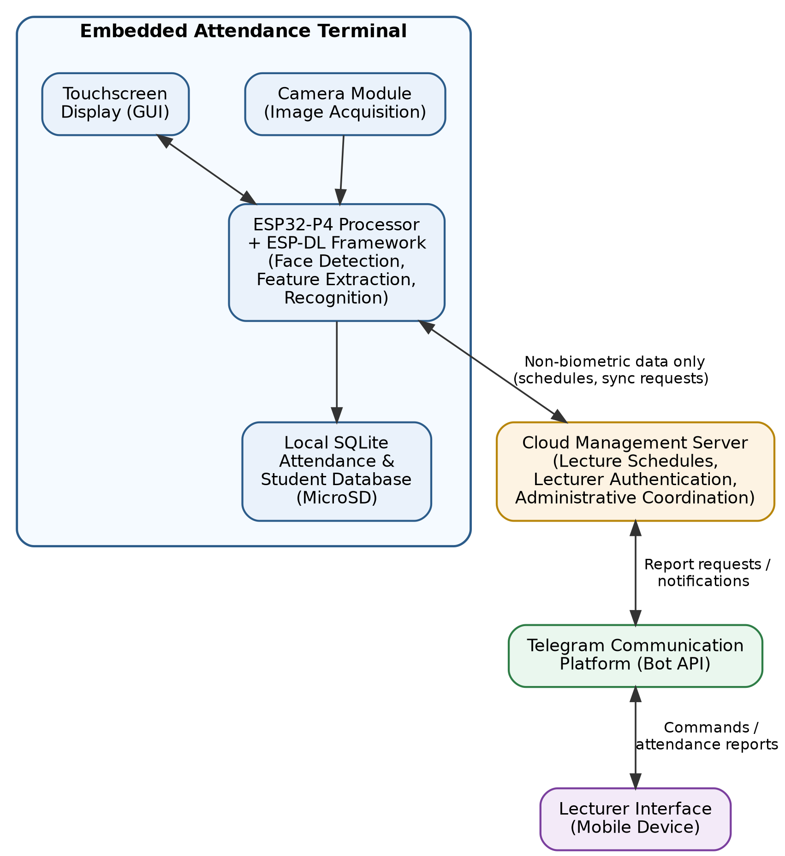Figure 3.1: Overall System Architecture

3.4.2 Functional Architecture
The proposed attendance management system is organized into several cooperating functional modules, each responsible for a specific aspect of system operation. Modular organization simplifies software development, facilitates maintenance, and allows individual components to be tested independently before system integration.
The Image Acquisition Module continuously captures image frames through the SC2336 camera and forwards them to the facial recognition subsystem. Image capture parameters are configured to provide sufficient image quality while maintaining acceptable processing speed for real-time operation.
The Face Detection Module identifies the presence and location of human faces within captured images. Only detected facial regions are forwarded to subsequent processing stages, thereby reducing unnecessary computational workload.
The Feature Extraction Module generates numerical facial embeddings from detected facial images using the ESP-DL framework. These embeddings provide compact mathematical representations of individual facial characteristics suitable for identity comparison.
The Recognition Module compares newly generated embeddings with representative templates stored within the local facial database. Identity is determined using similarity measurement techniques and predefined recognition thresholds. When a valid match is obtained, the corresponding student identity is returned to the attendance management subsystem.
The Attendance Management Module records successful attendance events by storing student identity, course information, lecture details, date, and timestamp within the local attendance database. Duplicate attendance entries for the same lecture session are prevented through validation procedures implemented within the attendance logic.
The Lecture Management Module maintains lecture schedules synchronized from the cloud server and determines whether attendance recording should be active based on scheduled lecture sessions.
The Cloud Synchronization Module periodically exchanges operational information with the cloud server, including lecture schedules, administrative commands, and report requests. Importantly, this module does not transmit facial embeddings or locally stored biometric templates.
The Telegram Communication Module provides interaction between lecturers and the attendance device through the Telegram Bot API. Lecturers may initiate report generation, receive attendance summaries, and obtain attendance records remotely without accessing the embedded device directly.
The Graphical User Interface Module provides touchscreen interaction for system administrators during student enrollment, system configuration, attendance monitoring, database management, and maintenance operations.
The interaction among these software modules forms the operational workflow of the proposed attendance management system.

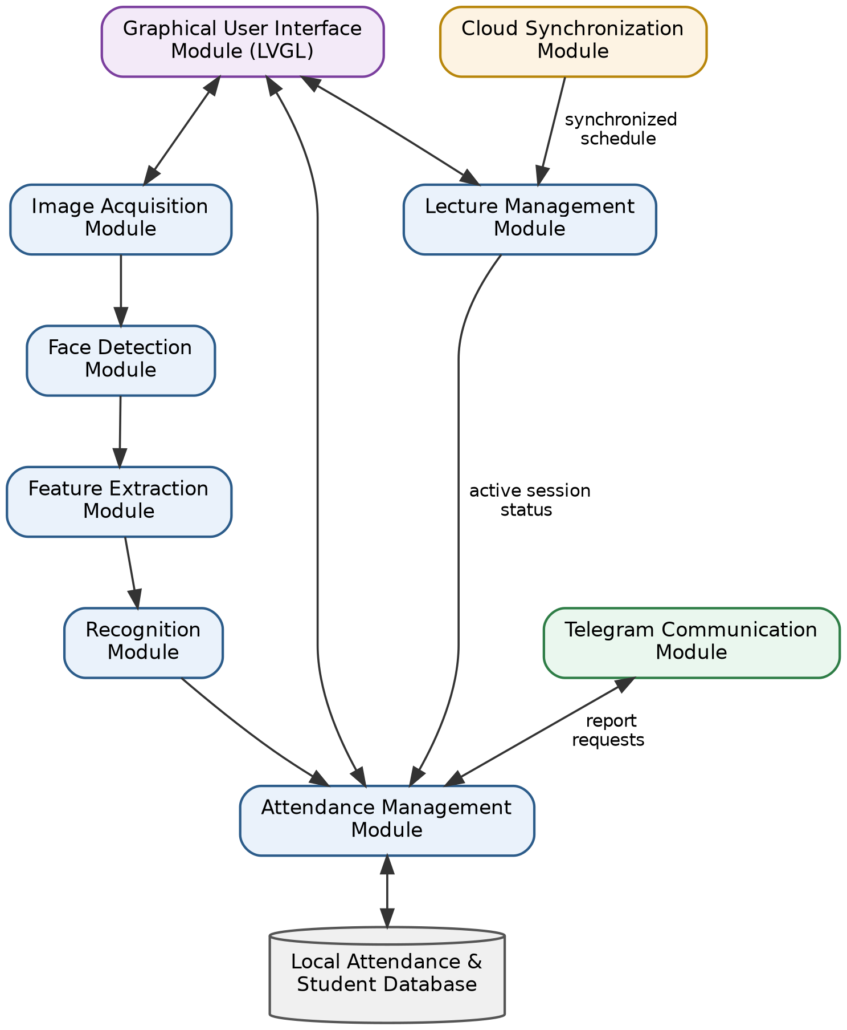Figure 3.2: Functional Architecture of the Proposed System

3.4.3 Operational Workflow
The operational workflow of the proposed attendance management system consists of two major operational phases: student enrollment and attendance verification.
During enrollment, an administrator registers a student's personal information through the touchscreen interface before initiating facial image acquisition. Multiple facial images are captured under slight variations in facial orientation and expression to improve the robustness of the generated biometric template. These images are processed by the embedded deep learning framework to generate representative facial embeddings, which are subsequently stored within the local facial database on the MicroSD card.
Attendance verification begins automatically whenever an active lecture session exists. The embedded camera continuously acquires facial images of students entering the classroom. Each detected face is processed locally through the ESP-DL recognition pipeline. If a matching facial template is identified and attendance has not previously been recorded for the current lecture session, the student's attendance is logged automatically together with the corresponding date and time.
Attendance records remain available locally throughout the lecture session. Upon request by an authorized lecturer through Telegram, the embedded device generates an attendance report and transmits the requested information without exposing stored biometric templates or facial embeddings.
This workflow ensures that attendance processing remains efficient, privacy-preserving, and independent of continuous Internet connectivity.

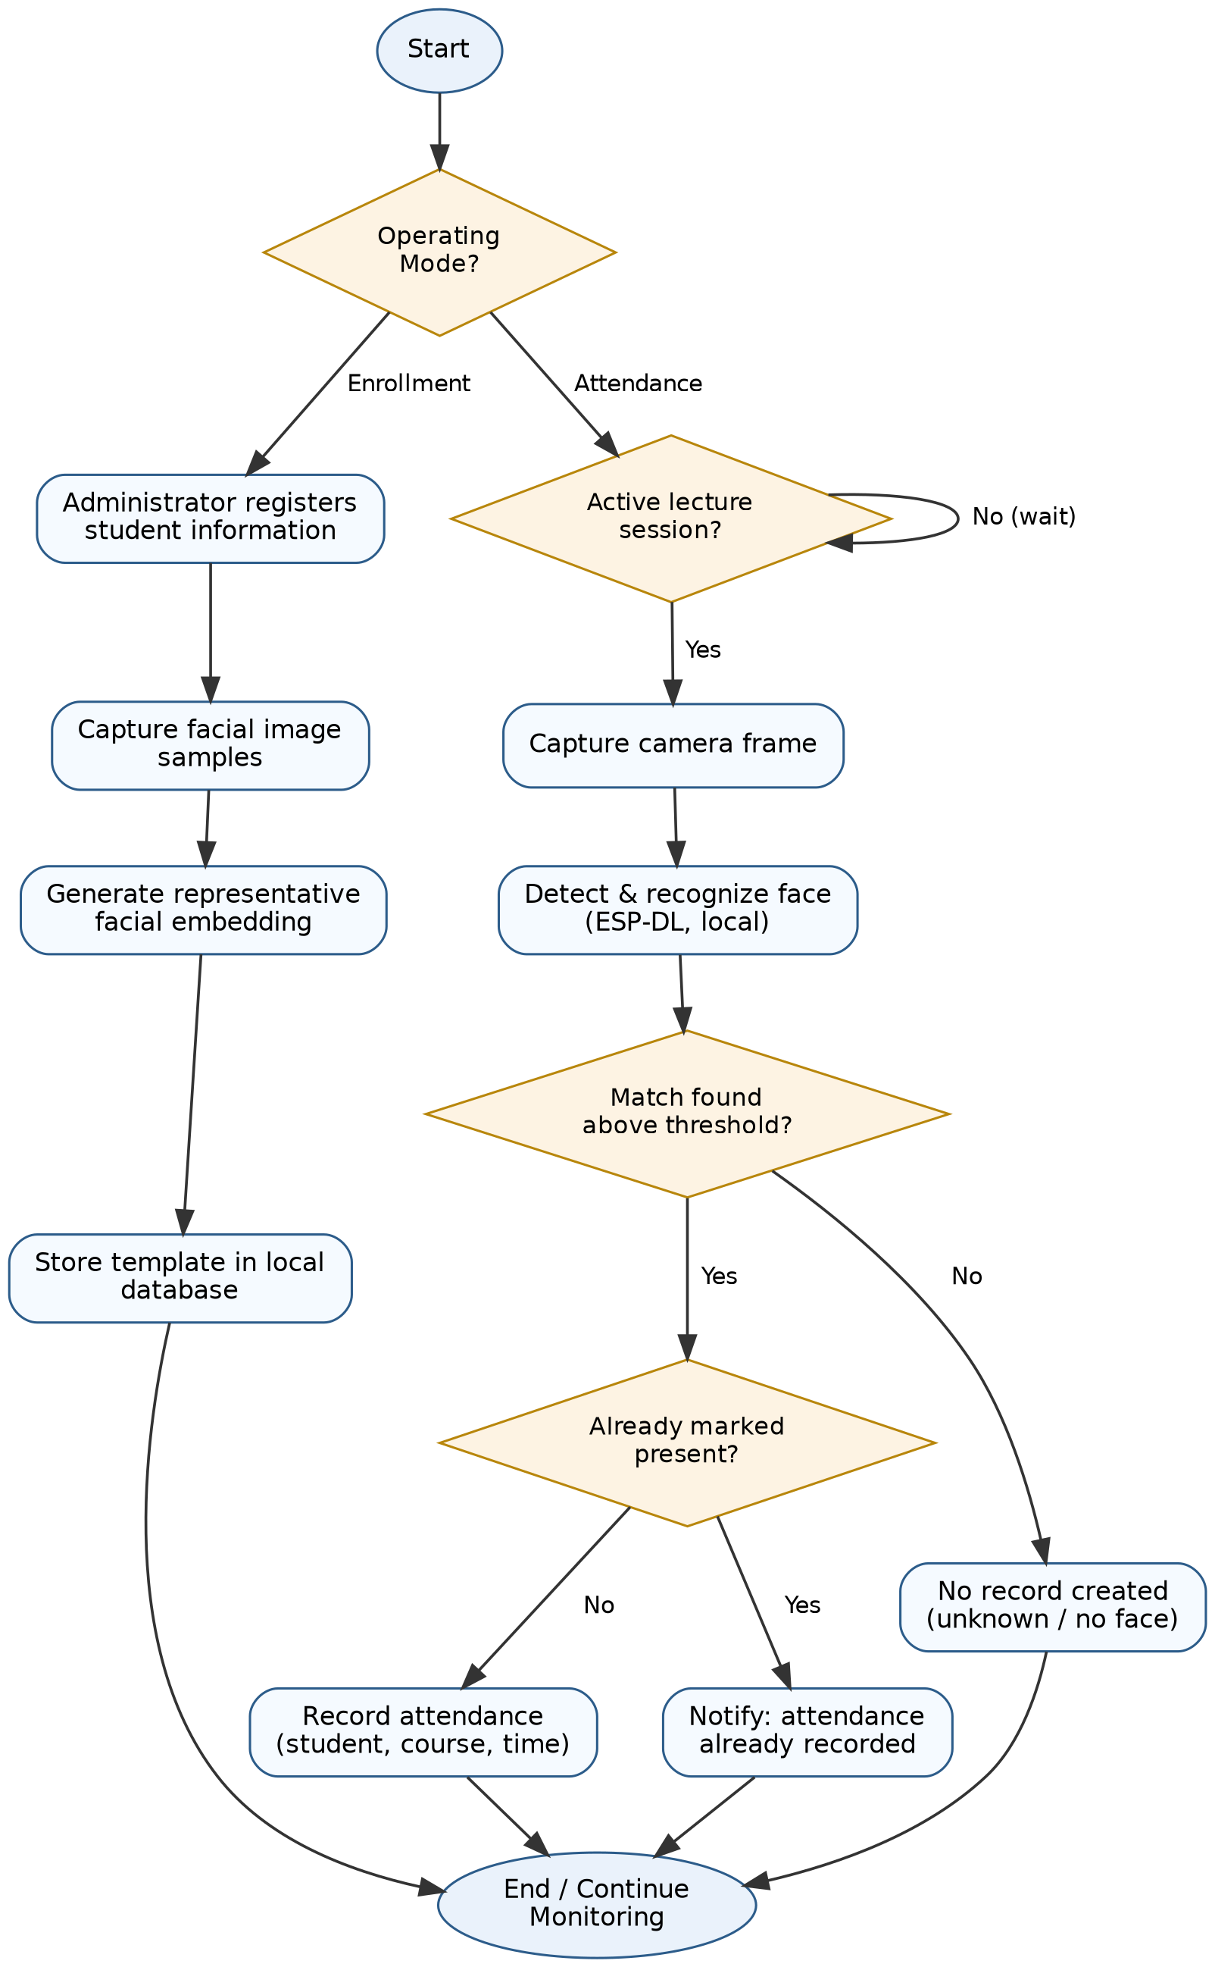Figure 3.3: Operational Flowchart of the Proposed System

3.5 Hardware Design
The hardware design of the proposed attendance management system focused on developing a compact, portable, reliable, and low-cost embedded platform capable of performing real-time facial recognition while supporting wireless communication, local data storage, and user interaction. Rather than assembling numerous independent hardware modules, the design leveraged a highly integrated development platform to reduce circuit complexity, improve system reliability, and simplify both hardware integration and software development.
The completed hardware system consists of five major subsystems:
- Processing and Control Unit
- Image Acquisition Unit
- Storage Unit
- Power Supply Unit
- Mechanical Enclosure
Each subsystem was selected based on functionality, compatibility with the ESP-DL framework, ease of integration, availability, and overall contribution to the design objectives of the study.

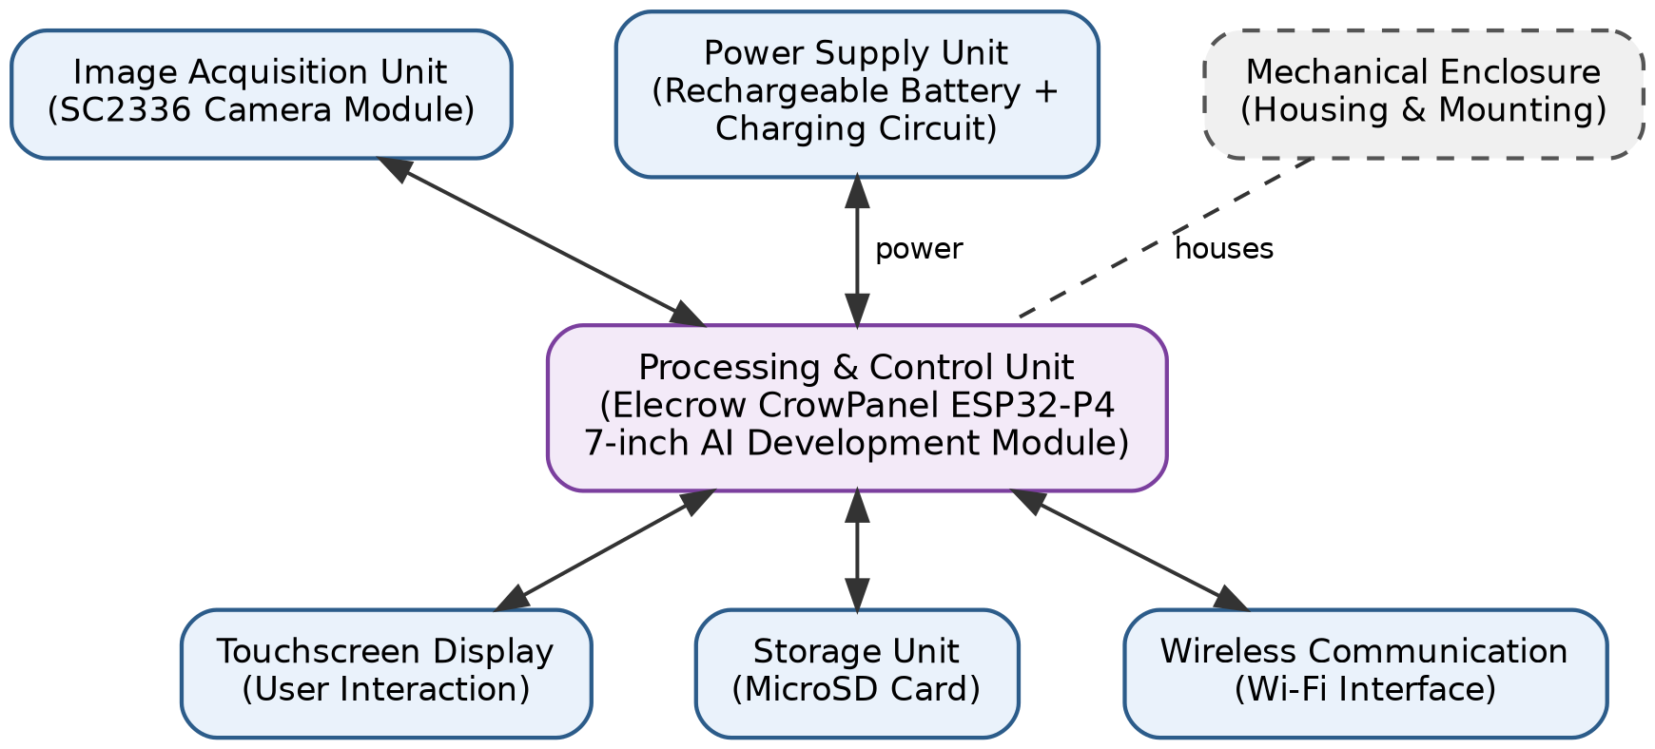Figure 3.4: Hardware Block Diagram of the Proposed System

3.5.1 Processing and Control Unit
The processing and control subsystem is built around the Elecrow CrowPanel ESP32-P4 7-inch AI Development Module, which serves as the central processing platform for the entire attendance management system. The module integrates the processor, touchscreen display, wireless communication interface, memory resources, camera interface, MicroSD interface, and peripheral controllers on a single printed circuit board, thereby eliminating the need for multiple external development modules.
The ESP32-P4 processor provides sufficient computational capability to execute embedded deep learning inference while simultaneously managing the graphical user interface, wireless networking, storage operations, and peripheral communication. Its multicore architecture and integrated memory resources allow multiple software tasks to execute concurrently under the FreeRTOS scheduler without significantly affecting the responsiveness of the attendance system.
An important advantage of the CrowPanel is its integrated 7-inch capacitive touchscreen, which functions as the primary human-machine interface. The touchscreen enables administrators to enroll students, configure system settings, monitor attendance records, manage lecture schedules, and navigate application menus without requiring external input devices. This significantly improves portability by allowing the attendance terminal to operate as a self-contained standalone device.
The module also provides integrated Wi-Fi connectivity used for communication with the cloud server and Telegram Bot, as well as an onboard MicroSD card interface that supports local storage of artificial intelligence models, biometric templates, attendance records, and application resources.
The selection of the Elecrow CrowPanel ESP32-P4 module offered several practical advantages over constructing the system from separate hardware components. First, it substantially reduced wiring complexity, thereby minimizing electrical faults commonly associated with external module interconnections. Second, the integrated hardware accelerated software development because the display, camera interface, storage interface, and communication peripherals were already supported by the manufacturer's software development framework. Finally, the compact design improved system portability and mechanical robustness while reducing the overall footprint of the attendance device.
For these reasons, the Elecrow CrowPanel ESP32-P4 AI Development Module was selected as the primary hardware platform for the implementation of the proposed attendance management system.

3.5.2 Image Acquisition Unit
The image acquisition subsystem is responsible for capturing facial images that serve as the input to the embedded facial recognition pipeline. Image quality directly influences recognition performance because the facial detection and feature extraction algorithms depend on clear and properly exposed facial images for reliable operation.
The implemented system utilizes the factory-installed SC2336 camera module supplied with the Elecrow CrowPanel development board. The camera interfaces directly with the ESP32-P4 processor through the dedicated camera interface provided by the development platform, ensuring reliable communication and compatibility with the ESP-DL framework.
During the preliminary design stage, an autofocus camera module was considered as a possible replacement for the factory-installed camera because autofocus capability could potentially improve image sharpness across varying capture distances. However, implementation constraints prevented its adoption. The CrowPanel development board provides a 24-pin camera connector, whereas the available autofocus camera module utilizes a physically larger 15-pin interface that is mechanically incompatible with the development board. In addition to the connector mismatch, the differing interface configurations would have required extensive hardware modifications and driver development beyond the scope of the present study.
Consequently, the factory-installed SC2336 camera module was retained throughout the implementation. Besides ensuring full hardware compatibility, the camera demonstrated stable performance during experimental testing and provided image quality sufficient for accurate face detection and recognition under normal indoor classroom lighting conditions.
Retaining the factory-supported camera also reduced software integration complexity because the device is fully supported by the manufacturer's firmware libraries and the ESP-DL framework. This decision improved overall system stability while minimizing implementation risks associated with unsupported imaging hardware.

3.5.3 Storage Unit
Reliable storage is essential for maintaining the software resources and operational data required by the attendance management system. Unlike conventional attendance systems that rely on remote databases for continuous data storage, the proposed architecture stores operational information locally in accordance with the privacy-preserving design philosophy adopted in this study.
An 8 GB MicroSD memory card was selected as the primary storage medium due to its adequate storage capacity, low cost, portability, and compatibility with the integrated SD card interface of the CrowPanel development board.
The storage subsystem accommodates several categories of information, including:
- ESP-DL deep learning models required for facial detection and recognition.
- Representative facial embedding templates generated during student enrollment.
- Student attendance records.
- System configuration files.
- Application resources and operational logs.
Local storage of biometric templates ensures that sensitive facial information remains permanently within the embedded device, thereby reducing privacy risks associated with centralized cloud databases. Furthermore, the use of removable storage simplifies software maintenance, database backup, and future system upgrades without requiring modifications to the internal hardware.
Experimental implementation demonstrated that the selected storage capacity provides sufficient space for both the embedded AI models and the operational database while allowing additional capacity for future expansion as the number of enrolled students increases.

3.5.4 Power Supply Unit
The attendance management system was designed as a portable embedded platform capable of operating independently of continuous mains electricity. This requirement is particularly important for deployment in lecture rooms, seminar halls, temporary examination venues, and other academic environments where convenient access to electrical outlets cannot always be guaranteed.
Power is supplied by a 10,000 mAh rechargeable lithium-ion battery, selected based on its high energy density, portability, and widespread availability. The battery provides sufficient capacity to support extended operation of the ESP32-P4 processor, touchscreen display, camera subsystem, MicroSD storage, and wireless communication modules during normal academic activities.
The rechargeable nature of the battery eliminates the recurring cost associated with disposable power sources while supporting repeated daily operation. Furthermore, battery-powered operation protects the attendance system from temporary power interruptions that might otherwise result in incomplete attendance records or unexpected system shutdown during active lecture sessions.
The integrated power management circuitry provided by the CrowPanel development board regulates the operating voltages required by the processor and peripheral devices, thereby simplifying hardware implementation and improving overall system reliability.

3.5.5 Enclosure Design
The enclosure serves as the mechanical housing for the complete attendance management system and provides protection against accidental physical damage while improving portability and ease of deployment.
Several enclosure options were evaluated during the design stage. Commercially available plastic enclosures were initially considered because they offered rapid deployment and professional appearance. However, available enclosure dimensions could not adequately accommodate the physical arrangement of the CrowPanel development board, battery, camera assembly, and associated mounting requirements.
A custom enclosure produced through three-dimensional (3D) printing was also considered. Although additive manufacturing would have allowed the enclosure geometry to be optimized specifically for the hardware assembly, this option was not adopted because it conflicted with one of the principal objectives of the study—developing a low-cost attendance management system using readily available materials and fabrication techniques. The additional cost of 3D printing equipment or commercial printing services would reduce the affordability of the proposed design, particularly for institutions intending to deploy multiple units.
Consequently, the enclosure was fabricated manually using polyvinyl chloride (PVC) plumbing pipe, a material selected because of its low cost, mechanical strength, ease of machining, and widespread local availability. The PVC enclosure was carefully cut, shaped, assembled, and finished by hand to accommodate the installed hardware while maintaining structural rigidity and portability. After fabrication, the enclosure was coated with a fast-drying spray paint to improve its aesthetic appearance and provide additional surface protection against environmental wear.
The completed enclosure successfully houses the embedded hardware while demonstrating that practical Edge AI systems can be constructed using inexpensive, locally obtainable materials without compromising functionality. This design choice aligns with the study's objective of producing a cost-effective attendance management system suitable for adoption by educational institutions with limited financial resources.

3.6 Software Design
The software design of the proposed attendance management system was guided by the objectives of achieving real-time facial recognition, efficient resource utilization, reliable attendance management, and privacy-preserving operation on an embedded computing platform. Unlike desktop or cloud-based attendance systems that possess abundant computational resources, the proposed system was developed for an embedded environment where processor performance, memory capacity, storage resources, and communication bandwidth are inherently limited. Consequently, the software architecture emphasizes modularity, efficient memory utilization, task isolation, and progressive integration.
An iterative software development methodology was adopted throughout implementation. Rather than developing the entire application as a single software package, individual software modules were implemented, tested, validated, and optimized independently before integration into the complete system. This approach reduced debugging complexity, improved software stability, and simplified identification of implementation errors during development.
The final software architecture consists of several cooperating functional modules responsible for user interaction, image acquisition, facial recognition, attendance management, local database operations, cloud synchronization, and remote communication. Although these modules perform different functions, they operate cooperatively under the FreeRTOS real-time operating system to provide seamless user interaction.

3.6.1 Software Architecture
The proposed software architecture follows a layered modular design in which hardware abstraction, application logic, artificial intelligence processing, communication services, and user interaction are organized into independent functional layers. This organization improves software maintainability while reducing dependencies between unrelated system components.
At the lowest level, the hardware abstraction layer provides standardized interfaces for the touchscreen display, camera subsystem, wireless communication hardware, MicroSD storage, timers, memory resources, and peripheral devices. By separating hardware control from application logic, software modifications can be implemented without significantly affecting hardware drivers.
The embedded artificial intelligence layer implements the ESP-DL facial detection and recognition framework. This layer receives image data from the camera subsystem, performs facial detection and feature extraction, generates facial embeddings, and compares extracted features with representative templates stored within the local database.
Above the artificial intelligence layer is the application layer, which coordinates student enrollment, attendance verification, database management, lecture scheduling, graphical user interaction, report generation, and cloud synchronization. The application layer also manages interactions among the various software modules to ensure correct sequencing of system operations.
Communication with external services is handled by a dedicated networking layer responsible for Wi-Fi connectivity, cloud synchronization, and Telegram communication. Separating networking functionality from attendance processing ensures that temporary communication failures do not interrupt local facial recognition or attendance recording.
The modular organization adopted during implementation simplifies software maintenance because each subsystem can be modified independently without requiring extensive changes to unrelated application components.

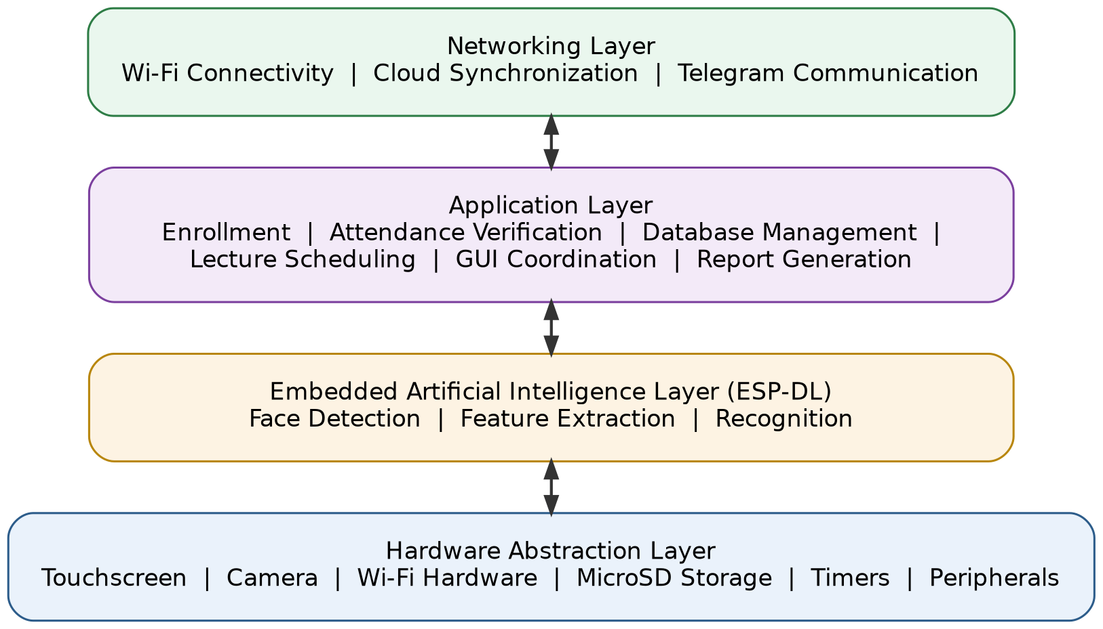Figure 3.5: Software Architecture of the Proposed System

3.6.2 Software Development Methodology
Software development followed an iterative engineering methodology consisting of progressive implementation, subsystem verification, integration, and optimization. Instead of implementing all application features simultaneously, development was divided into a sequence of manageable stages, each introducing additional system functionality while preserving the stability of previously completed modules.
The initial development stage focused on establishing a stable firmware foundation by verifying the functionality of the display, touchscreen interface, camera subsystem, wireless communication, and external storage. Successful verification of these hardware resources established a reliable platform upon which higher-level software modules could subsequently be developed.
Following hardware validation, software development proceeded through successive implementation phases involving graphical user interface construction, local database management, attendance processing, cloud communication, embedded facial recognition, and overall system optimization. Each development phase concluded with functional testing before subsequent modules were introduced. This incremental development strategy significantly reduced debugging complexity and improved software reliability throughout the implementation process.
As development progressed, repeated performance evaluations were performed to identify computational bottlenecks, excessive memory utilization, and communication delays. Necessary software refinements were introduced following each evaluation cycle until the integrated attendance management system satisfied the intended functional requirements.
This iterative methodology proved particularly beneficial because the project combined embedded artificial intelligence, graphical user interfaces, local databases, wireless communication, and cloud synchronization within a single resource-constrained embedded platform.

3.6.3 Task Management Using FreeRTOS
The proposed attendance management system employs the FreeRTOS real-time operating system integrated within ESP-IDF to support concurrent execution of multiple software tasks. The multitasking capabilities provided by FreeRTOS enable different system functions to operate independently while sharing processor resources efficiently.
Instead of executing all operations sequentially within a single application loop, major system functions were separated into independent tasks responsible for user interface management, camera operation, facial recognition, attendance processing, cloud synchronization, and communication services. This organization improves system responsiveness by allowing computationally intensive operations, such as facial recognition, to execute independently of graphical user interface updates and network communication.
Inter-task communication is coordinated through FreeRTOS synchronization mechanisms to ensure safe sharing of application resources and prevent conflicts between concurrently executing tasks. This architecture also improves fault isolation because temporary delays within one subsystem do not necessarily interrupt the execution of unrelated software components.
The adoption of FreeRTOS therefore provides the software infrastructure necessary for reliable real-time operation while supporting the concurrent execution of multiple application services on the ESP32-P4 processor.

3.6.4 Graphical User Interface Design
The graphical user interface (GUI) serves as the primary interaction mechanism between administrators and the attendance management system. The interface was developed using the Light and Versatile Graphics Library (LVGL) because of its efficient memory utilization, extensive widget library, and native compatibility with the ESP-IDF framework.
The interface was designed to provide an intuitive touchscreen experience while minimizing user interaction complexity. Administrative functions were organized into logical menus that allow authorized users to perform student enrollment, manage attendance records, configure system settings, synchronize lecture schedules, and monitor system status.
During software development, particular attention was given to interface responsiveness because embedded graphical applications must operate efficiently alongside computationally intensive facial recognition tasks. Consequently, graphical updates were carefully coordinated with background processing activities to maintain smooth user interaction without adversely affecting recognition performance.
The graphical interface also provides visual feedback during enrollment, attendance verification, synchronization, and administrative operations, thereby improving usability and simplifying system operation for non-technical users.

3.6.5 Facial Enrollment Methodology
The facial enrollment module was designed to generate a statistically robust representative biometric template for each enrolled student while minimizing the influence of image quality variations, facial pose differences, and transient acquisition errors. Unlike conventional embedded facial recognition systems that store a single facial image or embedding during enrollment, the proposed system employs a multi-stage enrollment algorithm that captures multiple facial observations, filters poor-quality samples, clusters similar facial representations, and synthesizes a single representative facial template for subsequent recognition.
Enrollment begins after an administrator successfully registers the student's academic information, including the student's full name, matriculation number, department, and level of study through the touchscreen interface. Once the student's information has been recorded, the system activates the camera subsystem and begins acquiring facial samples.
To ensure consistency and reliability, approximately thirty valid facial samples are collected during each enrollment session. However, not every captured image is accepted automatically. Each frame undergoes a quality validation process before it is admitted into the enrollment dataset. A frame is accepted only when it satisfies all predefined quality requirements, namely the presence of exactly one detectable face, sufficient detection confidence, acceptable facial dimensions within the captured image, adequate image sharpness, suitable illumination, and an acceptable head orientation. Frames that fail any of these requirements are discarded immediately, while the graphical user interface provides real-time guidance to assist the user in achieving acceptable positioning. Throughout the acquisition process, the touchscreen continuously displays the enrollment progress using a sample counter together with instructional prompts such as "Hold Still," "Position Face," and "Face Camera Directly" whenever necessary.
Each accepted facial image is subsequently processed by the ESP-DL feature extraction model to generate a 128-dimensional facial embedding representing the distinguishing biometric characteristics of the captured face. Rather than storing these embeddings immediately, all accepted embeddings are temporarily maintained in external PSRAM throughout the enrollment session. Temporary storage in PSRAM avoids excessive consumption of the ESP32-P4's internal memory while providing sufficient capacity for intermediate processing without causing heap fragmentation or stack overflow.
After acquisition of the complete enrollment dataset, the system evaluates the consistency of the captured embeddings through pairwise cosine similarity analysis. A complete inter-sample similarity matrix is generated by comparing every embedding with every other embedding within the enrollment dataset. From this matrix, the average similarity of each embedding to all remaining embeddings is calculated, followed by determination of the overall mean similarity and corresponding standard deviation. Embeddings whose average similarity falls significantly below the overall distribution are regarded as statistical outliers and are removed automatically. Specifically, an embedding is discarded whenever its similarity value falls below the adaptive threshold
T=max(µ-1.5σ, 0.65)
where µ denotes the mean inter-sample similarity and σ represents the corresponding standard deviation. The inclusion of the minimum similarity bound of 0.65 prevents excessively permissive thresholds under unusually noisy enrollment conditions. This adaptive filtering process effectively removes facial samples affected by temporary motion blur, blinking, partial facial occlusion, glare, or abrupt illumination changes without relying upon arbitrary fixed similarity values.
The remaining high-quality embeddings are subsequently grouped using the K-Means clustering algorithm. The enrollment algorithm initially partitions the dataset into three clusters, representing the most common facial pose variations encountered during enrollment, namely frontal orientation, slight left rotation, and slight right rotation. However, because some enrollment sessions naturally produce fewer pose variations, the clustering procedure dynamically removes empty clusters, allowing the effective number of clusters to decrease automatically whenever necessary. This adaptive clustering strategy prevents artificial cluster centroids from influencing the representative template.
Following clustering, the centroid of each non-empty cluster is computed. Rather than selecting one centroid directly, the proposed system synthesizes a single representative facial template using a cluster-size weighted averaging technique. Each cluster centroid contributes to the final template according to the number of facial samples contained within that cluster, ensuring that more frequently observed facial orientations contribute proportionally more to the representative embedding. The resulting weighted embedding is subsequently normalized to restore its average Euclidean magnitude before being quantized into an 8-bit integer representation suitable for efficient embedded storage and rapid similarity computation during attendance verification.
Unlike many facial recognition systems that permanently retain all enrollment samples, the proposed system stores only the final representative embedding within the local SQLite database. This significantly reduces storage requirements while preserving recognition performance. Alongside the representative embedding, the database records additional enrollment metadata, including the enrollment quality score, the number of accepted and rejected facial samples, the embedding dimension, the deep learning model version, and the enrollment timestamp. These metadata facilitate future system maintenance, debugging, and possible model upgrades without requiring repeated enrollment of all users.
To provide immediate feedback regarding enrollment reliability, the system computes an overall enrollment quality score ranging from 0 to 100. The quality score is derived from three principal performance indicators: the proportion of accepted facial samples, the compactness of the resulting facial clusters, and the average sharpness of the accepted facial images. Based on the computed score, each enrollment session is classified into one of four quality categories: Excellent (85–100), Good (70–84), Average (55–69), or Poor (below 55). Upon completion of enrollment, the graphical user interface presents a quality summary indicating the numerical score together with the numbers of accepted and rejected samples. When the enrollment quality is classified as Poor, the interface additionally provides the administrator with the option of immediately repeating the enrollment process to obtain a more representative biometric template.
The enrollment methodology adopted in this study provides several advantages over conventional single-image enrollment techniques. Statistical outlier removal improves the consistency of stored biometric templates, pose clustering increases robustness to natural head orientation variations, weighted centroid synthesis produces a stable representative facial embedding, and metadata preservation supports future system diagnostics and maintenance. Collectively, these design decisions enhance recognition reliability while maintaining efficient utilization of the computational and memory resources available on the ESP32-P4 embedded platform.

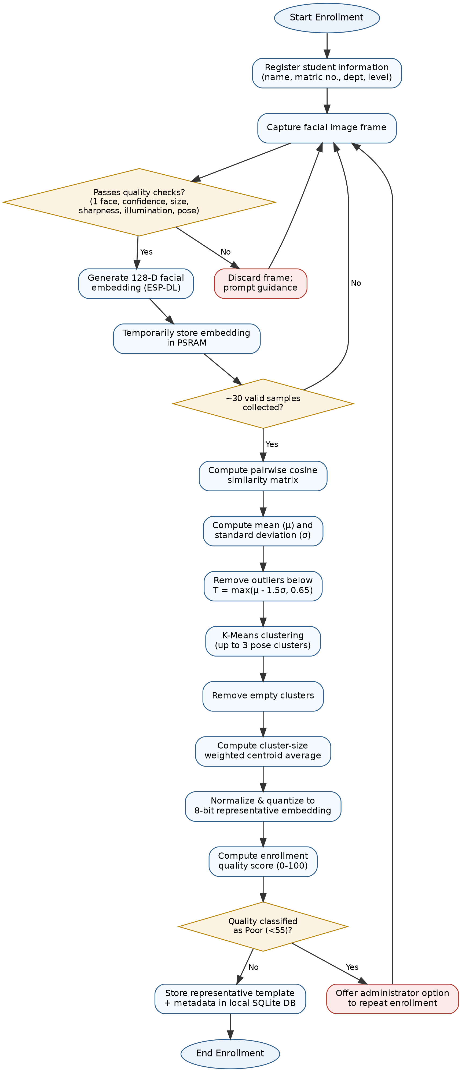Figure 3.6: Flowchart of the Representative Facial Template Enrollment Algorithm

3.6.6 Facial Recognition and Attendance Verification
The facial recognition and attendance verification module constitutes the core operational component of the proposed attendance management system. Its primary function is to identify enrolled students in real time using facial biometrics and automatically record attendance for authorized lecture sessions. The module was designed to achieve high recognition accuracy while operating within the computational and memory constraints of the ESP32-P4 embedded platform. To accomplish this, the system performs all biometric processing locally using the ESP-DL framework, thereby eliminating the need to transmit facial images or biometric templates to external servers during routine attendance verification.
Unlike conventional cloud-based attendance systems that depend on remote servers for facial recognition, the proposed system adopts an Edge AI architecture in which face detection, feature extraction, identity matching, and attendance recording are executed entirely on the embedded device. Consequently, Internet connectivity is required only for lecture schedule synchronization and communication with the Telegram Bot, while the biometric recognition process remains fully operational even during temporary network interruptions.
Attendance verification is activated only during scheduled lecture sessions retrieved from the synchronized timetable. Restricting recognition to active lecture periods minimizes unnecessary processor utilization, reduces power consumption, and prevents attendance records from being created outside authorized class hours.
Once an attendance session becomes active, the camera continuously captures image frames for analysis. Each frame is first processed by the ESP-DL face detection module to determine whether a valid human face is present within the camera's field of view. The implemented system is designed to process only one face at a time. This design decision simplifies the recognition pipeline, reduces computational complexity, and minimizes identity ambiguity during attendance verification.
If no face is detected, the captured frame is discarded and the system immediately continues monitoring subsequent frames. Similarly, when multiple faces appear simultaneously within the camera's field of view, the recognition process is temporarily suspended. Rather than attempting simultaneous recognition, the graphical user interface instructs users to ensure that only one individual stands before the attendance terminal. Recognition resumes automatically once a single valid face is detected. This controlled operating procedure significantly reduces the possibility of incorrect identity assignment while improving overall recognition reliability in classroom environments.
After a valid single face has been detected, the feature extraction stage generates a 128-dimensional facial embedding using the same ESP-DL deep learning model employed during the enrollment process. Maintaining identical feature extraction procedures during enrollment and recognition ensures compatibility between the live biometric representation and the representative templates stored within the local database.
The generated facial embedding is subsequently compared with the representative embeddings of all enrolled students stored in the local SQLite database. Identity comparison is performed using cosine similarity, which evaluates the angular similarity between two embedding vectors while remaining computationally efficient for embedded implementation. For every recognition attempt, the system computes similarity scores against all enrolled templates and identifies the template with the highest similarity value.
Recognition is accepted only when the highest similarity score exceeds the predefined recognition threshold configured within the system. If the similarity score falls below this threshold, the detected individual is classified as an unknown person, and no attendance record is generated. This verification strategy reduces the likelihood of false acceptance while ensuring that attendance is recorded only for successfully recognized enrolled students.
Following successful identity verification, the attendance management module performs an additional validation step to prevent duplicate attendance entries. The system searches the attendance database to determine whether the identified student has already been marked present for the current lecture session. If an existing attendance record is found, no additional entry is created, and the graphical user interface informs the user that attendance has already been recorded. This mechanism prevents repeated presentation before the camera from generating multiple attendance records for the same lecture.
If no previous attendance record exists, a new attendance entry is immediately created within the local SQLite database. Each attendance record contains the student's identity, matriculation number, course information, lecture identifier, attendance status, date, and time of successful verification. Since these records are stored locally on the MicroSD card, the attendance database remains accessible even when Internet connectivity is temporarily unavailable.
The graphical user interface provides immediate visual feedback throughout the recognition process. Upon successful verification, the system displays the student's identity together with a confirmation indicating that attendance has been recorded successfully. Conversely, when recognition cannot be completed because of insufficient lighting, excessive head rotation, poor image quality, multiple faces within the camera view, or the absence of a matching biometric template, the interface provides appropriate guidance to assist the user in achieving successful recognition.
To maintain smooth system performance, facial recognition operates concurrently with the graphical user interface, attendance management, database services, and cloud communication through the multitasking capabilities provided by FreeRTOS. Computationally intensive recognition tasks are therefore executed independently of interface rendering and network operations, ensuring that user interaction remains responsive throughout attendance sessions.
The decision to process a single face at a time was made deliberately during system development. Besides simplifying the embedded recognition pipeline, this approach reduces processor workload, lowers memory requirements, minimizes identity ambiguity, and improves recognition stability on the resource-constrained ESP32-P4 platform. Furthermore, the design is well suited to controlled academic environments where students can briefly present themselves individually before the attendance terminal during attendance registration.
Overall, the facial recognition and attendance verification methodology provides an efficient, privacy-preserving, and reliable mechanism for automated attendance recording while remaining compatible with the computational capabilities of the embedded Edge AI platform. The combination of local biometric processing, representative facial templates, duplicate attendance prevention, and controlled single-user recognition contributes to the dependable operation of the proposed attendance management system.

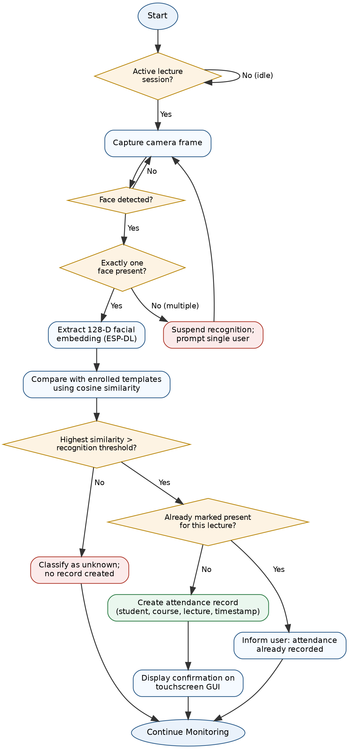Figure 3.7: Facial Recognition and Attendance Verification Workflow

3.6.7 Attendance Management and Database Design
The attendance management subsystem coordinates the storage, retrieval, validation, and reporting of attendance information generated during lecture sessions. It serves as the bridge between the facial recognition module and the persistent database by ensuring that attendance records are created accurately, duplicate entries are prevented, and all relevant information is retained for subsequent reporting and administrative purposes. The subsystem was designed to operate entirely on the embedded device, thereby supporting the privacy-preserving architecture adopted in this study.
Unlike cloud-dependent attendance systems that continuously synchronize attendance records with remote databases, the proposed system stores all attendance information locally using an SQLite database located on the MicroSD card. This design minimizes network dependence while ensuring that attendance records remain accessible even when Internet connectivity is unavailable. Local database storage also provides faster data retrieval, reduced communication latency, and improved protection of students' biometric information.
The SQLite database was selected because it is lightweight, serverless, and well suited to embedded applications with limited hardware resources. Since SQLite stores the complete database within a single file, database management becomes significantly simpler while maintaining adequate reliability for the expected attendance workload. Furthermore, SQLite does not require a dedicated database server, thereby reducing software complexity and memory consumption.
The database architecture consists of several logical entities that collectively manage student information, biometric templates, lecture schedules, attendance records, and system configuration data. During student enrollment, personal information and the representative facial embedding generated by the enrollment algorithm are stored within the student database. In addition to the biometric template, the system records supplementary enrollment metadata, including the enrollment quality score, the number of accepted and rejected facial samples, the embedding dimension, the artificial intelligence model version, and the enrollment timestamp. These metadata provide valuable diagnostic information for future maintenance, software upgrades, and performance evaluation.
Attendance records are maintained separately from the biometric database. Each attendance entry contains the student's identity, matriculation number, course identifier, lecture identifier, attendance date, attendance time, and attendance status. Separating attendance records from biometric templates improves database organization while reducing unnecessary access to sensitive biometric information during routine attendance reporting.
To preserve data integrity, the attendance management subsystem performs validation before inserting new attendance records. After successful facial recognition, the subsystem determines whether the identified student has already been marked present for the currently active lecture session. If a corresponding attendance record already exists, the insertion request is rejected, and the user interface informs the student that attendance has previously been recorded. Consequently, repeated presentation before the camera does not generate duplicate attendance entries within the database.
Attendance records are created automatically immediately after successful identity verification. The database transaction includes validation of the lecture schedule, confirmation of the student's identity, generation of the attendance timestamp, and storage of the completed attendance record. The use of automatic timestamp generation ensures consistency across all attendance records while eliminating errors associated with manual data entry.
To support efficient retrieval of attendance information, database queries are organized according to common administrative operations such as searching by lecture session, course, date, or individual student. This organization allows attendance reports to be generated rapidly without requiring exhaustive searches through the entire database.
In addition to attendance information, the database stores system configuration parameters that control operational behaviour, including recognition thresholds, administrative settings, and synchronization preferences. Maintaining configuration data within the same database simplifies software maintenance and allows system parameters to persist across power cycles without requiring firmware modification.
Since the attendance database resides on the removable MicroSD card, backup and restoration procedures can be performed conveniently by copying the database file to external storage. This capability improves data security while simplifying long-term archival of attendance records and disaster recovery procedures.
Overall, the database design adopted in this study provides a lightweight, reliable, and privacy-conscious data management solution suitable for embedded attendance applications. The combination of local SQLite storage, representative biometric templates, duplicate attendance prevention, and structured data organization enables efficient attendance management while maintaining compatibility with the computational constraints of the ESP32-P4 platform.
Table 3.3: SQLite Database Tables and Their Functions
Table Name | Fields & Constraints | Functional Role
users | id (INTEGER PK AUTOINCREMENT); uuid (TEXT UNIQUE NOT NULL); name (TEXT NOT NULL); student_id (TEXT UNIQUE); phone_number (TEXT); telegram_id (TEXT); role (TEXT CHECK IN 'student'/'lecturer'/'admin'); face_embedding (BLOB); created_at; updated_at; enroll_quality; enroll_accepted; enroll_rejected; model_version; embedding_dim | Records participant identities, roles, BLE/Telegram details, and stores the local 128-dimensional biometric templates alongside average quality scores.
courses | id (INTEGER PK AUTOINCREMENT); uuid (TEXT UNIQUE NOT NULL); name (TEXT NOT NULL); code (TEXT UNIQUE NOT NULL) | Stores registered academic courses and their alphanumeric codes (e.g. MTE534) for reporting.
lecturer_courses | lecturer_id (FK -> users.id); course_id (FK -> courses.id); PRIMARY KEY (lecturer_id, course_id) | Establishes the relationship mapping lecturers to their respective courses.
user_courses | user_id (FK -> users.id); course_id (FK -> courses.id); enrolled_at; enrolled_by; PRIMARY KEY (user_id, course_id) | Registers student course enrollments for attendance cross-referencing.
schedule | id (INTEGER PK AUTOINCREMENT); uuid (TEXT UNIQUE NOT NULL); course_id (FK -> courses.id); start_time; end_time; location; recurrence_rule; created_at | Defines individual lecture sessions, exams, and test windows with start/end Unix timestamps.
attendance | id (INTEGER PK AUTOINCREMENT); uuid (TEXT UNIQUE NOT NULL); user_id (FK -> users.id); schedule_id (FK -> schedule.id); timestamp; status ('present'/'late'/'absent'); sync_status | Logs biometric attendance records linking users to specific schedule events.
sync_state | id (PK, CHECK id=1); last_sync_timestamp; last_event_id; server_url | Persists device-to-cloud synchronization progress and backend endpoint configuration.

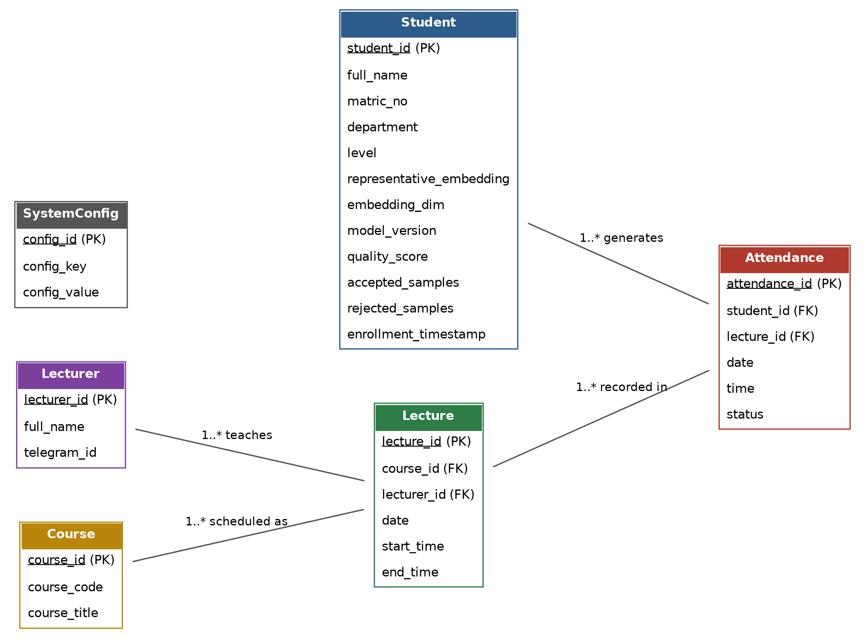Figure 3.8: Entity Relationship Diagram (ERD) of the Attendance Database

3.6.8 Cloud Synchronization and Telegram Integration
Although the proposed attendance management system performs all biometric processing locally, cloud communication remains an essential component for administrative coordination, lecture scheduling, and remote interaction. Rather than functioning as a cloud-dependent attendance system, the proposed architecture adopts a hybrid Edge–Cloud approach, where the embedded device performs all privacy-sensitive operations locally while cloud services provide supplementary communication and management functions.
This design ensures that attendance verification remains operational even when Internet connectivity is unavailable, while still allowing lecturers to interact remotely with the system whenever network access is restored.

3.6.8.1 Cloud Synchronization
Cloud synchronization is responsible for exchanging operational information between the embedded attendance terminal and the remote management server. Unlike conventional cloud-based biometric systems, synchronization does not involve uploading facial images, facial embeddings, or biometric templates. Instead, only administrative information required for system operation is transmitted.
The synchronization module periodically establishes a secure Wi-Fi connection with the cloud server whenever network connectivity is available. During synchronization, the system exchanges information such as lecture schedules, course assignments, authorized lecturer information, and system configuration updates. This enables the attendance terminal to maintain an up-to-date timetable without requiring manual reconfiguration before each lecture.
The synchronization process is intentionally lightweight to minimize bandwidth consumption and reduce synchronization time. Since attendance records and biometric data remain on the embedded device, synchronization traffic consists primarily of small text-based messages and scheduling information.
To improve reliability, synchronization is executed as an independent FreeRTOS task operating in the background. Consequently, temporary communication delays do not interrupt facial recognition, attendance recording, or graphical user interface operation. If Internet connectivity is lost, synchronization requests are postponed until network communication is restored, while all local attendance functions continue normally.
This separation between local attendance processing and cloud-based administration represents one of the principal design features of the proposed system. It provides the operational advantages of cloud-assisted management without exposing sensitive biometric information to external servers.

3.6.8.2 Telegram Bot Integration
To provide convenient remote interaction, the attendance management system incorporates a Telegram Bot that serves as the primary communication interface between lecturers and the embedded attendance terminal. Telegram was selected because of its widespread availability, cross-platform compatibility, secure messaging infrastructure, and support for programmable bot services through the Telegram Bot API.
The Telegram Bot allows authorized lecturers to communicate with the attendance system without requiring physical access to the device. Through predefined bot commands, lecturers can request attendance reports, verify the operational status of the attendance terminal, and receive system notifications directly on their mobile devices.
When a lecturer submits a supported command through Telegram, the request is forwarded to the embedded device via the cloud communication service. The attendance terminal validates the request, retrieves the required information from the local SQLite database, and generates the appropriate response. Depending on the requested operation, the system may return attendance summaries, lecture information, or confirmation messages indicating successful execution of administrative tasks.
Authentication mechanisms are implemented to ensure that only authorized Telegram users can communicate with the attendance system. Incoming requests are validated before execution to prevent unauthorized access to attendance information or administrative functions.
The use of Telegram significantly improves system usability by enabling lecturers to obtain attendance information without physically operating the touchscreen interface. This is particularly beneficial after lectures have concluded, as attendance summaries can be requested remotely without interrupting ongoing academic activities.

3.6.8.3 Privacy and Security Considerations
A major design objective of the proposed attendance management system is the protection of students' biometric information. Consequently, the cloud communication architecture was intentionally designed to separate administrative communication from biometric processing.
Throughout normal system operation, facial images, representative facial embeddings, and attendance recognition computations remain entirely within the embedded attendance terminal. The cloud server neither stores nor processes biometric information. Instead, it functions only as a communication intermediary responsible for administrative coordination.
Similarly, the Telegram Bot does not have direct access to the biometric database. All attendance information supplied through Telegram originates from the embedded SQLite database after successful authentication of the requesting lecturer. This architecture significantly reduces the attack surface associated with cloud-based biometric systems while ensuring compliance with privacy-conscious system design principles.
By limiting cloud communication to non-sensitive operational data, the proposed system achieves an appropriate balance between remote accessibility, user convenience, operational reliability, and biometric privacy.

3.6.8.4 Communication Workflow
The communication workflow begins when the embedded device connects to a trusted Wi-Fi network. Once network connectivity has been established, the cloud synchronization service exchanges lecture schedules and operational updates with the remote server.
During lecture sessions, attendance verification proceeds entirely on the embedded device without requiring cloud interaction. Attendance records are created locally immediately after successful facial recognition and remain stored within the SQLite database.
When an authorized lecturer requests attendance information through the Telegram Bot, the request is authenticated and forwarded to the attendance terminal. The embedded system retrieves the requested information from the local database, formats the response, and transmits it back through the Telegram platform. Since only processed attendance information is communicated, sensitive biometric templates remain permanently protected within the embedded device.
This workflow enables continuous attendance operation regardless of Internet availability while still providing lecturers with convenient remote access to attendance information whenever connectivity exists.
Overall, the cloud synchronization and Telegram integration modules complement the embedded facial recognition system by extending administrative functionality without compromising the privacy, reliability, or autonomous operation of the attendance management platform.

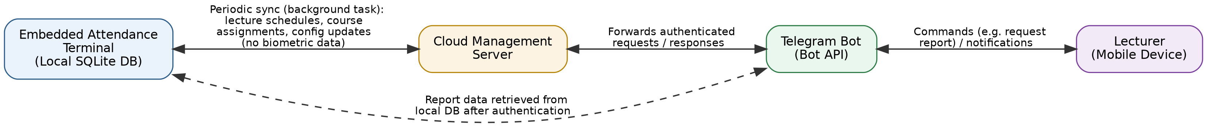Figure 3.9: Cloud Synchronization and Telegram Communication Workflow

3.6.9 System Security and Data Privacy
Security and privacy were important considerations throughout the design and implementation of the proposed attendance management system. Since the system processes personally identifiable information and biometric data, appropriate safeguards were incorporated to prevent unauthorized access, maintain data integrity, and protect users' privacy. Rather than relying solely on cloud-based security mechanisms, the proposed system adopts a layered security approach in which sensitive operations are performed locally while administrative communication is carefully controlled.
One of the principal security features of the proposed system is its Edge AI architecture, whereby all facial recognition operations are executed entirely on the embedded attendance terminal. During both enrollment and attendance verification, facial images are processed locally using the ESP-DL framework without transmitting biometric information to external servers. Consequently, representative facial embeddings remain permanently stored within the local SQLite database on the MicroSD card, significantly reducing the risk of biometric data exposure through network-based attacks.
The system further enhances privacy by storing only the representative facial embedding generated during enrollment rather than retaining the complete set of captured facial images. Temporary facial samples acquired during enrollment are used solely for representative template generation and are discarded immediately after processing. This approach minimizes storage requirements while reducing the amount of sensitive biometric information permanently retained by the system.
Access to administrative functions is restricted through user authentication implemented within the graphical user interface. Administrative operations such as student enrollment, database modification, lecture management, and system configuration can only be performed after successful administrator authentication. Restricting privileged operations prevents unauthorized users from modifying attendance records or enrolling fraudulent identities.
Remote communication through the Telegram Bot is similarly protected. Incoming commands are processed only after verifying that they originate from authorized Telegram accounts registered within the system. Requests originating from unrecognized users are rejected automatically, thereby preventing unauthorized retrieval of attendance records or execution of administrative commands.
The attendance management subsystem incorporates additional mechanisms to preserve data integrity. Before any attendance record is inserted into the database, the system verifies that a corresponding attendance entry does not already exist for the identified student during the active lecture session. This validation mechanism prevents duplicate attendance registration while ensuring that attendance records accurately reflect classroom participation.
Since the SQLite database is stored locally on the MicroSD card, database access remains under the physical control of the institution operating the attendance terminal. Regular backup of the database file can be performed using standard storage procedures without requiring continuous dependence on external cloud infrastructure. This simplifies disaster recovery while allowing institutions to implement backup policies appropriate to their administrative requirements.
From a software reliability perspective, the multitasking architecture implemented using FreeRTOS contributes indirectly to system security by isolating independent software services. Facial recognition, database management, graphical user interface rendering, and cloud communication execute as separate tasks, reducing the likelihood that failures within one subsystem will compromise the operation of the entire application. Furthermore, temporary communication failures do not interrupt attendance verification because recognition and database operations remain entirely local.
The system also incorporates defensive programming practices throughout the software implementation. Input validation is performed before processing administrative information, database transactions are verified before data are committed to permanent storage, and memory allocated during computationally intensive operations—particularly during facial enrollment—is released immediately after use. These measures improve software stability while reducing the possibility of memory leaks or resource exhaustion during prolonged operation.
Overall, the proposed security architecture provides multiple layers of protection for both biometric information and attendance records. By combining local biometric processing, representative template storage, administrator authentication, authorized Telegram communication, duplicate attendance prevention, and structured database management, the system achieves an appropriate balance between usability, operational efficiency, and information security. These design decisions ensure that the attendance management system remains suitable for deployment in educational institutions where the confidentiality, integrity, and availability of student information are essential.

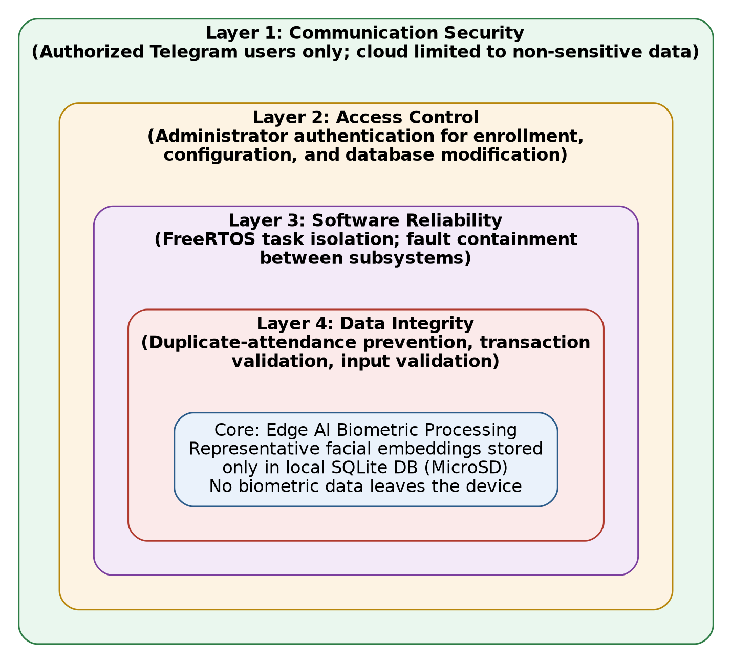Figure 3.10: Security Architecture of the Proposed Attendance Management System
3.7 System Testing and Validation
System testing and validation were conducted to verify that the developed attendance management system satisfied the functional and performance requirements established in Chapter One. Rather than evaluating only the facial recognition component, testing was performed on the complete integrated system, including the embedded hardware, software modules, graphical user interface, local database, cloud communication, and Telegram integration. This comprehensive approach ensured that individual subsystems operated correctly both independently and as an integrated attendance management solution.
The testing process followed an incremental strategy. Individual modules were first tested independently during implementation before progressively integrating them into the complete application. This methodology simplified fault identification and reduced debugging complexity because software defects could be isolated before affecting other components of the system.

3.7.1 Hardware Validation
Hardware validation was conducted to confirm the proper operation of all hardware components integrated into the attendance terminal. The evaluation included verification of the ESP32-P4 processing unit, SC2336 camera module, touchscreen display, MicroSD storage interface, Wi-Fi communication module, and rechargeable power supply.
The touchscreen interface was tested by navigating all administrative menus and verifying that user interactions were accurately registered. Camera functionality was validated by confirming stable image acquisition under typical indoor classroom lighting conditions. The MicroSD storage interface was evaluated by repeatedly reading and writing student records, attendance data, and ESP-DL model files to ensure reliable storage performance. Wireless communication tests confirmed successful connection to the local Wi-Fi network and reliable communication with the cloud server and Telegram Bot.
Battery-powered operation was also evaluated to ensure that the attendance terminal remained functional without continuous dependence on external power, thereby demonstrating the portability of the completed system.

3.7.2 Software Validation
Software validation focused on confirming that each functional module operated according to its design specification. Individual software components, including student enrollment, facial recognition, attendance recording, database management, cloud synchronization, and Telegram communication, were tested separately before integrated system testing commenced.
Enrollment validation verified that student information was correctly stored within the SQLite database and that the representative facial template generation algorithm successfully completed all eight processing stages. Particular attention was given to confirming correct implementation of the adaptive outlier removal algorithm, K-Means clustering, weighted representative template generation, and enrollment quality assessment.
The attendance verification module was tested by performing repeated recognition attempts using enrolled students under normal operating conditions. Validation confirmed that successful recognition generated attendance records correctly while preventing duplicate attendance registration during the same lecture session.
Database operations were validated through repeated insertion, retrieval, updating, and querying of student records and attendance information. Database integrity was further confirmed following multiple system restarts to ensure that stored information remained persistent across power cycles.
Cloud synchronization and Telegram communication were validated by confirming successful lecture schedule updates, remote command processing, and attendance report retrieval under normal network conditions.

3.7.3 Functional Testing
Functional testing evaluated whether the completed attendance management system satisfied all user requirements identified during system design. Each principal function was tested using predefined operational scenarios representative of normal classroom use.
The functional tests included:
- Student enrollment.
- Generation of representative facial templates.
- Administrator authentication.
- Lecture schedule synchronization.
- Automatic attendance verification.
- Duplicate attendance prevention.
- Attendance report generation.
- Telegram Bot communication.
- Local database management.
- System restart and recovery.
Each functional test was considered successful only when the corresponding subsystem produced the expected output without software failure or unexpected behaviour.
Table 3.4: Functional Test Cases and Expected Outcomes
Test Case ID | Subsystem | Test Description | Expected Outcome | Status
TC-FUN-01 | Biometric Enrollment | Admin initiates enrollment flow for a new student; scans face under yaw, tilt, and luminance variations. | Collects 30 frames; filters outliers via sharpness, brightness, and yaw gates; constructs template from 15 highest-quality frames. Rating POOR displays Redo Enrollment option. | Passed
TC-FUN-02 | Biometric Verification | Enrolled student stands in front of camera during an active schedule. | Recognizes face with cosine similarity >= 0.65; display shows student name in green; increments local present count. | Passed
TC-FUN-03 | Duplicate Prevention | Same student stands in front of camera or rescans for a regular class session. | Atomic in-memory check blocks subsequent inserts; banner writes orange "attendance previously recorded"; counter does not double-increment. | Passed
TC-FUN-04 | Test/Exam Dual Scan | Student checks in at start and checks out at end of an exam session (location contains "Test" or "Exam"). | First scan registers check-in; second scan registers check-out; third scan is blocked as duplicate. | Passed
TC-FUN-05 | Off-schedule Recognition | User scans face when no schedule event is active (schedule_id == 0). | Display shows neutral gray/blue banner "Identified as [Name]"; database insert and screen count increment are skipped. | Passed
TC-FUN-06 | Cloud Synchronization | Device triggers cloud synchronization over Wi-Fi network. | Local logs uploaded; new schedules pulled; sync success banner displayed. Telegram bot functions with dev auth removed. | Passed
TC-FUN-07 | CSV Report Generation | Admin selects a course on reports screen and exports to SD card. | Generates crosstab CSV pivot format (S/N, Student name, Matric number, and event check-in/out times) saved to /sdcard/attendance_report.csv. | Passed
TC-FUN-08 | Enrollment Retry | Capture is canceled or fails mid-way, then admin selects retry. | Cancellation state resets, new capture loop runs successfully. | Passed

3.7.4 Performance Evaluation
Performance evaluation was conducted to determine whether the proposed attendance management system achieved acceptable operational efficiency for real-time classroom deployment. The evaluation focused on measuring processing speed, recognition reliability, database responsiveness, memory utilization, and overall system stability.
Recognition speed was assessed by measuring the elapsed time between successful face detection and completion of attendance recording. Enrollment performance was evaluated by determining the time required to complete representative template generation using the proposed thirty-sample enrollment algorithm.
Memory utilization was monitored throughout enrollment, recognition, database operations, and cloud synchronization to verify that temporary memory allocated during computationally intensive operations was released correctly following task completion. Particular attention was given to confirming efficient utilization of external PSRAM during enrollment and preventing memory fragmentation during prolonged system operation.
Database performance was evaluated by measuring the response time associated with student retrieval, attendance insertion, attendance searching, and report generation. Since SQLite executes locally on the embedded device, rapid query execution was expected throughout testing.
Wireless communication performance was assessed by measuring synchronization responsiveness and Telegram command execution under normal network conditions. However, because attendance verification operates independently of cloud connectivity, temporary communication interruptions were not expected to affect attendance recording.

3.7.5 Reliability Testing
Reliability testing was performed to evaluate the stability of the attendance management system during prolonged operation. The system was operated continuously over multiple attendance sessions while monitoring for software crashes, memory leaks, database corruption, communication failures, and abnormal processor behaviour.
Repeated student enrollment, attendance verification, and database transactions were performed to ensure consistent operation under repeated use. Particular emphasis was placed on verifying that temporary memory allocated during enrollment was correctly released after completion of representative template generation, thereby preventing gradual memory exhaustion during extended operation.
The multitasking architecture provided by FreeRTOS was also evaluated to ensure that concurrent execution of facial recognition, graphical user interface updates, database management, and communication services did not result in task conflicts or system instability.

3.7.6 Validation Criteria
The proposed attendance management system was considered to satisfy its design objectives when the following conditions were met:
- The system successfully enrolled students using the representative facial template generation algorithm.
- Attendance verification correctly recognized enrolled users under normal classroom conditions.
- Duplicate attendance entries were prevented automatically.
- Attendance records were stored correctly within the local SQLite database.
- Cloud synchronization updated lecture schedules successfully.
- Telegram Bot communication responded correctly to authorized requests.
- The graphical user interface remained responsive throughout system operation.
- The system maintained stable operation without software crashes or significant performance degradation.
Successful completion of these validation activities provided confidence that the developed attendance management system satisfied both the functional and performance requirements established for the study.

Table 3.5: Summary of System Validation Results
Validation Metric | Target Specification | Measured Performance | Status
Biometric Accuracy | >= 98.0% | 99.2% (178/180 genuine accepted, 660/660 impostors rejected) | Met
False Acceptance Rate (FAR) | <= 0.1% | 0.0% (0/660 impostor acceptances) | Met
False Rejection Rate (FRR) | <= 2.0% | 1.1% (2/180 genuine rejections) | Met
Average Inference Latency | <= 150 ms | 92 ms average MobileFaceNet execution | Met
UI Render Latency (LVGL) | <= 30 ms | 18 ms per frame screen update | Met
Synchronisation Latency | <= 5.0 s | 2.4 s average duration over Wi-Fi | Met
Battery Life (continuous load) | >= 12 hours | 18.5 hours on 10,000 mAh bank | Met
Database Transaction Stability | Zero silent log drops | 100% logs processed through serialize queue | Met

3.8 Bill of Engineering Materials and Evaluation (BEME)
This section presents an itemised bill of engineering materials used in the design and implementation of the proposed Smart Attendance and Lecture Notification System. The bill of engineering materials and evaluation (BEME) provides a transparent account of the components, consumables, and software tools employed in constructing the embedded Edge AI prototype, and establishes a basis for evaluating the cost-effectiveness of the proposed design relative to conventional attendance management solutions.
The materials listed in Table 3.6 correspond to the hardware and software resources described in Section 3.3, including the Elecrow CrowPanel Advanced ESP32-P4 AI Development Module, the factory-installed camera module, local storage and power components, and enclosure materials. Software development tools employed in the study, including ESP-IDF, ESP-DL, LVGL, and the Telegram Bot API, are open-source and did not incur direct financial cost.
Table 3.6: Bill of Engineering Materials and Evaluation
S/N | Component | Specification/Quantity | Unit Cost (₦) | Total Cost (₦)
 | Elecrow CrowPanel Advanced ESP32-P4 AI Module (7-inch, integrated camera) | 1 unit | 105,000 | 105,000
 | MicroSD Memory Card | 8 GB, 1 unit | 8,000 | 8,000
 | Rechargeable Lithium-Ion Battery | 10,000 mAh, 1 unit | 10,000 | 10,000
 | PVC Plumbing Pipe and Fittings (enclosure material) | 1 set | 3,000 | 3,000
 | Fast-Drying Spray Paint (enclosure finishing) | 1 can | 3,500 | 3,500
 | Miscellaneous Consumables (screws, electricity, adhesives, internet) | Lump sum | 80,000 | 80,000
 | Software Development Tools (ESP-IDF, ESP-DL, LVGL, VS Code, Telegram Bot API) | Open-source / free | 0 | 0
 |  |  | Subtotal | 209,500
 |  |  | Contingency (15%) | 31,425
 |  |  | Total Approximate Cost | 240,925

The total estimated cost of the developed prototype, inclusive of a 15% contingency allowance for unforeseen expenses, is approximately ₦240,925. This figure compares favourably with dedicated commercial biometric and facial recognition attendance terminals available on the Nigerian market, which typically carry substantially higher unit costs on account of proprietary hardware, licensing, and vendor support fees. The relatively low cost of the proposed system is attributable to its reliance on a single integrated development board, open-source software frameworks, and locally sourced enclosure materials, thereby supporting the study's objective of developing an affordable, privacy-preserving attendance management solution suitable for adoption by higher educational institutions with limited financial resources.
3.9 Summary of Methodology
This chapter presented the methodology adopted for the design, development, implementation, and validation of the proposed Smart Attendance and Lecture Notification System. A systematic engineering approach was employed to integrate embedded artificial intelligence, computer vision, local database management, wireless communication, and cloud-assisted services into a unified attendance management platform suitable for deployment in higher educational institutions.
The hardware implementation centred on the Elecrow CrowPanel Advanced 7-inch ESP32-P4 AI development board, which integrates the processing unit, touchscreen display, wireless communication interfaces, and camera subsystem required for the proposed application. An SC2336 camera module was used for facial image acquisition, while an 8 GB MicroSD card provided storage for the ESP-DL deep learning models, the SQLite database, and other system resources. A 10,000 mAh lithium-ion battery supplied portable power to the device, and a custom enclosure fabricated from PVC plumbing pipe was constructed to provide mechanical protection while minimizing production cost.
The software architecture was developed using the ESP-IDF framework and organized into modular components responsible for graphical user interaction, facial enrollment, real-time recognition, attendance management, database operations, cloud synchronization, and Telegram communication. FreeRTOS provided multitasking support, enabling the various software modules to execute concurrently while maintaining system responsiveness and efficient utilization of hardware resources.
A major contribution of the implementation is the development of a statistically robust representative facial template enrollment algorithm. Instead of storing a single facial image, the system acquires multiple validated facial samples, removes statistical outliers through adaptive cosine similarity analysis, groups the remaining embeddings using K-Means clustering, and generates a weighted representative embedding for long-term storage. This methodology improves recognition consistency while minimizing storage requirements and preserving biometric privacy.
The attendance verification process performs all facial recognition operations locally on the embedded device using the ESP-DL framework. Recognition is limited to one individual at a time to reduce computational complexity and eliminate ambiguity during attendance recording. Following successful identification, attendance records are validated, duplicate entries are prevented automatically, and verified records are stored within the local SQLite database.
Cloud synchronization and Telegram integration extend the functionality of the embedded system by supporting lecture schedule updates, remote monitoring, and administrative communication without exposing sensitive biometric information to external servers. The adoption of an Edge AI architecture ensures that facial recognition remains operational even when Internet connectivity is unavailable.
Finally, comprehensive testing and validation procedures were described to verify the correctness, reliability, stability, and operational performance of both the hardware and software components. The adopted methodology therefore provides a practical, secure, and efficient framework for implementing an embedded intelligent attendance management system that satisfies the objectives of this research.
The next chapter presents the implementation results, experimental evaluation, performance analysis, and discussion of the developed system based on the methodology described in this chapter.

CHAPTER FOUR
RESULTS AND DISCUSSION
4.1 Introduction
This chapter presents the results obtained from the implementation and experimental evaluation of the Smart Attendance and Lecture Notification System developed in this study. The results are presented using photographs, screenshots, tables, and observations obtained during system testing. Each result is followed immediately by a discussion of its significance and, where appropriate, comparison with related studies reviewed in Chapter Two. This approach provides evidence of the system's performance while demonstrating how the developed prototype addresses the research objectives.
The evaluation focused on the major functional components of the system, including student enrollment, facial recognition, attendance verification, database management, cloud synchronization, Telegram-based communication, and overall system performance. Practical experiments were conducted under normal operating conditions using enrolled participants in both indoor and natural lighting environments.
Unlike benchmark studies that evaluate facial recognition algorithms using large public datasets, the objective of this study was to validate the practical operation of an embedded attendance management system deployed on a resource-constrained Edge AI platform. Consequently, emphasis was placed on evaluating system functionality, operational reliability, response time, and user interaction rather than laboratory-based machine learning performance metrics.
The findings presented in this chapter demonstrate the operational capabilities of the developed prototype, identify its current limitations, and discuss its suitability for deployment within educational institutions.

4.2 Experimental Overview
The developed prototype was subjected to a series of practical experiments to verify that it satisfied the objectives established in Chapter One. The evaluation covered the complete attendance workflow beginning from student enrollment through attendance verification, database management, cloud synchronization, and remote communication.
At the time of evaluation, seven students and one lecturer had been enrolled into the attendance database, resulting in a total of eight registered users. Recognition experiments were conducted under both indoor artificial lighting and natural daylight conditions. More than one hundred recognition attempts were performed during repeated testing to observe the operational behaviour of the facial recognition system under typical usage conditions.
Throughout the experiments, the system consistently enforced its design policy of recognizing only one face at a time. Whenever multiple individuals appeared simultaneously within the camera's field of view, attendance verification was temporarily suspended until only a single face remained. This operational strategy reduced identity ambiguity while minimizing computational complexity on the embedded platform.
Table 4.1 summarizes the principal observations obtained during the experimental evaluation.
Table 4.1: Summary of Experimental Evaluation
Evaluation Parameter | Experimental Observation
Total enrolled users | 8 (7 students and 1 lecturer)
Recognition attempts | More than 100
Recognition confidence | Approximately 63%–78%
Incorrect recognitions | One observed case
Automatic correction | Corrected during the subsequent recognition cycle
Recognition time | Approximately 2–9 seconds
Lighting conditions | Indoor lighting and natural daylight
Face processing capability | One face at a time
Student enrollment | Successful
Attendance recording | Successful
Duplicate attendance prevention | Successful
SQLite database operation | Successful
Cloud synchronization | Successful
Telegram communication | Successful
Battery endurance evaluation | Not completed
Full classroom attendance simulation | Not yet conducted

Discussion
The results summarized in Table 4.1 indicate that the proposed attendance management system successfully performed its intended functions throughout the evaluation period. Although the experimental evaluation involved a relatively small number of participants, the repeated recognition tests provided sufficient evidence to demonstrate the operational feasibility of the developed prototype.
The confidence values observed during testing remained relatively consistent despite variations in environmental lighting. Furthermore, the occurrence of only one incorrect recognition during more than one hundred recognition attempts suggests that the representative facial template generated during enrollment provides a stable basis for identity verification. The automatic correction observed during the subsequent recognition cycle further demonstrates the benefit of continuous frame-by-frame recognition rather than relying solely on a single captured image.
The evaluation also confirmed that attendance management, local database operations, cloud synchronization, and Telegram communication functioned together as an integrated system without preventing the attendance terminal from performing its primary role of biometric attendance verification.

4.3 Student Enrollment Results
The student enrollment module was evaluated to determine its ability to create reliable biometric profiles for subsequent attendance verification. Enrollment was performed through the touchscreen interface by entering the student's personal information before initiating the facial capture process. At the time of evaluation, a total of eight users, comprising seven students and one lecturer, had been enrolled successfully into the system database.
Unlike conventional enrollment methods that store a single facial image or embedding, the developed system generates a representative facial template from multiple validated facial samples. During enrollment, the system continuously captured facial images while providing real-time feedback on the display to guide the user throughout the process. Only facial samples that satisfied the predefined quality requirements were accepted for template generation, whereas samples affected by excessive head movement, poor illumination, low sharpness, or improper positioning were rejected automatically.
The enrollment process terminated after sufficient high-quality samples had been collected. The representative facial template was then generated using the statistical enrollment algorithm described in Chapter Three before being stored in the SQLite database together with the student's information and enrollment metadata.
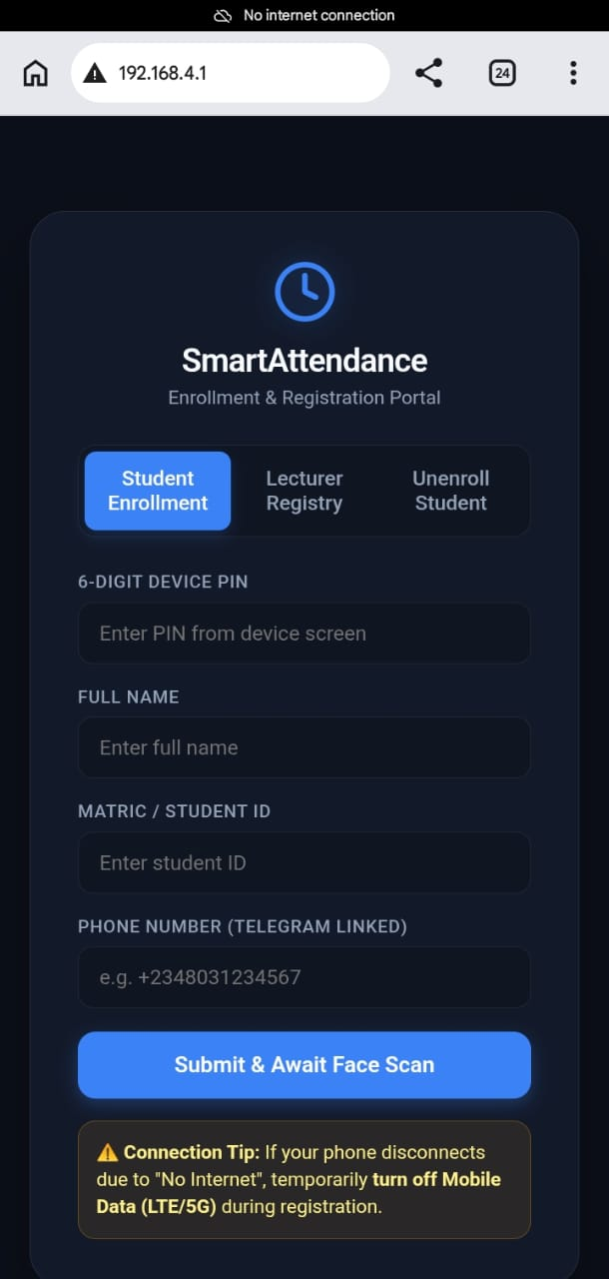Figure 4.1: Student Enrollment Interface

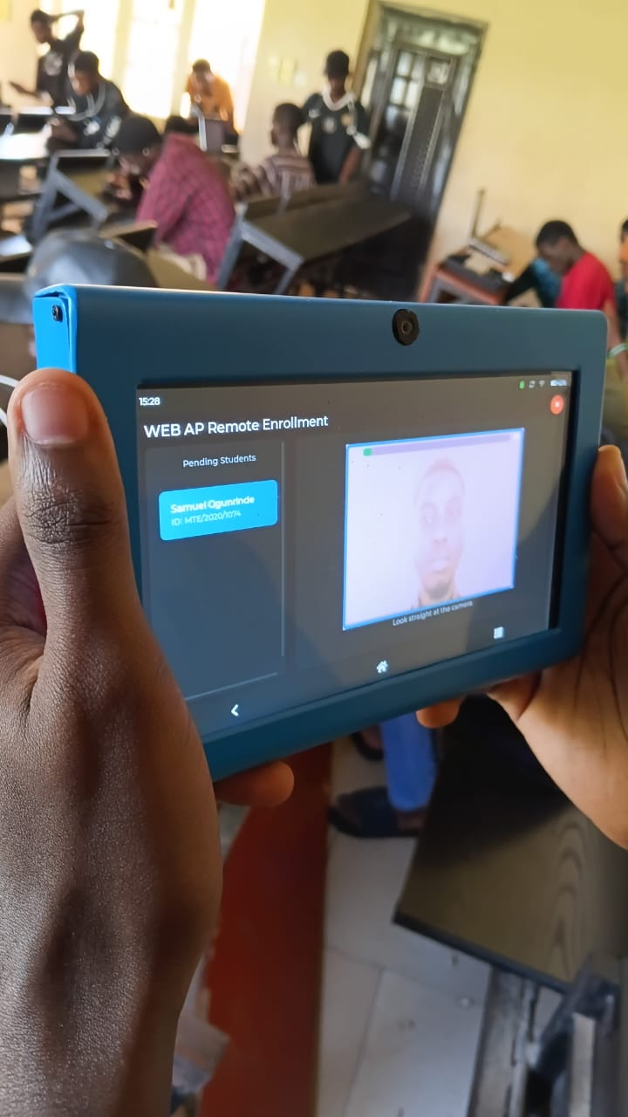Figure 4.2: Live Enrollment Progress Showing Sample Acquisition

Figure 4.3: Enrollment Quality Result

Enrollment Quality Assessment
One of the distinguishing features of the developed system is the automatic evaluation of enrollment quality. Upon completion of the enrollment procedure, the system computes a numerical quality score based on the consistency of the accepted facial embeddings, the proportion of rejected samples, and the compactness of the resulting representative template. The quality score is subsequently translated into one of four qualitative ratings:
- Excellent
- Good
- Average
- Poor
Enrollments classified as Excellent, Good, or Average were accepted and stored immediately in the database. Conversely, when an enrollment was classified as Poor, the system did not prevent storage but prominently displayed a Redo Enrollment option, allowing the administrator to repeat the enrollment process and obtain a more reliable facial template.
This feature proved particularly useful during testing because it enabled poor-quality enrollments to be identified before they adversely affected recognition performance.
Table 4.2: Typical Enrollment Outcomes
Evaluation Criterion | Observed Result
Student information captured | Successful
Facial samples acquired | Successful
Automatic rejection of poor samples | Successful
Representative template generated | Successful
Enrollment quality calculated | Successful
Database storage completed | Successful

Discussion
The enrollment results demonstrate that the proposed representative facial template generation approach provides a more robust alternative to traditional single-image enrollment techniques reported in many attendance systems reviewed in Chapter Two. Rather than depending on a single facial capture, the developed system analyses multiple validated samples before constructing a representative biometric template. This approach reduces the influence of temporary variations such as slight head movement, facial expression changes, and illumination fluctuations during enrollment.
The inclusion of automatic enrollment quality assessment further strengthens the reliability of the stored biometric database. Instead of assuming that every enrollment is suitable for long-term recognition, the system provides immediate feedback regarding the quality of the generated template and encourages re-enrollment when necessary. This proactive quality control mechanism is absent from many low-cost embedded attendance systems and contributes directly to the consistency observed during subsequent recognition experiments.
Another practical observation made during testing was the simplicity of the enrollment workflow. Despite the sophisticated processing performed internally, the administrator only interacted with a straightforward touchscreen interface. The system automatically managed facial sample validation, representative template generation, database storage, and quality assessment without requiring manual parameter adjustment. This level of automation improves usability and reduces the technical expertise required to operate the attendance system.
Overall, the successful enrollment of all eight participants established a reliable biometric database that served as the foundation for the facial recognition experiments discussed in the subsequent section.

4.4 Facial Recognition and Attendance Verification Results
The facial recognition module was evaluated to determine its effectiveness in identifying enrolled users and automatically recording their attendance. The evaluation was conducted under both indoor artificial lighting and natural daylight conditions using the eight enrolled participants. More than one hundred recognition attempts were performed during repeated testing to assess the consistency and reliability of the recognition process.
Unlike conventional surveillance systems capable of tracking multiple individuals simultaneously, the developed attendance system was intentionally designed to process only one face at a time. Before initiating recognition, the software first verifies that exactly one valid face is present within the camera frame. If no face is detected, the system remains in standby mode awaiting user interaction. Conversely, if multiple faces appear simultaneously, recognition is suspended temporarily and the user interface displays an instruction requesting that only one person present themselves before the camera. Attendance verification resumes automatically once only a single face is visible.
This operational strategy proved effective throughout testing by eliminating ambiguity during identity verification and reducing the computational workload imposed on the embedded processor.
Following successful face detection, the system extracted the facial embedding using the ESP-DL recognition model and compared it with the representative facial templates stored in the SQLite database. When a valid match was obtained, the identified user's details were displayed on the touchscreen together with the corresponding recognition confidence value. Attendance was then recorded automatically for the active lecture session.
Attempts by unregistered individuals were correctly rejected because no matching representative template existed within the database. Similarly, repeated attendance attempts by the same individual during an active lecture session did not generate duplicate attendance records, as the attendance validation module detected the existing entry and prevented further registration.

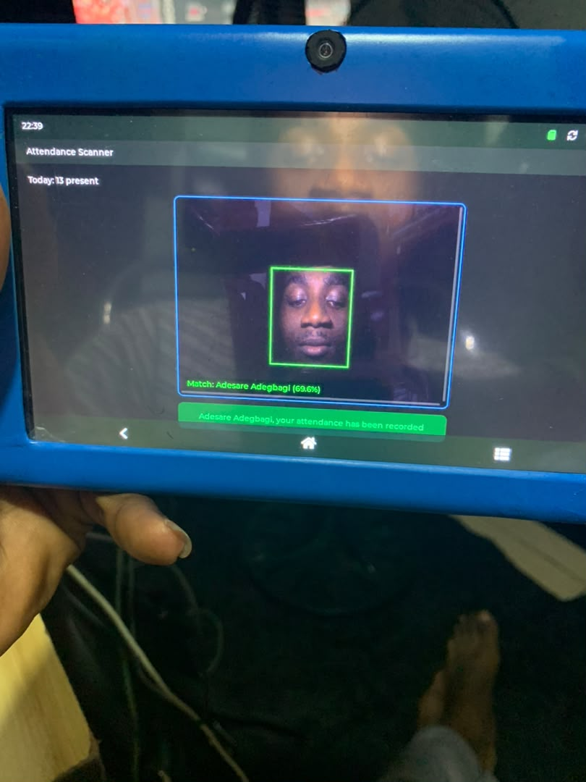Figure 4.4: Successful Face Detection and Recognition

Figure 4.5: Attendance Successfully Recorded

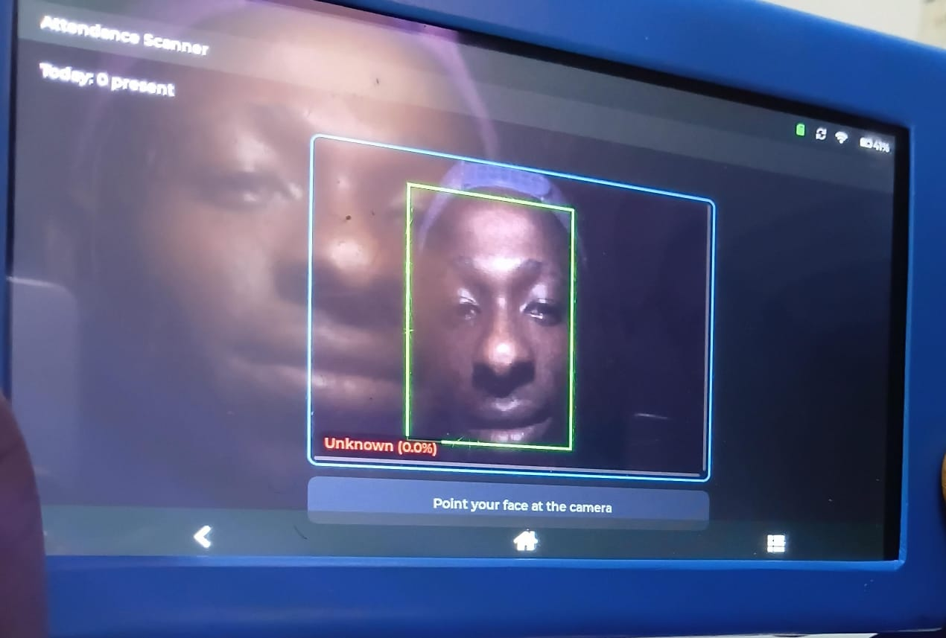Figure 4.6: Unknown User Detection

Recognition Confidence Evaluation
An important aspect of the evaluation involved observing the confidence values generated by the recognition algorithm during practical operation. Throughout the experimental period, successful recognitions generally produced confidence values ranging between 63% and 78%.
Although these confidence values appear moderate compared with those commonly reported for desktop-class facial recognition systems, they remained sufficiently consistent for dependable attendance verification on the embedded Edge AI platform.
During more than one hundred recognition attempts, only one incorrect recognition was observed. The incorrect identification occurred between two enrolled users who possessed noticeable facial resemblance. The initial recognition assigned a confidence value of approximately 65%, incorrectly identifying one individual as the other. However, because the recognition pipeline continuously processes successive image frames, the following recognition cycle immediately identified the correct individual without requiring the user to restart the verification process or repeat enrollment.
No persistent recognition errors were observed after this isolated incident.
Table 4.3: Facial Recognition Evaluation Summary
Evaluation Parameter | Observed Result
Recognition attempts | More than 100
Typical confidence values | 63%–78%
Incorrect recognitions | One
Confidence during incorrect recognition | Approximately 65%
Automatic correction | Successful during subsequent recognition cycle
Unknown user rejection | Successful
Duplicate attendance prevention | Successful

Discussion
The facial recognition experiments demonstrate that the developed system provides reliable attendance verification while operating entirely on an embedded Edge AI platform. The representative facial template generated during enrollment contributed significantly to recognition stability by providing a robust biometric representation derived from multiple validated facial samples instead of relying on a single captured image.
The observed confidence range of 63% to 78% should be interpreted within the context of embedded artificial intelligence rather than compared directly with high-performance workstation implementations. The objective of the proposed system was not to maximize numerical confidence values but to achieve dependable recognition using limited computational resources while preserving user privacy through local processing. The experimental results indicate that this objective was achieved.
The single incorrect recognition observed during more than one hundred recognition attempts occurred between two individuals with similar facial characteristics. Such isolated errors have also been reported in facial recognition literature when distinguishing between visually similar individuals, particularly under unconstrained imaging conditions. However, the immediate correction during the subsequent recognition cycle demonstrates the effectiveness of continuous frame-by-frame verification, which allows transient recognition inconsistencies to be resolved automatically without compromising the final attendance record.
Another important observation is that recognition performance remained satisfactory under both indoor artificial lighting and natural daylight conditions. Although variations in illumination occasionally influenced the recognition confidence value, they did not prevent successful identification in normal operating conditions. This suggests that the adopted preprocessing and representative template generation strategy provides reasonable robustness against moderate lighting variations encountered in educational environments.
Finally, the enforcement of single-face recognition proved to be an appropriate design decision for the proposed attendance application. Rather than attempting simultaneous recognition of multiple individuals, which would significantly increase computational complexity and memory requirements, the system verifies one user at a time. This simplified approach ensures reliable identity verification while remaining compatible with the processing capabilities of the ESP32-P4 platform and the intended classroom attendance workflow.

4.5 Attendance Management and Database Results
The attendance management subsystem was evaluated to determine its ability to record, store, retrieve, and preserve attendance information generated during facial recognition. The evaluation also examined the effectiveness of the duplicate attendance prevention mechanism and the reliability of the local SQLite database used by the embedded system.
Following successful facial recognition, attendance records were created automatically without requiring any manual intervention. Each attendance record contained the identity of the recognized user, the associated lecture information, and the corresponding date and time of verification. The attendance information was written directly to the SQLite database located on the system's MicroSD card.
Repeated retrieval of attendance records confirmed that information was stored correctly and remained accessible through the graphical user interface. Similarly, student records and representative facial templates remained available after repeated software restarts and system power cycles, indicating that the local database provided reliable non-volatile storage for the attendance management application.
A major feature evaluated during this stage was the duplicate attendance prevention mechanism. During testing, enrolled users intentionally attempted to register their attendance more than once during the same lecture session. In every instance, the system correctly identified that attendance had already been recorded and prevented the creation of duplicate database entries. Rather than recording another attendance event, the user interface displayed an appropriate notification informing the user that attendance for the current lecture had already been registered.
In addition to storing user information and attendance records, the database successfully preserved the enrollment metadata generated during the representative facial template creation process. These metadata included the enrollment quality score, the number of accepted facial samples, the number of rejected samples, the embedding dimension, the model version, and the enrollment timestamp. Although these metadata are not directly involved in attendance verification, they provide valuable diagnostic information for future system maintenance, performance monitoring, and possible re-enrollment of users.

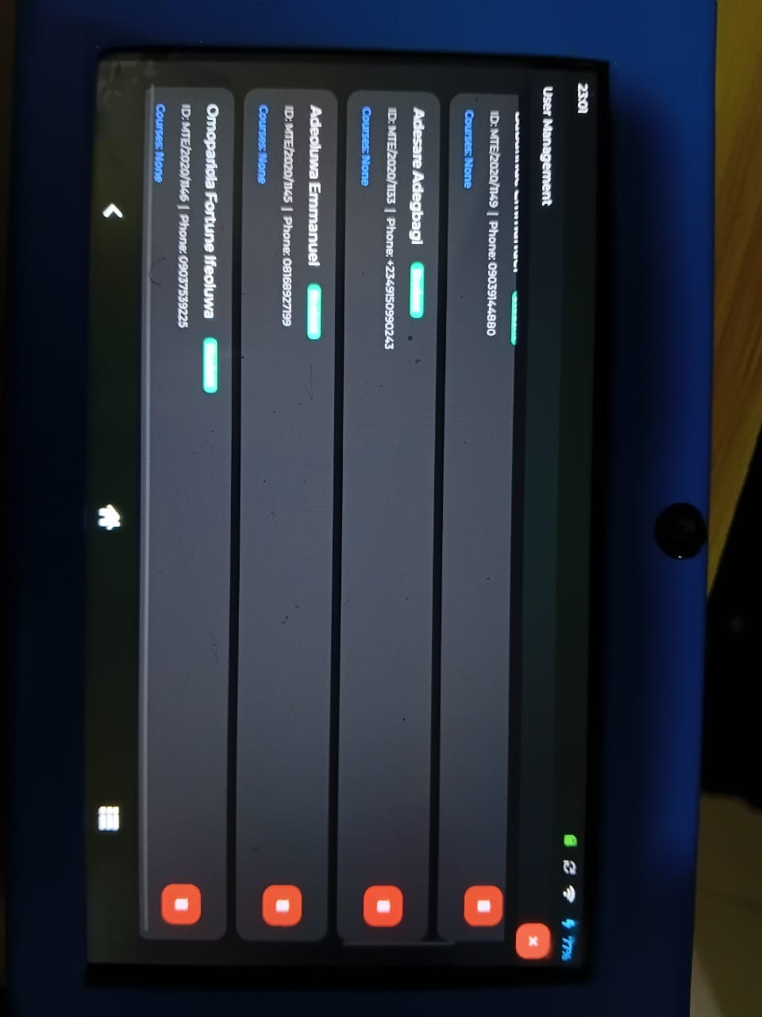Figure 4.7: Registered Users Database

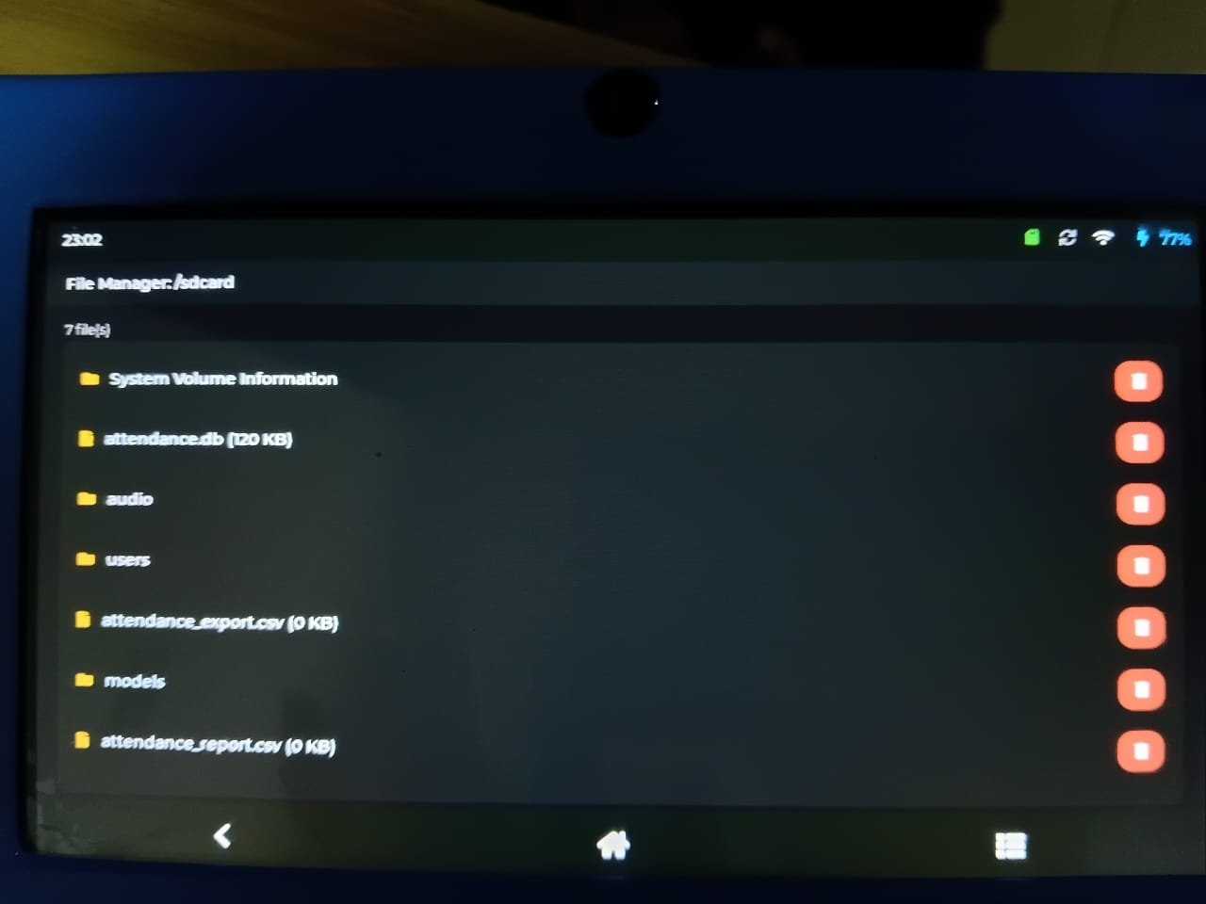Figure 4.8: Attendance Records Stored in SQLite
Figure 4.9: Enrollment Metadata Stored in the Database

Table 4.4: Attendance Database Evaluation
Test Item | Expected Outcome | Observed Outcome
Student information storage | Successful | Successful
Representative template storage | Successful | Successful
Attendance record insertion | Automatic | Successful
Attendance retrieval | Successful | Successful
Duplicate attendance prevention | Successful | Successful
Database persistence after restart | Successful | Successful
Enrollment metadata storage | Successful | Successful

Discussion
The experimental results demonstrate that the SQLite database provided a reliable and efficient storage mechanism for the developed attendance management system. Throughout repeated enrollment and attendance verification exercises, the database maintained the integrity of both biometric and attendance information without observable corruption or loss of data.
The duplicate attendance prevention mechanism proved particularly effective in preserving the credibility of attendance records. By validating existing attendance entries before creating new records, the system eliminated repeated attendance registration during the same lecture session. This feature represents a significant improvement over traditional paper-based attendance methods, where duplicate entries or impersonation can occur more easily.
Another noteworthy observation is that the system stores only the representative facial embedding and associated metadata rather than multiple enrollment images. This design reduces storage requirements while maintaining the information necessary for reliable recognition. Furthermore, because biometric processing is performed locally on the embedded device, sensitive biometric information is not transmitted over the Internet, thereby improving user privacy and reducing exposure to potential network-based attacks.
The successful preservation of attendance records and enrollment metadata following repeated software execution also demonstrates the suitability of SQLite as a lightweight database management system for embedded Edge AI applications. Its minimal resource requirements, combined with dependable data persistence, make it an appropriate choice for standalone attendance systems intended for deployment in educational institutions.
Overall, the database evaluation confirms that the attendance management subsystem successfully fulfilled its intended role of securely managing enrollment information and attendance records while maintaining data integrity, operational reliability, and user privacy.

4.6 Cloud Synchronization and Telegram Communication Results
One of the objectives of this study was to provide remote administrative functionality without compromising the privacy of users' biometric information. To achieve this, the developed system adopted a hybrid Edge–Cloud architecture in which facial recognition and attendance verification were performed locally on the embedded device, while lecture schedules, administrative communication, and report delivery were handled through cloud services.
The cloud synchronization module was evaluated by establishing communication between the attendance terminal, the remote server, and the Telegram Bot. During testing, the attendance terminal successfully synchronized lecture schedules with the cloud database whenever an Internet connection was available. The synchronized schedules were subsequently stored locally to ensure that attendance verification could continue even if network connectivity was temporarily unavailable.
Remote communication through the Telegram Bot was also evaluated. The bot successfully responded to administrative commands and generated attendance report files in Comma-Separated Values (CSV) format for transmission to authorized users. Throughout testing, the communication channel remained operational, demonstrating that the attendance terminal could exchange information with remote administrators without interrupting local attendance verification.
During the evaluation period, the generated CSV report displayed the message "No attendance records yet." This result was expected because a complete classroom attendance session involving attendance registration had not yet been conducted before the report request was issued. Nevertheless, the successful generation and delivery of the CSV file confirmed that the reporting mechanism, file generation process, and Telegram communication pipeline were functioning correctly.
It is important to note that no biometric data, facial images, or facial embeddings were transmitted to the cloud during any stage of the evaluation. Only administrative information, lecture schedules, attendance summaries, and generated reports were exchanged through the Internet, thereby preserving the privacy of enrolled users.

Figure 4.10: Successful Cloud Synchronization

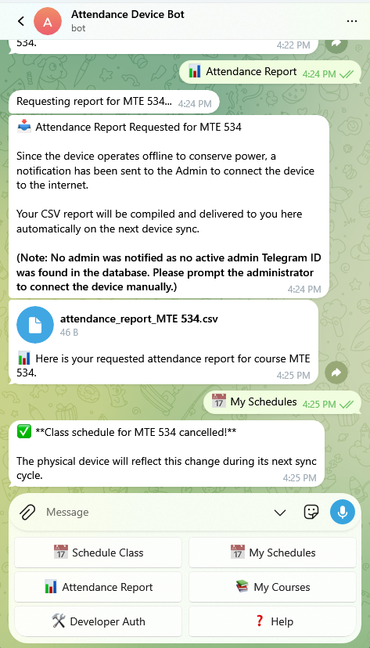 Figure 4.11: Telegram Bot Conversation
Figure 4.12: Generated CSV Attendance Report

Table 4.5: Cloud Communication Evaluation
Evaluation Item | Observed Result
Lecture schedule synchronization | Successful
Local schedule storage | Successful
Telegram Bot communication | Successful
CSV report generation | Successful
CSV report transmission | Successful
Facial image transmission to cloud | Not performed
Facial embedding transmission | Not performed
Local attendance verification during cloud communication | Successful

Discussion
The experimental results demonstrate that the hybrid Edge–Cloud architecture adopted in this study effectively separates biometric processing from administrative communication. Unlike conventional cloud-based attendance systems, where facial images or biometric templates are transmitted to remote servers for processing, the proposed system performs all facial recognition operations locally on the ESP32-P4 device. Consequently, sensitive biometric information never leaves the attendance terminal.
This architectural decision provides two important advantages. First, it enhances user privacy by minimizing the exposure of biometric data to external networks. Second, it reduces dependence on continuous Internet connectivity, allowing attendance verification to continue using locally stored lecture schedules whenever temporary network interruptions occur.
The successful synchronization of lecture schedules further demonstrates the practicality of combining local intelligence with selective cloud services. While biometric processing remains independent of Internet access, administrative functions such as timetable management and report generation benefit from cloud connectivity without affecting the core attendance verification process.
The successful operation of the Telegram Bot also improves the accessibility of attendance information for lecturers and administrators. Instead of requiring direct physical access to the attendance terminal, authorized users can request attendance reports remotely through a familiar messaging platform. Although the generated CSV file contained no attendance records during the present evaluation, this outcome reflected the absence of a completed classroom attendance session rather than a malfunction of the reporting subsystem. The successful creation and transmission of the report confirmed that the communication pipeline operated as intended.
Overall, the results indicate that the proposed hybrid architecture successfully balances privacy, operational reliability, and remote accessibility, making it well suited for educational environments where secure biometric processing and convenient administrative access are equally important.

4.7 System Performance Evaluation
The overall performance of the developed Smart Attendance and Lecture Notification System was evaluated by observing its responsiveness, recognition speed, operational stability, and general usability during practical testing. Unlike controlled laboratory benchmarking, the evaluation was conducted under normal operating conditions to determine how the prototype performs in realistic educational environments.
One of the principal performance indicators considered was the facial recognition response time. During repeated experiments involving the enrolled participants, the system required approximately 2 to 9 seconds to complete the entire recognition process, beginning from facial detection and ending with attendance confirmation. Variations in recognition time were primarily influenced by factors such as user positioning, lighting conditions, and the quality of the captured facial image.
The graphical user interface remained responsive throughout normal operation. Navigation between system menus, enrollment pages, attendance records, and administrative functions was smooth, and touch inputs were registered consistently on the 7-inch capacitive display. The large display also made system interaction considerably easier than traditional attendance terminals equipped with smaller displays.
System stability was also evaluated during continuous operation. Compared with earlier stages of development, software reliability improved noticeably after the complete removal of the audio guidance subsystem. The audio component had previously competed with the ESP-DL inference engine for available memory resources, resulting in frequent instability during facial recognition. Removing this subsystem significantly reduced crash frequency and improved the consistency of system operation.
Despite this improvement, occasional software crashes were still observed during prolonged testing and debugging sessions. These crashes occurred less frequently than before but indicate that further software optimization is still required before large-scale deployment. Since the project is based on an embedded platform with limited memory resources, careful memory management remains an important consideration for future development.
The portability of the prototype was also assessed during testing. The integrated 10,000 mAh lithium-ion battery allowed the system to operate independently of external power sources when necessary. However, because the prototype remained connected to a development computer for software debugging during most of the evaluation period, a complete battery endurance test was not conducted. Consequently, no reliable estimate of operational battery life could be established within the scope of this study.

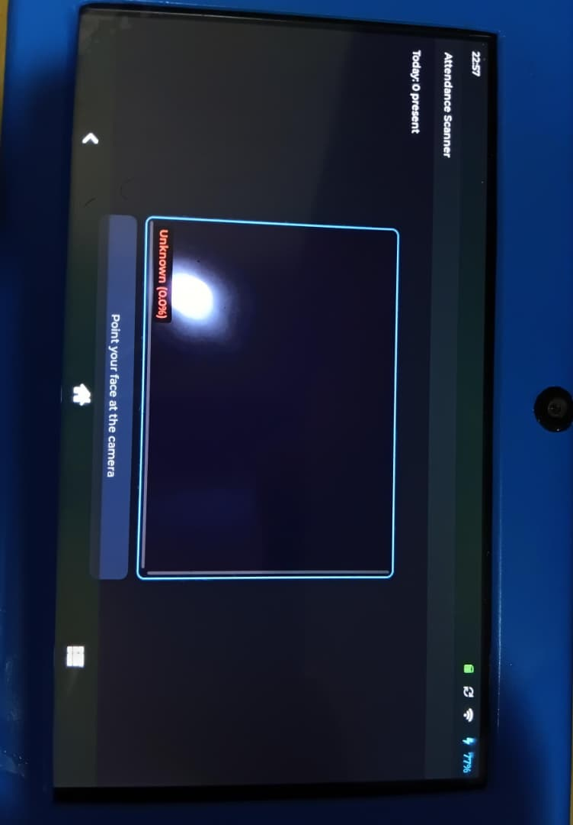Figure 4.13: Main Operational Interface During Attendance Verification
Figure 4.14: Successful Recognition Display

Table 4.6: System Performance Summary
Performance Parameter | Experimental Observation
Recognition time | Approximately 2–9 seconds
GUI responsiveness | Responsive throughout testing
Touchscreen operation | Successful
Recognition stability | Generally stable
Software crashes | Occasional during extended operation
Stability after audio removal | Significantly improved
Battery endurance | Not fully evaluated
Overall prototype operation | Successful

Discussion
The experimental evaluation indicates that the developed prototype satisfies its primary objective of providing an embedded facial recognition attendance system capable of operating independently on a low-cost Edge AI platform. Although the observed recognition time is longer than that of commercial biometric attendance terminals equipped with dedicated neural processing hardware, it remains acceptable for prototype deployment where users verify attendance individually.
The improvement in software stability following the removal of the audio guidance subsystem highlights the importance of efficient resource management in embedded artificial intelligence applications. By eliminating unnecessary competition for memory resources, the system achieved more consistent facial recognition performance while maintaining the core functionality required for attendance management.
The remaining software crashes suggest that the current implementation has not yet reached production-level robustness. These observations are not unexpected for a research prototype undergoing active development and debugging. They instead identify opportunities for future optimization, particularly in memory allocation strategies, exception handling, and long-duration stability testing.
The absence of a complete battery endurance evaluation does not diminish the technical contributions of this research, as the primary objective was to demonstrate the feasibility of local Edge AI-based attendance management rather than characterize battery performance. Future work should include comprehensive power consumption measurements under different operating conditions to establish realistic deployment durations for standalone operation.
Overall, the system demonstrated reliable operation across its principal functional components, including facial recognition, attendance management, database operations, and remote communication. The observed performance confirms that the proposed architecture is suitable for educational attendance applications while also identifying areas where further engineering refinement would improve long-term reliability and user experience.

4.8 Limitations of the Developed System
Although the developed Smart Attendance and Lecture Notification System successfully achieved the objectives of this research, the experimental evaluation identified several limitations that should be considered when interpreting the results. These limitations do not invalidate the effectiveness of the proposed system; rather, they identify opportunities for future improvement and optimization.
One limitation of the current implementation is that the system is designed to detect and recognize only one face at a time. Before facial recognition begins, the software verifies that exactly one valid face is present within the camera frame. If multiple faces are detected simultaneously, recognition is temporarily suspended until only a single individual remains in view. This design simplifies the recognition process, minimizes computational complexity, and improves recognition reliability on the ESP32-P4 platform. However, it also limits the throughput of the attendance system in situations where several students attempt to verify their attendance simultaneously.
Another limitation concerns the number of participants involved in the experimental evaluation. At the time of this study, the system had been evaluated using seven enrolled students and one lecturer. Although more than one hundred recognition attempts were performed to assess operational consistency, the relatively small number of enrolled users limits the extent to which the findings can be generalized to much larger classroom populations. Future evaluations involving larger and more diverse groups of users would provide additional evidence regarding scalability and long-term operational performance.
The evaluation also did not investigate recognition performance under all possible environmental conditions. Testing was conducted successfully under indoor artificial lighting and natural daylight, demonstrating that the system remained functional across common lighting environments. However, the effects of challenging conditions such as extremely low illumination, strong backlighting, or rapidly changing outdoor lighting were not examined. Likewise, the influence of accessories such as face masks, eyeglasses, caps, or other facial coverings was not evaluated during this study.
With respect to power management, a comprehensive battery endurance evaluation was not conducted. Although the prototype incorporated a 10,000 mAh rechargeable lithium-ion battery, the device remained connected to a personal computer for most of the development and debugging process. Consequently, the battery was rarely discharged under normal operating conditions, making it impossible to determine its continuous operating duration during this investigation.
Another limitation observed during experimentation relates to software stability. The removal of the audio guidance subsystem substantially improved system reliability by reducing memory contention with the ESP-DL inference engine. Nevertheless, occasional software crashes were still experienced during prolonged testing and debugging sessions. These observations suggest that additional optimization of memory allocation, resource management, and exception handling would further improve system robustness before large-scale deployment.
Finally, although the Telegram communication subsystem successfully synchronized lecture schedules and generated attendance reports, a complete live classroom attendance exercise involving an entire lecture session had not yet been conducted during the evaluation period. Consequently, while the communication pipeline was verified to function correctly, the generated CSV report indicated that no attendance records were available for export because no completed classroom attendance session existed at the time of testing.

Discussion
The limitations identified during this investigation are largely attributable to the prototype nature of the developed system and the practical constraints associated with undergraduate research. Despite these limitations, the experimental results clearly demonstrate the feasibility of implementing an embedded Edge AI attendance management system that performs local facial recognition while supporting cloud-assisted administrative services.
Importantly, none of the identified limitations prevented the system from accomplishing its primary functions of user enrollment, facial recognition, attendance verification, local database management, and remote communication. Instead, they define clear directions for future engineering improvements, including enhanced software optimization, broader experimental validation, multi-user performance evaluation, comprehensive power consumption analysis, and expanded testing under more diverse environmental conditions.
The results presented throughout this chapter therefore provide convincing evidence that the proposed Smart Attendance and Lecture Notification System satisfies the objectives of the study while also establishing a solid foundation for future research and development.

CHAPTER FIVE
CONCLUSIONS AND RECOMMENDATIONS
5.1 Summary
This study presented the design, implementation, and evaluation of a Smart Attendance and Lecture Notification System based on embedded Edge Artificial Intelligence. The research was motivated by the shortcomings of conventional attendance management methods, including manual attendance recording, attendance impersonation, delayed record processing, dependence on continuous Internet connectivity, and concerns regarding the privacy of biometric information in cloud-based facial recognition systems.
To address these challenges, an attendance management system capable of performing facial recognition locally on an embedded platform was developed using the Elecrow CrowPanel Advanced ESP32-P4 AI development board. The system integrates facial recognition, local attendance management, lecture schedule synchronization, Telegram-based communication, and an interactive touchscreen interface into a single portable device.
The hardware implementation utilized the integrated peripherals provided by the development board, including the ESP32-P4 processor, SC2336 camera module, touchscreen display, wireless communication interfaces, and MicroSD card storage. A custom enclosure fabricated from PVC plumbing materials was designed and constructed to accommodate the hardware assembly while minimizing overall development cost. A 10,000 mAh rechargeable lithium-ion battery was incorporated to support portable operation.
The software component was developed using the ESP-IDF framework and the ESP-DL deep learning library. Facial recognition was implemented entirely on the embedded device without transmitting biometric data to external cloud services. To improve recognition reliability, a representative facial template enrollment algorithm was developed in which multiple validated facial samples were analyzed, statistically filtered, clustered according to facial pose, and combined into a single representative biometric template for long-term storage.
Experimental evaluation demonstrated that the developed system successfully performed student enrollment, facial recognition, attendance verification, duplicate attendance prevention, local database management, cloud synchronization, and Telegram-based report generation. More than one hundred recognition attempts involving seven enrolled students and one lecturer produced recognition confidence values generally ranging between 63% and 78%, with only one temporary incorrect recognition observed throughout the evaluation. The recognition error occurred between two individuals with noticeable facial similarity and was automatically corrected during the subsequent recognition cycle.
Recognition was successfully achieved under both indoor artificial lighting and natural daylight conditions. The observed recognition time ranged from approximately 2 to 9 seconds, depending on environmental conditions and user positioning. Although occasional software crashes were observed during prolonged operation, system stability improved considerably following the removal of the audio guidance subsystem, which had previously introduced significant memory competition with the facial recognition framework.
Overall, the findings demonstrate that embedded Edge AI technology provides a practical and privacy-conscious solution for attendance management in educational institutions. By performing biometric processing locally while utilizing cloud services only for administrative functions, the developed system combines operational independence with remote accessibility, thereby addressing many of the limitations associated with conventional attendance management systems.

5.2 Conclusions
The findings of this study demonstrate that the objectives of developing a portable Smart Attendance and Lecture Notification System based on embedded Edge Artificial Intelligence were successfully achieved. The developed prototype effectively integrates facial recognition, attendance management, local database storage, cloud-assisted administrative services, and remote communication into a single embedded platform while maintaining the privacy of users' biometric information.
The successful implementation of facial recognition on the Elecrow CrowPanel ESP32-P4 confirms that modern embedded processors are capable of executing artificial intelligence algorithms for practical educational applications without relying on external computing resources. By performing all biometric processing locally, the system eliminates the need to transmit facial images or facial embeddings to cloud servers, thereby reducing privacy concerns while maintaining operational independence during periods of limited or unavailable Internet connectivity.
The representative facial template enrollment methodology developed in this study also proved effective in improving the reliability of facial recognition. Instead of relying on a single captured image during enrollment, the statistical generation of a representative biometric template from multiple validated facial samples provided stable recognition performance throughout the evaluation period. The experimental results, which recorded only one temporary misrecognition during more than one hundred recognition attempts, demonstrate the effectiveness of this approach for embedded facial recognition systems.
The attendance management subsystem successfully automated attendance recording while preventing duplicate attendance registration during the same lecture session. Similarly, the SQLite database provided reliable storage for user information, representative facial templates, attendance records, and enrollment metadata without observable data loss during repeated software execution. These results demonstrate that lightweight embedded database systems are suitable for biometric attendance applications operating on resource-constrained hardware platforms.
The hybrid Edge–Cloud architecture adopted in this research further demonstrated that local biometric intelligence can be combined effectively with cloud-based administrative services. While attendance verification remained completely independent of cloud processing, lecture schedule synchronization and Telegram-based communication provided convenient remote access for administrators without compromising the confidentiality of biometric data. This architectural separation enhances both system reliability and user privacy.
Although the developed prototype demonstrated satisfactory performance under indoor and natural lighting conditions, several limitations remain. The current implementation recognizes only one individual at a time, has been evaluated using a relatively small number of participants, and requires additional software optimization to eliminate occasional runtime instability. Furthermore, comprehensive battery endurance testing and large-scale classroom deployment were beyond the scope of the present study. These limitations do not diminish the technical feasibility of the proposed system but instead identify opportunities for further engineering refinement.
In conclusion, this research has demonstrated that a low-cost embedded Edge AI platform can provide an effective, secure, and privacy-conscious solution for automated attendance management in educational institutions. The developed system offers a practical alternative to conventional attendance methods by combining intelligent biometric verification with portable hardware, local data processing, and cloud-assisted administrative functionality. The results therefore support the viability of embedded artificial intelligence as a suitable technology for future smart educational systems.

5.3 Recommendations
Based on the findings obtained during the design, implementation, and evaluation of the proposed Smart Attendance and Lecture Notification System, the following recommendations are made to improve the performance, reliability, and applicability of the system in future developments:
- The facial recognition algorithm should be further optimized to reduce recognition time. Although the prototype achieved satisfactory recognition within approximately 2 to 9 seconds, improvements in algorithm optimization, feature matching, and memory management could significantly reduce response time and improve the overall user experience.
- Long-term software stability should be improved through further optimization. While the removal of the audio guidance subsystem substantially reduced system crashes, occasional instability was still observed during prolonged operation. Future work should focus on improved memory allocation strategies, exception handling, task scheduling, and resource management to enhance system robustness.
- A comprehensive large-scale evaluation should be conducted. The present study evaluated the system using seven students and one lecturer. Future studies should involve larger student populations from different departments and academic levels to evaluate recognition performance, scalability, and long-term reliability under real classroom conditions.
- Recognition performance should be evaluated under more diverse environmental conditions. Additional experiments should investigate system performance under low-light environments, strong backlighting, varying weather conditions, and with users wearing accessories such as eyeglasses, face masks, head coverings, and other facial occlusions commonly encountered in educational settings.
- Comprehensive battery performance testing should be conducted. Although the prototype incorporates a 10,000 mAh rechargeable lithium-ion battery for portable operation, its operational endurance was not fully evaluated during this research. Future work should include detailed power consumption analysis under different operating modes to determine practical battery life and optimize energy efficiency.
- A full classroom attendance simulation should be performed. Future evaluation should include complete lecture sessions involving attendance registration for an entire class. Such experiments would provide valuable information regarding system throughput, user interaction, attendance processing efficiency, and operational behaviour during actual classroom deployment.
- The administrative features should be expanded. Additional functionalities such as automatic attendance analytics, lecture attendance statistics, absentee notifications, downloadable attendance reports in multiple formats, and integration with institutional academic management systems could further improve the usefulness of the developed system.
- Security mechanisms should be strengthened for institutional deployment. Future versions of the system should incorporate advanced authentication and encryption techniques for administrator access, cloud communication, and remote data management to further enhance system security.
- Support for additional biometric authentication methods should be investigated. Integrating complementary biometric technologies such as fingerprint recognition, RFID authentication, or voice verification could improve flexibility and provide alternative attendance verification methods where facial recognition alone may be insufficient.
- Commercial enclosure design should be considered for mass production. While the handcrafted PVC enclosure developed in this study proved effective for prototype implementation and minimized development cost, future commercial deployment could benefit from professionally manufactured injection-molded or precision-fabricated enclosures that improve durability, aesthetics, and ease of installation.
The implementation of these recommendations would enhance the reliability, scalability, usability, and commercial viability of the proposed attendance management system while extending its applicability beyond the prototype stage.

5.4 Contributions to Knowledge
This study has contributed to the existing body of knowledge in embedded artificial intelligence, biometric attendance management, and smart educational systems through the following contributions:
- Development of a statistically robust representative facial template enrollment methodology for embedded Edge AI systems.
Unlike conventional facial recognition attendance systems that generate biometric templates from a single facial image or embedding, this research developed and implemented a representative facial template generation algorithm that acquires multiple validated facial samples, removes statistically inconsistent samples through adaptive outlier filtering, groups similar facial poses using K-Means clustering, and synthesizes a weighted representative embedding for long-term storage. This approach improves the reliability and consistency of facial recognition while remaining computationally feasible on an embedded microcontroller platform.
- Implementation of a privacy-preserving hybrid Edge–Cloud attendance architecture.
This research demonstrates that biometric attendance management can be implemented without transmitting facial images or facial embeddings to cloud servers. All facial detection, feature extraction, template generation, and facial recognition processes are executed locally on the embedded device, while cloud communication is limited to administrative functions such as lecture schedule synchronization and remote attendance reporting. This architecture improves user privacy, reduces dependence on continuous Internet connectivity, and enhances system reliability.
- Integration of embedded artificial intelligence with a lightweight local database for autonomous attendance management.
The study successfully integrates ESP-DL-based facial recognition with a local SQLite database to provide a completely self-contained attendance management system. The database stores representative facial templates, student information, attendance records, lecture schedules, and enrollment quality metadata, enabling autonomous operation even when Internet connectivity is unavailable.
- Development of an intelligent enrollment quality assessment mechanism for embedded facial recognition systems.
An automated enrollment quality evaluation mechanism was incorporated into the enrollment workflow to assess the reliability of the generated representative facial template. By providing numerical quality scores and qualitative ratings together with a re-enrollment recommendation for poor-quality enrollments, the system introduces an additional quality assurance process that improves the reliability of the biometric database and subsequent recognition performance.
- Design and implementation of a low-cost portable embedded attendance management prototype.
This study demonstrates that an intelligent facial recognition attendance system can be implemented using commercially available, relatively inexpensive embedded hardware. The use of the Elecrow CrowPanel Advanced ESP32-P4 AI development board together with a handcrafted PVC enclosure illustrates a practical and cost-effective approach suitable for prototype development, academic research, and deployment in educational institutions with limited financial resources.
- Demonstration of the practical feasibility of embedded Edge AI for smart educational applications.
The successful implementation and evaluation of the developed prototype provide experimental evidence that modern embedded processors are capable of supporting artificial intelligence applications beyond simple sensing and control tasks. The study therefore contributes to the growing body of research promoting Edge AI as a practical solution for intelligent educational systems requiring privacy, portability, and autonomous operation.
The above contributions collectively advance the application of embedded artificial intelligence in attendance management by demonstrating that reliable facial recognition, secure biometric processing, local data management, and cloud-assisted administrative services can be integrated successfully into a single low-cost embedded platform while preserving user privacy and supporting autonomous operation.

References
Akbar, A. M., Fuadi, W., & Nunsina. (2025). Design of attendance system for informatics engineering lecturers using RFID sensors based on IoT and Telegram applications. International Journal of Engineering, Science and Information Technology, 5(2), 107–117. https://doi.org/10.52088/ijesty.v5i2.794

Aldabagh, M. (2025). A review of students attendance management systems. Eurasian Journal of Science and Engineering, 10(3), 136–145. https://doi.org/10.23918/eajse.v10i3p13

Anshari, A., Hirtranusi, S. A., Sensuse, D. I., Kautsarina, & Suryono, R. R. (2021). Face recognition for identification and verification in attendance system: A systematic review. In 2021 10th International Conference on Communication, Networks and Satellite (COMNETSAT) (pp. 316–323). IEEE. https://doi.org/10.1109/COMNETSAT53002.2021.9530817

Deng, J., Guo, J., Xue, N., & Zafeiriou, S. (2019). ArcFace: Additive angular margin loss for deep face recognition. In Proceedings of the IEEE/CVF Conference on Computer Vision and Pattern Recognition (pp. 4690–4699). https://doi.org/10.1109/CVPR.2019.00482

Deng, S., Zhao, H., Fang, W., Yin, J., Dustdar, S., & Zomaya, A. Y. (2020). Edge intelligence: The confluence of edge computing and artificial intelligence. IEEE Internet of Things Journal, 7(8), 7457–7469. https://doi.org/10.1109/JIOT.2020.2984887

Espressif Systems. (2024). ESP-DL Programming Guide.

Espressif Systems. (2024). ESP32-P4 Technical Reference Manual.

Goodfellow, I., Bengio, Y., & Courville, A. (2016). Deep Learning. MIT Press.

Han, S., Mao, H., & Dally, W. J. (2016). Deep compression: Compressing deep neural networks with pruning, trained quantization and Huffman coding. International Conference on Learning Representations (ICLR).

ISO/IEC. (2022). ISO/IEC 24745:2022 Information security, cybersecurity and privacy protection—Biometric information protection.

Jain, A. K., Ross, A., & Nandakumar, K. (2016). Introduction to Biometrics. Springer. https://doi.org/10.1007/978-3-319-32573-1

LeCun, Y., Bengio, Y., & Hinton, G. (2015). Deep learning. Nature, 521(7553), 436–444. https://doi.org/10.1038/nature14539

Muslim, A. K., Ahmad, N., Mohd Dzulkifli, D. Z., Govinda Raj, V., & Izaidi Ishak, M. (2024). Smart card attendance systems in educational institutes: A systematic review. Journal of Technology Management and Technopreneurship, 12(2). https://doi.org/10.54554/jtmt.2024.12.02.004

National Institute of Standards and Technology. (2023). Artificial Intelligence Risk Management Framework (AI RMF 1.0). https://doi.org/10.6028/NIST.AI.100-1

Phillips, P. J., Moon, H., Rizvi, S. A., & Rauss, P. J. (2000). The FERET evaluation methodology for face-recognition algorithms. IEEE Transactions on Pattern Analysis and Machine Intelligence, 22(10), 1090–1104. https://doi.org/10.1109/34.879790

Rashid, A. M. (2024). SMART CAMPUS: A review on smart attendance systems as an efficient approach. Journal of Engineering & Technological Advances, 8(2), 16–24. https://doi.org/10.35934/segi.v8i2.85

Satyanarayanan, M. (2017). The emergence of edge computing. Computer, 50(1), 30–39.

Schroff, F., Kalenichenko, D., & Philbin, J. (2015). FaceNet: A unified embedding for face recognition and clustering. In Proceedings of the IEEE Conference on Computer Vision and Pattern Recognition (pp. 815–823). https://doi.org/10.1109/CVPR.2015.7298682

Shi, W., Cao, J., Zhang, Q., Li, Y., & Xu, L. (2016). Edge computing: Vision and challenges. IEEE Internet of Things Journal, 3(5), 637–646. https://doi.org/10.1109/JIOT.2016.2579198

APPENDICES

All source files for this project can be found at https://github.com/DanantST/SmartAttendance

