Installation Instructions for the ESP32

# Step 1:

Connect the ESP32 via a Micro USB cable to your PC. Install the drivers, if necessary. The ESP32 should be recognized as a COM port:

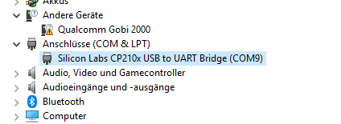

# Step 2:

Download the ESP32 Flash Download Tool from the website: <https://www.espressif.com/sites/default/files/tools/flash_download_tools_v3.6.5_0.zip>

Step 3:

Start flash_download_tools_v3.6.5.exe.

Choose ESP32 DownloadTool:

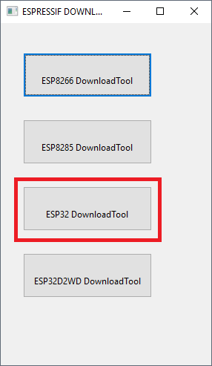

Step 4:

The main window will pop up. Configure as follows:

SPI flashing, 32Mbit flash, 40 MHz SPI speed.

Add the binary to the list of files to flash, and set a start address of 0x0. Also make sure to choose the correct COM port. After setting up everything correctly, press „START“.

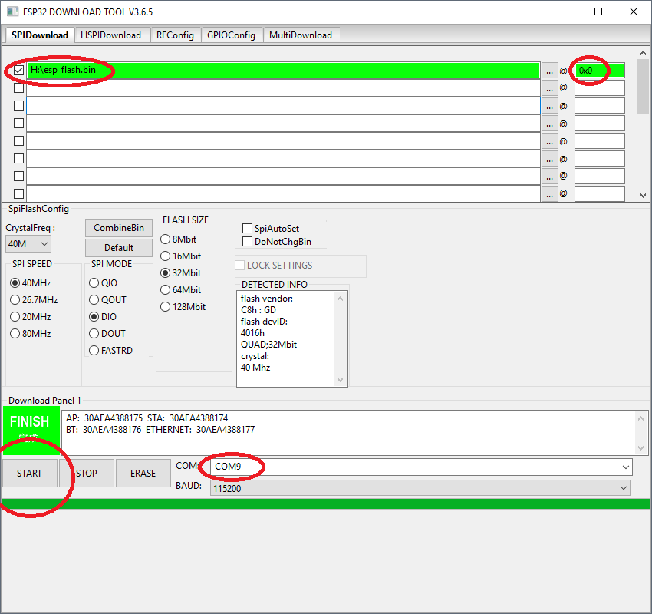

After reset the target, you should see some debug output in the serial interface, looking like this:

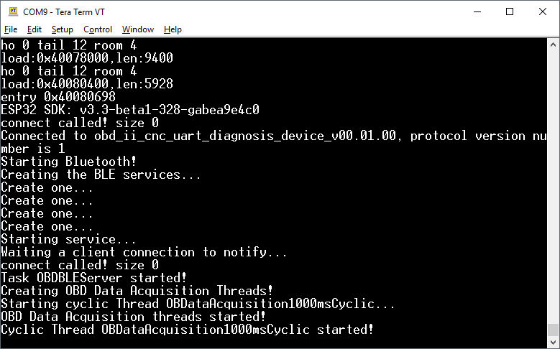

That means that flashing was successful!