+1

Analyzing Social Media Data to Detect and Map Suspicious Individuals

Danayal Khan

- INTRODUCTION

The use of Social Media in organizing and promoting protests was made popular during the Arab Spring revolution. Social Media is a powerful tool that allows users to commu-nicate across borders easily; and to spread their propaganda effectively. As a result, it is easy to misuse the power of open communication.

Affiliates of terrorist organizations such as ISIS and the Taliban actively use Twitter to promote hate speech and spread their propaganda. Furthermore, they target and recruit susceptible individuals through the strong ideologies they spread online. It is essential for governments and social media companies to monitor and track these individuals in order to ensure the safety of their population and their sovereignty.

Before strict regulation of social media, affiliates of terrorist organizations would use their real names since there was little that was done to control the social media space. However, Twitter has recently enforced strict community guidelines and aims to enforce these guidelines effectively. As a result, a lot of accounts with pseudonyms and random characters have been created to spread hate speech. This makes it difficult to identify suspicious individuals.

- SOLUTION

I aim to use data mining and data analysis techniques to mine tweets with certain keywords and determine the users who most frequently use these keywords. The keywords to be used are common terms used by affiliates of terrorist organizations. Once a list of users is established, I aim to identify which users follow each other and make a social graph that connects these individuals. By mining for certain keywords and automatically connecting suspicious individuals, one can overcome the hindrance of finding suspicious individuals who use random characters as their username, furthermore, this technique can be applied to mine for any set of keywords. The social graph can then be used to determine who has the most influence in the social media space and governments or technology companies can take action accordingly.

- PROCEDURE

Twitter has restricted only approved developers to use their API. This is a good step in terms of security as it makes it more difficult for ill-intentioned developers, hackers, or journalists to collect tweets on a mass-scale. I tried requesting for their developer API but Ire rejected.

As a result, I resorted to a third-party API called TweetScraper to scrape user tweets using certain queries. The

Fig. 1. Rejection for Accessing Twitter Developer API
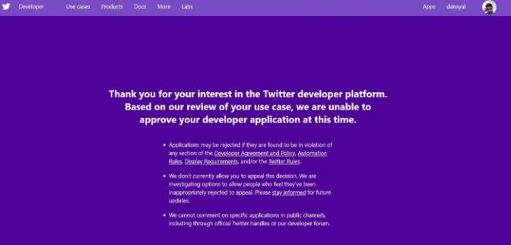

following is an example of a spider crawler that uses the query "ISIS" or "Taliban" that saves a list of tweets with those keywords in a folder.

Fig. 2. An example of a query used to scrape Tweets with keywords

After some initial testing, I realized that English key- words do not return desirable results; the list of accounts mined from these keywords Ire not suspicious. After con- ducting research, I tried using Arabic keywords such as "دھاجملا" as my query and it returned significantly better results. The following is a query I have used for our initial results. The list of query was taken from [1].

Fig. 3. Query using Arabic keywords

By using a sentiment analyzer, the list of tweets returned Ire sorted according to the most negative tweets first in a Pandas dataframe.
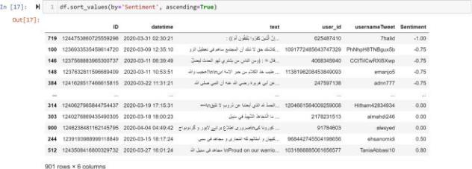

Fig. 4. Tweets sorted according to their sentiment

2

The most frequent occurring users were determined for further analysis.
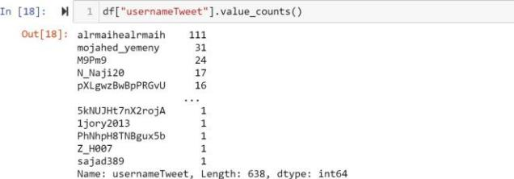

Fig. 5. Most frequent occurring users

The following are the profiles of a couple of suspicious individuals determined by the analysis conducted.
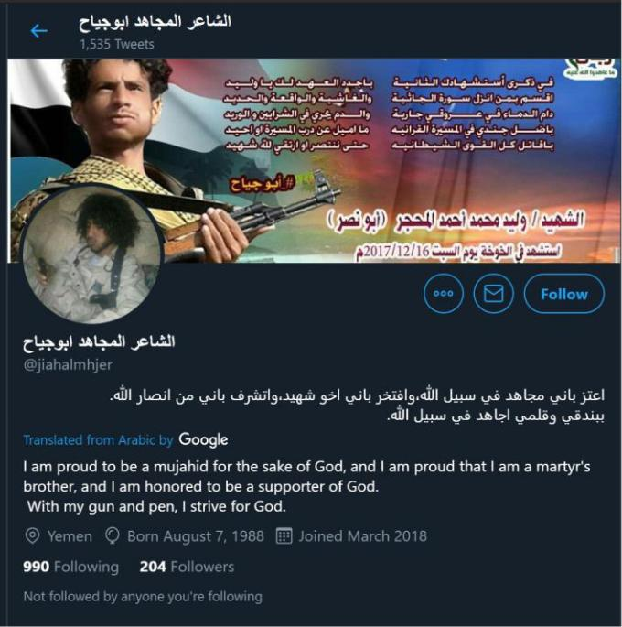

Fig. 6. Twitter Profile of Suspect 1

Fig. 7. Twitter Profile of Suspect 2
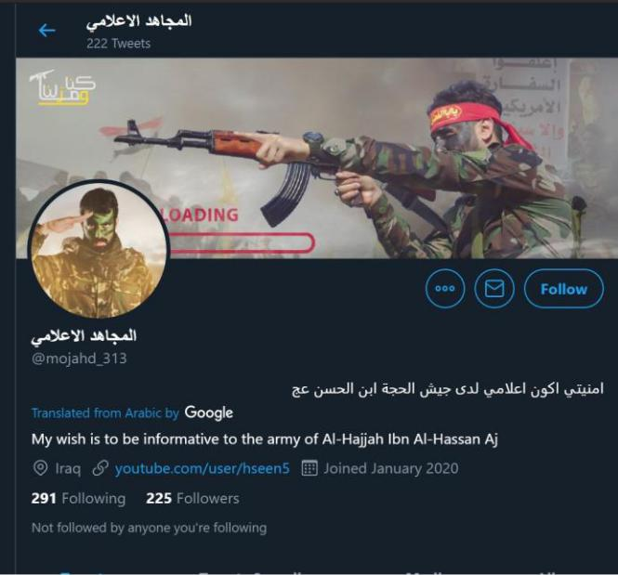

IV. Relationships
From the list of all the users retrieved, the followers of each user was analysed to see if any of the other users in the list follow them. The users with the most common followers amongst the list were determined and deemed to be the most influential amongst all users found.
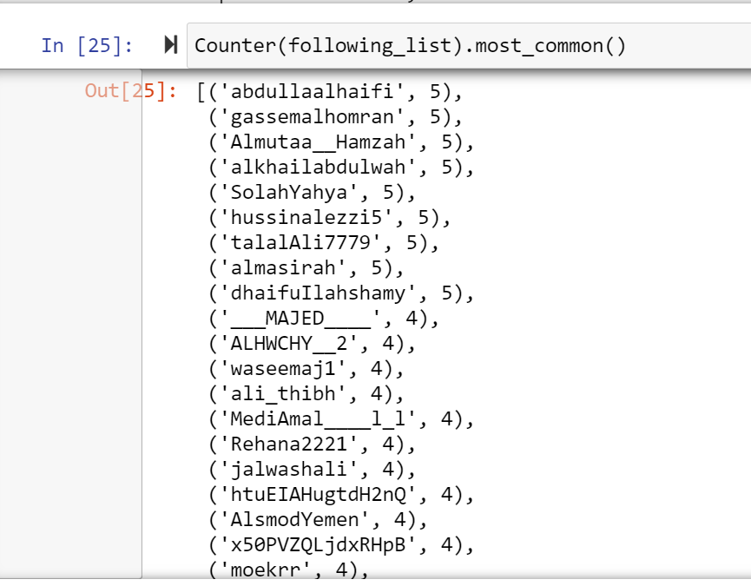

These influential users were separated in a new dictionary as keys and their follows were inserted as the value. Using these dictionaries, a matrix was created to visualize the follow/following relationship amongst the influential users and the followers. The users on the columns are followed by the users on the columns if the value is returned true. 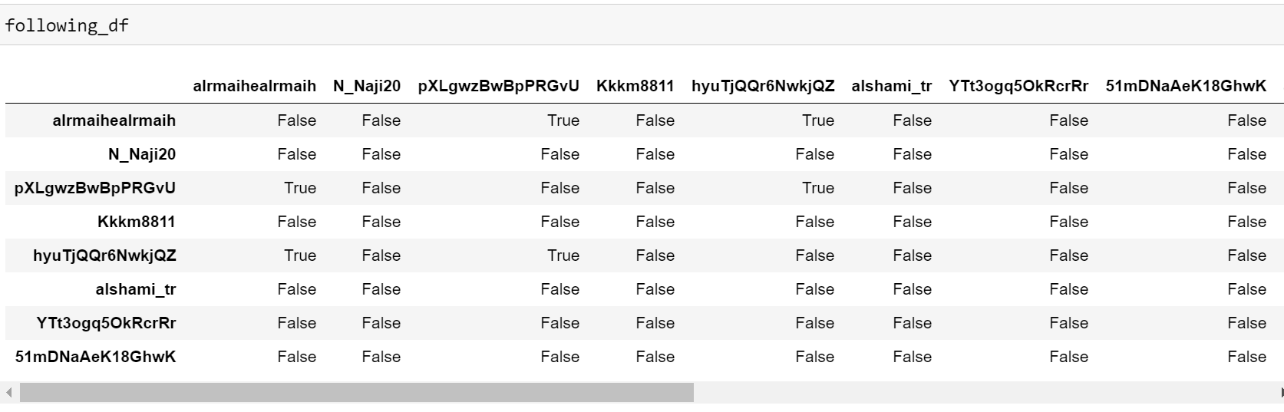

From this analysis, it is easy to create a social network graph with end nodes being the users and the edges being a follow/following relationship. The users with the most connected edges were placed at the center of the graph since they are deemed to be the most influential suspicious indivuals.
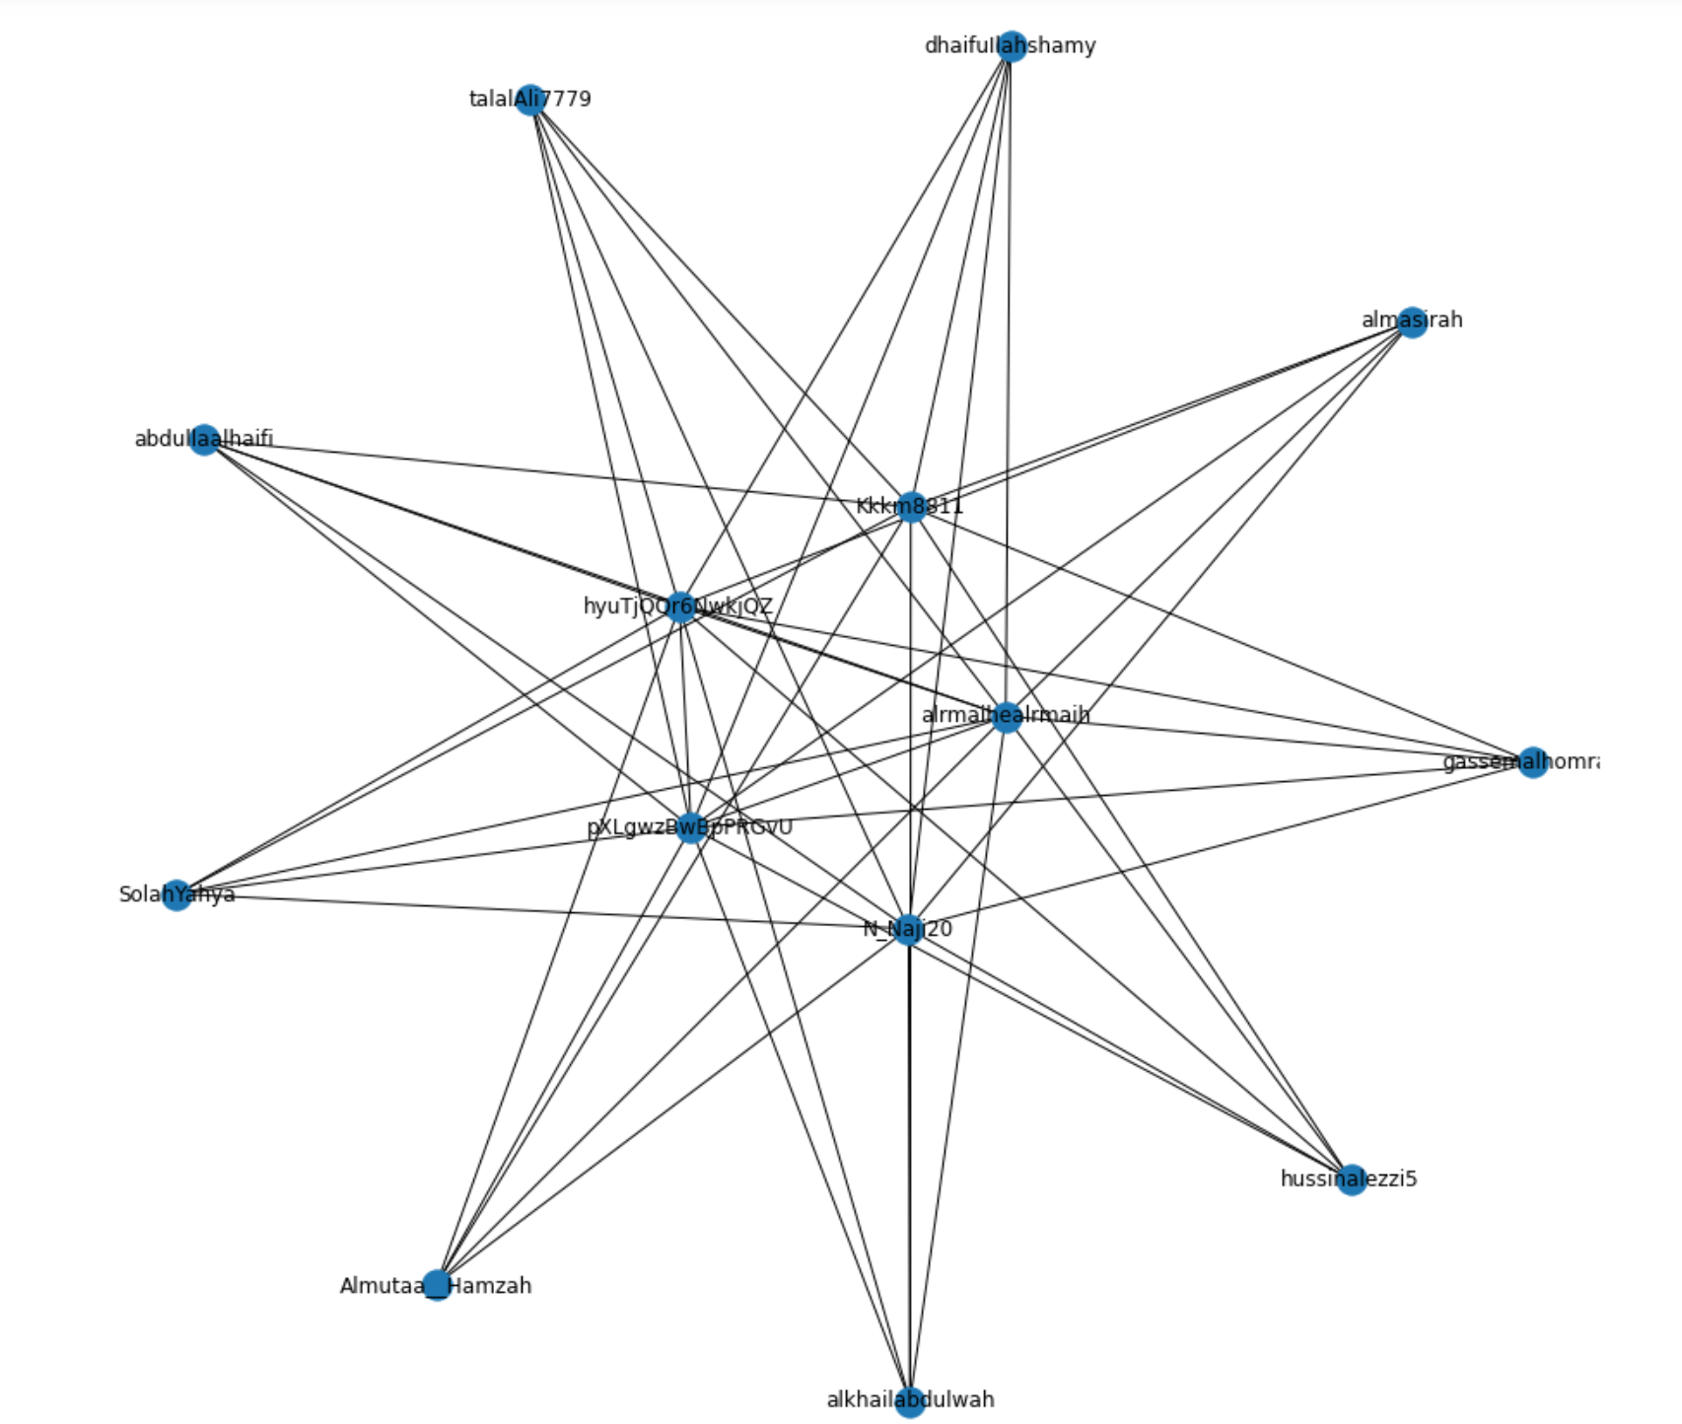

Users on Twitter have an option to display their location. Since this is an opt-in feature, not a lot of users have their locations public by default. However, a heat graph depicting the most frequent location of these suspicious indivudals was created and shown in the following figure.
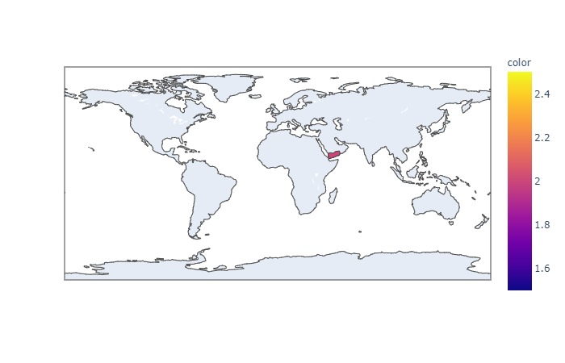
V. Relationships
The work conducted in this project highlights the impact that simple web scraping and data analysis have on finding insights. It also shows how easy and widespread it is to create an account with random alphanumeric combinations and promote hate speech without getting detected by Twitter. A social graph was produced that highlights the most influential suspicious individuals that should be a focus on an investigation by Twitter or relevant authorities.

For the full code, please visit:
https://github.com/Danayal/Analyzing-Social-Media-Data-to-Detect-and-Map-Suspicious-Individuals/blob/master/security.ipynb

REFERENCES

- R. Gupta and H. Brooks, Using social media for global security. Indi-anapolis, IN: John WIley & Sons, Inc, 2013.

