**ABSTRACT**

Quizzes are a great way to have fun, but they can also be used as a tool for self-improvement. They can help you learn more about yourself and how others view you.  
In a quiz, which is also known as a mind sport, participants compete to answer questions either individually or in teams correctly.  
Beyond the obvious academic advantages of exposing a child to new ideas and abilities at a young age, quizzes fundamentally alter how education is provided.

Today's online quizzes are interactive avenues where students may learn, look for possibilities to succeed beyond the classroom, and secure their futures rather than compete for cash prizes or overnight fame.  
And not just that. Students develop the habit of creative learning early on since questions are not focused on the curriculum and demand critical thought and in-depth study.  
Quizzes require students to work in groups, allowing them to develop their teamwork abilities. It is bridging the gap between academia and industry. Recruiters have discovered during interviews that students are strong in theoretical knowledge but lack industrial understanding due to the traditional curriculum structure. Consequently, our students' market readiness is still a sizable gap.

Of course, the purpose of learning quizzes is to monitor, document, and assess student learning results. A course's final quiz serves as the course's graded assessment. A quiz at the end of each course seeks to review essential topics before learning new material.   
In other words, mini-quizzes online or worksheets are employed to ensure that students successfully absorb the material before going on to the next subject.

**INTRODUCTION**

**OBJECTIVE**

The objectives of the online quiz system is to design a software where a virtual quiz is conducted. This solves the hassle of offline quizzes which requires more effort from the teachers. Also online quizzes are a fun way to learn and improve in academics. Moreover, this method of online quizzing makes the students more interested in the lectures and eventually in the subject itself.

Some of the major objectives that can be checked are:

1. **Convenience**: Online quiz systems provide a convenient way for students to take exams from anywhere, at any time, without the need for physical presence.
2. **Cost-effective**: Online quiz systems are cost-effective as they eliminate the need for paper, printing, and manual grading.
3. **Efficiency**: Online quiz systems can be used to automate the grading process, which saves time and effort for instructors.
4. **Flexibility**: Online quiz systems can be customized to suit the needs of different types of exams, such as multiple-choice, true/false, or essay questions.
5. **Feedback**: Online quiz systems can provide instant feedback to students, which can help them identify their strengths and weaknesses and improve their performance.

**Structure**

The structure of a quiz system can vary depending on the specific requirements of the system. However, here is a brief overview of the components that are typically included: User interface This is the part of the system that allows users to interact with the quiz. It can include features such as login, registration, and quiz-taking functionality. Question database: This is where the questions for the quiz are stored. The database can be organized by topic, difficulty level, or other criteria. Scoring system: This is the part of the system that calculates the user's score based on their answers to the questions.

**MODULES**

**User module**

In this module, login page is developed to enter the user’s details. After creation the user is prompted to the quiz section to take up the quiz.

Basic details such as name and topic is accepted in this module.

**Quiz module**

In this module, the questions for taking the quiz is displayed.

Along with a maximum of four options with one correct answer.

The quiz module consists of :

* + Bookmark feature.

This feature reminds the user to check on a question that has been omitted or saved for later review.

**Result Module**

This module displays the result of the quiz along with the total questions. This result module also includes attended and unattended questions along with the total score.

**Sample Coding**

/*Online Java quiz*/

import java.awt.*;

import java.awt.event.*;

import javax.swing.*;

class OnlineTest extends JFrame implements ActionListener

{

JLabel l;

JRadioButton jb[]=new JRadioButton[5];

JButton b1,b2;

ButtonGroup bg;

int count=0,current=0,x=1,y=1,now=0;

int m[]=new int[10];

OnlineTest(String s)

{

super(s);

l=new JLabel();

add(l);

bg=new ButtonGroup();

for(int i=0;i<5;i++)

{

jb[i]=new JRadioButton();

add(jb[i]);

bg.add(jb[i]);

}

b1=new JButton("Next");

b2=new JButton("Bookmark");

b1.addActionListener(this);

b2.addActionListener(this);

add(b1);add(b2);

set();

l.setBounds(30,40,450,20);

jb[0].setBounds(50,80,100,20);

jb[1].setBounds(50,110,100,20);

jb[2].setBounds(50,140,100,20);

jb[3].setBounds(50,170,100,20);

b1.setBounds(100,240,100,30);

b2.setBounds(270,240,100,30);

setDefaultCloseOperation(JFrame.EXIT_ON_CLOSE);

setLayout(null);

setLocation(250,100);

setVisible(true);

setSize(600,350);

}

public void actionPerformed(ActionEvent e)

{

if(e.getSource()==b1)

{

if(check())

count=count+1;

current++;

set();

if(current==9)

{

b1.setEnabled(false);

b2.setText("Result");

}

}

if(e.getActionCommand().equals("Bookmark"))

{

JButton bk=new JButton("Bookmark"+x);

bk.setBounds(480,20+30*x,100,30);

add(bk);

bk.addActionListener(this);

m[x]=current;

x++;

current++;

set();

if(current==9)

b2.setText("Result");

setVisible(false);

setVisible(true);

}

for(int i=0,y=1;i<x;i++,y++)

{

if(e.getActionCommand().equals("Bookmark"+y))

{

if(check())

count=count+1;

now=current;

current=m[y];

set();

((JButton)e.getSource()).setEnabled(false);

current=now;

}

}

if(e.getActionCommand().equals("Result"))

{

if(check())

count=count+1;

current++;

//System.out.println("correct ans="+count);

JOptionPane.showMessageDialog(this,"correct ans="+count);

System.exit(0);

}

}

void set()

{

jb[4].setSelected(true);

if(current==0)

{

l.setText("Que1: Which one among these is not a datatype");

jb[0].setText("int");jb[1].setText("Float");jb[2].setText("boolean");jb[3].setText("char");

}

if(current==1)

{

l.setText("Que2: Which class is available to all the class automatically");

jb[0].setText("Swing");jb[1].setText("Applet");jb[2].setText("Object");jb[3].setText("ActionEvent");

}

if(current==2)

{

l.setText("Que3: Which package is directly available to our class without importing it");

jb[0].setText("swing");jb[1].setText("applet");jb[2].setText("net");jb[3].setText("lang");

}

if(current==3)

{

l.setText("Que4: String class is defined in which package");

jb[0].setText("lang");jb[1].setText("Swing");jb[2].setText("Applet");jb[3].setText("awt");

}

if(current==4)

{

l.setText("Que5: Which institute is best for java coaching");

jb[0].setText("Utek");jb[1].setText("Aptech");jb[2].setText("SSS IT");jb[3].setText("jtek");

}

if(current==5)

{

l.setText("Que6: Which one among these is not a keyword");

jb[0].setText("class");jb[1].setText("int");jb[2].setText("get");jb[3].setText("if");

}

if(current==6)

{

l.setText("Que7: Which one among these is not a class ");

jb[0].setText("Swing");jb[1].setText("Actionperformed");jb[2].setText("ActionEvent");jb[3].setText("Button");

}

if(current==7)

{

l.setText("Que8: which one among these is not a function of Object class");

jb[0].setText("toString");jb[1].setText("finalize");jb[2].setText("equals");jb[3].setText("getDocumentBase");

}

if(current==8)

{

l.setText("Que9: which function is not present in Applet class");

jb[0].setText("init");jb[1].setText("main");jb[2].setText("start");jb[3].setText("destroy");

}

if(current==9)

{

l.setText("Que10: Which one among these is not a valid component");

jb[0].setText("JButton");jb[1].setText("JList");jb[2].setText("JButtonGroup");jb[3].setText("JTextArea");

}

l.setBounds(30,40,450,20);

for(int i=0,j=0;i<=90;i+=30,j++)

jb[j].setBounds(50,80+i,200,20);

}

boolean check()

{

if(current==0)

return(jb[1].isSelected());

if(current==1)

return(jb[2].isSelected());

if(current==2)

return(jb[3].isSelected());

if(current==3)

return(jb[0].isSelected());

if(current==4)

return(jb[2].isSelected());

if(current==5)

return(jb[2].isSelected());

if(current==6)

return(jb[1].isSelected());

if(current==7)

return(jb[3].isSelected());

if(current==8)

return(jb[1].isSelected());

if(current==9)

return(jb[2].isSelected());

return false;

}

public static void main(String s[])

{

new OnlineTest("Online Test Of Java");

}

}

**Screenshots**

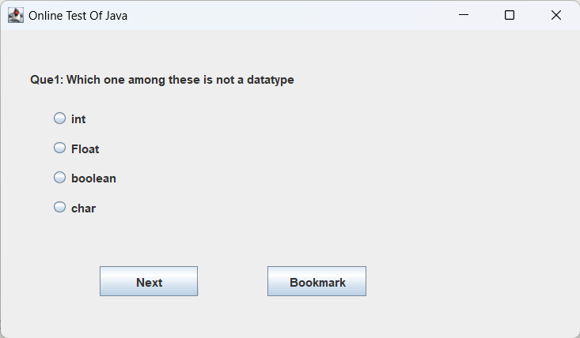

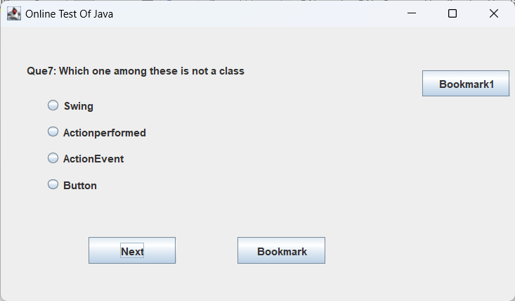

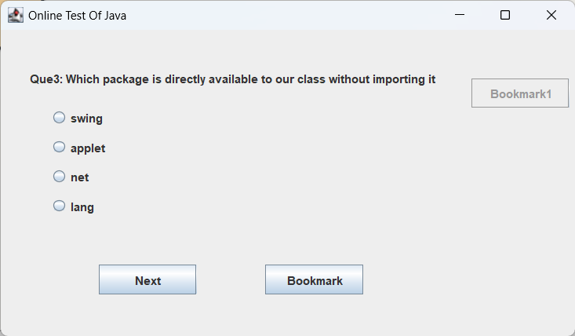

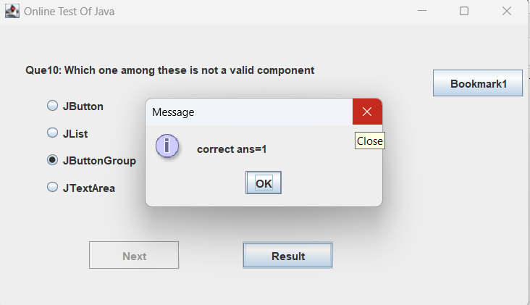

**CONCLUSION**

It would be best to take any quiz you see because you want to test your knowledge. This fact is the same for online tests. Online tests included in an e-Learning program are often made to monitor, record, and assess student performance. Offline quizzes must be manually evaluated, which takes time. With the aid of technology, online tests are reviewed. Once you click the submit button on the quiz, you immediately see the results. Online tests can be intricate and challenging. They are intended to be enjoyable, nevertheless. E-Learning is a notion that is highly intriguing since it is interesting. The quizzes that are a part of this are intriguing because of how they were created. Quizzes are typically completed quickly. Online tests are an excellent way to gauge your knowledge. Numerous websites run online tests covering a range of topics and industries. Regardless of age, taking a quiz is always entertaining. It is an exciting approach to learning. Quizzes must therefore be a part of every student's assessment plan.

**Reference**

[The Importance Of Quiz Competition For Students | 98thPercentile](https://www.98thpercentile.com/blog/the-importance-of-quiz-competition-for-students/)

[Tutorials List - Javatpoint](https://www.javatpoint.com/)