Ruth St. Denis processing update 8/29/13

I have organized seven of the eight series: journals, correspondence, writings, performance materials, ephemera, business materials, and books. The journals series is 43 boxes and contains journals from the 1920s to the 1960s, with the bulk of the journals written in the 1960s. The correspondence series is 16 boxes and includes St. Denis family letters from the late 1800s to the 1930s, as well as greeting cards and contact lists. The writings series is 10 boxes and includes inventories of writings, poems, essays, speeches and lectures, and other people’s writings. The performance materials is 10 boxes and includes materials for dance dramas, performance sketches and artwork, performance research materials, Temple materials, and sheet music. The ephemera series is 13 boxes and includes pamphlets, flyers and programs, magazines and publications, invitations and memberships, and newspaper clippings. The business materials series is 7 boxes and includes medical documents, legal documents, informal and formal business notes, and financial materials. The books series is 8 boxes 2 letter size doc boxes and 6 paige boxes, and includes books from St. Denis’s personal library. The folder titles of the writing and correspondence series have already been entered into Archivists Toolkit.

The remaining series that needs to be organized is the media series, 29 boxes, which contains photographs, negatives, glass negatives, and tape to tape reels. Some of the photographs of performances are already organized and labeled. There are also 22 boxes that contain miscellaneous materials that still need to be organized. Most of these boxes are not full and will be condensed.

Once the media series and the remaining miscellaneous materials have been organized, I will finish entering data into Archivists Toolkit and add description to the finding aid.

Images

1. 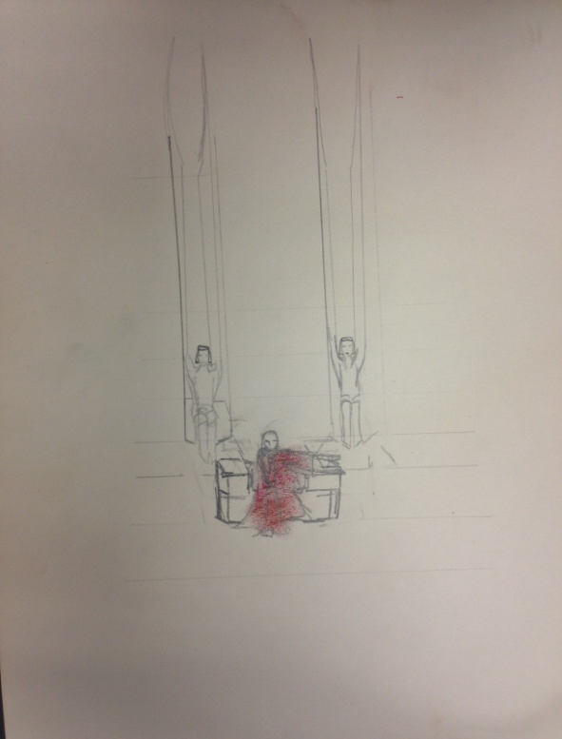 Performance sketch, 9x12
2. 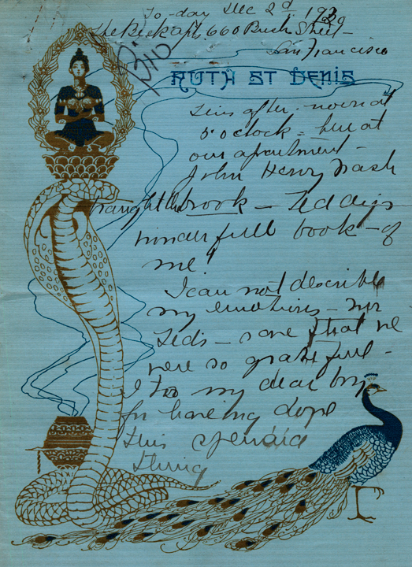 Miscellaneous journal entry, 8x10
3. 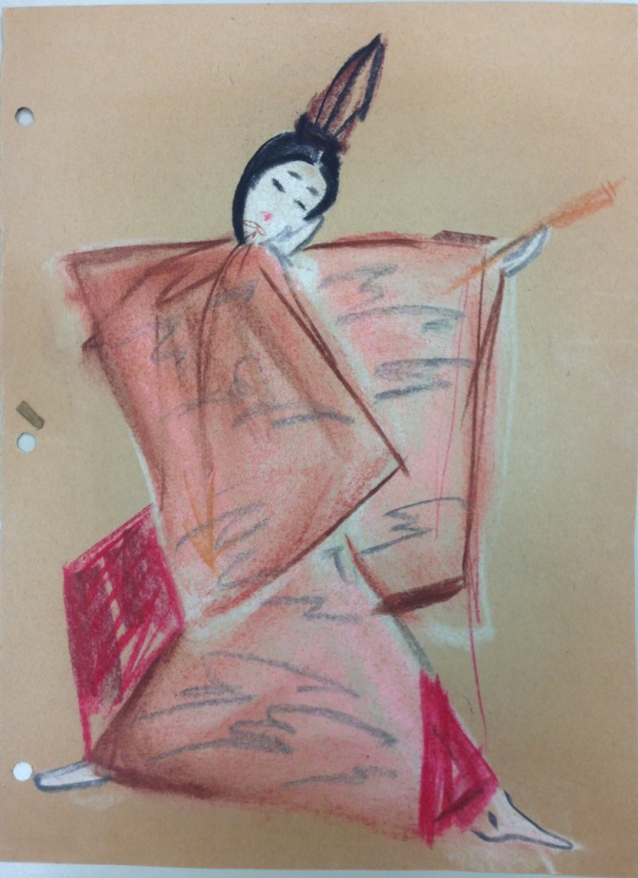Performance sketch, 8x10