CLIR “Foundations of Dance” Year 1 report

Ruth St. Denis Papers

UCLA Library Special Collections

Genie Guerard, Manuscripts Librarian, UCLA Library Special Collections

Zoe MacLeod, UCLA MLIS and CFPRT student

March 10, 2013

-----------------------------------------------------------------------------------------------

The UCLA Library Special Collections’ participation in the Dance Heritage Coalition / CLIR Hidden Collections grant is to process the Ruth St. Denis papers--92 linear feet of archival material, in 18 months. To date, approximately 40 linear feet have been processed in 300 hours.

Zoe MacLeod is a first year graduate student in UCLA’s Information Studies Department. Ms. MacLeod is currently processing the Ruth St. Denis papers in the UCLA Library Special Collections under direction of the Head of the Center for Primary Research and Training (CFPRT), Jillian Cuellar. In the center, students are “matched” with unprocessed archival collections in their area of research. The CFPRT provides a substantive educational experience for graduate students by training them in archival methods, while simultaneously making accessible lesser-known collections through the creation of finding aids. Ms McLeod’s special interest is in the visual and performing arts archives. Before beginning the MLIS program at UCLA, she processed two collections in this area at UC Irvine: the papers of fashion designer Irene Saltern Salinger, and dance artist Verena Ruegg.

The Ruth St. Denis papers will be arranged into eight series, including Journals, Writings, Correspondence, and Performance and Dance Materials. Processing is more than half-way complete. To date, Ms. MacLeod has completed processing the following: Journals, Writings, and the Correspondence series. The journals document St. Denis’s personal life, performance tours, and travels from the 1890s to the 1960s. They provide extensive insight into the development of St. Denis’s perspectives on dance and spirituality. The essays, poetry, and lectures in the Writings series provide concrete evidence of St. Denis’s philosophy on the connection between performance and spirituality. The Correspondence is a rich trove that includes St. Denis’s family letters beginning in 1886, letters to and from Ted Shawn, William Skipper, Harro Miller, and letters from students.

Ms. MacLeod will next begin processing St. Denis’s performance materials, business materials, and photographs, and various ephemera. The three series that have been processed so far--Journals, Writings, and Correspondence--are all of high research value, but in general had the least order, therefore were time intensive to process and organize. Of the remaining series that need to be processed, the Performance and Dance Materials will require the most reorganization. This series includes materials of high research value and include summaries of ballets, original sheet music with dance and music notation, and sketches of costumes and stage designs. The photographs, which will require preservation housing, will present new challenges. The sheet music and sketches in this series, as well as the photographs, stand out as excellent candidates for digitization, once the collection is processed. Because many of the photographs are not identified, they may also be appropriate candidates for gathering value-added metadata through crowd sourcing.

As Ms. MacLeod processes the collection, she is performing basic preservation work, providing appropriate housing for materials, and identifying materials to send to UCLA Library’s Preservation Lab. She is also taking copious notes as she works for reference in writing the front matter of the finding aid.

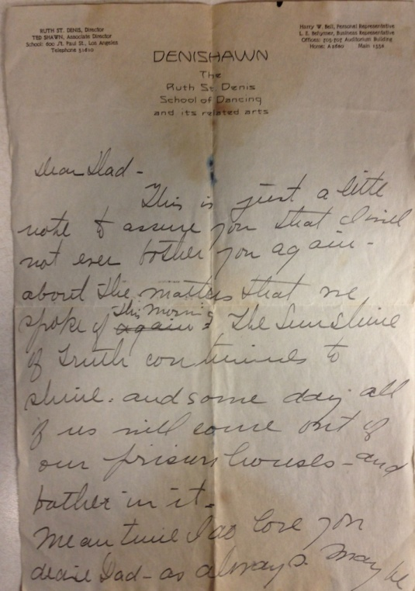

Letter from Ruth St. Denis to her father, page 1, undated.

Holograph letter on paper, 7-1/4 x10-1/2”.

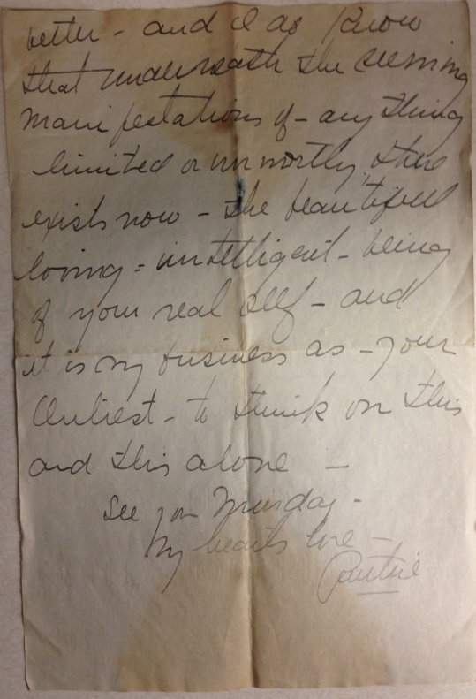

Letter from Ruth St. Denis to her father, page 2, undated.

Holograph letter on paper, 7-1/4 x x10-1/2”.

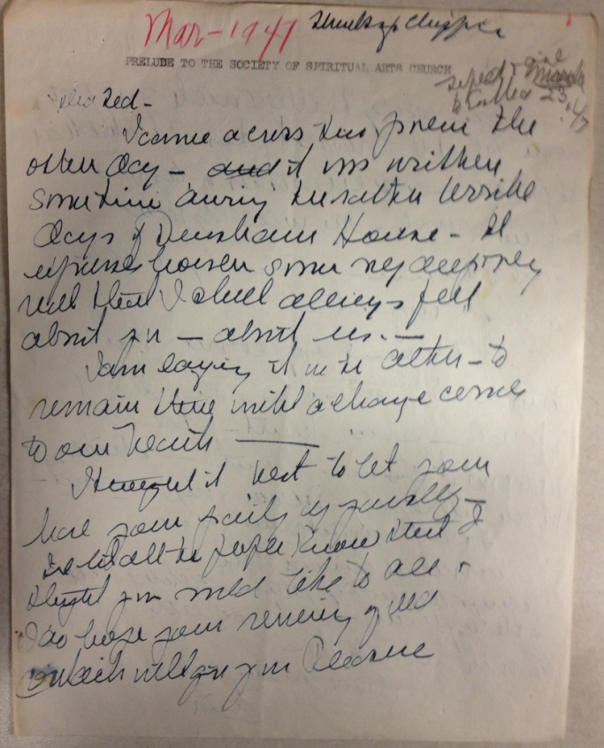

Letter from Ruth St. Denis to Ted Shawn, page 1, March 1947.

Holograph letter on paper, 8-1/2x11”.

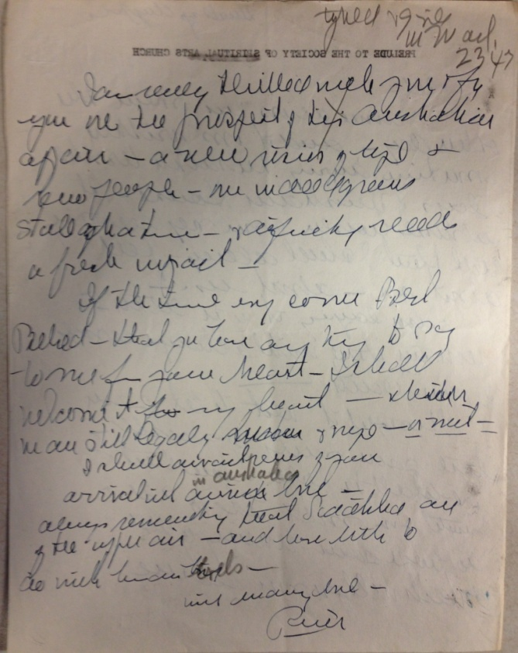

Letter from Ruth St. Denis to Ted Shawn, page 2, March 1947.

Holograph letter on paper, 8-1/2x11”.

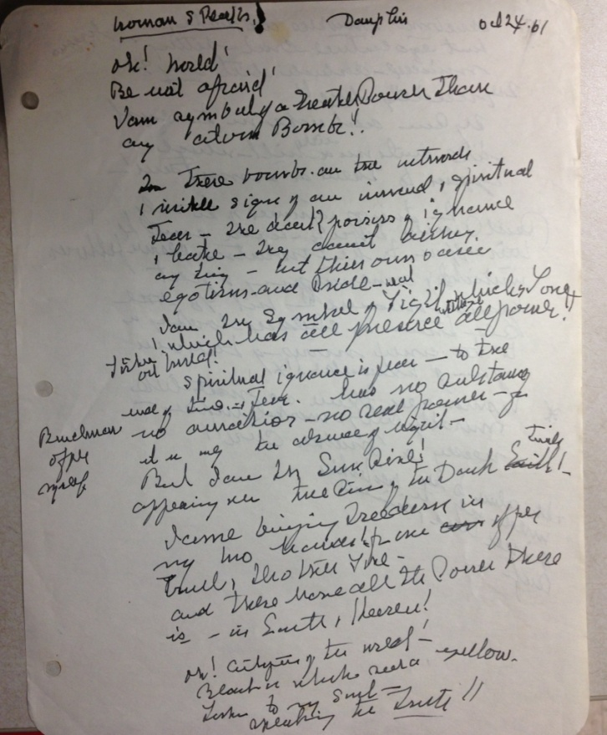

Ruth St. Denis, “Woman Speaks,” page 1, October 24, 1961

Holograph notes on paper, 8.5x11”

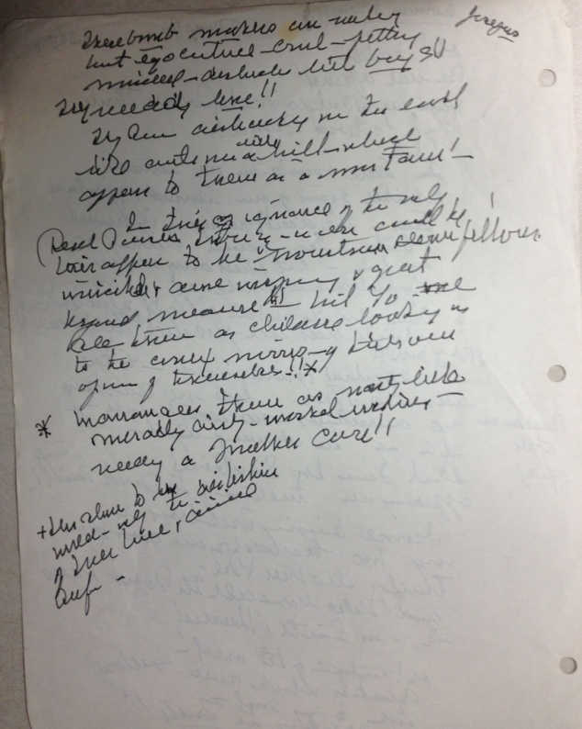

Ruth St. Denis, “Woman Speaks,” page 2, October 24, 1961

Holograph notes on paper, 8.5x11”

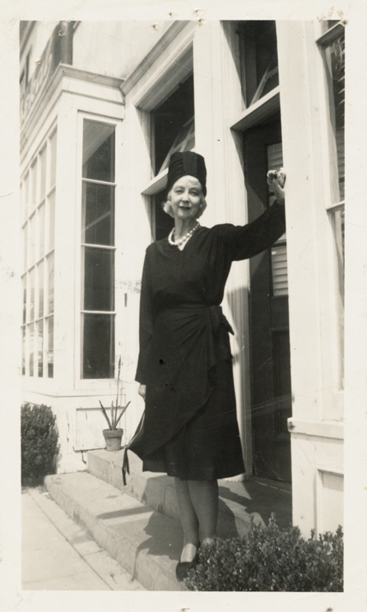

Photograph of Ruth St. Denis, 1960’s.

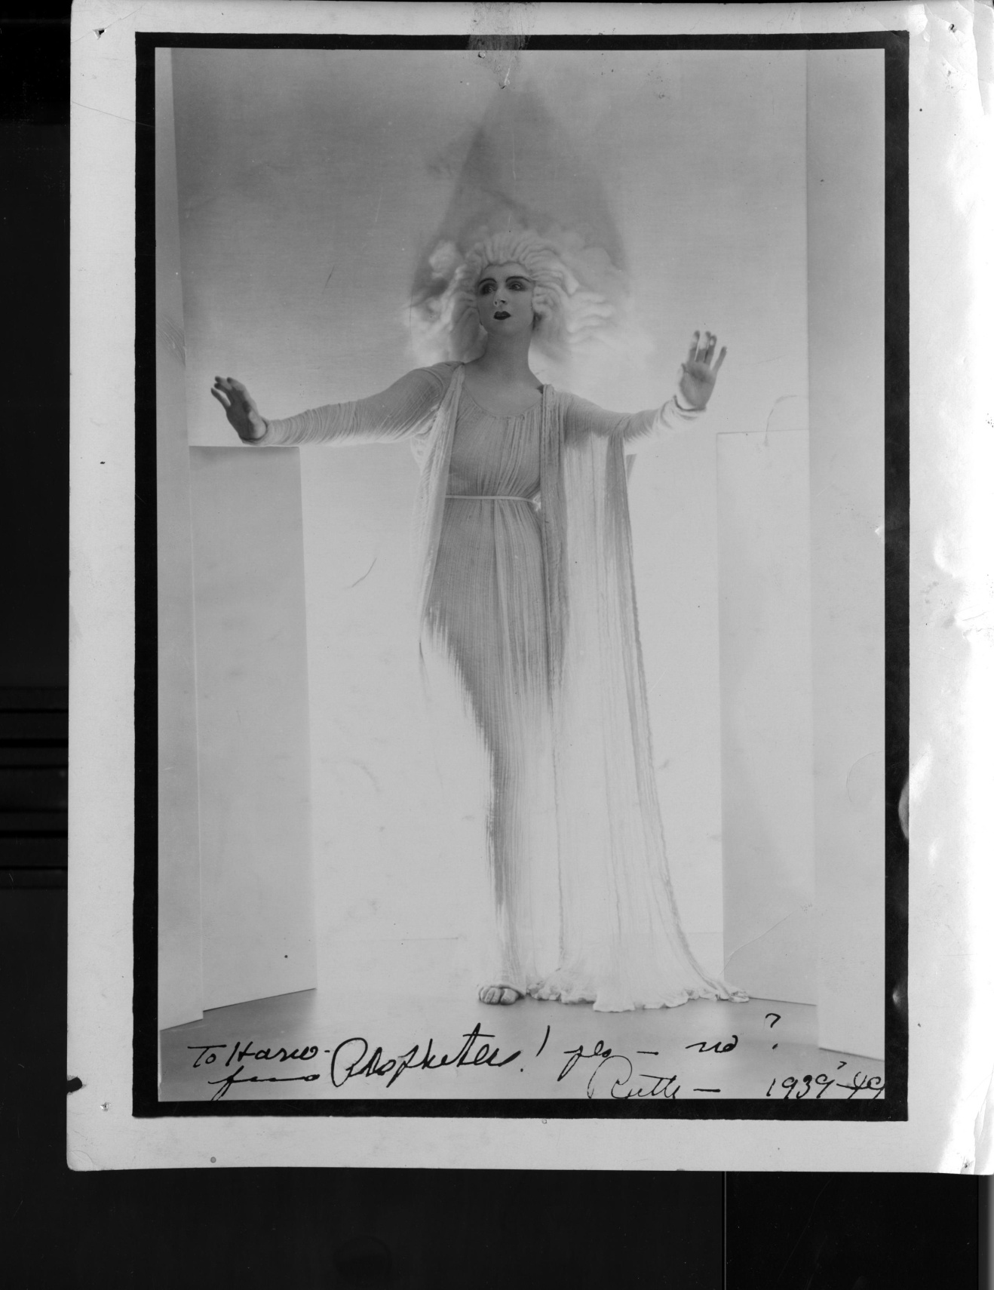

Photograph of Ruth St. Denis in costume, *The Prophetess*, 1939 or 1949.

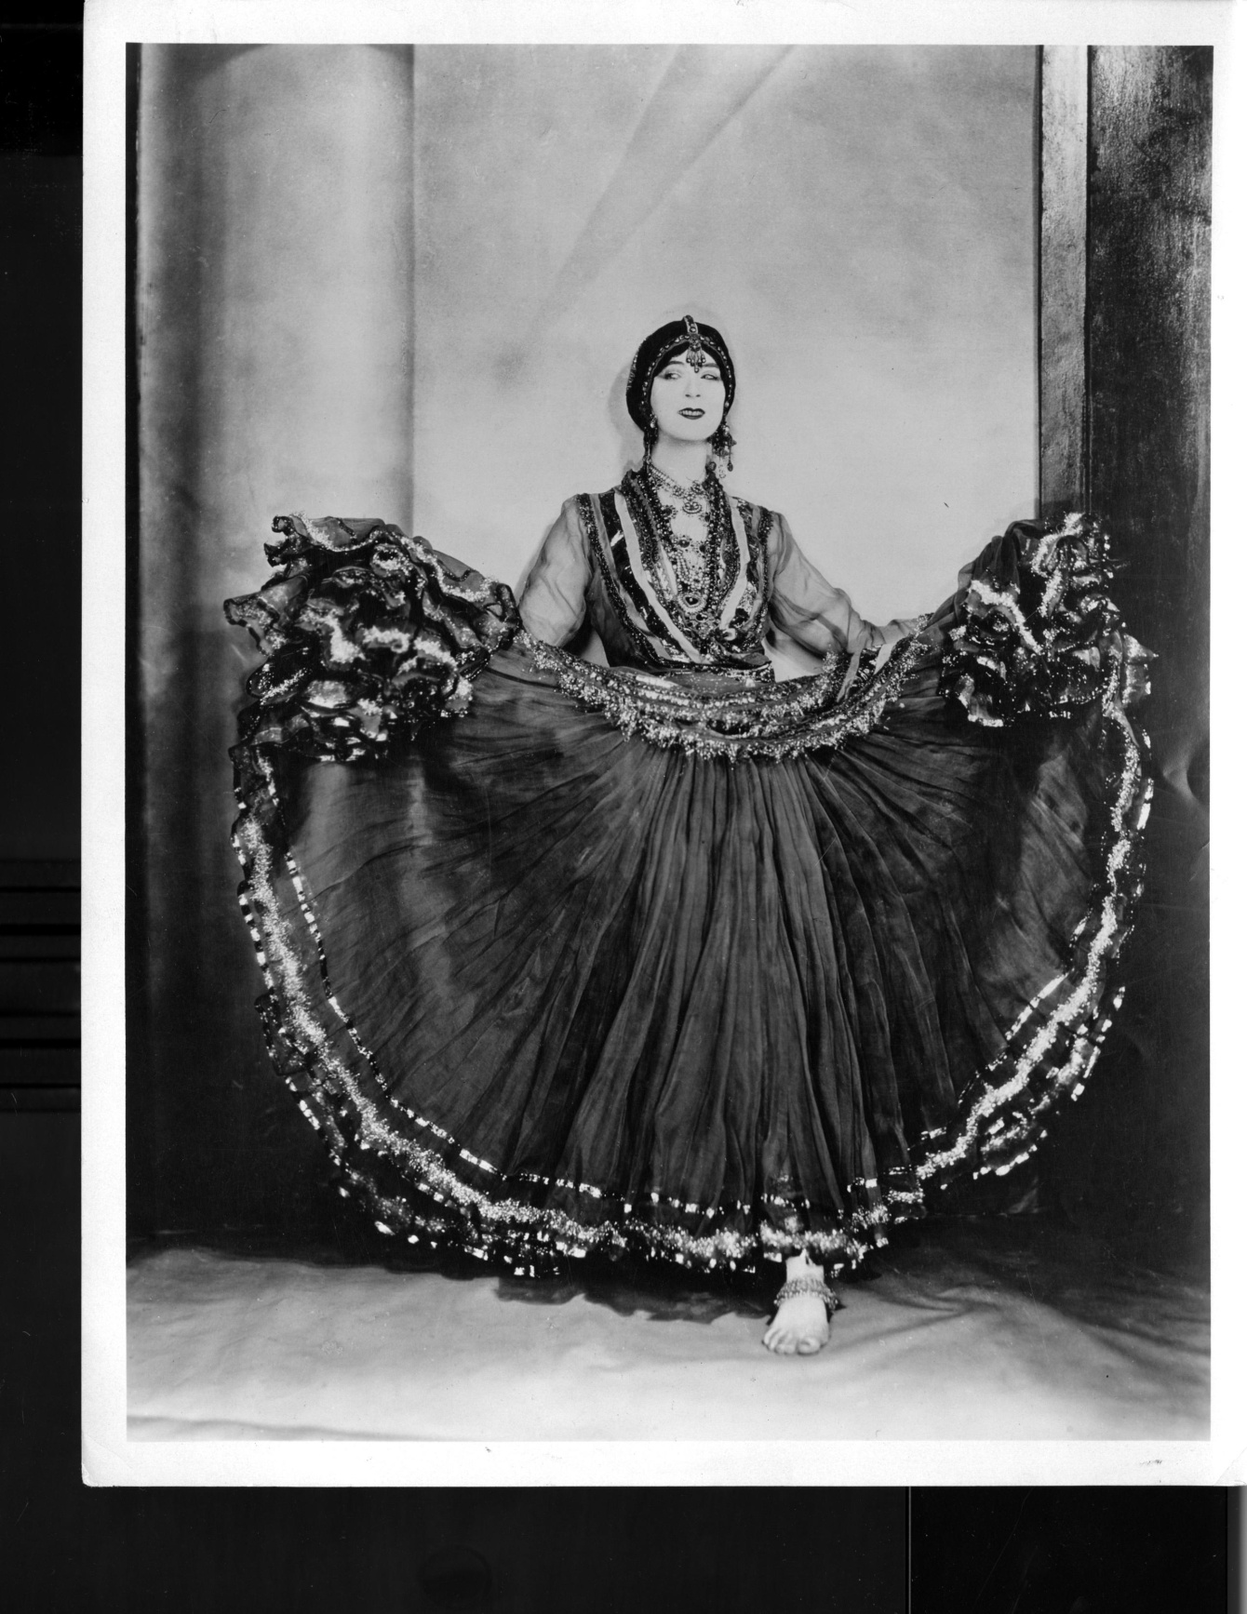

Photograph of Ruth St. Denis in costume, *Nautch,* 1920s or 1930s.