**From jungle to pasture: 25 years of land cover change**

**in Guerrero (2001–2025) using Terra data**

**Team: Dancing' Bros**

**Members:**

Oliver Sebastian Ortega García.

David Alejandro Ortega García.

Yazid Itzayana Rodríguez Rodríguez.

Jaquelin de los Angeles Garcia Constantino.

David Israel Ortega González.

**Date:**October 5, 2025

A simple image in the video game Minecraft, depicting a tree being cut down, led me to a profound reflection. This curiosity transformed into a NASA project to process large amounts of environmental data. The goal is to understand how technology can be applied to environmental monitoring, combining digital tools with ecological awareness.

# Summary

Between 2001 and 2024, the state of Guerrero lost approximately 29,660 hectares of forest. This paper analyzes spatiotemporal patterns of deforestation in the Sierra Madre del Sur and discusses environmental and social implications. Territorial planning solutions with the help of institutions are proposed to reverse this trend.

**Introduction**

The Sierra Madre del Sur is a key region in terms of biodiversity, ecosystem services, and water resources. However, it faces constant pressures from agricultural and livestock expansion. This work seeks to contribute to the understanding of the dynamics of land-use change and provide scientific information for local decision-making.

**Justification**

Using Google Earth Engine enables processing of large volumes of satellite data and detection of coverage loss with temporal and spatial precision, reducing costs and increasing transparency.

By combining TERRA data (MODIS, ASTER), you can:

* Identify deforestation hotspots at the municipal level.
* Quantify productivity variations (NDVI).
* Validate in the field with ASTER images (15–30 m).
* Generate monitoring boards open to the community.

These capacities strengthen national restoration programs (PNRA) and environmental services programs (PSA), in addition to supporting evidence-based decision-making.

# Goals

# Implement a comprehensive forest monitoring, prioritization, and restoration system in Guerrero using TERRA satellite data and Google Earth Engine, promoting community management and open access to environmental information.

# Specific objectives:

# Identify deforestation hotspots 2001–2024 at the municipal level using MODIS and NDVI.

# Prioritize critical micro-watersheds for reforestation and PSA.

# Design an interactive dashboard in GEE with annual updates.

# Link results with SEMARNAT/CONAFOR programs and local organizations.

# Methodology

Terra data were processed: MODIS MCD12Q1 (annual coverage), MODIS MOD13Q1 (NDVI), and ASTER (high-resolution imagery). The methodology included: delimitation of the study area, thematic classification, temporal analysis (2001–2024), calculation of change matrices by municipality and five-year period, detection of NDVI anomalies, and visual validation with ASTER in hotspots.

* **Methodological flow:**

# Importing TERRA data into GEE.

# Calculation of annual average NDVI indices and detection of breaks 2001–2024.

# Supervised classification (forest/grassland/agricultural).

# Visual validation with ASTER.

# Crossing layers with ANP and ejidos (CONAFOR/INEGI).

# Export to dashboard (public dashboard in GEE or App Engine).

**NASA TERRA satellite models used**

This study used three key products from NASA's TERRA mission, which allowed us to analyze the dynamics of land cover change in Guerrero over the period 2001–2024:

* **MODIS MCD12Q1 – Land Coverage**
  + This product offers global land cover maps at a spatial resolution of 500 my with annual updates. The project used it to classify land into two main categories: Forest and Agriculture/Grassland, allowing for the generation of five-year land change matrices and the quantification of deforestation magnitude.
* **MODIS MOD13Q1 – Vegetation Indices (NDVI)**
  + This is a 16-day composite product with a 250 m resolution, designed to estimate vegetation productivity and vigor using the Normalized Difference Vegetation Index (NDVI). This analysis was used to identify anomalies in photosynthetic activity and assess vigor reduction in areas where canopy change was detected.
* **ASTER – Advanced Spaceborne Thermal Emission and Reflection Radiometer**
  + ASTER provides high-resolution (15–30 m) multispectral imagery, used in this project as a visual validation tool in hotspots. Its purpose was to corroborate the forest cover loss detected by MODIS and to more precisely delineate the transformed areas.

**Methodological relevance**

The combination of MODIS (with broad temporal and spatial coverage) and ASTER (with high spatial resolution) products allowed for robust documentation of deforestation patterns in Guerrero. While MODIS provided the capability for systematic long-term monitoring, ASTER provided detailed visual evidence that strengthened the validation of the results.

**Results**

The cumulative forest loss in Guerrero was 29,660 ha. Atoyac de Álvarez accounted for 1,567 ha (5.3%). The peaks were observed in 2014 and 2024. In the 2016–2024 period, Atoyac accounted for 8.4% of the state's forest loss. Significant declines in NDVI were observed in deforested areas, confirming the effects on plant productivity.

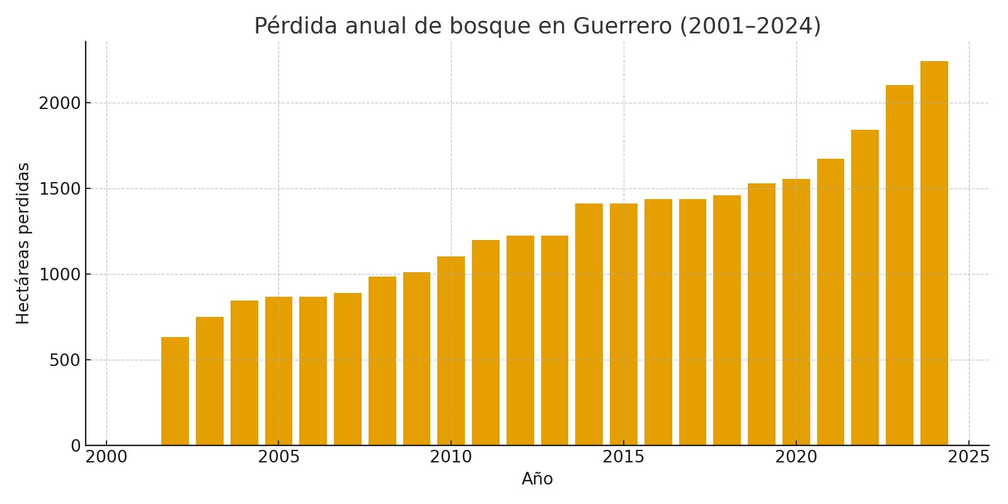

**Participation 2016–2024: Atoyac explains 8.4% of the state loss (712 + 570 = 1,282 ha vs. 7,410 + 7,852 = 15,262 ha → 8.4%).**

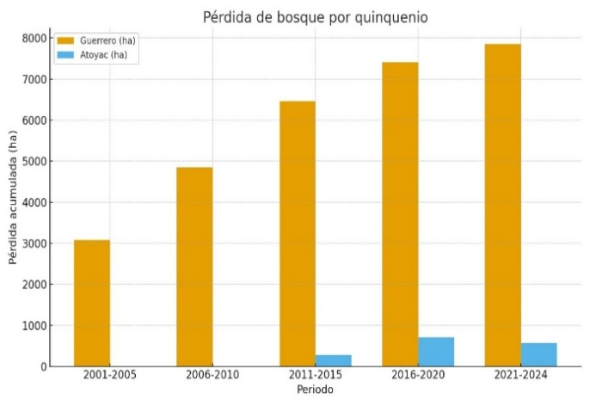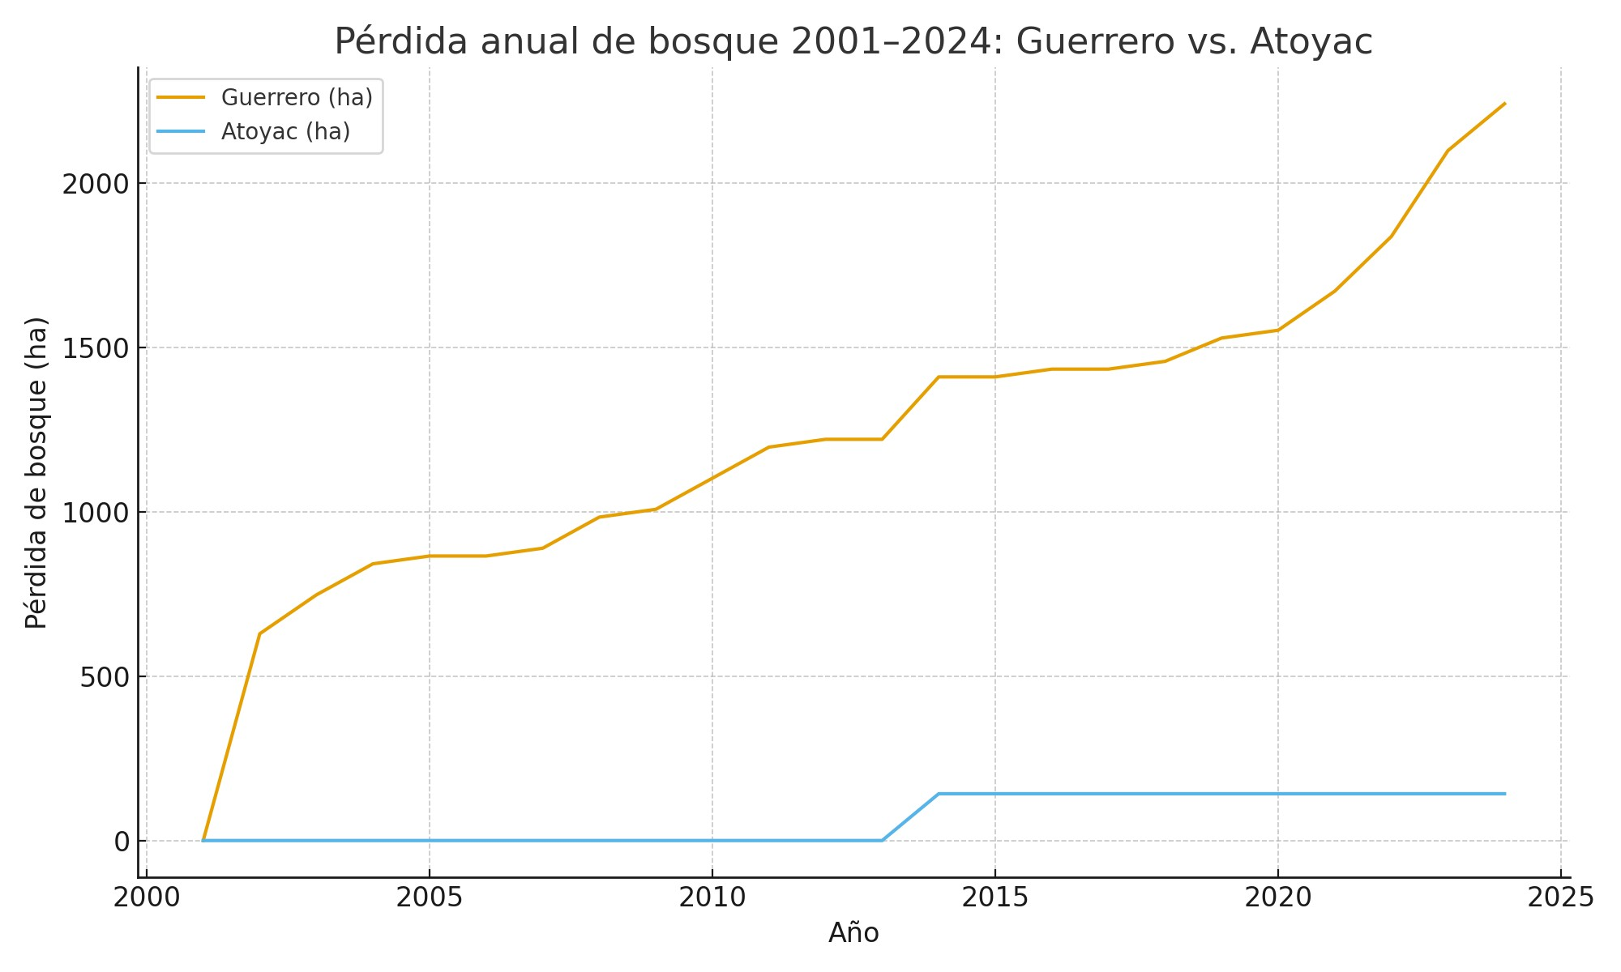

# Discussion

The results show a non-random pattern: deforestation is concentrated primarily in municipalities in the north and northeast of Guerrero, while the Costa Grande maintains greater forest cover. This pattern is related to agricultural and livestock expansion in more inland areas of the state, as well as the recurrent use of fire for pasture management. Forest loss implies a reduction in essential environmental services such as water regulation, soil conservation, and carbon sequestration.

The recent statewide peaks and the increase in Atoyac's participation (although lower compared to other areas) suggest that the pressure is on hillsides and areas near inland roads, rather than on the coastal strip. Therefore, hotspot prioritization should focus on the 2016–2024 period, combining indicators of cover loss with NDVI analysis (MOD13Q1) and, optionally, fire scars (MCD64A1), which allows for more comprehensive monitoring.

**Limitations**

# The resolution of MCD12Q1 (500 m) may underestimate small patches of deforestation and does not reflect local dynamics in detail.

# This synthesis is based on the coverage archive; the use of NDVI (MOD13Q1) and ASTER will be integrated into the final repository for greater accuracy.

# Global land cover classes may differ from local definitions (e.g., “forest” or “grassland”), so additional field validation is recommended.

# Satellite time-lapse suggests that deforestation is not concentrated in the Costa Grande, but in other regions of the state, implying that spatial scale can influence the interpretation of regional patterns.

# Proposed solutions

# By using this program, we will connect with specialized institutions that can provide specific solutions to this problem.

# Federals:

# SEMARNAT: Coordinates environmental policy (e.g. National Restoration Program 2025-2030).

# CONAFOR: Channel for subsidies, community reforestation, PSA and fire fighting.

# CONANP: Manages Protected Natural Areas and biological corridors.

# PROFEPA: Implements surveillance and measures against illegal land use changes.

# Wellbeing: Implements "Sowing Life" for agroforestry systems.

# CONAGUA/IMTA: Focus on watersheds and green infrastructure (linked to water PSA).

# UNDP + SEMARNAT: Technical assistance against illegal logging.

# State (Guerrero):

# SEMAREN: State co-financing, ecological planning and fire management.

# Municipal:

# Ecology Units: Local authorizations, community brigades and river basin committees.

# International:

# TerraData: Specialized technical support.

# State of the art (who has used GEE and how they applied it)

# Several leading institutions use Google Earth Engine (GEE) with satellite data such as MODIS and ASTER for environmental monitoring and decision-making. Its main applications are:

# Forest Monitoring:Organizations such as WRI (Global Forest Watch) and MapBiomas use GEE to generate near-real-time deforestation alerts and annual land cover change maps, combining MODIS data with more detailed imagery.

# Training and Operational Projects:Programs like NASA SERVIR offer training and develop GEE applications for fire, drought, and restoration management, using products like MCD64A1 for fires.

# Public Policy and Transparency:Government agencies (e.g., Mexico, Peru, Brazil) and the UN (FAO) use GEE to create public dashboards that enable citizen oversight and assess impacts on land productivity.

# Relevance: These cases demonstrate that GEE is a standard and transferable tool for the rapid detection of environmental problems, prioritization of intervention areas, and impact monitoring, and is directly applicable to monitoring in regions like Guerrero.

# Conclusions

The study demonstrates that the combination of satellite technology, collaborative analysis, and public management can reverse trends of environmental deterioration if combined with active restoration and environmental education policies. Guerrero still has resilient forest areas that, with proper management, could become pilot models for community forest restoration.

Ultimately, the "From Jungle to Pasture" project not only quantifies the loss, but also paves a concrete path toward territorial sustainability based on scientific evidence and citizen participation.

# Declaration of use of generative AI

Generative AI was used only for writing/editing. Geospatial analysis was performed using GEE and reproducible methods.

**References**

Friedl, M.A., et al. (2010). MODIS Collection 5 global land cover. Remote Sensing of Environment.

Huete, A., et al. (2002). Overview of the MODIS vegetation indices. Remote Sensing of Environment.

NASA LP DAAC (2024). MODIS & ASTER data products.

INEGI (2020). Vector dataset of municipal boundaries.

University of Idaho: TerraClimate.

CONAFOR (PSA and Brigade Operating Rules, 2025).

SEMARNAT (PNRA 2025–2030).

GFW/GLAD for alerts and verification.