# From Forest to Pasture: 25 Years of Land Cover Change in Guerrero (2001–2025) using Terra Data

**Team: Dancing' Bros**

**Members:**

Oliver Sebastian Ortega García

David Alejandro Ortega García

Yazid Itzayana Rodríguez Rodríguez

Jaquelin de los Ángeles García Constantino

David Israel Ortega González

**Date: October 4, 2025**

## Abstract

Between 2001 and 2024, the state of Guerrero lost approximately 29,660 hectares of forest. This work analyzes spatio-temporal patterns of deforestation in the Sierra Madre del Sur and discusses environmental and social implications. Community-based and territorial planning solutions are proposed to reverse the trend.

## Introduction

The Sierra Madre del Sur is a key region in terms of biodiversity, ecosystem services, and water resources. However, it faces constant pressures derived from agricultural and livestock expansion. This work aims to contribute to the understanding of land-use change dynamics and provide scientific information for local decision-making.

## Objectives

1. Identify the magnitude and distribution of forest loss in Guerrero (2001–2025).

2. Analyze the relationship between land cover change and NDVI as a proxy for vegetation productivity.

3. Locate priority hotspots for restoration and conservation actions.

## Methodology

Terra data were processed: MODIS MCD12Q1 (annual land cover), MODIS MOD13Q1 (NDVI), and ASTER (high-resolution images). The methodology included: delimitation of the study area, thematic classification, temporal analysis (2001–2024), calculation of change matrices by municipality and five-year periods, detection of NDVI anomalies, and visual validation with ASTER in hotspots.

## NASA Terra Satellite Models Used

Three key products from NASA's Terra mission were employed in this study, enabling analysis of land cover change dynamics in Guerrero over the 2001–2024 period:

**• MODIS MCD12Q1 – Land cover**

Provides global land cover maps at 500 m spatial resolution with annual updates. In this project, it was used to classify the territory into two main categories: Forest and Agriculture/Pasture, allowing the generation of five-year change matrices and quantification of deforestation magnitude.

**• MODIS MOD13Q1 – Vegetation indices (NDVI)**

This product provides 16-day composites at 250 m resolution, designed to estimate vegetation productivity and vigor through the normalized difference vegetation index (NDVI). It was used here to identify anomalies in photosynthetic activity and evaluate vigor reduction in areas with land cover change.

**• ASTER – Advanced Spaceborne Thermal Emission and Reflection Radiometer**

ASTER provides high-resolution (15–30 m) multispectral images, used in this project as a visual validation tool in critical areas (hotspots). Its function was to confirm forest loss detected by MODIS and delineate transformed areas with greater precision.

## Methodological Relevance

The combination of MODIS products (with broad temporal and spatial coverage) and ASTER (with high spatial resolution) allowed robust documentation of deforestation patterns in Guerrero. While MODIS provided systematic long-term monitoring capacity, ASTER contributed detailed visual evidence that strengthened validation of the results.

## Results

Cumulative forest loss in Guerrero was 29,660 ha. Atoyac de Álvarez concentrated 1,567 ha (5.3%). Peaks were observed in 2014 and 2024. Between 2016–2024, Atoyac accounted for 8.4% of state-level forest loss. Significant declines in NDVI were observed in deforested areas, confirming impacts on vegetation productivity.

**Participation 2016–2024:** Atoyac accounts for **8.4%** of state-level loss (712 + 570 = 1,282 ha vs. 7,410 + 7,852 = 15,262 ha → 8.4%).

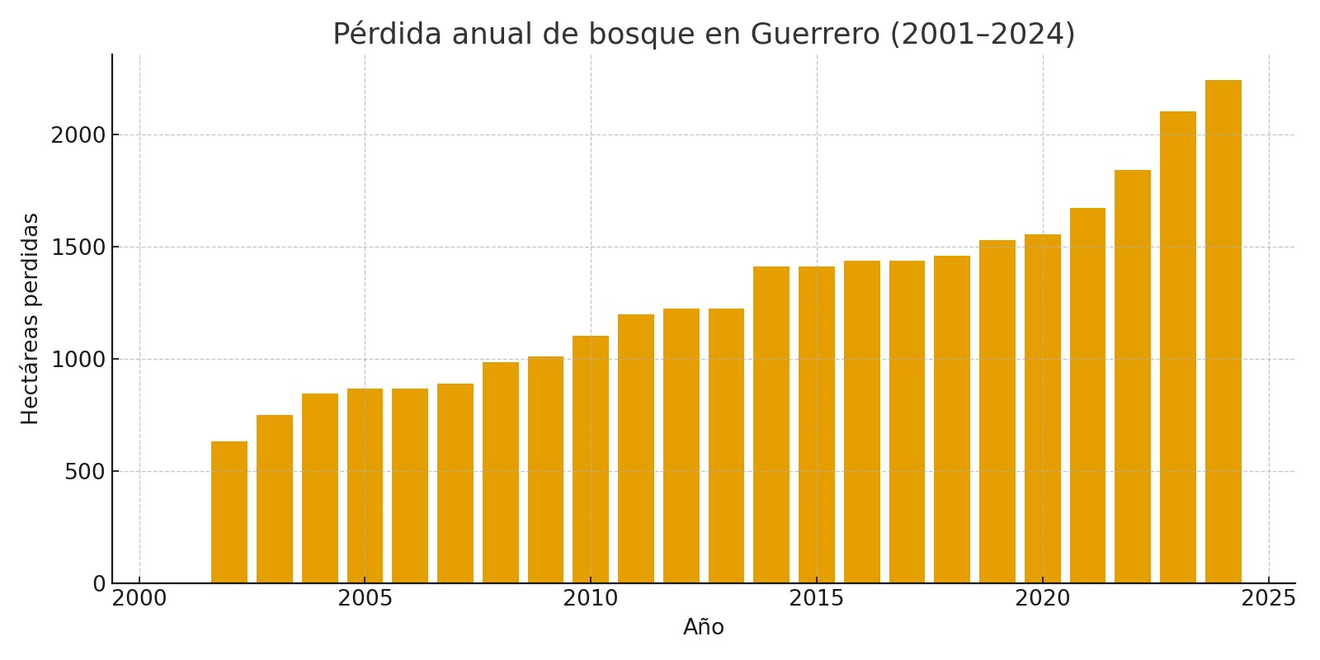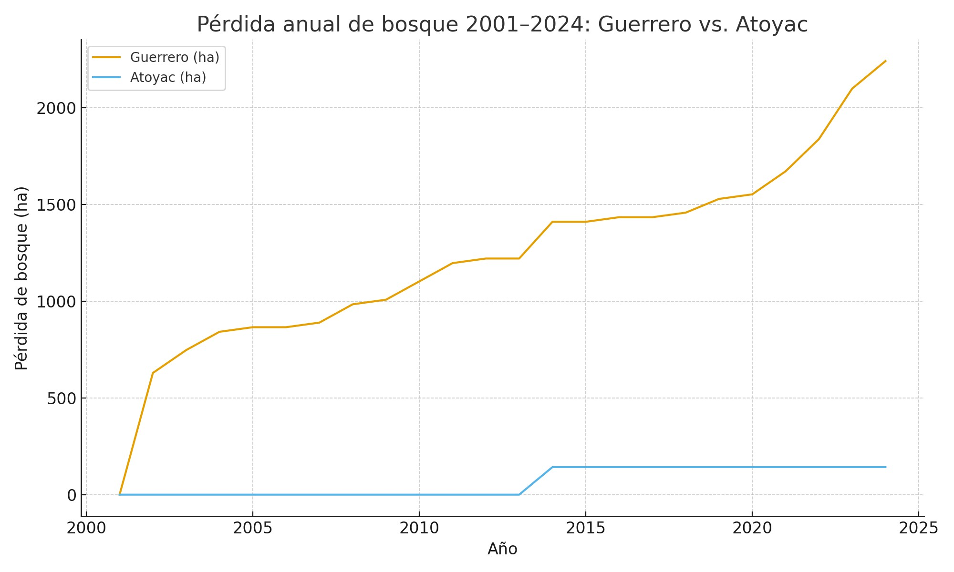

## Discussion

Results show a non-random pattern: deforestation is mainly concentrated in municipalities of northern and northeastern Guerrero, while the Costa Grande maintains greater forest cover. This pattern relates to agricultural and livestock expansion in more internal areas of the state, as well as the recurrent use of fire for pasture management. Forest loss entails a reduction of essential environmental services such as water regulation, soil conservation, and carbon capture.

Recent state-level peaks and the increase in Atoyac's share (although smaller compared to other areas) suggest that pressure occurs on slopes and areas close to interior roads rather than the coastal strip. Therefore, hotspot prioritization should focus on the 2016–2024 period, combining land cover loss indicators with NDVI (MOD13Q1) and, optionally, fire scars (MCD64A1), allowing more comprehensive monitoring.

## Limitations

• The resolution of MCD12Q1 (500 m) may underestimate small patches of deforestation and does not capture local-scale dynamics in detail.  
• This synthesis is based on land cover data; NDVI (MOD13Q1) and ASTER will be integrated into the final repository for higher precision.  
• Global land cover classes may differ from local definitions (e.g., 'forest' or 'pasture'), so additional field validation is recommended.  
• The satellite time-lapse suggests that deforestation is not concentrated in the Costa Grande, but rather in other regions of the state, implying that spatial scale influences interpretation of regional patterns.

## Proposed Solutions

- Community reforestation in critical watersheds of the Sierra Norte and northeast, where forest loss is concentrated.  
- Integrated fire management through local brigades to reduce the practice of slash-and-burn agriculture.  
- Slope protection with terraces, live barriers, and agroforestry systems to mitigate erosion and landslides.  
- Participatory monitoring using platforms such as Google Earth Engine and open Terra data, strengthening local capacities.  
- Territorial planning to limit the expansion of pastures and road openings in fragile areas.

## Conclusions

Deforestation in Guerrero is an urgent and localized problem, with greater impact in the Sierra and the northeast of the state, while the Costa Grande maintains relatively more stable forest cover. Terra satellites (MODIS and ASTER) provide robust and open evidence to design regionally adapted interventions. The combination of open science and community action can alter the current trajectory, promoting ecosystem restoration and socio-environmental resilience.

## Generative AI Use Statement

Generative AI was only used for drafting/editing. Geospatial analysis was conducted with GEE and reproducible methods.

## References

Friedl, M. A., et al. (2010). MODIS Collection 5 global land cover. Remote Sensing of Environment.  
Huete, A., et al. (2002). Overview of the MODIS vegetation indices. Remote Sensing of Environment.  
NASA LP DAAC (2024). MODIS & ASTER data products.  
INEGI (2020). Municipal boundary vector dataset.