tHE dOG rESCUE iNTERFACE- ADVOCACY ONLINE
  - EDUCATION

Overview

The USA’s dog crisis.
Our country is having a dog crisis nationwide. Dogs have been overbred, abandoned, exploited and harmed for a long time by the worst of human beings. Learn about illegal breeding and which breeds are suffering the consequences; Learn about exploitation of dogs and how these illegal systems operate nationwide; Learn about dog abuse and neglect, and how it negatively impacts a dogs behavior and chances for adoption or re-homing at the expense of emotional damage and breed stereotyping; Learn about dog abandonment statistics, how it places strain on our stray population and the rescue organizations.

The rescue process.
Everything you need to know about the rescue process- from shelter, to foster, to adoption. Review the key concepts of The Decompression Protocol.

Learn about Euthanasia.
Learn about “kill shelters” and how this process works. This is a hard reality that our very important shelter workers and volunteers face every single day.
- What is euthanasia?
- How do dogs get placed on a euthanasia list?
- What the community is doing to implement more “no-kill shelters”.
- Current statistics of dog euthanasia in the USA.

Rescue Groups and Volunteers.
Learn all about what it means to be a rescue partner. Learn all about what rescue volunteers do and how it helps spread awareness of dogs in need.

What the people can do to help.
Learn all about what the public can do to help the dog crisis in order to eliminate more suffering, help those who are suffering, and to keep supporting the dog rescue community.

What rescue partners and shelters need the most to provide optimal care, comfort and networking for dogs in need.
Stay informed on the core needs of rescue partners and shelters, such as veterinary needs, comfort needs, training needs, and feeding needs.

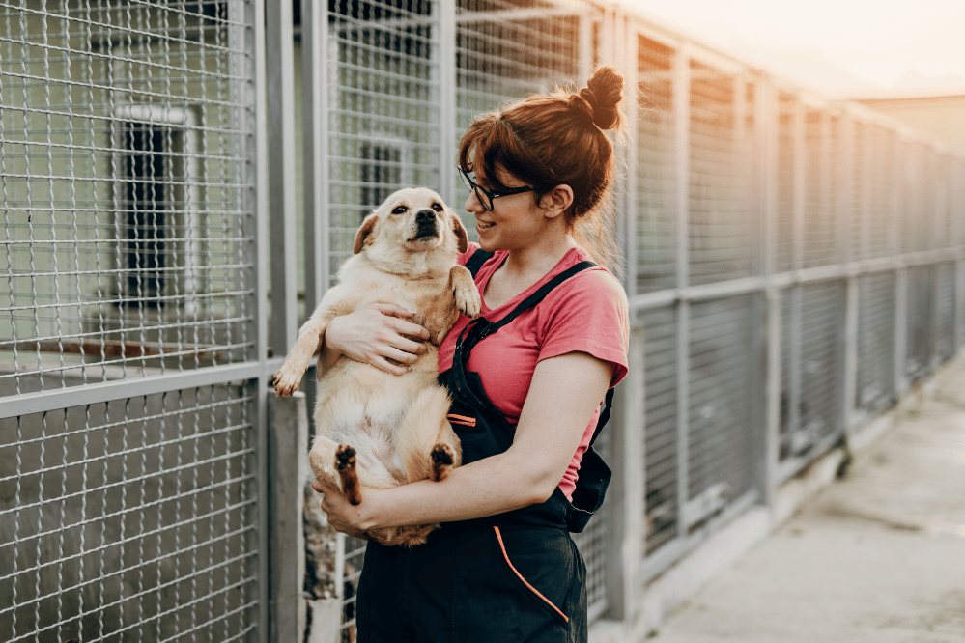

- The USA’s Dog Crisis

Our country is in a crisis. Our dog population keeps growing due to irresponsible and illegal breeding operations both big and small. Dog adoptions have decreased significantly since 2022, theoretically due to economic and financial reasons that keep rescue groups low funded and potential adopters hesitant. The dog rescue community operates on optimized and supported facilitation of the foster-to-adopt processes, which we will learn about in a few sections. As advocates for dogs in need, we hope that spreading education and awareness of this crisis will provide more functional and productive support to the table as we try to increase adoption rates and provide safe and reliable placements simultaneously. Placing these dogs where they can thrive is our ultimate goal. The right people are out there. We are meant to live in harmony with these dogs. According to the ASPCA and annual reports of Shelter Animals Count, about 2.8 million dogs were placed in the U.S shelter system in the year of 2025. Approximately 59% of these dogs arrived as strays and 30% were owner-surrendered (aspca.org). Thousands of stray dogs were lost and safely reunited to their owners (aspca.org). Ultimately, most of these dogs become lost in the system. The growing population overwhelms shelter systems and the way they operate as they operate heavily on volunteer work and little to no funding assistance from the government. Illegal and irresponsible breeding operations occur nationwide for many different reasons, more than likely all related to exploitation. You may ask, how are dogs exploited? What is exploitation anyway? Explpoitation is the use of a living being for selfish or financial reasons usually leading to inhumane outcomes. Dogs are exploited in the illegal oir underground breeding world. The breeding of dogs comes with responsibility for proper vetinary care and humane treatment of the animals, especially with litters of puppies. Even in clean and proper cpnditions, overbreeding becomes a selfish activity for financial gain that leads to an overpopulation of dogs. Not all breeders vet their adoption applicents properly or with the best intentions. Placing dogs in the correct home best for for their indiviaulized needs is crucial to successful adoptions, especially considering the Fact that failed adoptions play a key role in this crisis right in front of us. Shelter workers and rescue coordinators are privy to the reality sufficient vetting can do and does for successful or non-successful adoptions. Workers of the rescue community do what they do out of passion for animal welfare. This is a different kind of business and culture, where dogs will not be viewed as objects with a price. Included with proper vetting is reputable references including veterinary reference if other pets are owned to ensure that the dogs vital needs are going to be met efficiently. Personal references can also tell us a lot about how reliable this potential adopter is – are they going to give up on this dog if things get “tough”? Are they prepared and willing to work their lives around a new member of the family? These types of questions are important as we navigate to avoid adopting a dog out to someone who will bring the dog back to the shelter, or leave on the side of the road or tied up to a fence. Shelter workers can provide adopters with many different resources for affordable veterinary cares, spay and neutering and even training. Overbreeding occurs when breeders overbreed their dogs. This negatively impacts the health of the puppy litters, and mother in most cases. It is a cause of suffering that can be avoided. Aside from the immense mental suffering and various different health concerns of mother and puppies, it contributes to overcrowded shelters. Once the reality of these shelters is seen, breeding for sales will seem irresponsible during a time like this.
Besides breeding irresponsibly or for sales, there are people who illegally breed for underground dog fighting rings. This operation is

This is why education is so important to the cause: There are many failed adoptions and foster plans due to lack of knowledge behind decompression protocol and not only properly handling the behaviors of different breeds, but also the behaviors that result from traumatic experiences such as abuse, neglect and rehoming. See below a brief description of the Decompression Protocol, which was implemented as a crucial part of the rescue process developed by shelter workers and foster partners in the communities.
Dog Decompression is a period meant for low stimulation for the dog to begin to feel safe in their new environment.

