**Job Application Tracker on Sales Force**

**Phase 2: Org Setup & Configuration**

1. Set up your environment

* + Dev Hub in your org
  + Install Salesforce CLI
  + Install Visual Studio Code
  + Install the Visual Studio Code Salesforce extensions

2. Authorize your hub org and provide it with an alias:

**Command:** sf org login web -a myhuborg -d

3. Create a scratch org and provide it with an alias:

**Command:**sf org create scratch -f config/project-scratch-def.json -a jat -y 30 -d

**Phase 3: Data Modeling & Relationships**

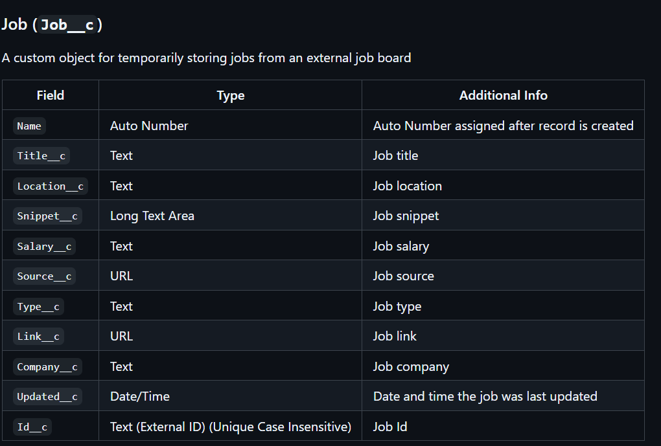

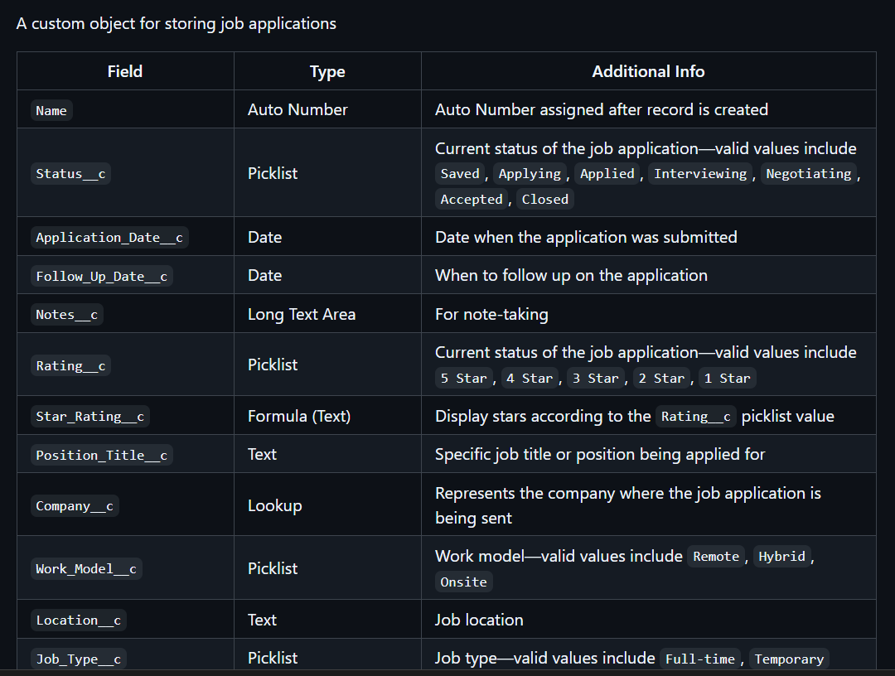

**VS Code Execution:**

