ASSIGNMENT-2

NAME: D.Shanmukhi

EMAIL: [dachepallishannu@gmail.com](mailto:dachepallishannu@gmail.com)

Phone number: 6305192824

Roll Number: 20NN1A05B0

College: Vignan’s Nirula Institute Of Technology And Science For Women

1. App.js

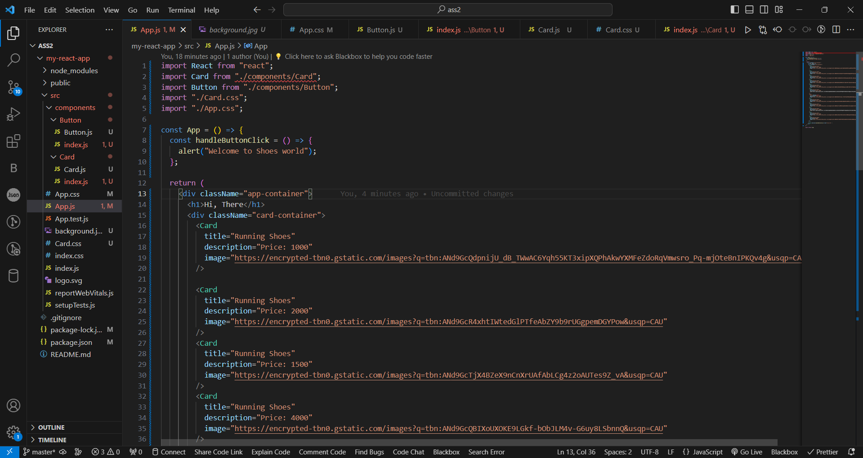

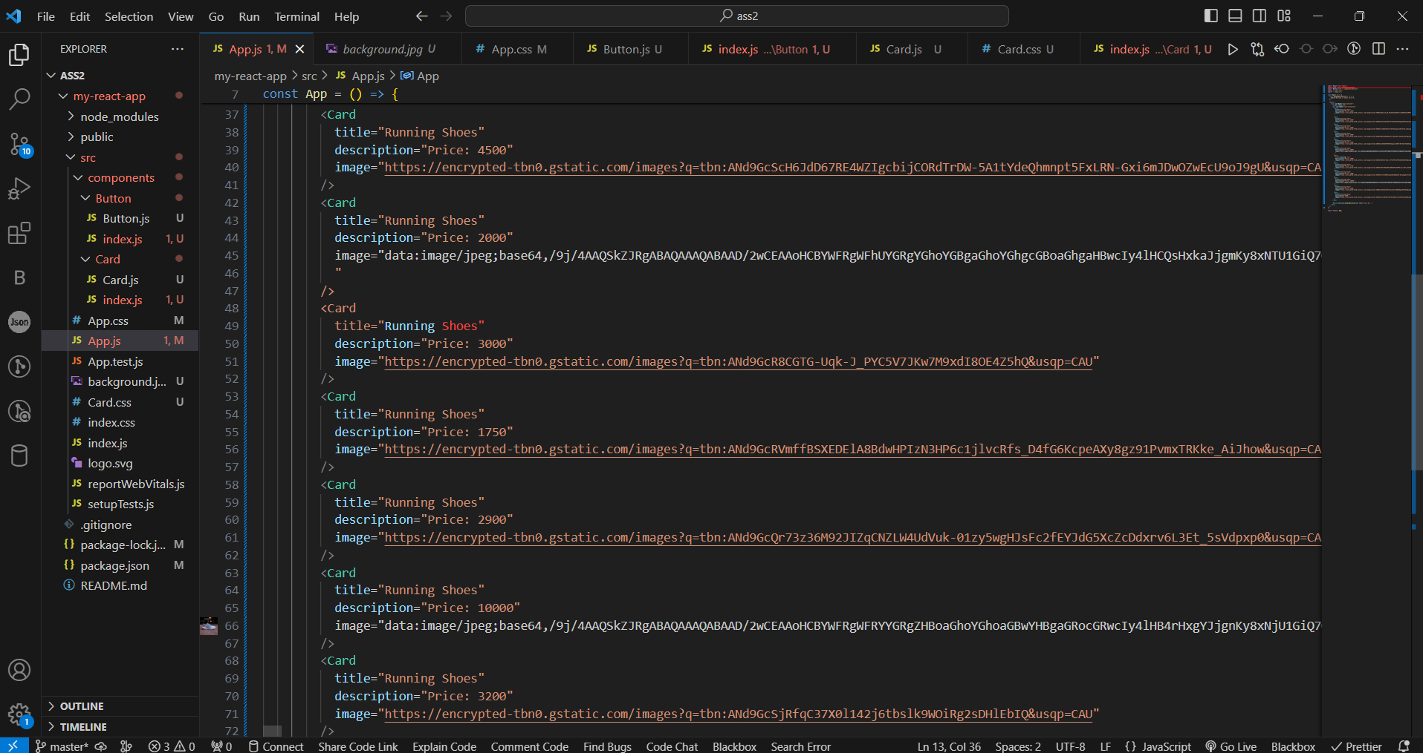

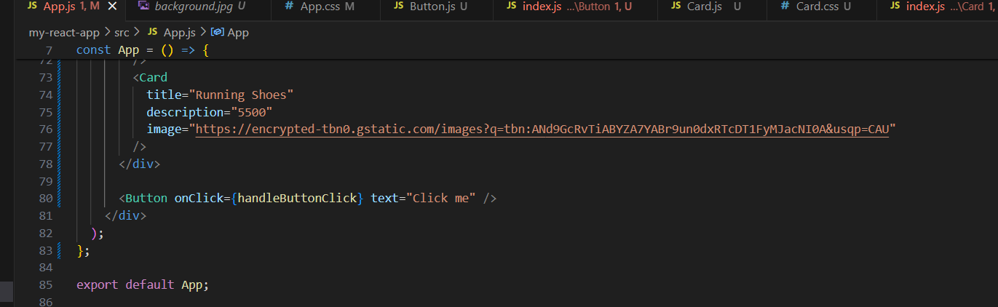

1. App.css

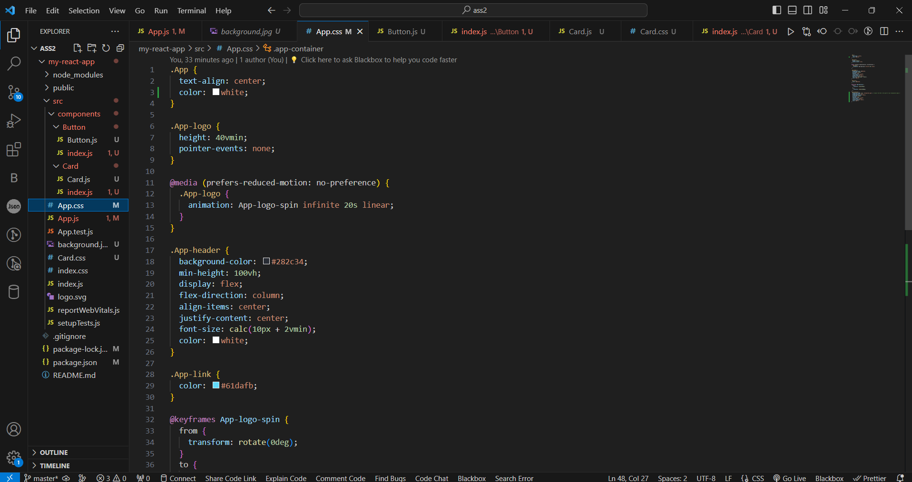

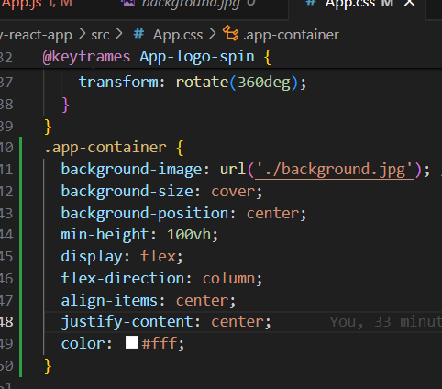

1. Card.js

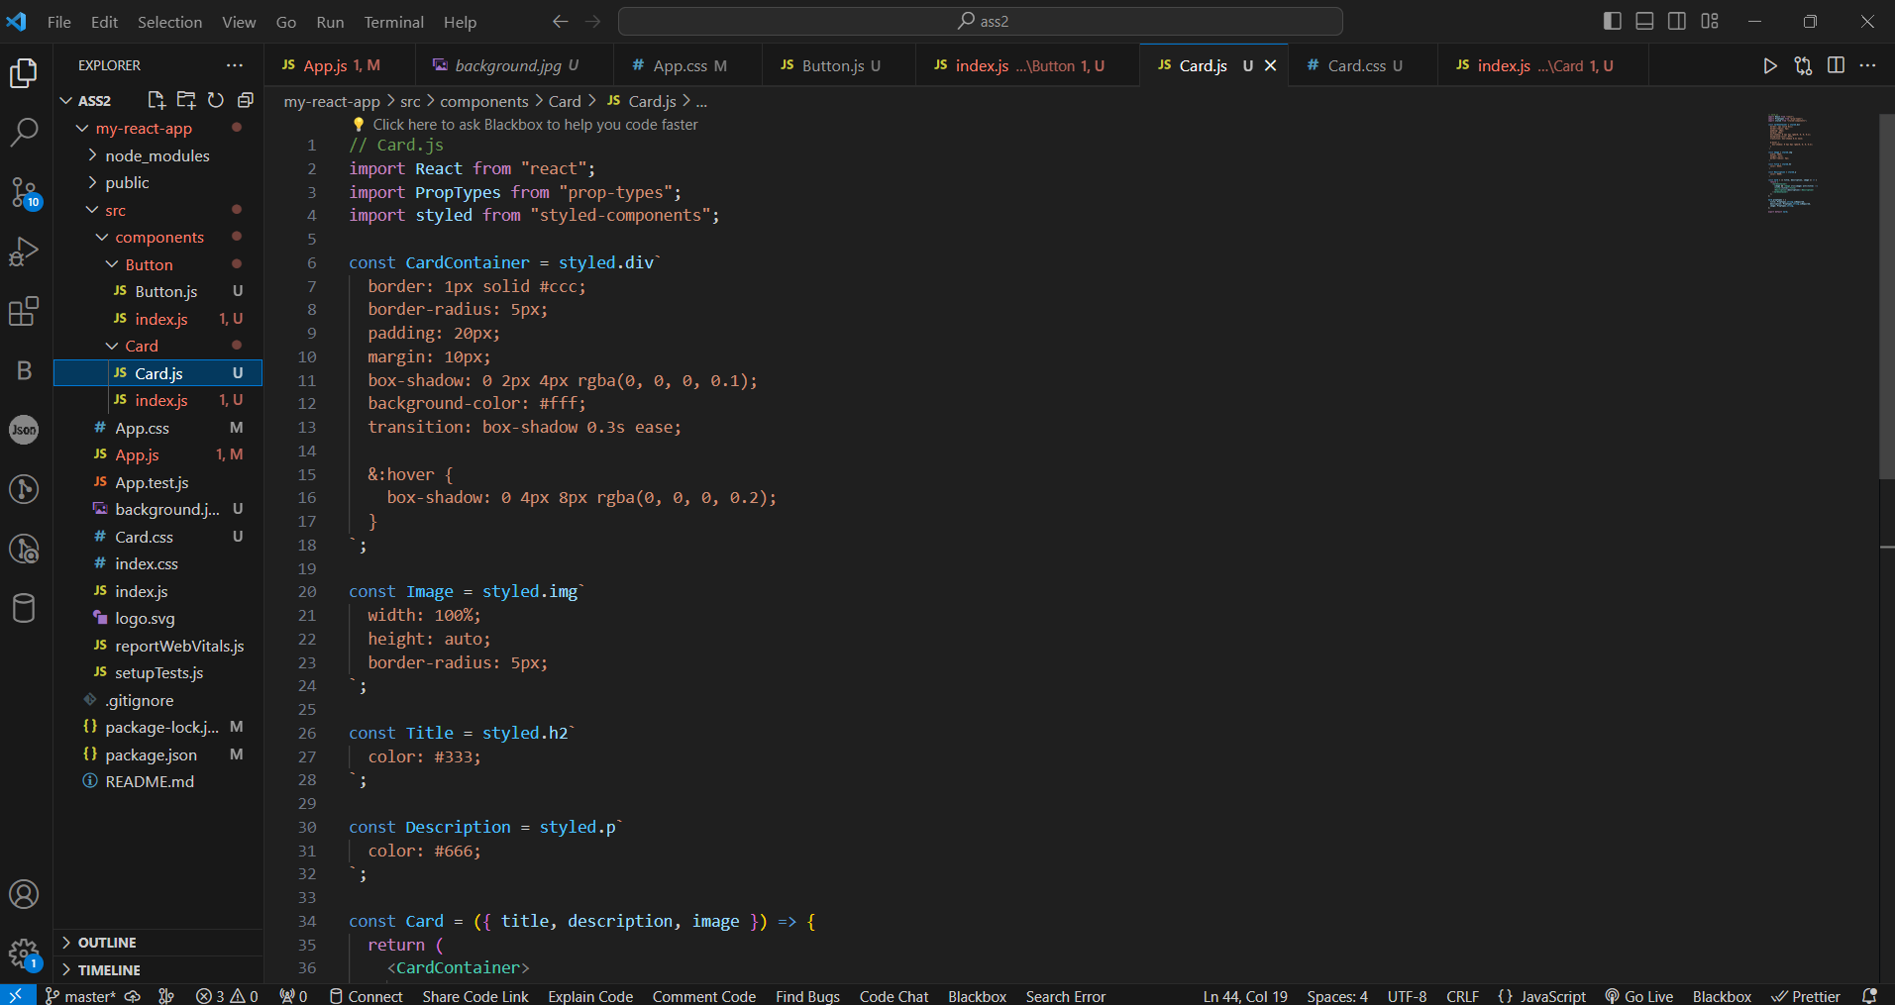

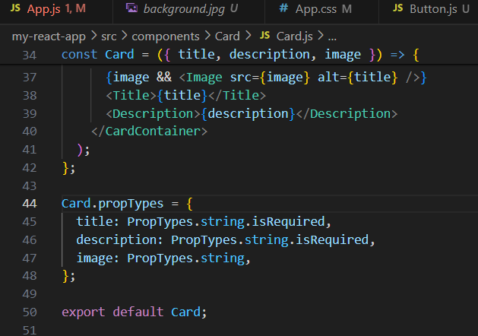

1. index.js

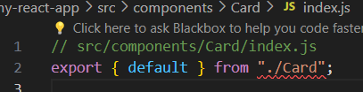

1. Button.js

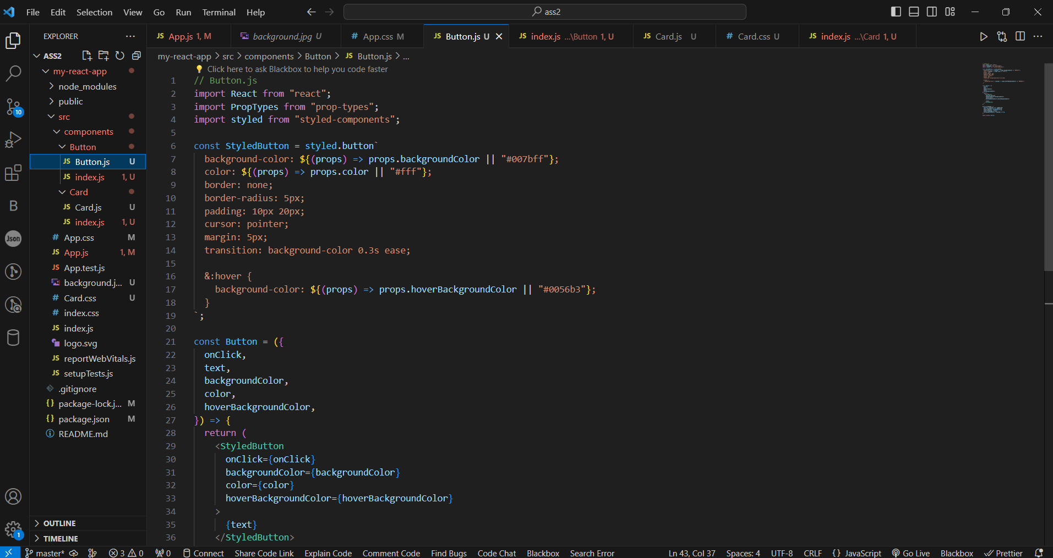

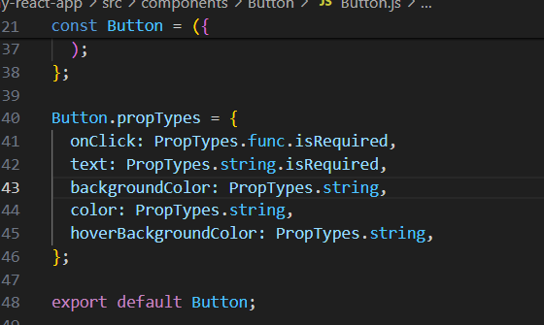

1. index.js

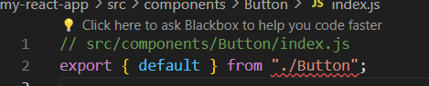

1. Card.css

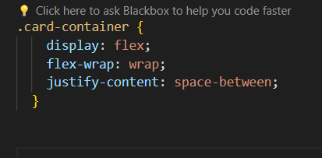

1. Output

