**Team Meeting**

**August 31st**

**Time: 7:00 PM to 8:00PM**

Discussed the questions to ask client and prepared the agenda for the client meeting on Friday.

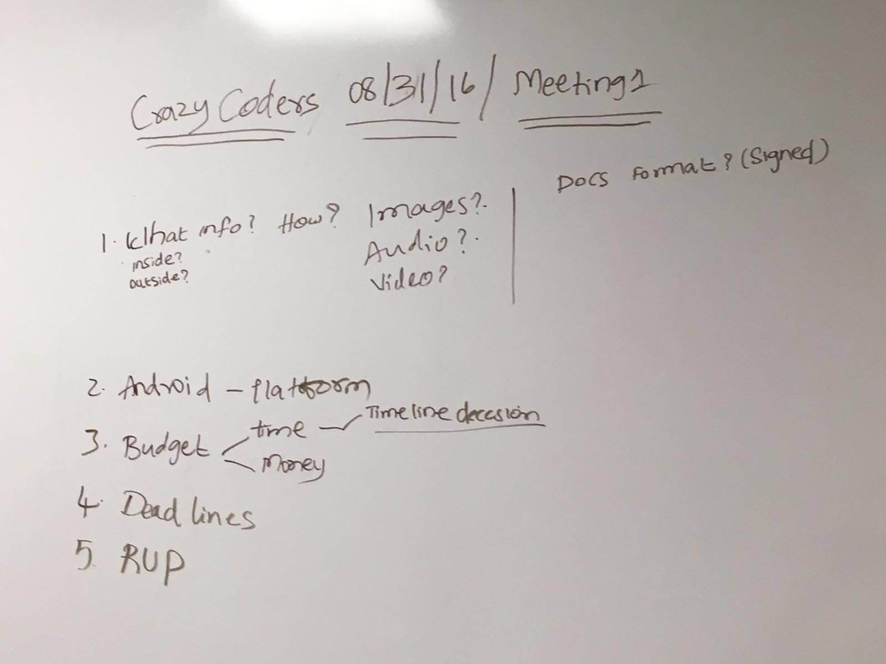

**September 2nd**

**Time: 8:00 AM to 8:50 AM**

Points discussed in today’s meeting as per client requirement

We need to develop an app with which user should

1. Be given an campus tour,

2. Have QR codes on each building which once scanned should give out details of the building like the departments in the building etc.

3. Once near a code / building buzz the phone and notify of the surrounding infrastructure and navigation window to provide current location and nearby amenities .

4. Voice info, Text , Building pic exterior and interior are some details which should be popped up when a QR code is scanned.

5. The client also should be able to modified and add extra content to the audio or text information being displayed.

6. The frequency of client meetings would be biweekly in a month.