Hepius

**App Description** **2**

Features 2

**User Segment** **2**

**Prototype** **2**

Figma 2

Vectr 2

**Extras** **2**

Icons 2

**Photos** **3**

**“The Takeaway”** **4**

Empathise 4

Define 4

Ideate 4

**Exercise** **4**

Mouse 4

Find examples of images for your personal product (2 per each item): 4

## 

# 

# App Description

It’s an app where you can get answers to different medical problems and get a doctors appointment.

## Features

* Allows you to get answers about different medical problems and medication.
* Allows you to get a doctors appointment.
* Allows you to see what medication you might need when you describe your problem.
* Allows you to see all prescription drugs that you got prescribed.

# User Segment

This app will be used by people over 18, and it will make getting medical answers and checking into hospitals a lot easier.

I hope the app will be easy to use and a lot of people will prefer using it over browsing google for different answers.

# Prototype

## Figma

<https://www.figma.com/file/W7AqfQpDt1Mtw1tnLO2Gjn/Hepius>

## Vectr

<https://vectr.com/dian25/c32cuOhACC.svg?width=640&height=640&select=c32cuOhACCpage0>

# Extras

## Icons

<https://www.flaticon.com/packs/medical-115>

# Photos

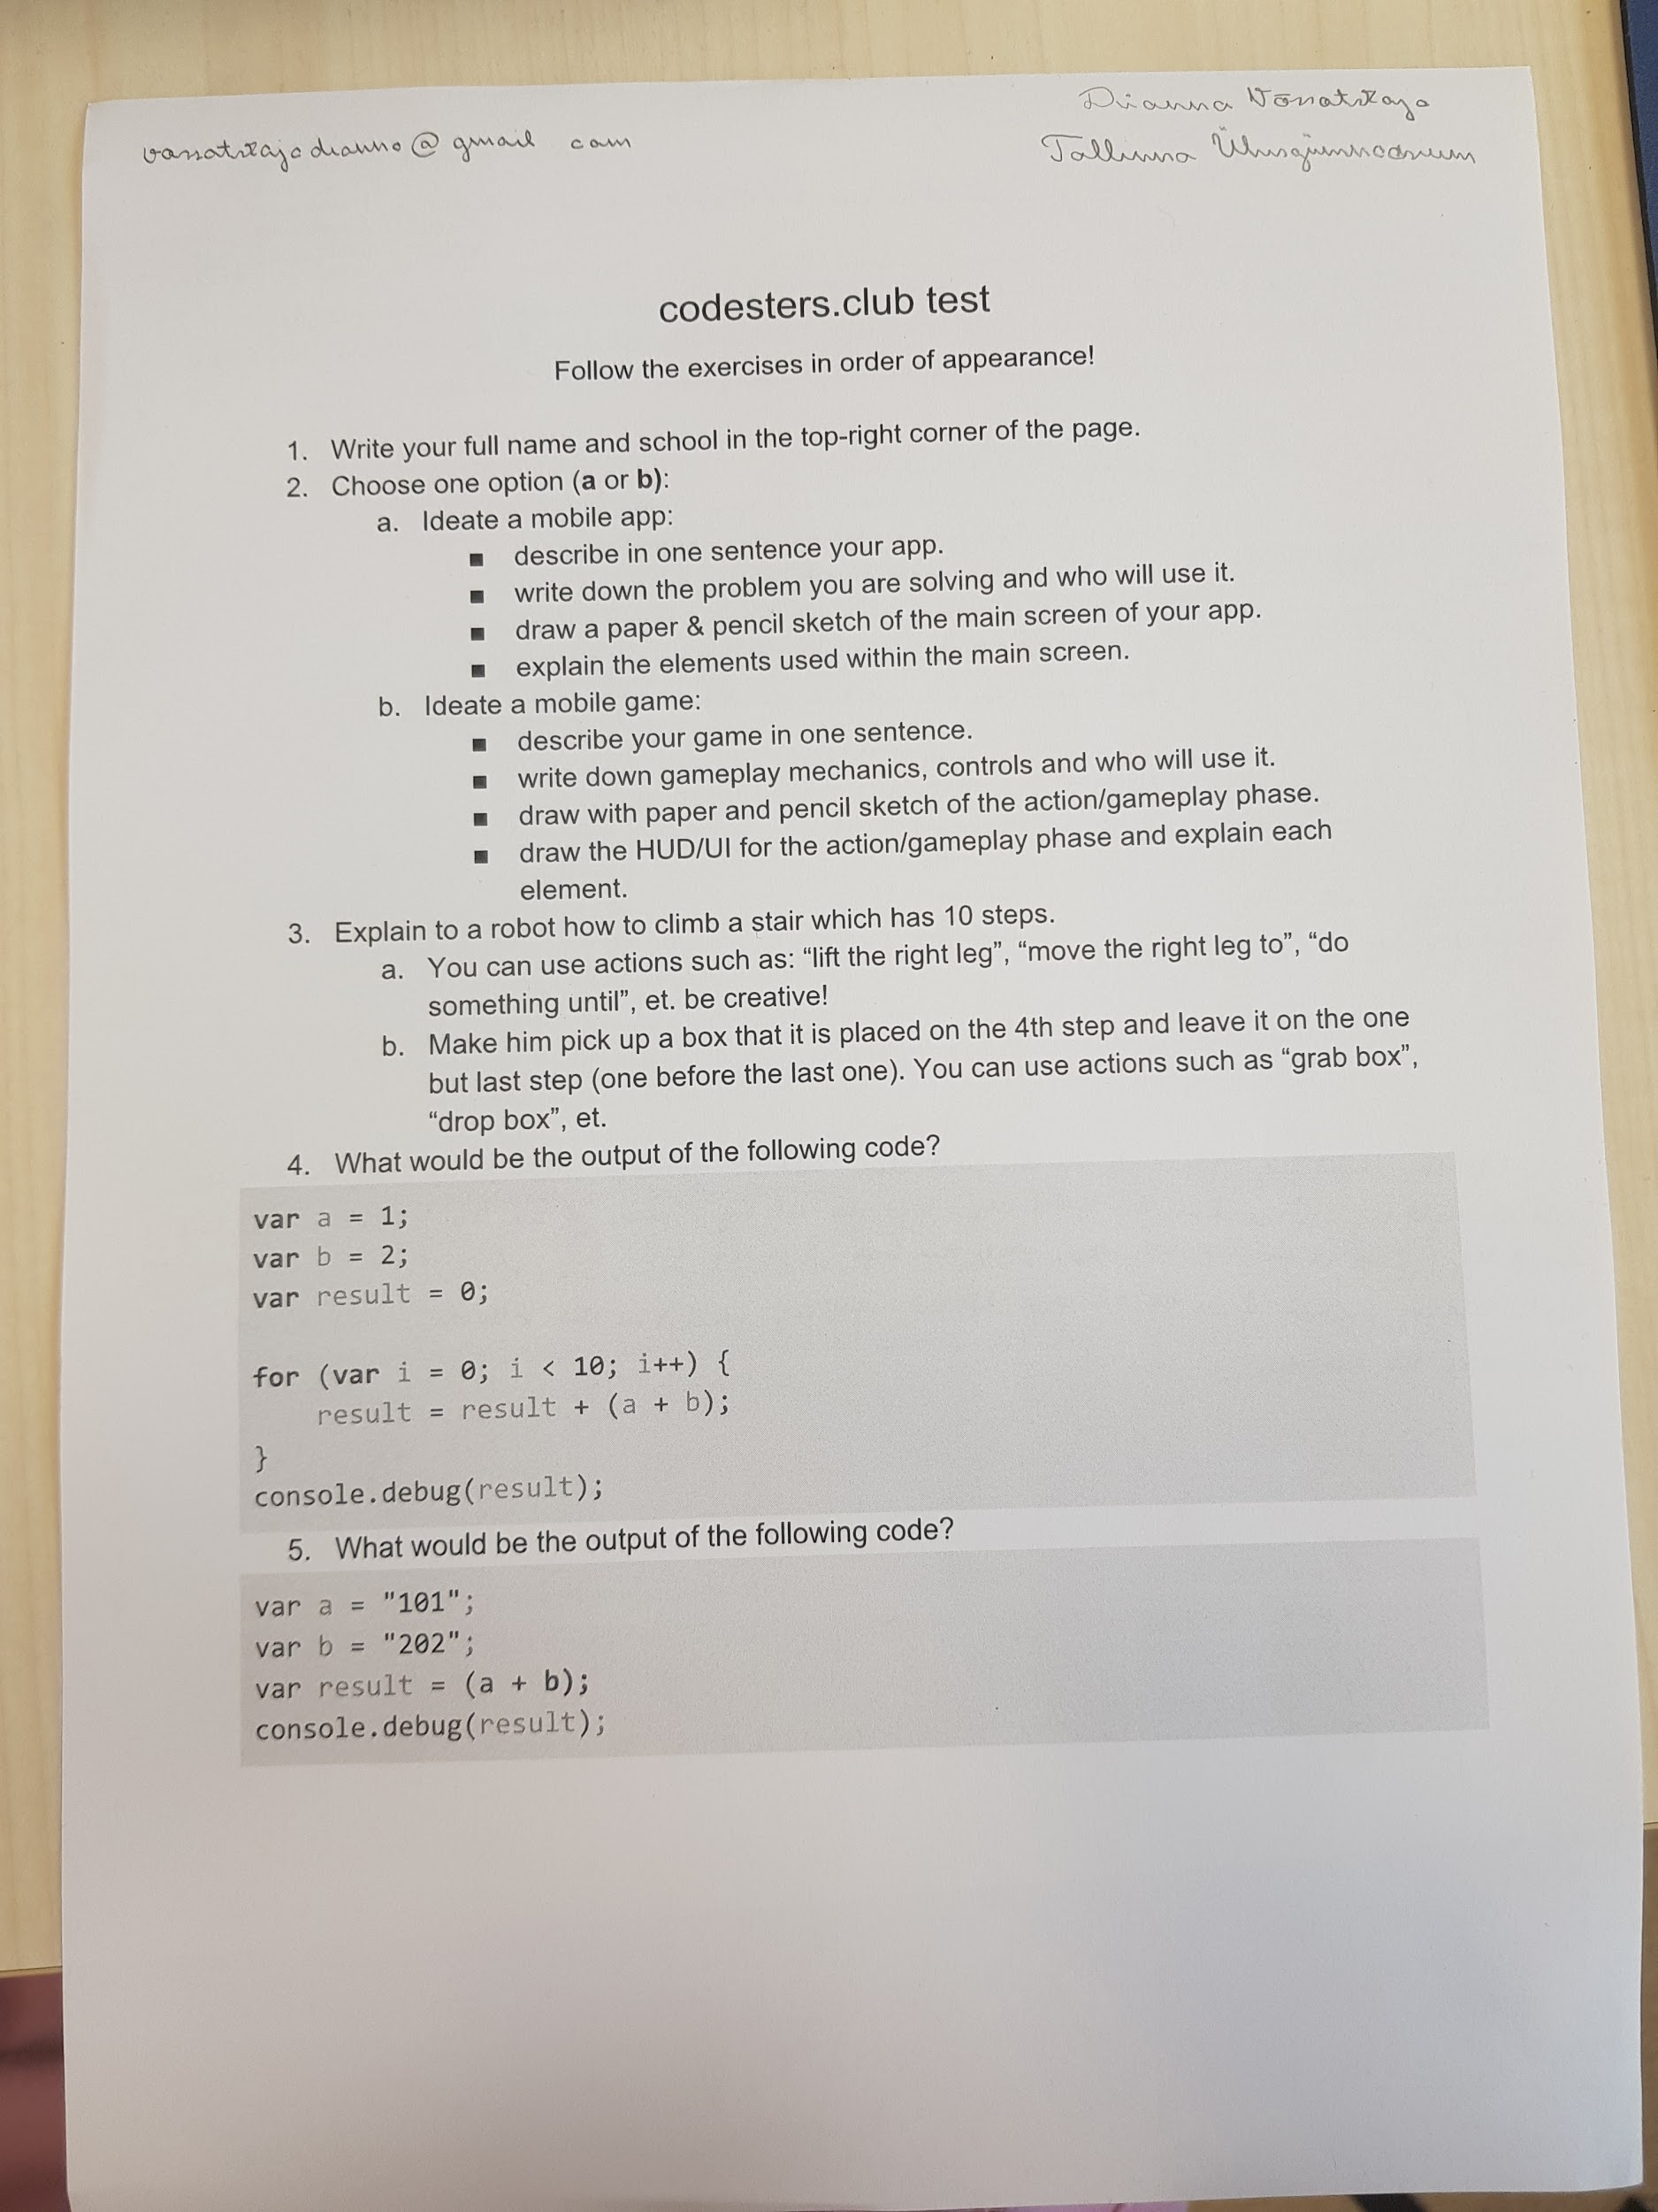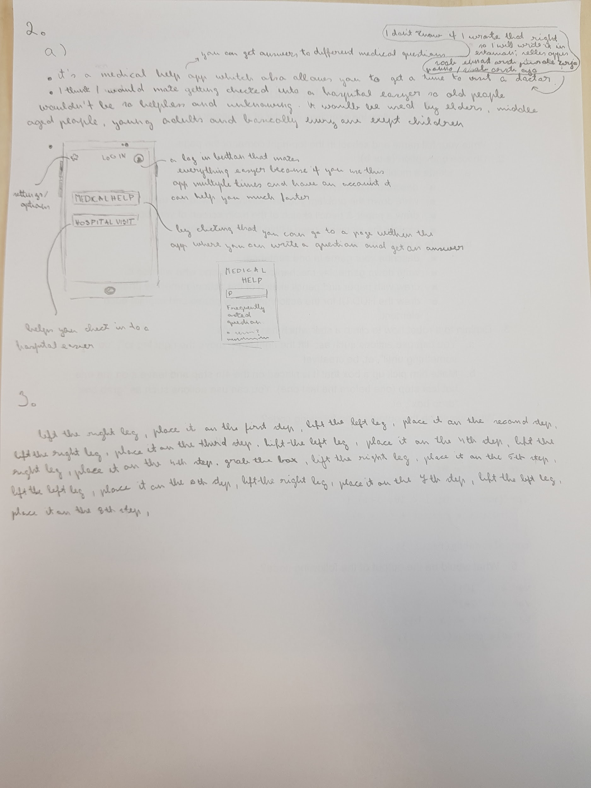

# 

# “The Takeaway”

## Empathise

People need something that can provide a quick solution.

## Define

Accessing the hospitals website is time consuming and doesn’t always give you the answers you are looking for.

## Ideate

An app would make accessing stuff faster and easier, everything would be right on their phone and simple notifications would be sent if needed.

# Exercise

## Mouse

* Adapts to your hand
* Is glowy uwu
* Wont break when you throw it against the wall :))

## Find examples of images for your personal product (2 per each item):

* Capture the Eyes of the Audience
* Tap Into Primal Urges
* The Power of Emotion & Storytelling
* Provide Information that Stands Out