SC Department of Environmental Services
Permitting Optimization: Cutting Clerical Drag, Protecting Programs from Energy-Project Surges
A data-based case for where to focus process improvement and AI · Prepared June 2026 · Brett Butz

Bottom line
SCDES is not failing to issue permits. Across every program, the agency completes the large majority of what it receives, about 98% overall. The issue leadership should act on is not throughput; it is the time a handful of complex permits take, and the disruption a single energy-infrastructure project can cause across several programs at once. Both are fixable, and both point to the same lever: remove the clerical work that consumes reviewer time, and create a coordination lane so energy projects do not derail the work around them.
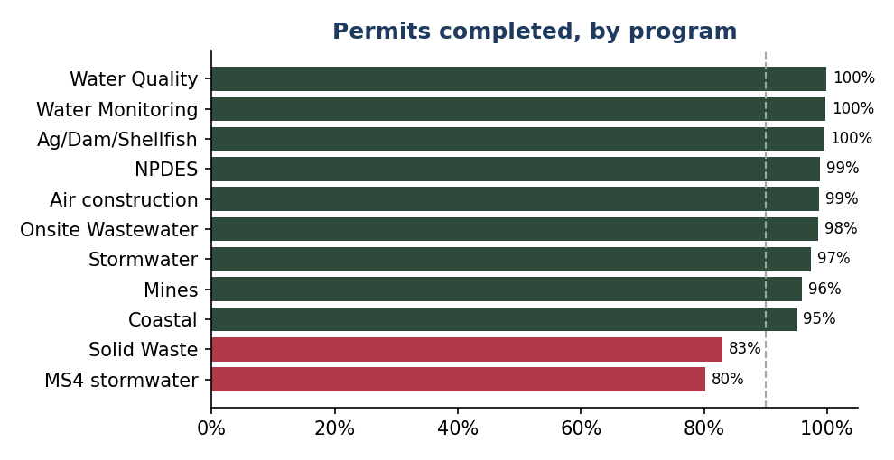

The data: we complete the work; speed is the gap
Drawing on the agency's live Target-90 dashboards (summarized in the accompanying workbook), completion runs 95 to 99 percent in nearly every program. Two look lower and are explained rather than failing: Solid Waste (83%) carries the inherently multi-year major-landfill caseload, and MS4 stormwater (80%) reflects a recent reporting window plus holds awaiting municipal review.
The real signal is cycle time. Most routine permits clear in days; a small set of complex permit types run for months to years, new landfills near 950 days, mines 480 to 960, major coastal actions about 280, and the larger air permits 160 to 230. These are where applicants wait, where backlogs age, and where our exposure to statutory deadlines is greatest.
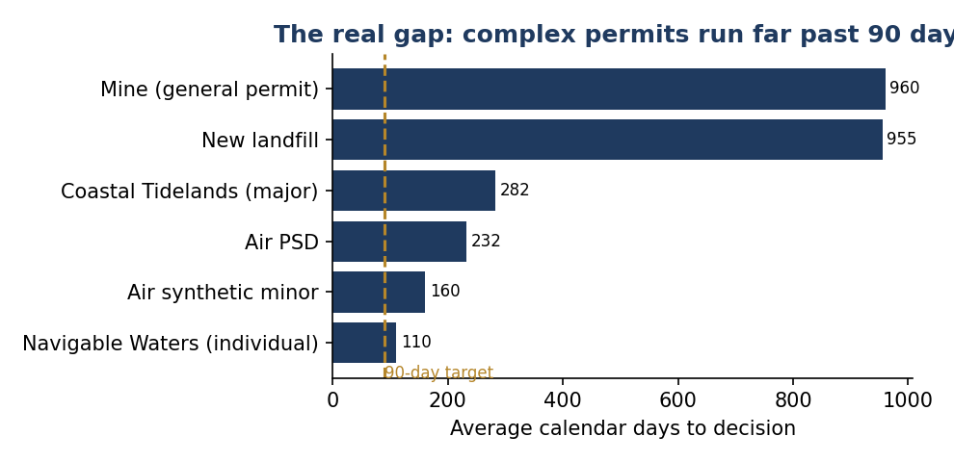

Problem 1: clerical drag is the hidden cost
When a complex permit sits, it is usually not because the technical review is hard; it is because the submission is looping through corrections and administrative back-and-forth. In the stormwater example below, more than two-thirds of holds trace to correction requests and electronic-submission fixes, not technical analysis. That is clerical work, checking completeness, requesting missing items, re-routing, logging correspondence, and it is exactly the kind of work automation and AI can absorb.
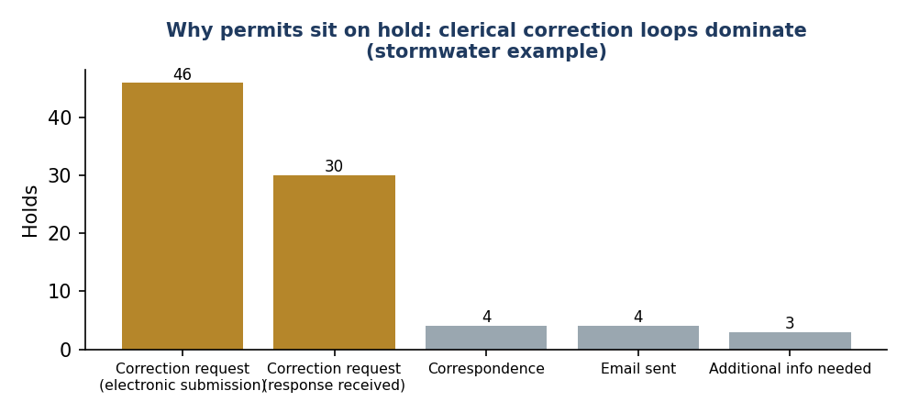
To target it precisely, we need the Lean Six Sigma process analyses now underway for each permitting team. Those maps will show, step by step, where the clerical time actually accumulates. Once we can see that, we point automation at the specific clerical steps first, completeness checks, document validation, status routing, freeing reviewers to spend their time on judgment, not paperwork. The principle is governance-first: standardize and measure the process, then automate the clerical layer, rather than buying tools and hoping.

Problem 2: energy projects must not disrupt the rest of the work
Energy-infrastructure projects, solar, battery storage, substations, and transmission, are a different kind of pressure. A single project does not arrive as one permit; it triggers five to seven permits at once across Stormwater, Coastal Zone Consistency, Navigable Waters, Air, and Wastewater. They carry a hard 180-day issuance clock, require a pre-application meeting, and draw heightened public and federal attention. The agency is already tracking 145 such project submissions.
The risk is downstream. When an energy project lands, the coordination it demands pulls reviewers off routine work in several programs at the same time, and the 180-day clock forces priority. Without a deliberate intake and coordination process, these surges quietly lengthen everyone else's queue. The goal is not to slow energy projects; it is to handle them in a managed lane, early scoping, a single coordinator across the affected programs, and shared visibility, so they move on time without disrupting the programs around them.

The path forward
Two moves, sequenced and low-risk:
- Finish the Lean Six Sigma process maps for each team, then point automation at the clerical steps they expose, starting with high-volume, low-judgment work (completeness checks, corrections, routing). This compresses the long middle of complex reviews without touching the technical decision.
- Stand up an energy-project coordination lane: standard pre-application scoping, a cross-program coordinator, and a shared status view, so the 180-day projects are absorbed without spilling onto other programs.
What this needs from leadership: the Lean Six Sigma analyses as the gating input (they tell us where the clerical work is), and a one-time data pull from the permitting system so we can measure staff time and hold time precisely. With those, we can show, program by program, exactly where an hour of clerical automation returns an hour of reviewer judgment, and where the energy lane protects the most downstream work.
Supporting detail, including the corrected completion figures by program and the full data sources, is in the accompanying workbook (tab “Corrected Completion”).

