BANK LOAN MODEL

1. To display the top 100
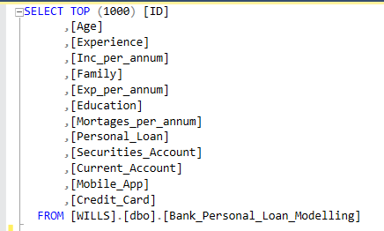

2. To see some of the distinct variables under some of the columns
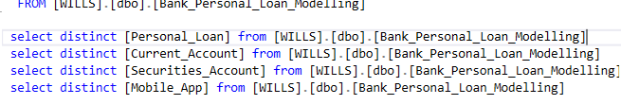

3. The total customers in the dataset. You may use any column but I am using the Student Column
In all, we have 5000 different ID in the dataset
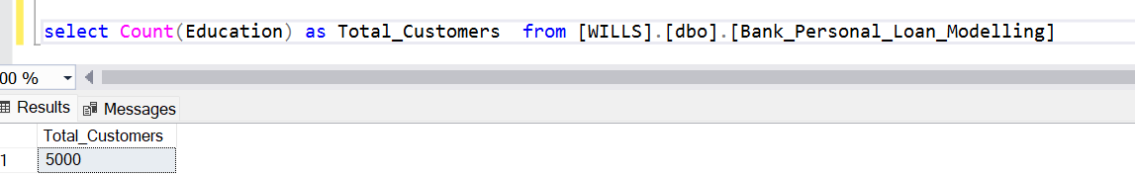

4. Get to know the sums of each category under the education
Degree holders are leading with Doctors second and Masters Last

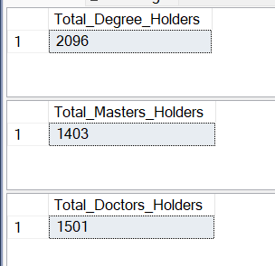

5. To get the percentage of each

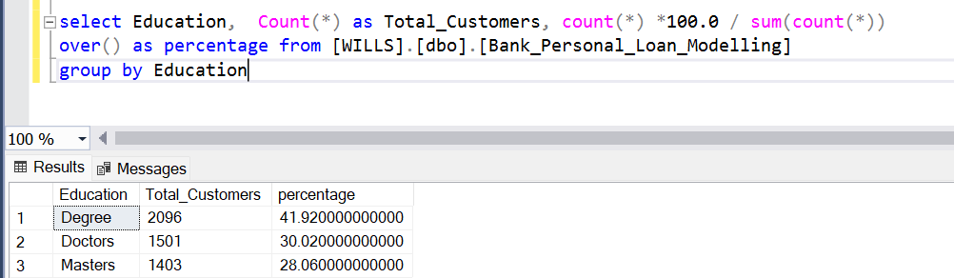

6.

