## **Artificial Intelligence**

## **::An AI Model For Classifying Flowers (40%)**

### **Due: 7 Feb, 11:59 PM, Monday**

Email to: [vu.tran@vnuk.edu.vn](mailto:vu.tran@vnuk.edu.vn)

According to the VNUK *Academic integrity policy*, plagiarism is:

*"Claiming and using the thoughts or writings or creative works of others without appropriate acknowledgement or attribution.  It includes:  
(a)  copying part or all of another student's assignment;  
(b)  allowing another person to write some or all of an assignment;  
(c)  copying paragraphs, sentences or parts of sentences directly from texts or the internet without enclosing them in quotation marks or otherwise showing them to be copied - even if the source is acknowledged, this is still plagiarism;  
(d)  using concepts or developed ideas, even if paraphrased or summarised, from another person, from texts or the internet without acknowledging the source;  
(e)  copying graphics, architectural plans, multimedia works or other forms of intellectual property without appropriate acknowledgment."*

The consequences of plagiarism (depending on the seriousness of the case) range from reducing your mark or failing the assignment up to a formal reference to a summary inquiry:

|  |
| --- |
| *By signing below we certify that the attached assignment is our own work.*  Student ID: 19020010        Student Name: Pham Minh Quan             Signature: Quan |
|  |

**Grade:**

|  |  |  |
| --- | --- | --- |
| **No.** | **Question** | **Grade** |
| 1 | Question 1 |  |
| 2 | Question 2 |  |
| 3 | Question 3 |  |
| 4 | Question 4 |  |
| Total gold coins | |  |

**Team**: 1 student

This AI Capstone course end project will validate your expertise as a job-ready AI Engineer. You will learn to apply the knowledge, skills and capabilities you learned in the AI Engineer Master’s program and build a project on your own from start to finish. You will gain real-world exposure to modern AI challenges and learn to build your own models using supervised and unsupervised techniques and make better data-driven decisions. You will also have the flexibility to choose your own domain for the project. The project may be:

- An idea or opportunity to use AI or new developments in the AI/machine learning field in the business.

- A specific business problem to be addressed using AI.

- A recurring issue in AI

### **Project aims**

### - Give learners the opportunity to carry out an independent research project in

### artificial intelligence aligned to a business problem.

### - Train learners to write up their findings and ideas accurately, clearly, coherently

### and to a high-professional standard.

### - Train learners to present their own arguments logically and competently, to engage

### specialist and non-specialist stakeholders.

**Project Outcome:**

In this capstone, learners will apply their deep learning knowledge and expertise to a real world challenge. They will use a library of their choice to develop and test a deep learning model. They will load and pre-process data for a real problem, build the model and validate it. Learners will then present a project report to demonstrate the validity of their model and their proficiency in the field of Deep Learning.

Learning Outcomes:

• determine what kind of deep learning method to use in which situation

• know how to build a deep learning model to solve a real problem

• master the process of creating a deep learning pipeline

• apply knowledge of deep learning to improve models using real data

• demonstrate ability to present and communicate outcomes of deep learning projects

## Questions.

1. Choose an AI Idea: (2pts)
2. Create 1 problem statement and at least 3 questions for the problem: (2 pts)

3. Solve your 3 questions (5 pts)

4. Github (1pts)

* + - 1. **Idea:** An AI model for classifying flowers
      2. **Problem Statement:** The childs are so curious about the world. Sometime, they see a flower and wonder “what is this flower’s name?”. The adults or parents could not know everything about this world. Therefore, we develop an AI model to help children could recognize the name of flower, encourage them studying and exploring more about this world.
* How to get exactly the name of flowers when user input an image?
* How to display the result that children could understand?
* What are the typical flowers that children usually see?
  + - 1. **Solutions:**
         1. Firstly, we download the flowers data from Kangle to train the model.
         2. Then, we convert all images to array using Numpy library.
         3. Next, we import the data to model and starting traning.
         4. When getting the model, we test the model to know the accuracy of this.
         5. Actual result demo:

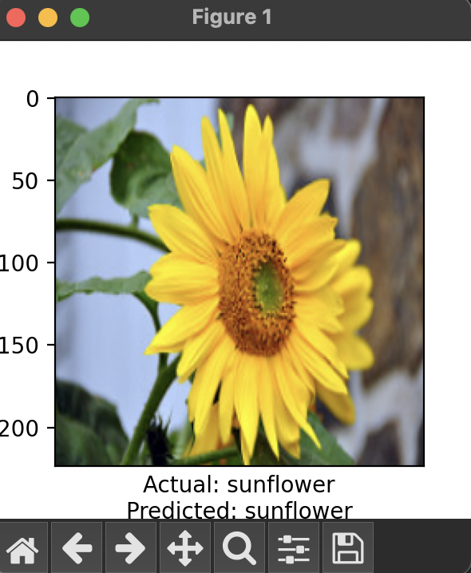

* + - 1. **GitHub:**