ECOCYCLE NLUC: NURTURING A LASTING, UNIFIED CONSERVATION THROUGH A DIGITAL GREEN RECYCLING HUB

HONEY BOY B. CORIAL
SHASNEY S. ALMINIANA
BANIELY M. PAJARIT

DON MARIANO MARCOS MEMORIAL STATE UNIVERSITY
NORTH LA UNION CAMPUS
COLLEGE OF INFORMATION SYSTEMS
BACNOTAN LA UNION

BACHELOR OF SCIENCE IN INFORMATION SYSTEMS

MAY 2025
Chapter 1

INTRODUCTION
Situation Analysis
Traditionally, economies are configured to a linear fashion that get involved into extraction, consumption and disposal of materials that might have turned into waste. (Debrah et al., 2022; Mihai and Minea, 2021). The indiscriminate disposal of waste materials has led to the clogging of drainage systems, sewer lines and water pipes that resulted to unintended overflow of raw sewage (Rusca et al., 2022). Recently, waste material found its way to the dumpsites that is the beginning to get recycled (Bayar et al., 2021). Recycling is the key industrial activity of circular economy, the circular economy comprises the 3Rs, named reducing, reusing, and recycling (Smol et al., 2021).
In today's world, waste production and its handling have become a great challenge. Rapid urbanization and conversion of rural land into housing societies create a bulk of waste within a short span in any area. While increasing population, the increase in waste is a topic of discussion in developed as well as developing countries, and it may become the biggest problem in the near future for the world. It is emphasized that only municipal solid waste will reach 3.40 billion tons by 2050. Different types of waste are produced, and their handling also requires different techniques. Nowadays, different techniques are used to overcome this problem. These techniques reduce the waste by weight and severity of its effect, but they also release end products that may be harmful to the environment. This review will discuss techniques like landfills, incineration, composting, recovery, combustion, energy production, plasma gasification, etc. Different techniques have different merits and demerits. However, every technique requires specific input running costs, which may vary from area to area and country to country due to economic crises in developing countries. This review covers the types of waste, waste management opportunities, and challenges, as well as the benefits of waste management techniques (Iqbal, Naz, & Naseem, 2021).
The Sustainable Development Goals (SDGs) are a set of 17 interconnected global goals that were agreed to and endorsed by all United Nations Member States in 2015 as a core component of the 2030 Agenda for Sustainable Development. The SDGs cover a comprehensive set of universal global challenges, which include poverty, hunger, health, education, gender equality, climate change, water, sanitation, energy, economic growth, and peace and justice. Waste management has a central role to play in the realization of the United Nations Sustainable Development Goals through direct and indirect associations. Directly, four SDGs (SDG 6 Clean water and sanitation, SDG 11 Sustainable cities and communities, SDG 12 Responsible consumption and production and SDG 14 Life below water) address waste management concerns that related to landfilling is only discussed in SDG 6 in terms of water quality in relation to dumping waste. Waste management is an important aspect of contemporary society, which has experienced tremendous changes in recent decades in light of the increasing environmental issues and growing global movement toward sustainable development. The United Nations (UN) has adopted the SDGs in 2015 that are a complete guide to an even more sustainable future, consisting of 17 goals and 169 targets to be met by 2030 by all nations, irrespective of the state of the economy at present (United Nations 2023). The 17 SDGs and 169 targets were researched to determine their connection between waste, landfills and waste dumps. (Sanitary) landfills refer to controlled and managed waste disposal facilities, while waste dumps are facilities, not controlled at all or insufficiently. Regarding a direct connection of waste management with the SDGs, out of 169 targets and 17 SDGs, only six targets included in four SDGs mention waste.
Parks, gardens, and landscaped areas are examples of green spaces that are essential for fostering community well-being, public health, and environmental sustainability. Green spaces are not only beautiful additions to academic institutions, especially State Universities and Colleges (SUCs), but they are also vital elements that support the overall development of staff and students. The quantity and quality of green spaces have grown in importance as markers of campus sustainability and environmental responsibility as SUCs go through leveling evaluations to assess institutional performance and growth. The significance of environmental stewardship is now also emphasized by SUC Levelling, which assesses indicators related to academic, research, extension, and institutional development. Campus planning that includes green spaces supports national objectives for biodiversity preservation, climate change mitigation, and improved quality of life. Additionally, it has been demonstrated that green spaces improve cognitive function, lower stress levels, and create an environment that is favorable to learning and creativity. For these reasons, they are extremely valuable in educational settings. It explores the role of green spaces in the SUC Levelling framework, examining their impact on sustainability goals, student well-being, and institutional prestige. By highlighting best practices and identifying areas for improvement, this study aims to contribute to the ongoing enhancement of SUC campuses as environmentally conscious and student-centered spaces.
Australia produces approximately 2.54 Mt of waste plastics, 1.16 Mt of waste glass and 0.45 Mt of end-of-life automobile tires every year, of which about 85% of the plastics, 41% of glass and 24% of tires are sent to licensed or unlicensed landfills at high cost and as a potential risk to the environment (Pickin et al. 2020). Reports show that 85% of Australian seabirds are impacted by seabird plastic pollution and by 2025, 99% of seabirds are expected to have consumed plastic by 2050, with slow and agonizing deaths resulting (DCCEEW 2022). Producing at scale takes high amounts of energy, and recycling can cut that usage dramatically (in comparison to the new product). Companies that employ recycled and re-used products will be more likely to continue in existence because they are giving back to their local economy and offering lower-priced materials (in the majority of cases). The use of recycled material to produce products that can recover and re-use the greatest amount of the original material is a key part of the circular economy.
In global according to Hasan et al. (2024), plastic waste, one of the most critical issues to environment in the 21st century. A plastic in modern life has created an unparalleled surge of plastic waste, is to pose serve threats to ecosystems, human health, and the global economy (Noman et al., 2022). Today, 380 million metric tons of plastic are produced; insufficient waste management infrastructure are most parts of the world have a huge increase in generation of plastic waste, causing serve environmental pollution and resource inefficiency (Alsabt et al., 2024). The COVID-19 have over 554 million confirmed cases all over the world. According to WHO their global analysis has tens of thousands of tons for medical waste to the COVID-19 pandemic from the response that has put to tremendous on health waste care management systems around the world, threatening human and environmental health and need to improve waste management practices. Approximately 87,000 tons of personal protective equipment (PPE) was procured between March 2020-2021 and most of the equipment is expectedly ended up to a waste. Today, 30% of healthcare facilities are not equipped to handle existing waste. It impacted the communities living near poorly managed landfills and waste disposal sites through contaminated air from burning waste.
In Asia countries, the most issue is the improper waste disposal. Some local government in Asia countries also treat waste at facilities such as composting plants and waste to energy plants. However, the local government in Asian countries don’t have an environmentally sound waste management facility. According to World Bank in year 2021 mentioned the waste collection rate in East Asia and Pacific Region is 71%, while in South Asia is 44%. East Asia and Pacific Region have report of 135 million tons of waste that are not collected in part of South Asia and the 75% of waste collected waste are dump in open dumpsites of South Asia while the 18% is the same in East Asia and Pacific Region.
The solid wastes management in the Philippines could lead to increasing growth of waste and affect the environment. The Philippines has observed in waste generated from healthcare and domestic. The Asian Development Bank already projected Metro Manila generated 280 tons of healthcare waste per day, a 500% increase in solid waste from pre-COVID figure of 52 tons per day. In collecting waste, it utilizing the single track in all types of waste, also lacked of proper training in using Personal Protective equipment (PPE) to handle a different kind of waste. Waste Analysis Characterization Study (WACS) revealed that CSU could generate 31.22 tons of solid waste per year with an estimate bulk density of 470 x 103 kg/m3, an average waste generation per capital of 0.018kg/day. The massive increased of production, use, improper disposal of PPEs face masks, and face shields have contributed to plastic pollution.
In the Philippines the incineration of solid waste is not allowed under Republic Act 9003 for safety of human health and the protection of environment, landfilling and the 3R’s. The law is required the mandatory segregation at source of solid waste into containers labeled as: compostable, recyclable, non-recyclable, or special use. About 35,580 tons of garbage is generated every day in the Philippines. On the average, each person to the country produces about 0.5kg and 0.3kg of garbage every day in the urban and rural areas. For Metro Manila, it is estimated that 8,636 tons of garbage is generated per day, 0.7kg per person per day due to more modernized lifestyle. The household are the major source of waste in the Philippines at 74%. The total of solid waste generated from households, 95% can still be reused or recycled (43%), or turned into compost (52%). Only 5% are made up of residuals (4%) and special/ hazardous waste (1%) that are no longer usable or biodegradable. Only 40-85% of the waste generated is collected nationwide, 15-60% is improperly disposed of or littered. The maximum collection rate of 85% is recorded in Metro Manila. The uncollected garbage is burned or dumped anywhere onto open areas, adding to now polluted air shed and water body, and global warming in the country.
La Union is a province in the Ilocos Region has made a progress in looking forward the management challenges, especially the establishment of sanitary landfills in all municipalities of La Union. One of the issues in some part of La Union is lack of enforcement the waste segregation laws not utilized in materials recovery facilities (MRF) and burning of waste in some areas. The government reports a highlight issue for awareness of residents for proper waste practices but some of the residents they are not follow due to the lack of strict monitoring and don’t have enough community education. The improper waste disposal can cause clogged drainage, flooding, and air pollution especially in San Fernando City La Union.
The most effective to do to preserve our environment. Some of waste are able to reuse it again and recycle it instead of discarding them, we can minimize the amount of waste materials and conserve the natural resources (Osama, Asanousi & Lamma, 2021). In activity it can minimize the waste and to save the environment from pollution. Also, a solid waste recycling gives a benefit to the environment and health. The SSR Single Stream Recycling process are collecting recycles materials from a collection bin. Therefore, the SSR process is increased in western countries, Europe and Asia, thanks to the inherit of waste collection abilities. The recycling demands have compelled them to incorporate recycled materials, but it has generated the risk of conflicts regarding the safety matters for food packaging (Smith & Patel, 2022).
The adoption of the 3Rs as a component of an integrated, sustainable waste management approach can actually be an answer to this increasing dilemma. Therein, ongoing waste avoidance measures, including the 3Rs, which include source reduction, paper conservation, and recycling programs have been practiced in industrial facilities, government offices, and homes worldwide. These measures are a very cost-efficient means of waste management, whereby they seek to minimize the weight and volume of material inputs disposed of, hence reducing the costs of disposal. Promoting the 3Rs recognizes that prevention of waste is the most efficient, low-energy, resource-minimal, and most sanitary waste handling method. The schema for 3Rs places emphasis on the Reduce step, followed by Reuse and then Recycling, with disposal as the final resort.
The aim is a total reduction of waste generation which will address all types of unnecessary manufacturing and not only virgin plastic. This can be achieved by utilizing reusable products, like reusable bags and bottles, and refraining from single-use plastics, like straws and disposable plates. A reduction in single-use items which will minimize the necessity of manufacturing the product in the first place. With single-use products being produced from plastic by switching over to reusable containers it will contribute to the tens of tons of plastic that find their way into the supply chain. All these shifts in how a business operates will also save the business money once there has been a shift in mindset of the consumer from convenience to conscientiousness.
A web application (or web app) is a program of software use through web browser, such as Chrome or Firefox, over the internet.
EcoEx is an environmental services technology company committed to transforming waste management through the application of technology platforms that enable enhanced traceability for greater sustainability. The platform provides services in environmental collection, trading in waste commodities, and EPR services. Its technology-enabled compliance solutions are applicable to plastic, e-waste, tyre, battery, used-oil and other waste streams coming under the EPR category. EcoEx is the first Indian online marketplace help in plastic waste management and electronic waste services. All the registered members are able to sell or purchase their waste products in the portal of EcoEx to assist the recyclers of informal sector to enable them to enhance their business and to join the formal sector the already large pool of existing members are already trading and receiving best prices and the portal also allows payment online as part of services in addition all the transactions occurring in the portal are duly recorded with auditable logs for any type of future audits. EcoEx attempting to make their business more environment friendly and to bring out eco-friendly products that doesn't harm the environment and to use the natural resources to the maximum.
For domestic waste reduction, the State Council had aimed at achieving 35% in 2020 by sorting and recycling. Shanghai has implemented obligatory regulations, which other cities have since followed. Alibaba's popular smartphone app Alipay, widely used in Shanghai, has a "Garbage classification guide" that has indexed more than 4000 various forms of garbage. Nanjing has implemented "trash banks." The citizens first go through face recognition and afterwards sort the garbage. The mechanism pays back points to the user's account depending on the number of recyclables present in the garbage. Points may ultimately be exchanged for money. At Chongqing, the user authenticates himself by facial recognition and activates the "wisdom container," which separates the waste based on artificial intelligence (AI) technology or printed QR codes printed on recyclable plastic bottles. Production of hydrogen-rich syngas from MSW through pyrolysis or gasification is an auspicious waste-to-energy route for achieving a circular bioeconomy (Lee 2022).
According to Circular.co, Palo Alto, California, they are launched the full-service digital platform that introduces the new way to buy and sell sustainable commodities at scale, starting with a focus on recycled plastics. It helps the industries to evolve a more sustainable future by offering online trading, accessible data and transparent economy. Buyers and sellers can trade with confidence backed by full guarantee to facilitate the entire process. Circular selected recycled plastics to start because of the scale opportunity and the challenge in this industry faces according to Aidan Madigan. Over 380 million tons of plastics are produced each year and global recycling rates remain under 9% dropping to under 5% recently at U.S. By the delivering a transparent digital trading experience, brands and manufacturers can now confidently buy sustainable materials.
According to Rubicon they announced the launch of their company’s first Environmental, Social, and Governance (ESG) Report. Rubicon has partner with businesses and governments around the world to advance Rubicon’s mission through zero-waste, landfill diversion, and smart city solutions. Their various software-as-a-service (SaaS) offerings to help waste collection companies digitize their operations while equipping municipalities and businesses of all sizes to adopt an asset-light model in service of initiating or growing their waste collection capabilities. Rubicon brings waste generators (sellers) and waste haulers and recyclers (buyers) together through its software platform. The platform matches companies with the waste management solutions they require and supports haulers and recyclers in operating their businesses, with a goal of reducing waste to zero. Rubicon is committed to sustainable economic growth. The United Nations Sustainable Development Goals (SDGs) is a good blueprint, as they track closely with Rubicon’s mission to end waste, in all of its forms.
According to WasteTrade, the plastics waste is one of the most enduring and difficult environmental that challenge Europe faces. In 2021, each EU citizen generated an average of 36.1kg of plastics packaging waste. It amounted to over 16million tons of plastics waste, the total amount recycled was still just 6.56 million tons. That leaves the majority of plastic either incinerated, landfilled, or exported. Recycler face two major constraints: quality and price. WasteTrade operates the intersection of waste, data, and logistics. The WasteTrade does not view plastic as a problem to be moved offshore, but as a material that handled intelligently and can remain in circulation far longer. At WasteTrade, they are transforming the way the world is trading waste through linking sellers and buyers from around the world. Through their innovative online exchange, they have simplified the whole process by automating shipping cost, documentation, exchange rates, and carbon footprint with a single click. The platform is transparent and trustworthy in waste trading. With WasteTrade, we can safely exchange waste material while reducing risks, maintaining regulatory compliance, and making informed choices.
Environmental concerns have become increasingly urgent and complex in the face of rapid urbanization, climate change, pollution, and the continuous degradation of natural ecosystems. The impacts of these challenges rising global temperatures, loss of biodiversity, poor air and water quality, and extreme weather events pose significant risks not only to the environment but also to human health, food security, and economic stability. Addressing these concerns requires a multi-sectoral approach, with education playing a critical role in shaping awareness, innovation, and sustainable practices. However, many campuses still face challenges such as inadequate waste management, limited green spaces, energy inefficiency, and weak implementation of environmental policies.
A web application that use in businesses, online communication and interact with others. This web-app can able to post the recycling products and buy new recycling products. There’s a lot of waste materials that able to make a new product that helps our environment and to minimize the amount of waste. In order to develop the project, recycling materials will turn to recycling web-app. However, the field in computing today is improved time by time especially in developing a software, automation internet of things etc.
To overcome this problem, our capstone project proposes the EcoCycle NLUC: Nurturing a Lasting, Unified Conservation through a Digital Green Recycling Hub, this project is a web-app. This project aims to be developed and to help preserve our environment using a software to create the application. The project work, users can log in to the system that can sell recycling materials and then they are also buy recycling products through the system and they earn points called ecocoins that you can use for buying recycling products.

1.Profile of admin, customer, and stakeholder
- name
- age
- address
2. Data requirements
- functional and non-functional requirement of the developed system
- readiness of the customer
-technology access
-technological confidence
-attitude towards the implementation of technology

ECOCYCLE NLUC: NURTURING A LASTING, UNIFIED CONSERVATION THROUGH A DIGITAL GREEN RECYCLING HUB
- Development of the System using Agile Model
- Evaluate the functional and non-functional requirements of the developed system
- Assess of the readiness of the Environmental Concerns, Sustainability and Development Unit
- Evaluate the vulnerability of the developed system
- Assessment on the acceptability of the system
- functional suitability
- performance efficiency
- usability
- reliability
- security
- portability

---------------------------------------------------------------------------------------------------------

Feedback
Figure 1: Research Paradigm

Statement of Objectives
The study aims to design and develop a web-app ECOCYCLE NLUC: NURTURING A LASTING, UNIFIED CONSERVATION THROUGH A DIGITAL GREEN RECYCLING HUB to reduce waste materials that will turn into valuable products, generating revenue for sellers and buyers and reasonably priced material for stakeholders.
Specifically, this study aims to:
- determine the current problem in the waste management of Don Mariano Marcos Memorial State University-North La Union Campus (DMMMSU-NLUC).
- determine the functional and non-functional requirements of the developed system;
- evaluate the readiness of Environmental Concerns, Sustainability and Development Unit as to:
- technology access;
- technological confidence; and
- attitude towards the implementation of technology;
- evaluate the vulnerability of the developed system; and
- determine the acceptability of the developed system as to:
- functionality suitability;
- performance efficiency;
- usability;
- reliability;
- security; and
- portability;
Time and Place of the Study
To finish the study, the researchers will conduct a research in Environmental Concerns, Sustainability and Development Unit Office of DMMMSU-NLUC. The initial part of this project includes data collection and series of interview for web-app. Title defense was conducted at the College of Information Systems in presence of panelist and adviser. All their comments and suggestions were carefully compiled and incorporated for the improvement of the study. Furthermore, a series of interviews will be conducted to gather data to be used.
Title: ECOCYCLE NLUC: NURTURING A LASTING, UNIFIED CONSERVATION THROUGH A DIGITAL RECYCLING HUB |  |  |  |  |  |  |  |  |  |  |  |  | •
Researchers: Corial Honey Boy, Alminiana Shasney and Pajarit Baniely |  |  |  |  |  |  |  |  |  | '
Months (2025)
Activities | Jan | Feb | Mar | Apr | May | Jun | Jul | Aug | Sept |  | Oct |  | Nov | Dec
Concept evaluation
Initial Interview
Title Defense
Proposal Manuscript Writing
Revision
Figure 2: Schedules of Activities

Definition of Terms
To help ensure a clear understanding of this research for the reader, the following terms are precisely defined:
Digital Green Recycling Hub is a virtual portal that brings buyers and sellers of recyclables together, promoting a circular economy and improved waste management by simplifying and making it accessible.
Ecocoins is a points you can earn for selling recycling materials and you can use ecocoins for buying recycling products.
EcoCycle NLUC is the web-app application developed for this study, functioning as a digital green recycling hub to promote sustainable waste management at Don Mariano Marcos Memorial State University—North La Union Campus (DMMMSU-NLUC), facilitating the exchange of recycled materials.
E-commerce refers to online buying and selling of goods or services.
Materials for recycling are materials that can be transformed, made into a new product, conserving resources and eliminating the amount of waste that ends up in landfills. Some examples are paper, plastic, glass, and metal.
Sustainable waste management refers to practice that lessens environmental degradation, saves resources, and generates economic and social value. It is environmentally, socially, and economically considered.
Waste management is the total process of collecting, transporting, processing, recycling, and disposing of waste material with the objective of lessening environmental damage and saving resources.
Web app refers to a software application used through a web browser, letting users interact with the system from anywhere.
Chapter 2
METHODOLOGY
Research Design
This study will use applied research design.
Applied research is a well-planned and systematic investigation intended to solve concrete real-world issues or enhance current practices, products, or services. In contrast to basic research, whose aim is to enlarge general knowledge, applied research is solely concerned with applying available knowledge to solve practical problems. The core objective of applied research is to formulate actionable findings and solutions having direct implications for practical scenarios. It aims at closing the gap between theory and practice by utilizing available knowledge to solve problems in practical settings. Applied Research is motivated by the necessity to solve particular problems, make rational choices, and achieve innovation in different areas (Hassan, 2024).
This study employs applied research to address the pressing issue of environmental waste management through the development of a digital solution. The project, EcoCycle NLUC: Nurturing a Lasting, Unified Conservation through a Digital Green Recycling Hub, is an e-commerce web-app platform intended to enable the buying and selling of materials to be recycled. Through the incorporation of software development, e-commerce, and green principles, the research uses available knowledge in technology to develop a useful tool that seeks to encourage recycling and discourage waste. This is an example of applied research since it aims to produce outcomes that can be used directly to address an issue in the real world—enhancing environmental protection through technological innovation (George et al., 2021).
Materials and Procedures
To complete this study, the following materials and procedures will be used and followed:
Materials and Procedures
To complete this study, the following materials and procedures will be used and followed:
Materials
Software
In developing of the system, this study will make use of XAMPP for localhost server, MySQL for database, PHP is for our programming language, we use a visual studio code and sublime text for our text editor.
Hardware
In our system development, an 13th Gen Intel(R) Core (TM) i5-1334U will act aszour central processing unit (CPU) using Acer Aspire G15-51P that can do multitask. In addition to its powerful processor, the system has installed 8.00 GB of RAM (Random Access Memory), that can use for smooth doing activities. With an x64-based processing architecture and 64-bit operating system, the Acer Aspire G15-51P will make good use for running smoothly our system Marketplace that we develop.
Procedures
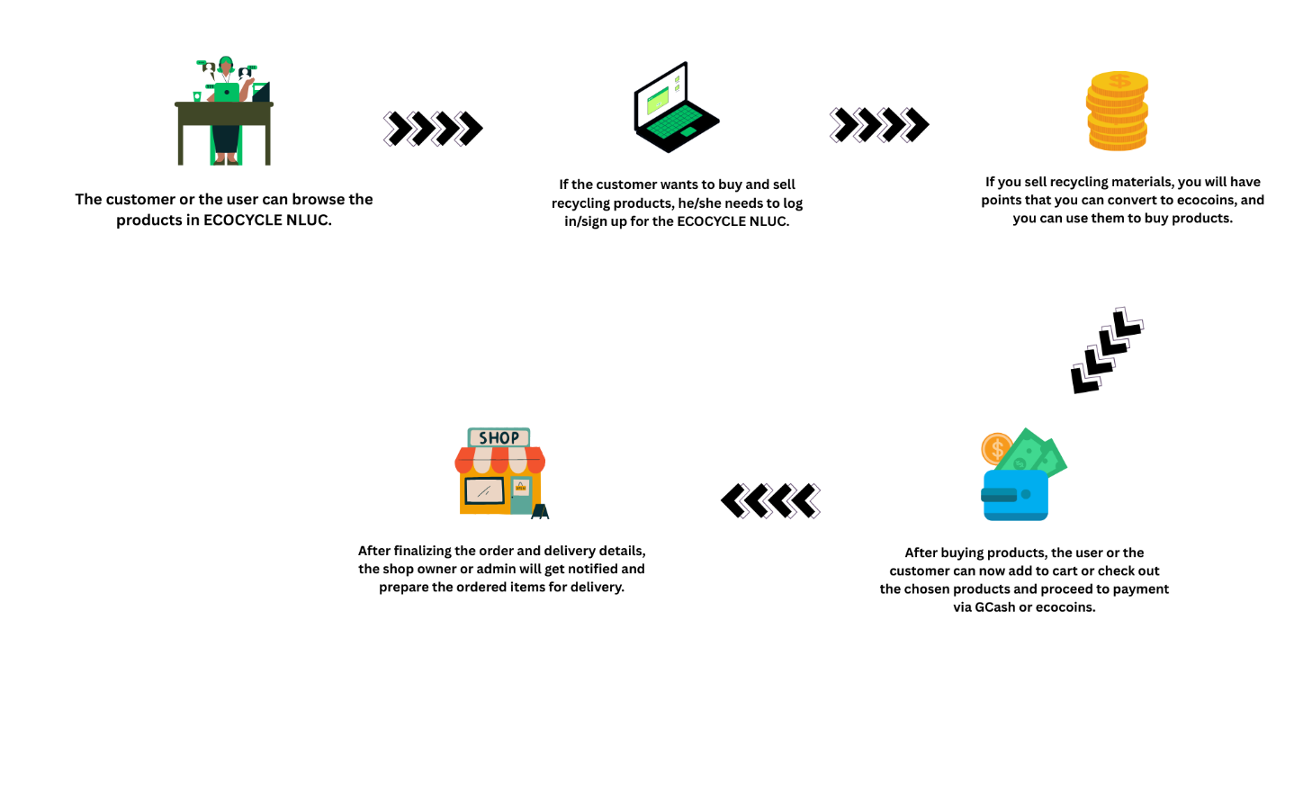
The concept of this study is a marketplace of recycling materials and new recycling products, to minimize the waste at Don Mariano Marcos Memorial State University-North La Union Campus. The concept of the system is shown in figure 3. This system allows the user to buy and sell recycling materials and new recycling products by posting materials and products through the system.
Figure 3: Concept of the Study

This Study followed the Agile Methodology and having six different phases that shown in Figure 4, it includes requirements gathering, design and architecture, development and coding, software testing, implementation and deployment, and lastly is review.
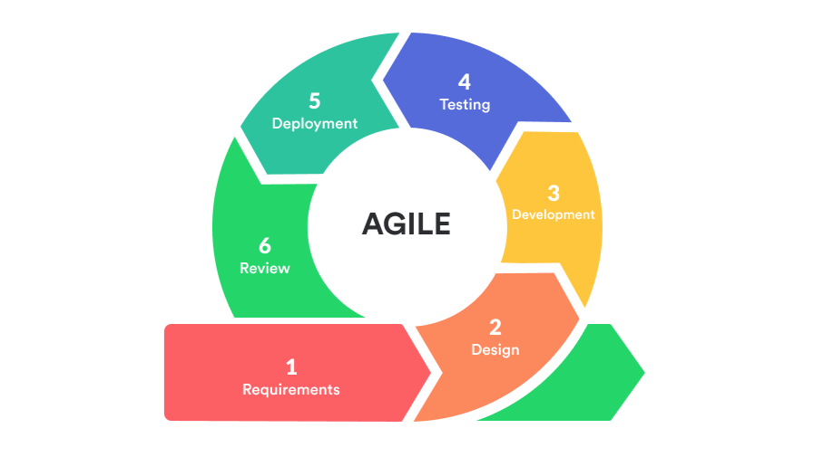
Phase I (Requirement Gathering). In this first phase, the researchers conduct a series of interview with the staff of Environmental Concerns, Sustainability and Development Unit to collect all the requirements that needed in developing the system and to know the process of Environmental Concerns, Sustainability and Development Unit wants to develop.
Figure 4: Agile Methodology
Phase II (Design). In this second phase, the researchers will discuss on how the system will be made. There are 2 entities in this system that can see in Figure 5 Use Case Diagram. The Admin user that can view, manage and monitor all the users or customers, transactions, and the materials and products that post in the system. The User or the Customer can browse products and recycling materials that posts in the system and it also allows the user to buy and sell recycling materials and new recycling products. Additionally, the user or the customer can pay through the system using their GCash.
Phase III (Development and Coding). In this third phase, the researchers will develop the design into a functional code using MySQL for the database, PHP is the programming language that use for coding, XAMPP is the localhost server, and the text editor application is Sublime and Visual Studio Code to edit and write the code.
Phase IV (Software Testing). In this Phase, Using the design and use case diagram as a reference, the researchers will conduct a testing to make sure the system will work to the users. To collect data on the users, client satisfactions and IT expert satisfactions that meets the systems functionality, performance, usability, and security.
Phase V (Implementation and Deployment). In this phase, the developed system to the Environmental Concerns, Sustainability and Development Unit at DMMMSU-NLUC and the users and customers, the researchers will conduct a demonstration to the end users and give some guidance and give some instruction on how to use the system to the users and customers.
Phase VI (Review). In this phase, the researchers give instructions and support to the client or the end users that operates the system. It also includes the instructions in review of the system and maintenance. Additionally, the researchers give the client or end users a manual of the system to help the user to use and run the system.
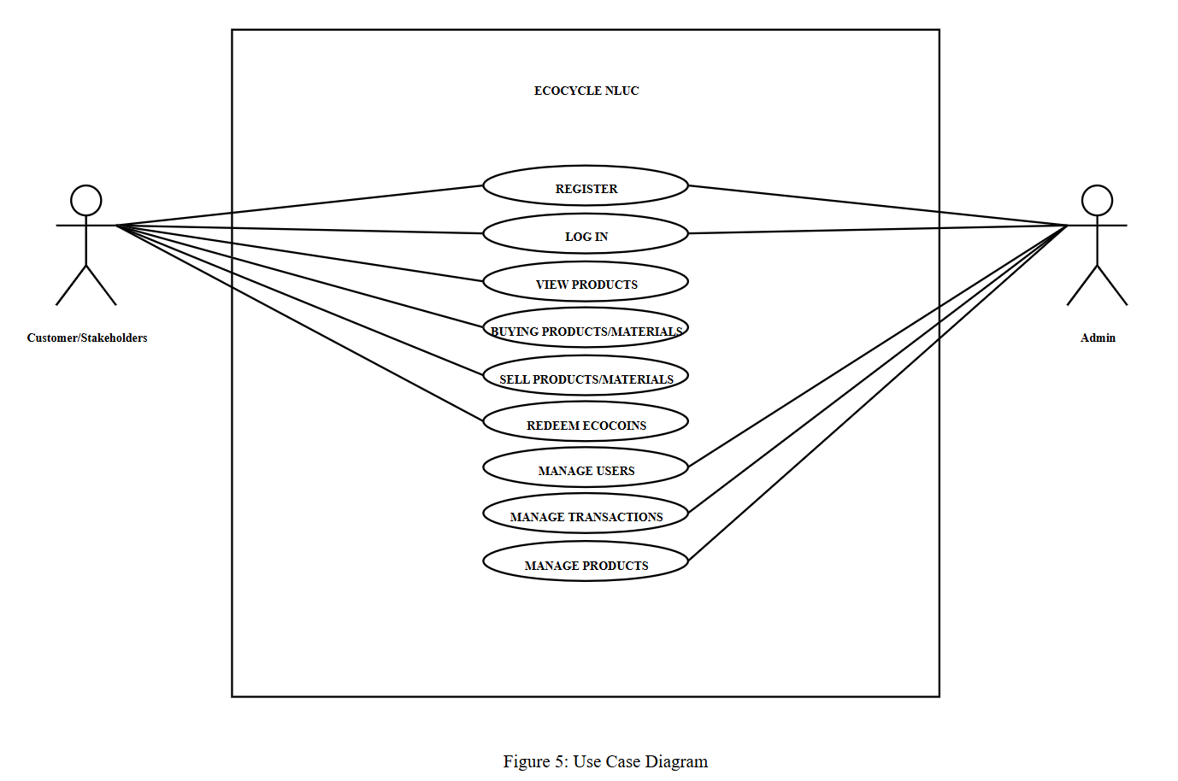
Figure 5: Use Case Diagram

Data Gathering
The study will be conducted in Environmental Concerns, Sustainability and Development Unit at DMMMSU-NLUC Sapilang, Bacnotan, La Union. In this study, there are 3 respondets, IT experts, admin, and users or customers that shown in summary Table 1.
Data Analysis
This questionnaire used in this study to gathered information from the different criteria for the acceptability of the developed system.
The criteria for the acceptability of the developed system are only answerable by “Agree” or “Disagree”. The data gathered will be treated using frequency counts and percentages. The developed system was deemed “Acceptable” if the overall rating in each criterion is within 51-100% and was “Not Acceptable” if the overall rating in each criterion is between 1-50% as seen in the statistical range below:
Statistical Range Descriptive Interpretation
51%-100% Acceptable
Respondents | n
IT experts | 12
Admin user | 1
Customers | 45
Total | 58
1%-50% Not Acceptable
Table 1. Respondents of the Study
Analysis of Variance (ANOVA) was used to assess the significant difference of responses according to type of respondents.
Table 2 summarizes the research design, materials and procedures, data gathered, and data analysis used in each objective of this study. These different methods will help in the attainment of the main and specific objectives of the study.

LITERATURES CITED
Iqbal, Shazia & Naz, Tayyaba & Naseem, Munaza. (2021). CHALLENGES AND OPPORTUNITIES LINKED WITH WASTE MANAGEMENT UNDER GLOBAL PERSPECTIVE: A MINI REVIEW. 1. 9-13. 10.52862/jqaas.2021.1.1.
Clark-Plaskie, M., Lukowski, A., Milojevich, H., & Lang, D. (2022, August 1). Developmental research designs. Pressbooks. https://iastate.pressbooks.pub/individualfamilydevelopment/chapter/developmental-research-designs/
Mukucha, Paul, and Divaries Cosmas Jaravaza. “Waste Material Recycling: The Horrors of Informal Waste Material Picking in Zimbabwe.” Journal of Responsible Production and Consumption, vol. 2, no. 1, 16 Apr. 2025, pp. 235–253, https://doi.org/10.1108/jrpc-01-2024-0003. Accessed 14 May 2025.
Reza, Ali, et al. “Global Plastic Waste Management: Analyzing Trends, Economic and Social Implications, and Predictive Modeling Using Artificial Intelligence.” Journal of Environmental and Agricultural Studies, vol. 5, no. 3, 30 Dec. 2024, pp. 42–58, https://doi.org/10.32996/jeas.2024.5.3.5. Accessed 9 Jan. 2025.
World. “Tonnes of COVID-19 Health Care Waste Expose Urgent Need to Improve Waste Management Systems.” Who.int, World Health Organization: WHO, Feb. 2022, www.who.int/news/item/01-02-2022-tonnes-of-covid-19-health-care-waste-expose-urgent-need-to-improve-waste-management-systems?fbclid=IwY2xjawKVOqdleHRuA2FlbQIxMABicmlkETFwYkxCUFhXS2tOUGdwYTRFAR5C7AE5EXSqzw2BBsG2ApeH07Nj-DHR6b-b_j5DXBRDaSiMGj9IqrJlaOrrag_aem_1j7MGDXXuKpE63-z9mhd7A. Accessed 21 May 2025.
Hassan, M. (2024, November 14). Applied Research - types, methods and examples. Research Method. https://researchmethod.net/applied-research/
Ciudad, Kenneth, et al. “Pre-COVID 19 Pandemic Solid Waste Management and Characterization in Caraga State University, Ampayon, Butuan City, Philippines.” Journal of Ecosystem Science and Eco-Governance, June 2022, pp. 43–53, https://doi.org/10.54610/jeseg/4.1.2022.005. Accessed 8 Apr. 2023.
Recyclingtoday.com, 2025, www.recyclingtoday.com/news/circular-launches-digital-platform-recycled-plastics/. Accessed 21 May 2025.
Castillo, Alicia, and Suehiro Otoma. Status of Solid Waste Management in the Philippines. 2022.
Kiernan, G. (2025, May 21). Fixing plastic in Europe | EU waste statistics and what they mean. WasteTrade. https://www.wastetrade.com/news/fixing-plastic-in-europe-eu-waste-statistics-and-what-they-mean/
Kwemoi, K. C. (2025). Engineering Sustainable Solutions for Waste Management. RESEARCH INVENTION JOURNAL of ENGINEERING and PHYSICAL SCIENCES, 4(1), 36–41. https://doi.org/10.59298/rijep/2025/413641
Rubicon. (n.d.). Atlas. Atlas. https://www.rubicon.com/
Home Page. (n.d.). WasteTrade. Retrieved June 21, 2023, from https://www.wastetrade.com/
Mojeed Omotayo Adelodun, & Anyanwu, E. C. (2025). Public Health Risks Associated with Environmental Radiation from Improper Medical Waste Disposal. International Journal of Multidisciplinary Research and Growth Evaluation, 6(2), 21–32. https://doi.org/10.54660/.ijmrge.2025.6.2.21-32
Viitala, M. (2024). Assessing the impact of new waste recycling targets on the operation of waste-to-energy incineration plants. Aaltodoc.aalto.fi. https://aaltodoc.aalto.fi/items/9b7d87a9-765d-4224-aeb6-4ca8a59f44a3
Schmid, R. D., & Xiong, X. (2023). China’s environmental solutions. Applied Microbiology and Biotechnology, 107(4), 987–1002. https://doi.org/10.1007/s00253-022-12340-z
The Plastic Waste Problem and its Solutions. (2023, March 8). Plastic Collective. https://www.plasticcollective.co/the-plastic-waste-problem-and-its-solutions/
Basha, Dr. A. V., A.Mahammed Shafeeulla, Allu Ankitha, Gangannagari Vyshnavi, & Derangula Jagadeesh. (2025). GENERATION OF ELECTRICITY FROM WASTE MATERIALS. International Scientific Journal of Engineering and Management, 04(03), 1–7. https://doi.org/10.55041/ISJEM02424
Sustainable Waste Management Solutions - EcoEx. (2020, January 9). EcoEx. https://ecoex.market/
Kopecká, R., Marlies Hrad, & Huber-Humer, M. (2024). Die Rolle der Abfallwirtschaft im Rahmen der Nachhaltigkeitsziele und der IPCC-Klimaberichte. Österreichische Wasser- Und Abfallwirtschaft. https://doi.org/10.1007/s00506-024-01034-7

