**WSJT-X Quick-Start Guide**

WSJT-X is an experimental version of WSJT implementing JT9, a new mode designed especially for use on the MF and LF bands. JT9 shares many characteristics with the popular modes JT65 and JT4. All three are designed for making QSOs under extreme weak-signal conditions. They use nearly identical message structure and source encoding. JT65 is used for EME on the VHF/UHF bands, and for worldwide QRP communication at HF. JT4 is used mainly on the microwave bands. In contrast, JT9 is optimized for the 1.8 MHz, 472 kHz, and 137 kHz bands.

JT9 offers five choices for the duration of timed T/R sequences: submodes JT9-1, JT9-2, JT9-5, JT9-10, and JT9-30 use 1, 2, 5, 10, and 30 minutes, respectively. Submodes with longer transmissions trade reduced throughput for smaller bandwidth and increased sensitivity. The slowest submode, JT9-30, has total bandwidth 0.4 Hz and operates at signal-to-noise ratios as low as -40 dB measured in the standard 2.5 kHz reference bandwidth.

In addition to presenting a new operating mode with uniquely desirable characteristics, WSJT-X also serves as test vehicle for a new WSJT programming framework. The graphical user interface in earlier versions was written in the programming language Python and used the Tcl/Tk toolkit. For these tasks WSJT-X uses C++ and the Qt framework. Most users will hardly notice these differences, but the new scheme should make program maintenance on multiple platforms more straightforward. This initial experimental release incorporates only the new JT9-x modes, but in time the other popular WSJT modes will be added.

This document assumes that you already have some familiarity with WSJT and/or WSPR.

**Installation and Setup**

1. WSJT-X can be downloaded from the WSJT Home Page, http://www.physics.princeton.edu/pulsar/K1JT/. Click on the WSJT link at the left margin and then on the appropriate download link for WSJT-X.
2. Under Windows, execute the downloaded file and follow the installation instructions. Under Vista or Windows 7 be sure to install WSJT-X into its own directory (the suggested default is c:\wsjtx) rather than C:\Program Files\wsjtx.
3. Start WSJT-X and Select **Options** from its **Setup** menu. Enter your callsign and locator. Select the **PTT Port** to be used for T/R control, or **None** if you if you will use VOX control (not recommended if you are running high power). Select suitable devices from the drop-down lists for **Audio In** and **Audio Out**. Click **OK** to dismiss the **Options** window, and click the **Stop** button on the main window to halt any data acquisition.
4. Select submode JT9-1 from the **Mode** menu. Click on the Wide Graph window just under 1500 Hz on the audio frequency scale, and select the **JT9 Sync** option for data display. Then select **File | Open**, navigate to directory …\Save\Samples under your WSJT-X installation directory, and open the example file 000000_0001.wav. You should see something like the following screen shot:

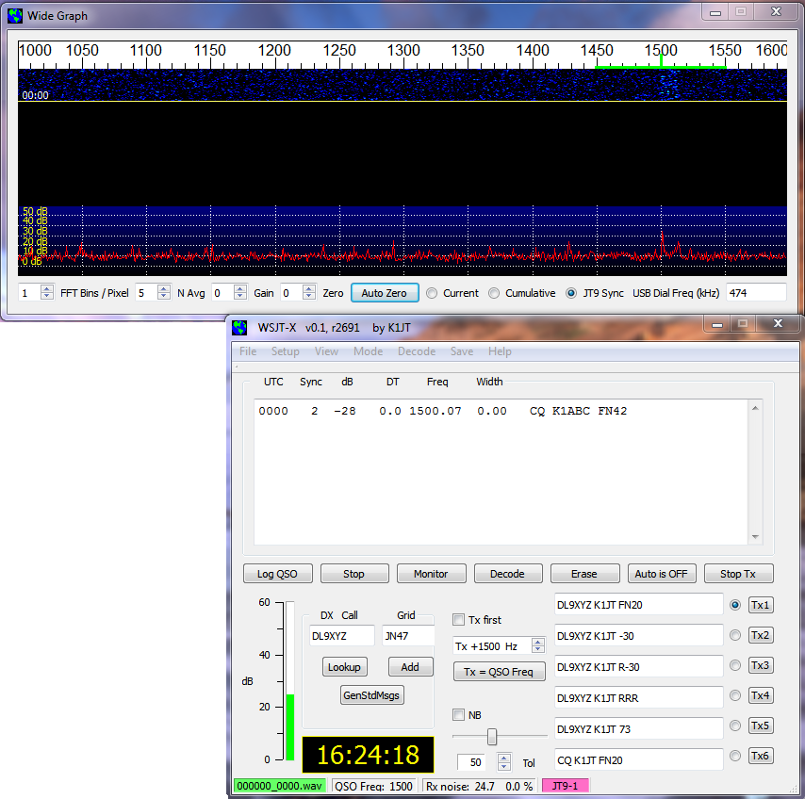

1. If all is well and you are familiar with earlier versions of WSJT, you should now be able to use the JT9 modes in WSJT-X.