**WSJT-X User’s Guide**

**Joe Taylor, K1JT**

Copyright © 2013

April 11, 2013

Contents

Introduction 3

Hardware and Software Requirements 3

Installation and Setup 5

Decoding Tutorial 11

Additional Features and Options 14

Appendix A: Installed and Generated Files 19

Appendix B: The JT65 Protocol 20

Appendix C: Astronomical Calculations 21

Appendix D: Source Code 22

# Introduction

[*WSJT-X*](http://physics.princeton.edu/pulsar/K1JT/map65.html)is a computer program designed for amateur radio communication using low power or when (for some other reason) signals are weak. The first four letters in the program name stand for “Weak Signal communication by K1JT”, and the “*-X*” suffix indicates that *WSJT-X* is an experimental branch of the earlier program *WSJT*.

Version 1.0 of *WSJT-X* offers the new mode JT9, designed especially for use on the HF, MF, and LF bands. JT9 shares many characteristics with the modes JT65 and JT4 made popular in *WSJT*. All three are designed for making minimal QSOs under extreme weak-signal conditions. They use nearly identical message structure and source encoding. JT65 is used for EME on the VHF/UHF bands, and for worldwide QRP communication at HF. JT4 is used mainly on the microwave bands. In contrast, JT9 is optimized for HF and lower frequencies, especially the 1.8 MHz, 472 kHz, and 137 kHz bands. JT9 is about 2 dB more sensitive than JT65A while using less than 10% of the bandwidth.

JT9 offers five choices for the duration of timed T/R sequences: submodes JT9-1, JT9-2, JT9-5, JT9-10, and JT9-30 use 1, 2, 5, 10, and 30 minutes, respectively. Even with JT9-1 a minimal QSO takes 5 ot 6 minutes, so for obvious reasons JT9-1 is the preferred submode under most circumstances. The sub-modes with longer transmissions trade reduced throughput for smaller bandwidth and increased sensitivity. The slowest sub-mode, JT9-30, has total bandwidth 0.4 Hz and operates at signal-to-noise ratios as low as –40 dB measured in the standard 2.5 kHz reference bandwidth. It requires very stable oscillators in both transmitter and receiver. JT9-1 is the recommended submode unless you really need the additional sensitivity of a slower mode.

# System Requirements

* SSB transceiver and antenna
* Computer running the Microsoft Windows/XP or later operating system. (*WSJT-X* also runs under Linux, but we do not yet provide a click-to-install package. See Appendix B.)
* 1.5 GHz or faster CPU and 512 MB of available RAM
* Monitor with at least 800 x 600 resolution (more is better)
* Sound card supported by your operating system
* Computer-to-radio interface using a serial port to key your PTT line, or CAT control.
* Audio connections between transceiver and sound card
* A means for synchronizing your computer clock to UTC. I recommend *Meinberg NTP*, see <http://www.satsignal.eu/ntp/setup.html> for installation instructions.

# Quick-Start Installation and JT9 Setup

1. *WSJT-X* can be downloaded from the WSJT Home Page at <http://www.physics.princeton.edu/pulsar/K1JT/>. Click on the WSJT link at the left margin and then on the appropriate download link for *WSJT-X*.
2. Under Windows, execute the downloaded file and follow the installation instructions. Install WSJT-X into its own directory (the suggested default is C:\WSJTX) rather than the conventional C:\Program Files\WSJTX.
3. Start WSJT-X and Select **Options** from its **Setup** menu. Enter your callsign and Maidenhead locator, and set the remaining parameters as required for your station. Click **OK** to dismiss the **Options** window.

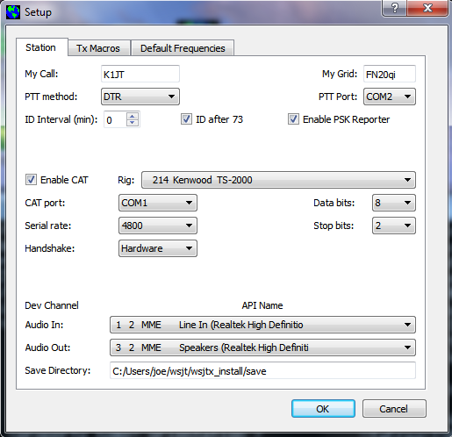

1. If necessary, click the **Stop** button on the main window to halt any data acquisition Select submode **JT9-1** from the **Mode** menu and **Normal** from the **Decode** menu. On the Wide Graph window select **JT9 Sync** (rather than **Current** or **Cumulative**) for data display. Select **Tab 2** (just below the **Erase** button on the main window) to choose the alternative set of controls for generating and selecting messages to be transmitted. Then select **File | Open**, navigate to directory …\Save\Samples under your WSJT-X installation directory, and open the example file 130228_2158.wav. You should see something like the screen shots below and on the next page.

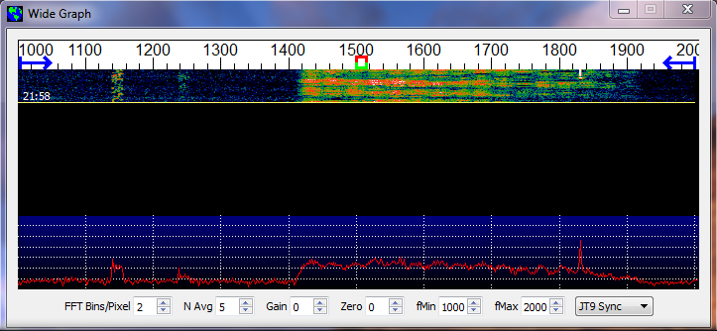

Notice the green, red, and blue markers on the waterfall frequency scale. Decoding in JT9 mode takes place at the end of a receive sequence and is organized in two stages. The first decodes are at the selected Rx frequency indicated by the green marker. These appear in the both the left (“QSO Frequency”) and right (“Band Activity”) text windows. The decoder then finds and decodes att JT9 signals between the blue markers at frequencies **f Min** and **f Max.** The normal wideband decoding range is 1000 – 2000 Hz, but you can move the limits using the **f Min** and **f Max** spinner controls. The red marker indicates the Tx frequency.

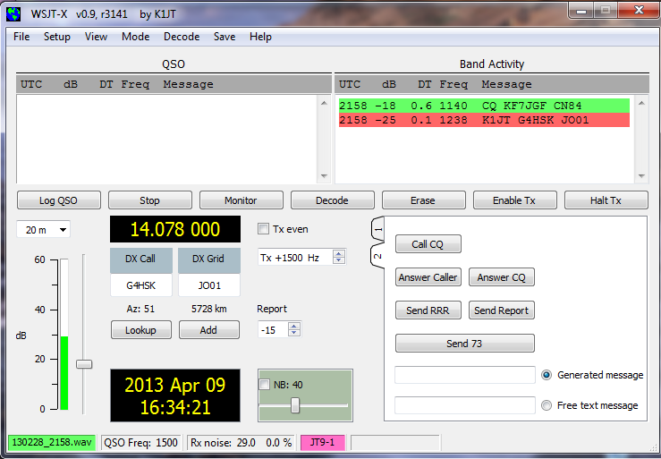

1. Note that two JT9 signals have been decoded: KF7JGF is calling CQ, and G4HSK is responding to a CQ from K1JT. These signals are visible on the waterfall near audio frequencies 1140 and 1238 Hz, respectively. At SNR = –25 dB, the signal from G4HSK is close to the minimum for reliable decoding. The strong, wide signal between about 1400 and 1800 Hz is some other data mode; the JT9 decoder will spend some time trying to make sense of it, and will then ignore it. The KF7JGF signal is highlighted in green because he is calling CQ. The signal from G4HSK is highlighted in red because it is directed to “MyCall”, in this case K1JT.
2. To gain some feeling for the controls to be used for making QSOs, try clicking with the mouse on the decoded text lines and on the waterfall spectrum display. You should be able to confirm the following behavior:
   1. Double-click on the decoded line highlighted in green. This action copies callsign and locator of a station calling CQ to the “DX Call” and “DX grid” entry fields, and then generates suitable messages for a minimal QSO. Rx and Tx frequency markers will be moved to the CQing station’s frequency.
   2. Double-click on the decoded line highlighted in red. Results will be similar to (a), except the Tx frequency (red marker) is not moved.
   3. Clicking on the waterfall moves the Rx frequency (green marker) to the selected frequency.
   4. CTRL-click on waterfall moves both Rx and Tx frequencies.
   5. Double-click on waterfall moves the Rx frequency and causes a narrow-band decode there. Decoded text appears in the left (“QSO”) window.
   6. CTRL-double-click moves both Rx and Tx frequencies and decodes there.
   7. Clicking **Erase** clears the QSO window. Double-clicking **Erase** clears both text windows.
3. Examine the user options presented on the **Setup** menu. You may want to select some of these for your normal operation.

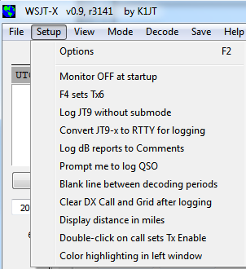

1. Click the **Monitor** button to return to normal receive operation. Using the receiver gain control(s) and/or the Windows mixer controls, set the background noise level to around 30 dB on the thermometer scale at lower left of the *WSJT-X* main screen. If necessary you can also use the slider next to the thermometer scale, but the overall dynamic range will be best with the slider at mid-scale. When this is true, the dB scale is calibrated relative to the least significant bit of a 16-bit A/D converter in the soundcard.
2. You should now be ready to make QSOs with the JT9 modes in *WSJT-X*.

# Operating Hints

JT9 is not a mode suitable for extensive conversations or rag-chewing.

# Additional Features and Options

The

# Appendix A: Installed and Generated Files

After installing *MAP65* as described in steps 1–3 on page 5, the following files will be present in the installation directory:

afmhot.dat Data for AFMHot palette

blue.dat Data for Blue palette

CALL3.TXT Callsign database

fftwf-wisdom.exe Program for FFT optimizations

fftwf_wisdom.dat Results of running fftwf-wisdom.exe

kvasd.exe Koetter-Vardy decoder

m65.exe Slave program, controls all decoding steps

map65.exe Master MAP65 program

qthid.exe Slave program for configuring FUNcube

save Directory for saved files of wideband data

unins000.dat Data for uninstall utility

unins000.exe Default uninstall program

wisdom1.bat Batch file to run short FFT optimizations

wisdom2.bat Batch file to run long FFT optimizations

wsjt.ico WSJT icon

In addition, the following *.dll support files will have been installed in your system directory, typically C:\Windows\System32 on a Windows system:

libfftw3f-3.dll

libgcc_s_dw2-1.dll

libstdc++-6.dll

libusb0.dll

mingwm10.dll

palir-02.dll

QtCore4.dll

QtGui4.dll

QtNetwork4.dll

QtSvg4.dll

qwt.dll

You might be curious about additional files that appear in the *MAP65* installation directory after using the program for a while. These include:

kvasd.dat Data for the Koetter-Vardy decoder

livecq.txt Information for web-based “LiveCQ” display

map65.ini Saved configuration parameters

map65.log Log file for decoder diagnostics, etc.

map65_rx.log Log of all decoded messages

map65_tx.log Log of all transmitted messages

prefixes.txt List of available add-on DXCC prefixes

timer.out Profile showing times in decoder routines

tmp26.txt Intermediate file used by decoder

# Appendix B: The JT65 Protocol

# Appendix D: Source Code

*MAP65* is an open-source program released under the [GNU General Public License](http://www.gnu.org/copyleft/gpl.html). Source code is available from the public repository at <http://developer.berlios.de/projects/wsjt/>. To compile the program you will need to install open source packages for Subversion, QtSDK, qwt, g++, g95 or gfortran, portaudio, and fftw3. For compiling in Windows I recommend installing the MinGW package.

The full source code for MAP65 may be downloaded by using the command

svn co svn://svn.berlios.de/wsjt/branches/map65 map65