

**CS 1632 Software Quality Assurance**

**Deliverable 4**

Member 1 Name:

Member 2 Name:

1. **Optimized Feature 1**
   1. Write the name of the feature optimized (the label on the button)  
      RUN continuous
   2. Write the name(s) of the method(s) you refactored to optimize this feature  
        
      MainPanel.calculateNextIteration, MainPanel.iterateCell()
   3. Insert a screenshot of VisualVM CPU profiling ***after*** optimizing Feature 1. Please include only the “Hot spots” window in the screenshot. 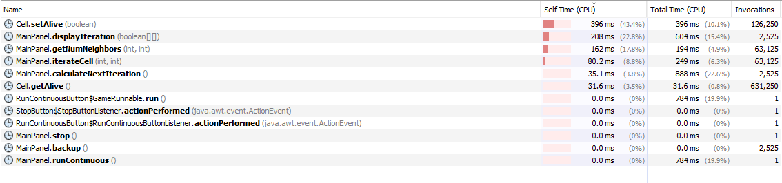
2. **Optimized Feature 2**
   1. Write the name of the feature optimized (the label on the button)  
        
      Write
   2. Write the name(s) of the method(s) you refactored to optimize this feature  
      Cell.toString()
   3. Insert a screenshot of VisualVM CPU profiling ***after*** optimizing Feature 2. Please show only the profile for Feature 2 (do not invoke Feature 1 while profiling). Please include only the “Hot spots” window in the screenshot, as before.

