**STORYBOARD**

* BASIC WEBSITE LAYOUT DESIGN

Home Page

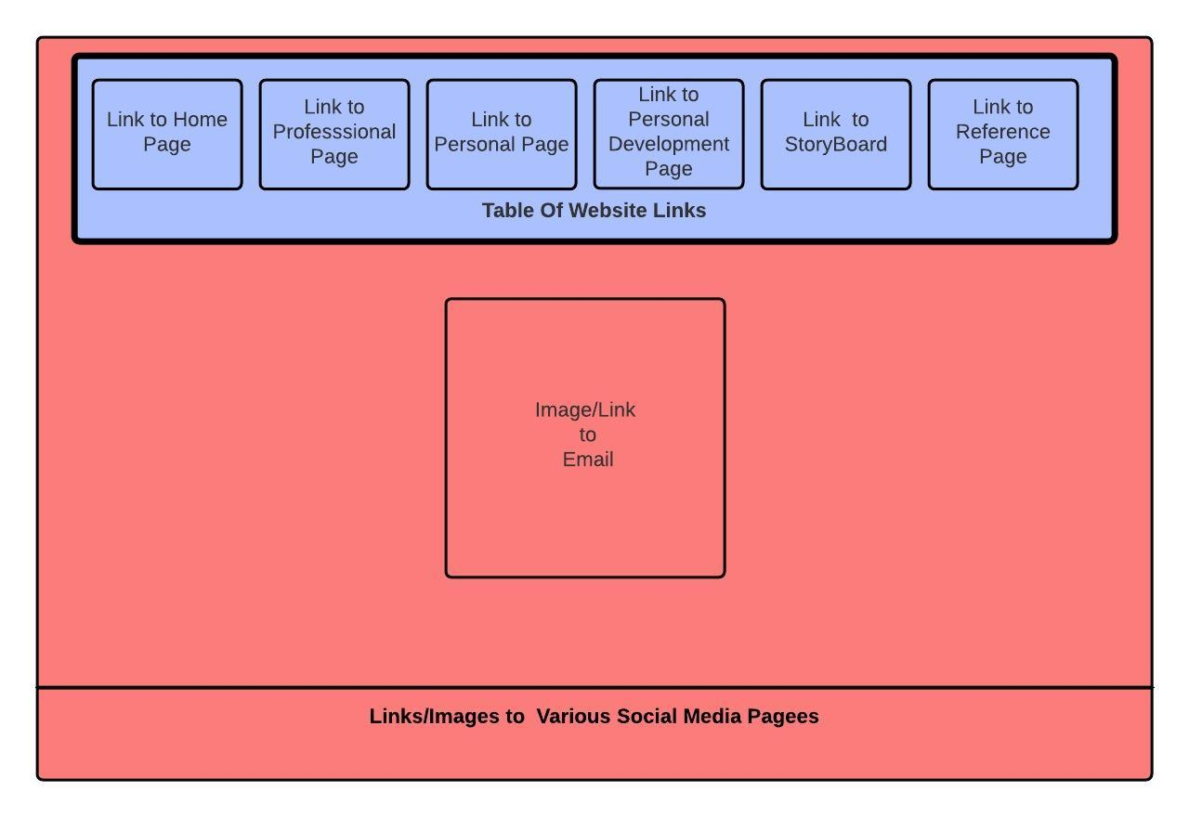

Other Pages

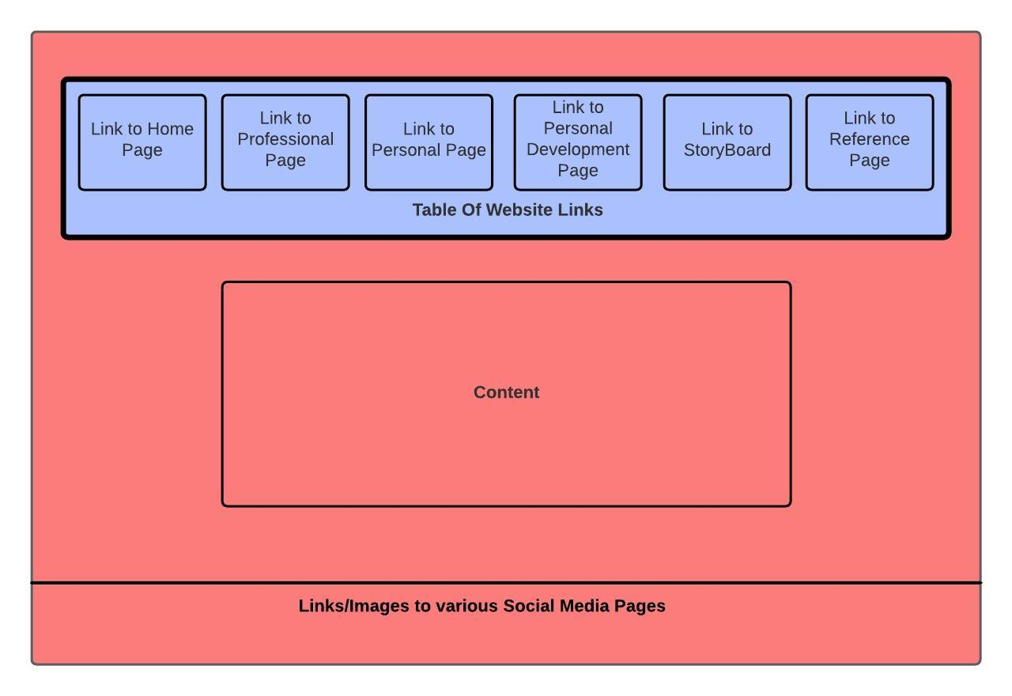

* PAGES AND THEIR PURPOSE

Home Page

*The purpose of this page is to show basic information on the website creator as well as an image of him that also functions as a link to the creator’s email.*

Professional Page

*The purpose of this page is to show the creators resume, his professional vision statement and skills.*

Personal Page

*The purpose of this page is show the creators character by showcasing his emotions and traits as well as a list of his likes, dislikes and hobbies.*

Personal Development Page

*The purpose of this page is for the creator to show if he’s developed in recent years from any area from 3 strengths he’s listed from a self-assessment.*

StoryBoard

*The purpose of the page is to show the layout of the creators pages as well as information regarding the website coding process.*

References

*The purpose of this page is to show all bibliographical sources that the creator used for assistance is creating this page in APA format.*

* THEME OF THE WEBSITE

The theme of my page was #ABC1FF and #FCB7B, the creator went with these colors to give the sites a relaxed yes fascinating collaboration to entice visitors without a strain on the eyes.

* TARGET AUDIENCE

The target audience I would be seeking from my website would be future employers.

* FEATURES

Social Media Links- Allows site visitors to click an icon and sent directly to the creator’s social accounts

Email Image Link- Allows site visitors to click the creators to image to send him an email.