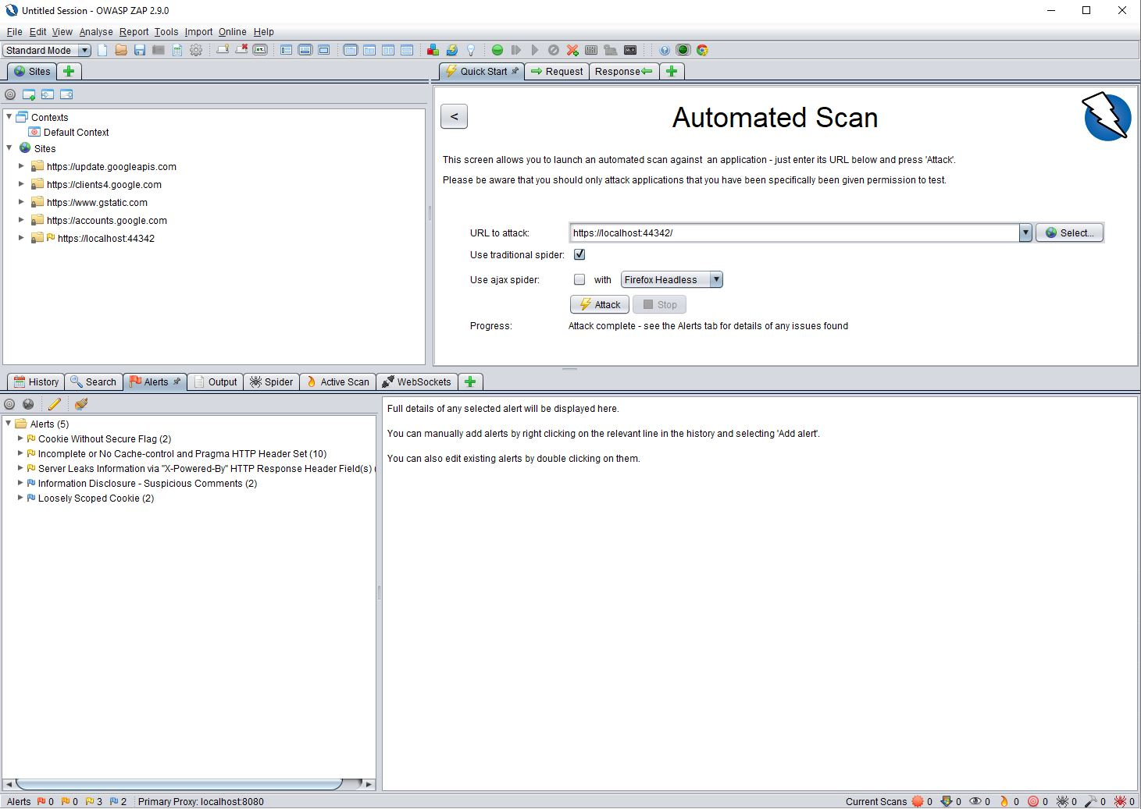

I implemented code that added headers to my site, these lines are in the location of startup. I got the lines of code primarily from my Lab code which also had to deal with the same issues.