Football Analysis Lab

**Purpose:** The purpose of this experiment is to determine the velocity and angle the football was kicked at from the video by use of Logger Pro in order to ascertain whether or not the ball would have made it over the upright, assuming it was aimed properly.

**Materials:**

* 1 Computer w/ Logger Pro
* Video of Football Kick

**Procedure:**

1. Import the football kick video into Logger Pro with Insert->Movie...
2. Right-click the video and go to Movie Options… Keep the default setting, except for “First VA point defines movie time zero”, which you must check. Also, make sure that underneath it the video advances **1** frame after adding a new point. Press OK to exit out of Movie Options.
3. Play the video until you reach the time of kick, at which point you use the frame navigation buttons to seek the frame in which the ball is on the ground and as close as possible to touching the kicker’s foot.
4. Set the origin on the approximate center of mass of the football. Slant the axes so that the +x-axis, represented by the dot, is parallel to the hash marks.
5. Set the scale from between two 1-yard markers, and set the distance to 0.9144m. The scale should be parallel to the x-axis.
6. Plot your first point in the approximate center of mass of the football. The video should advance one frame.
7. Repeat step 6 until the football is no longer in the video.
8. Seek the first frame that was found earlier.
9. Copy the video in Logger Pro and paste it twice.
10. Repeat steps 4-7 for each of the new videos, instead plotting the movement of each hash mark, one per movie analysis, as defined by the scale in the first frame. These will allow to account for dilation and translation in the video.
11. Export all the positional data to Excel.
12. Calculate the distance between the hash marks in each frame using Pythagorean Theorem.
13. Calculate the dilation in each frame by dividing the distance between the hash marks in that frame by the distance between the hash marks in the first frame.
14. Calculate the expected position of each hash mark in each frame due to solely dilation centered on the origin by multiplying the coordinate of the hash mark in the first frame by the dilation in each frame.
15. Calculate the x-y displacement of each hash mark in each frame from its expected position due to solely dilation by subtracting the expected position of each hash mark from the measured position of each hash mark.
16. Calculate the x-y displacement of the origin in each frame from the starting origin by taking the average of the x-y displacement of each hash mark.
17. Calculate the actual coordinates of the football by dividing the measured coordinates by the dilation and then subtracting by the x-y displacement of the origin.
18. Plot a scatter function of the actual x as a function of time and the actual y as a function of time, on the same graph, and find the lines of best fit for both. The slope of the line of best fit of x(t) is the horizontal velocity (vx), and the slope of the line of best fit of y(t) is the vertical velocity (vy).
19. Calculate the initial velocity by using Pythagorean Theorem on vx and vy.
20. Calculate the angle of the initial velocity by using Atan2(vy,vx).
21. Calculate the minimum velocity at 22° needed to reach the upright.
22. Conclude whether or not the football would have made it over the upright, according to the analysis from the video, not accounting for air resistance.

**Data:**

## Football Tracking

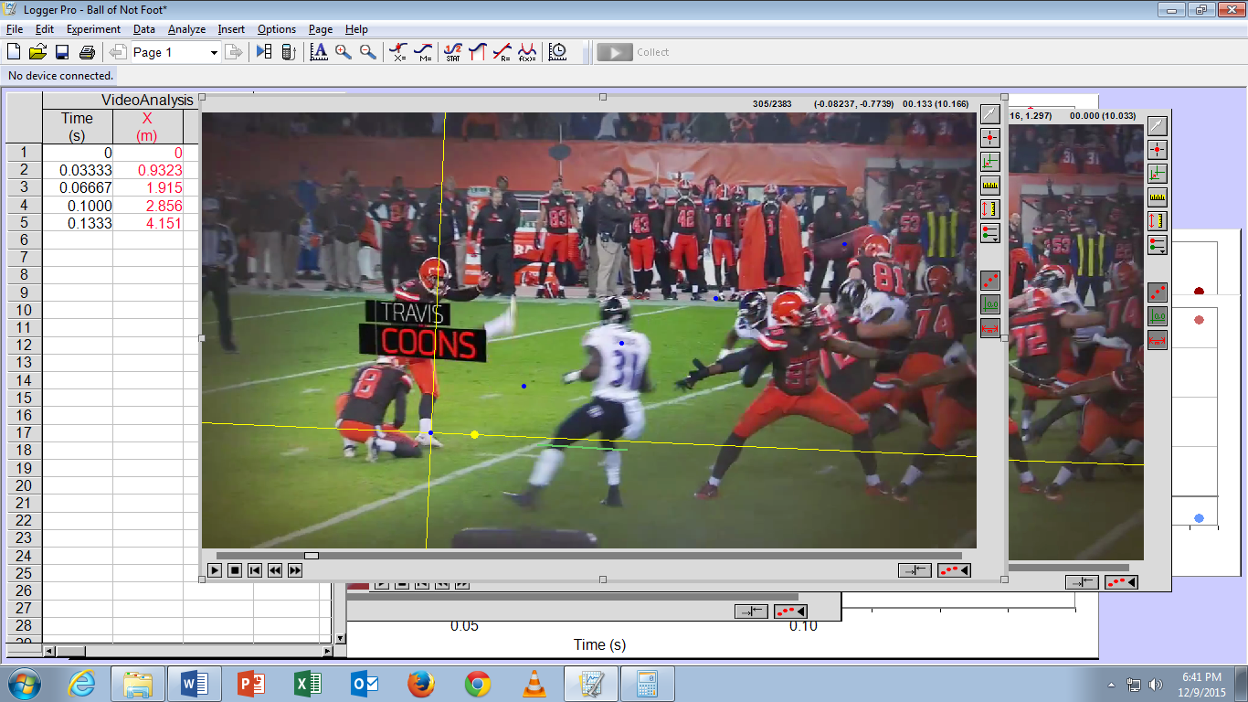

## Yard Line Tracking

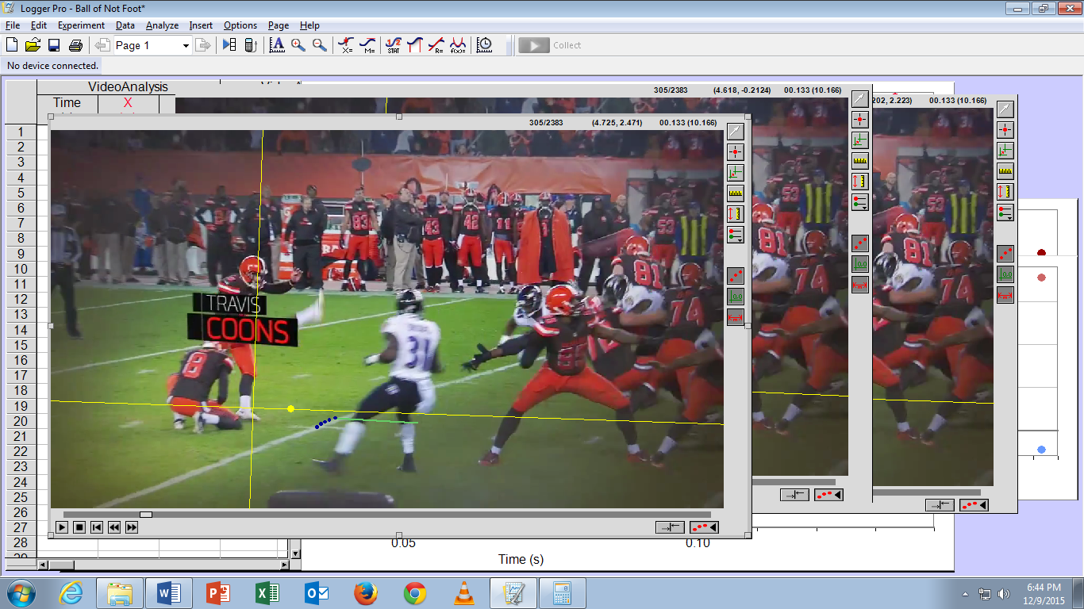

## Hash Mark Tracking

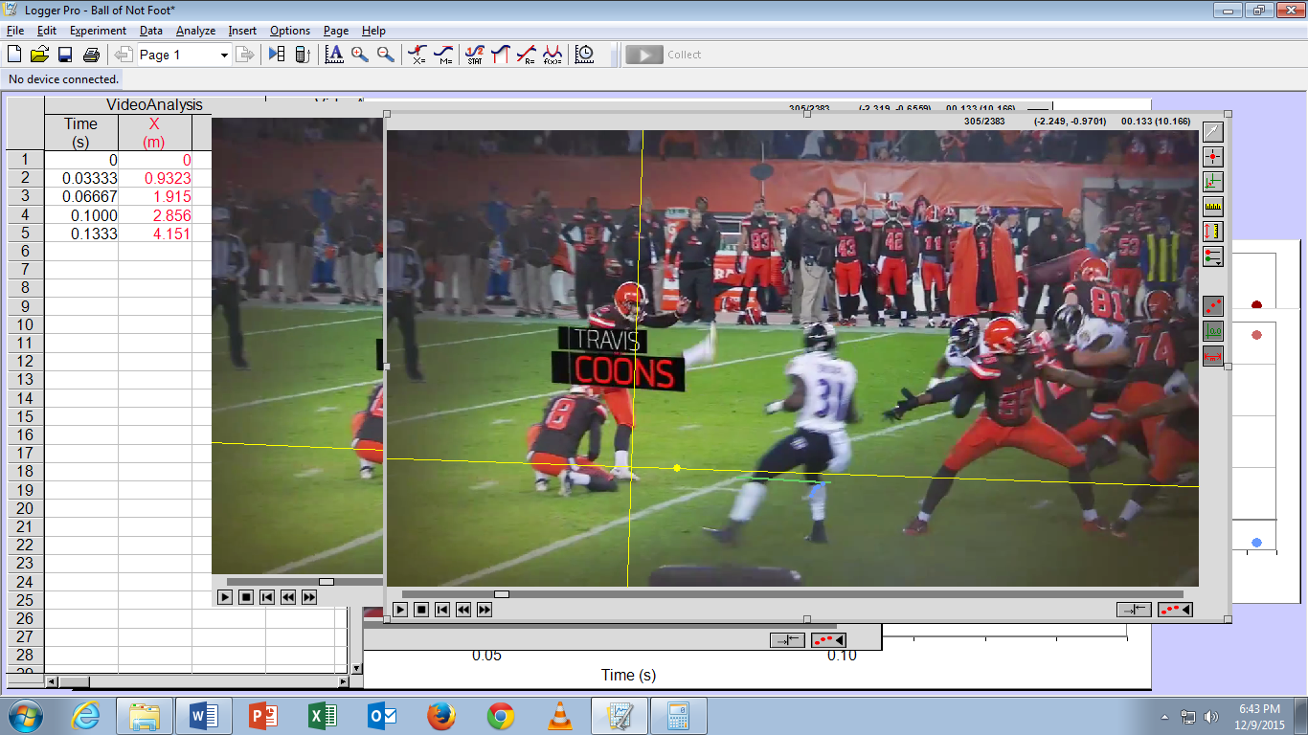

|  |  |  |  |  |  |  |  |  |
| --- | --- | --- | --- | --- | --- | --- | --- | --- |
|  | Football | | Field Line 1 | | Field Line 2 | | Calculations | |
| Time (s) | X (m) | Y (m) | X (m) | Y (m) | X (m) | Y (m) | Distance (m) | Dilation |
| 0 | 0 | 0 | 0.923794 | -0.08467 | 1.876811 | -0.10475 | 0.953229 | 1 |
| 0.033333 | 0.93232 | 0.514007 | 0.858865 | -0.10886 | 1.831236 | -0.12956 | 0.972591 | 1.020313 |
| 0.066667 | 1.914932 | 0.997568 | 0.808534 | -0.13255 | 1.801122 | -0.15383 | 0.992816 | 1.04153 |
| 0.1 | 2.855753 | 1.503786 | 0.765503 | -0.15597 | 1.78674 | -0.1853 | 1.021658 | 1.071787 |
| 0.133333 | 4.151035 | 2.115244 | 0.722981 | -0.194 | 1.772629 | -0.22449 | 1.05009 | 1.101614 |

|  |  |  |  |  |  |  |  |  |
| --- | --- | --- | --- | --- | --- | --- | --- | --- |
|  | Dilated F1 | | Dilated F2 | | F1 move from dil | | F2 move from dil | |
| Time (s) | X (m) | Y (m) | X (m) | Y (m) | ΔX (m) | ΔY (m) | ΔX (m) | ΔY (m) |
| 0 | 0.923794 | -0.08467 | 1.876811 | -0.10475 | 0 | 0 | 0 | 0 |
| 0.033333 | 0.942559 | -0.08639 | 1.914935 | -0.10687 | 0.083694 | 0.022472 | 0.083699 | 0.022685 |
| 0.066667 | 0.962159 | -0.08819 | 1.954756 | -0.1091 | 0.153625 | 0.044358 | 0.153633 | 0.044735 |
| 0.1 | 0.990111 | -0.09075 | 2.011543 | -0.11227 | 0.224608 | 0.065223 | 0.224802 | 0.073029 |
| 0.133333 | 1.017664 | -0.09328 | 2.067521 | -0.11539 | 0.294683 | 0.100724 | 0.294893 | 0.109099 |

|  |  |  |  |  |
| --- | --- | --- | --- | --- |
|  | Origin Movement | | Actual Football Motion | |
| Time (s) | ΔX (m) | ΔY (m) | X (m) | Y (m) |
| 0 | 0 | 0 | 0 | 0 |
| 0.033333 | 0.083696 | 0.022578 | 0.830063 | 0.48119551 |
| 0.066667 | 0.153629 | 0.044546 | 1.6849466 | 0.91324477 |
| 0.1 | 0.224705 | 0.069126 | 2.4397721 | 1.33393771 |
| 0.133333 | 0.294788 | 0.104911 | 3.4733517 | 1.81522048 |

**Calculations:**

**Conclusions:**

After intrepid analysis, accounting for translational and dilational transformation in the camera perspective, and without accounting for air resistance or gravity, the initial velocity vector was found to be around 28.809m/s @ 28.1° up from the x-axis. The minimum velocity in order to reach the uprights was calculated to be around 28.016m/s @ 22° up from the x-axis, again not accounting for air resistance. The optimal angle for the kick, according to the informative video, is 42°, so the initial velocity vector had a higher magnitude than the minimum velocity vector, and was also closer in angle to the optimal angle, so according to my analysis the football, if not stopped and aimed correctly, would have cleared the upright. This analysis, while accounting for camera transformation (aside from camera roll, which was not obviously present), neglected to account for several factors such as air resistance, wind, and partly gravity, so the analysis is incomplete and may be inaccurate. Further research is required. Bigger Excel sheets must be made.